Chapter 5

Evaluation and assessment framework
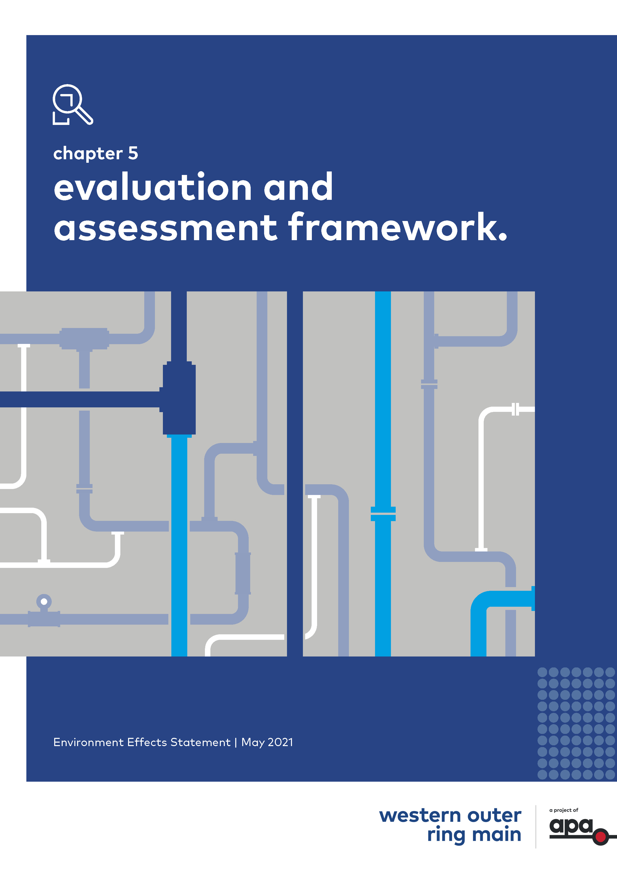
d

Contents
Chapter 5
5.1 Introduction 5-1
5.2 Approvals 5-1
5.3 Environment Effects Act 1978 (Vic) 5-2
5.3.1 EES purpose 5-2
5.3.2 Implications for the Project 5-3
5.4 Principal approvals legislation 5-3
5.4.1 Environment Protection and Biodiversity Conservation Act 1999 (Cth) 5-3
5.4.2 Pipelines Act 2005 (Vic) 5-6
5.4.3 Aboriginal Heritage Act 2006 (Vic) 5-8
5.5 Secondary approvals legislation 5-8
5.5.1 Flora and Fauna Guarantee Act 1988 (Vic) 5-8
5.5.2 Water Act 1989 (Vic) 5-9
5.5.3 Gas Safety Act 1997 (Vic) 5-9
5.5.4 Heritage Act 2017 (Vic) 5-9
5.6 Other applicable legislation 5-10
5.6.1 Environment Protection Act 1970 (Vic) and Environment Protection Act 2017 (Vic) 5-10
5.7 Overview of the EES assessment framework 5-11
5.8 Scoping requirements and evaluation objectives 5-12
5.9 Assessment approach 5-14
5.9.1 Existing conditions 5-14
5.9.2 Risk assessment 5-14
5.9.3 Impact assessment 5-17
5.9.4 Managing environmental effects 5-18
5.9.5 Assessing cumulative impacts 5-19
5.9.6 Integrated assessment 5-19
5.10 Project development 5-20
5.11 Consultation 5-20

Introduction
This chapter outlines the principal environmental and related approvals required for the Western Outer Ring Main (WORM) gas pipeline project (the Project) and applicable legislation.
Within the context of this legislative approvals framework, an assessment framework was developed for the Project EES to ensure a consistent and transparent approach to the evaluation of potential impacts on the environment.
The assessment framework for this EES was developed using the EES scoping requirements (see Section 5.8) and relevant legislation and policy. This chapter provides an overview of applicable legislation and describes the components of the assessment framework and how they underpin the Environment Effects Statement (EES) process.

Approvals
On 22 December 2019, the Minister for Planning (Minister) determined that the Project would require an EES under the Environment Effects Act 1978 (Vic) (EE Act) in order to inform the decision-makers in the granting of key approvals for the Project. Within the Minister’s Referral Decision, the Minister specified the procedures and requirements applicable to the preparation of the EES. The EES scoping requirements (August 2020) provide further detail on the specific matters to be investigated within the context of the Ministerial guidelines for assessment of environmental effects (seventh edition, 2006) under the EE Act.
The principal environmental approval for the Project under Commonwealth legislation is:
- Commonwealth approval under the Environment Protection Biodiversity Conservation Act 1999 (Cth) (EPBC Act).
The principal approvals for the Project under Victorian legislation are:
- Granting of a pipeline licence under the Pipelines Act 2005 (Vic) (Pipelines Act). Section 85 of the Pipelines Act provides that nothing in a planning scheme under the Planning and Environment Act 1987 (Vic) (Planning Act) requires a permit under that Act for the use or development of land or the carrying out of any matter or thing for the purpose of a pipeline that is the subject of a Pipeline Licence
- Approval of a Cultural Heritage Management Plan (CHMP) under the Aboriginal Heritage Act 2006 (Vic) (AH Act).
Other approvals for the Project under Victorian legislation that would be sought as a secondary process after the above principal approvals are obtained are:
- Amendment to the existing Victorian Transmission System (VTS) Safety Case, to include the new WORM pipeline under the Gas Safety Act 1997 (Vic)
- Permits under the Flora and Fauna Guarantee Act 1988 (Vic) (FFG Act) for the removal of FFG Act-listed species
- Permits under the Water Act 1989 (Vic) (Water Act) for works at waterway crossings
- Works in Conservation Areas application (WiCA) for works within a Conservation Area identified in the Biodiversity Conservation Strategy, to the Department of Environment, Land, Water and Planning (DELWP), under the Melbourne Strategic Assessment (Environmental Mitigation Levy) Act 2020 (Vic).
An overview of the planning, environmental and heritage legislation applicable to WORM is illustrated in Figure 5-1 below. For further detail on the discipline-specific legislation, refer to Technical reports A to M.
Figure 5-1 Overview of planning, environmental and heritage legislation applicable to WORM approvals
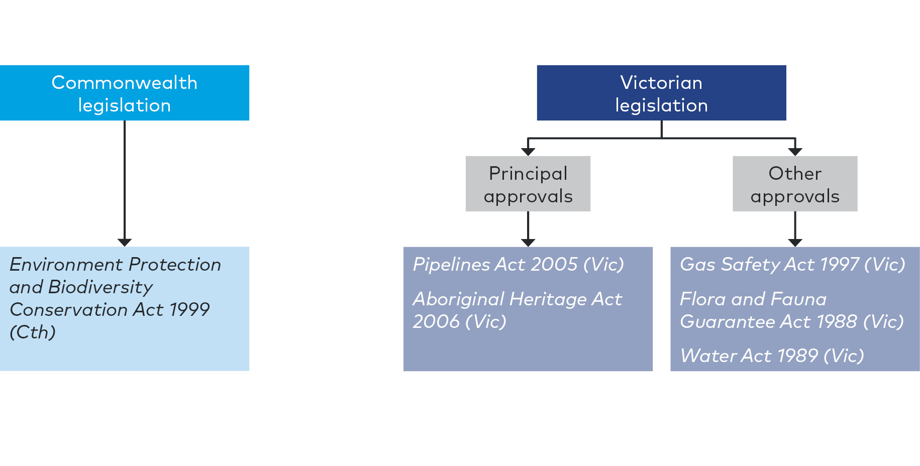

Environment Effects Act 1978 (Vic)

EES purpose
The EE Act sets out the process for the Minister to require the proponent of a project to prepare an EES where a project is considered to have a significant environmental or social effect pursuant to the Ministerial guidelines for assessment of environmental effects (seventh edition, 2006).
The EES process provides for a comprehensive and integrated assessment of the environmental effects of a project. It enables an assessment to be made as to whether the potential for adverse environmental effects are capable of being managed to achieve acceptable outcomes in accordance with project objectives. This includes the development of an outline of the environmental management framework (EMF) that includes a set of environmental management measures that will apply to the ongoing design, development and implementation of a project.
The EES does not provide an approval, but informs an assessment by the Minister of the environmental effects of a project and whether the likely environmental effects of a project are acceptable. The Minister’s assessment of the EES is then used to inform statutory decision-makers about the approvals required for a project to proceed.

Implications for the Project
On 22 December 2019, the Minister determined that the Project would require an EES under the EE Act as it has "the potential for significant environmental effects, in particular on native vegetation, habitat of terrestrial and aquatic species listed under the FFG Act, ecologically sensitive waterways and wetlands, and on Aboriginal cultural heritage". Refer to Chapter 1 Introduction for further detail about this decision.
Following this decision, the Minister issued the draft EES scoping requirements for public comment, which the Minister then finalised and issued in August 2020. This EES has been prepared in accordance with the final scoping requirements issued by the Minister.
This EES assesses the potential effects of the Project on the environment in accordance with the EES scoping requirements. It has been prepared in consultation with stakeholders via the Technical Reference Group (TRG), as required by the EES scoping requirements. The role and membership of the TRG is discussed in Chapter 6 Community and stakeholder consultation. Following the public exhibition of this EES and receipt of submissions, the EES and submissions are likely to be considered by an independent Inquiry and Advisory Committee appointed by the Minister for Planning. The Minister would consider the report from the Inquiry and Advisory Committee as well as the other matters as discussed above in the Minister's assessment of environmental effects of the Project. The EES assessment process is further detailed in the scoping requirements (Section 5.8).
Following the public exhibition of the application for a pipeline licence and receipt of submissions, the application and submissions are likely to be considered by a Panel appointed by the Minister for Energy, Environment and Climate Change. The Minister would consider the report from the Panel.
If both an EES Inquiry and a Pipeline Panel are required, the same members would likely be appointed for both the Inquiry and the Panel so that the submissions are heard and assessed together.

Principal approvals legislation
The scoping requirements for the Project require the EES to "identify legislation, regulations, policies, guidelines and standards, and assess their specific requirements or implications for the Project, particularly in relation to approvals".
This section outlines the principal legislation relevant to the Project approvals. Other legislation, regulations, policies, guidelines and standards relevant to the individual technical studies are outlined in each technical report.

Environment Protection and Biodiversity Conservation Act 1999 (Cth)
The EPBC Act is established to protect and manage designated Matters of National Environmental Significance (MNES). If the Minister for the Environment decides under the EPBC Act that a project is likely to have a significant impact on MNES, or to involve Commonwealth land, the project is designated a "controlled action" that must be assessed and approved by the Minister for the Environment before it can proceed.

Implications for the Project

Existing EPBC approvals
Part of the Project is located within a Melbourne Strategic Assessment (MSA) area approved under Part 10 of the EPBC Act (approved MSA areas). For all projects within the approved MSA areas, no further approvals are required under the EPBC Act for the Project provided certain conditions are adhered to, including:
- The requirement to comply with the Biodiversity Conservation Strategy for Melbourne’s Growth Corridors (DEPI 2013a) (the BCS) which identifies nominated Conservation Areas which require protection for conservation within the MSA area and any applicable sub-regional species strategies
- Any requirement to meet an Environment Mitigation Levy under the Melbourne Strategic Assessment (Environmental Mitigation Levy) Act 2020 (Vic) to fund mitigation measures. The liability to pay an MSA levy is triggered when a levy event occurs within the levy area, where habitat compensation obligations have not been previously met. It is noted that parts of the Project to be undertaken within privately owned land are exempt from this requirement under section 6(e) (i) and (ii) of the Act, which refers to the construction of prescribed minor infrastructure, including gas. The Environment Mitigation Levy is discussed further in Chapter 7 Biodiversity and habitats and details of the levy applicable to the Project are included in EES Attachment II Ecological Offset Strategy.
Land covered by the BCS has been subject to vegetation and habitat mapping (timestamping) conducted under the supervision of the DELWP and the Victorian Planning Authority (VPA). The BCS has been approved under Section 146B of the EPBC Act (Part 10 approval).  Specific locations which overlap with the MSA areas are shown in Figure 5-2 and include:  - KP 0 – 3.2 is within an approved MSA area (UGB 2010)  - KP 3.2 – 28.2 is outside of the approved MSA areas  - KP 28.2 – 51 is within an approved MSA area (UGB 2010).  A Works in Conservation Areas application (WiCA) would be submitted to DELWP for works within Conservation Areas identified in the BCS, under the Melbourne Strategic Assessment (Environmental Mitigation Levy) Act 2020 (Vic). Some WiCA applications also require Commonwealth approval prior to commencement of development. | What is the Melbourne Strategic Assessment?  The Melbourne Strategic Assessment program (MSA) applies to urban development that occurs within Melbourne’s urban growth areas. The program enables the Minister for the Environment to ‘globally’ approve developments under an endorsed policy, plan or program.  The practical effect of this is that project-by-project approvals are not required for actions taken in accordance with that endorsed policy, plan or program. This streamlines the assessment and approval processes required under the EPBC Act, while managing the impact of development in Melbourne’s growth areas on significant ecological communities.
Figure 5-2 Approved MSA areas in relation to WORM
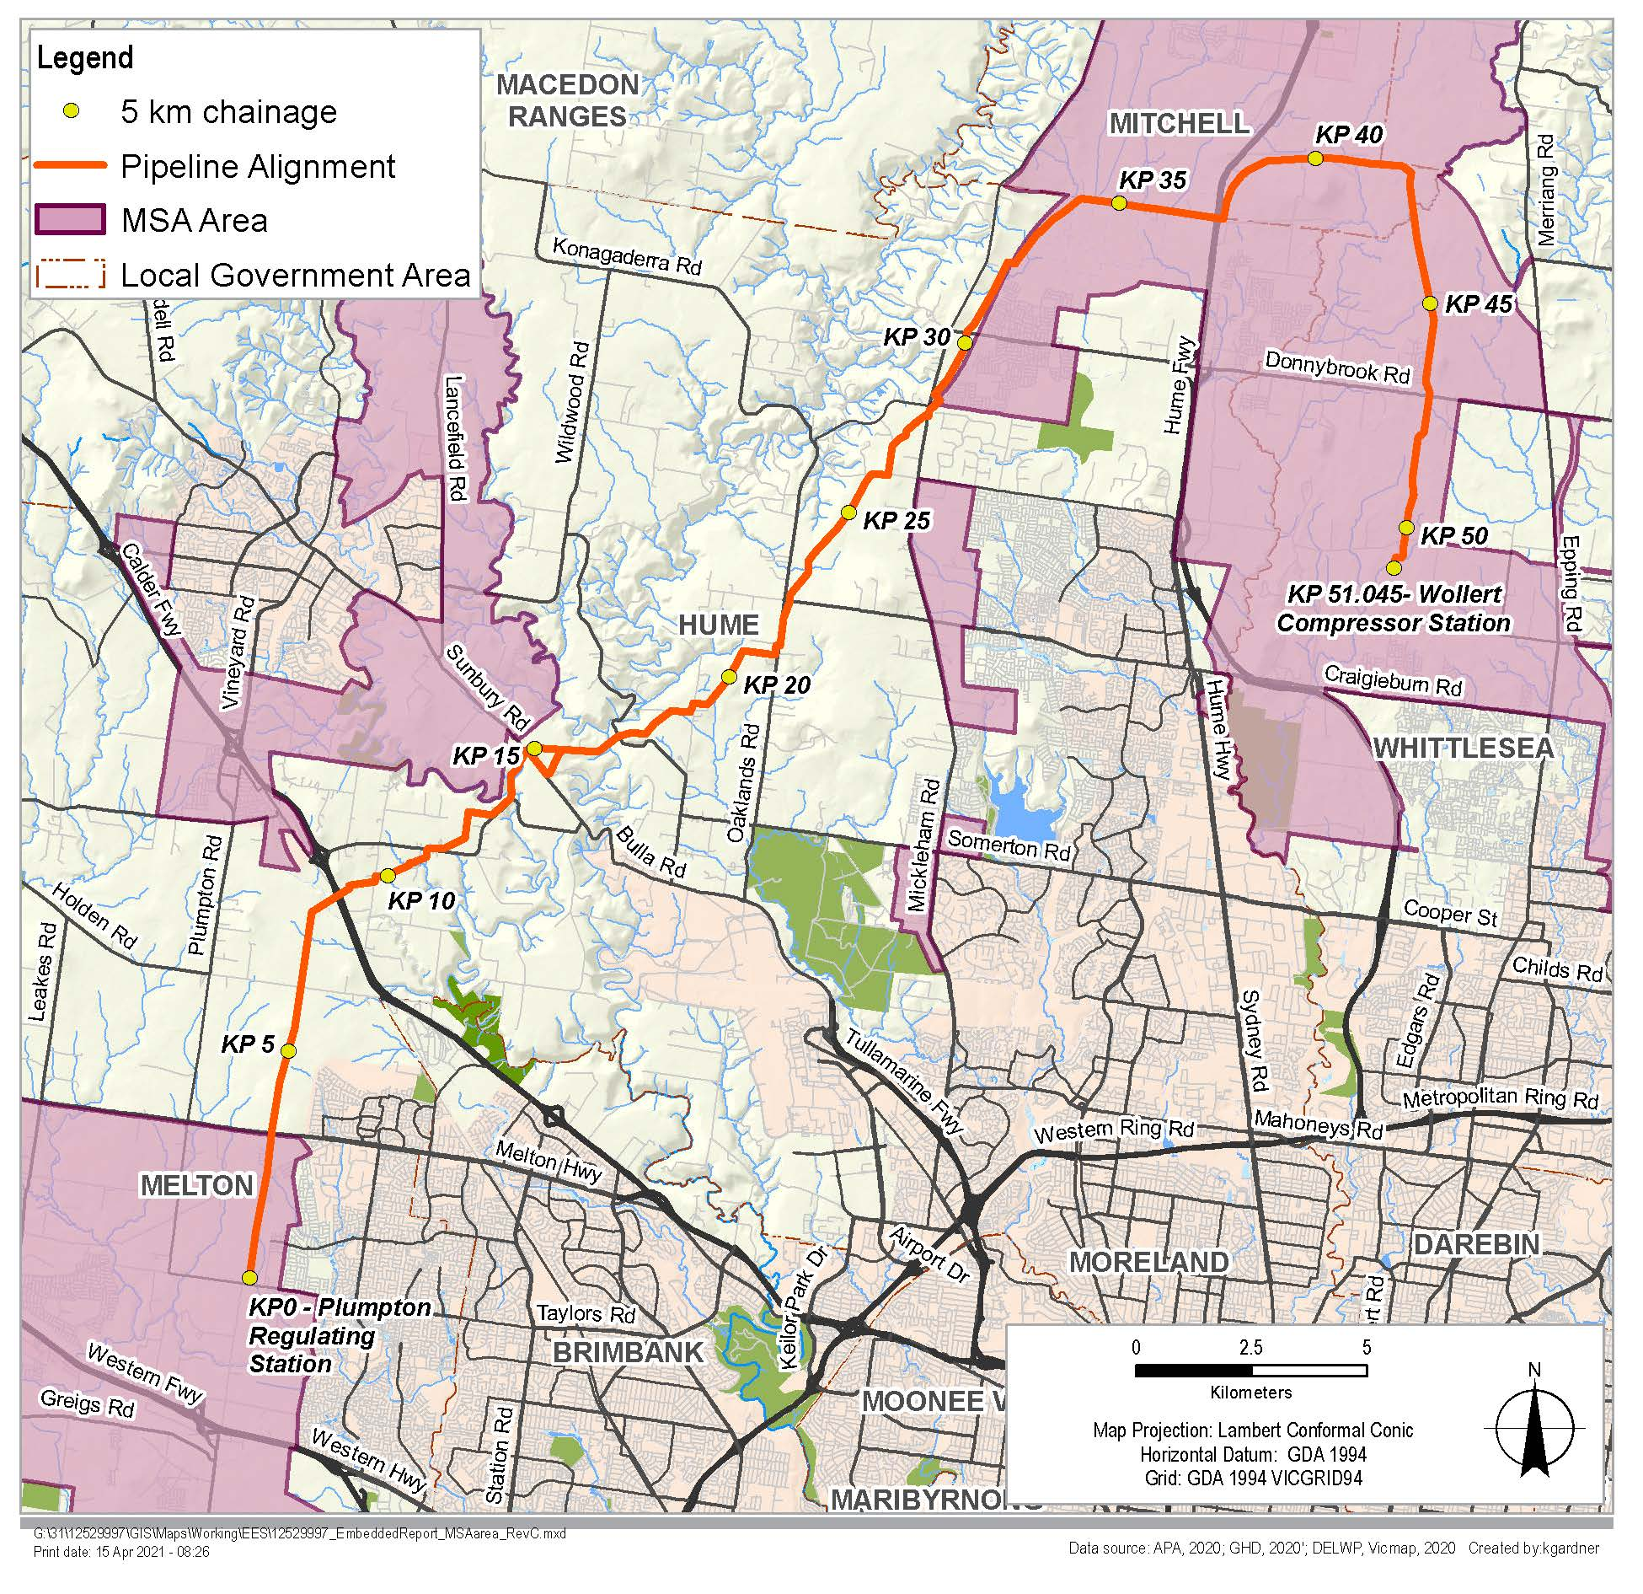

EPBC referral for areas outside the MSA
For the component of the Project located outside the MSA, a referral was submitted to the Commonwealth Department of Agriculture, Water and the Environment (DAWE) under section 75 of the EPBC Act. In February 2020, the Minister for the Environment determined that the proposed action is a controlled action due to the listed threatened species and communities (sections 18 and 18A).
Therefore, the Project requires assessment and approval under the EPBC Act, under the bilateral agreement with Victoria made under section 45 of the EPBC Act.
Matters of National Environmental Significance (MNES) are assessed in Chapter 18 Matters of National Environmental Significance and Technical Report A Biodiversity and habitats. Section 18.4 of Chapter 18 Matters of National Environmental Significance, describes the method of assessment which included the following key tasks:
- Desktop assessment to determine the likelihood of MNES in relation to the Project. The Protected Matters Search Tool (PMST) was used to determine potential MNES within a five kilometre buffer of the Project. For aquatic species, separate PMST searches were completed using a five kilometre buffer from each waterway crossing on Deep Creek, Jacksons Creek and Merri Creek
- A likelihood of occurrence assessment for each of the threatened flora, fauna or migratory species and each threatened community identified in the desktop assessment as having the potential to occur within five kilometres of the Project, or is assumed or known to occur from current records
- Rapid field assessment to determine the presence/absence of native vegetation and habitat. These were conducted on foot, by vehicle or from adjacent road reserves
- Targeted surveys for individual species where the outcome of the desktop review and rapid field assessment indicated a medium or higher likelihood of occurrence
- Assessment of the potential impacts during construction and operation of the Project on listed threatened species and ecological communities was undertaken considering the Matters of National Environmental Significance: Significant impact guidelines 1.1, Environment Protection and Biodiversity Conservation Act 1999 (Significant Impact Guidelines). Environmental management measures (EMMs) were identified in response to the impact assessment and residual impacts were considered. Refer to Chapter 19 Environmental management framework for the full list of environmental management measures.

Pipelines Act 2005 (Vic)
The Pipelines Act is the primary legislation governing the construction and operation of pipelines in Victoria. The Pipelines Act covers transmission pipelines for the conveyance of gas, oil and other substances. DELWP is responsible for administering the Pipelines Act along with the Pipeline Regulations 2017.

Implications for the Project
A pipeline licence is required for natural gas pipelines in Victoria with operating pressure above 1,050kPa, for the construction and ongoing operation of the pipeline. Therefore, the Project will require a Pipeline Licence under the Pipelines Act.
The Pipelines Act requires licensed pipelines to be constructed and operated in accordance with Australian Standard 2885: Pipelines - Gas and Liquid Petroleum. The standard requires pipeline licensees to implement a range of safety measures to reduce foreseeable risks associated with operating a licensed pipeline. This includes understanding how land is being used when pipelines are constructed and where land is planned to be redeveloped once they are operating.
The Pipelines Act specifies that a licensee must prepare a Safety Management Plan and Environmental Management Plan, which are required to be submitted and accepted by Energy Safe Victoria (ESV) and the Minister respectively. Pipeline operations cannot start without the acceptance of both requirements.
Section 3 of the Pipelines Act states the objectives of the Act, including:
(a) to facilitate the development of pipelines for the benefit of Victoria;
(e) to protect the public from environmental, health and safety risks resulting from the construction and operation of pipelines;
(f) to ensure that pipelines are constructed and operated in a way that minimises adverse environmental impacts and has regard for the need for sustainable development.
Section 4 of the Pipelines Act sets out the principles of sustainable development to be given regard in implementing the Act including that decision-making should be guided by a careful evaluation to avoid serious or irreversible damage to the environment wherever practicable and an assessment of the risk-weighted consequences of various options.
Section 54(c) of the Pipelines Act states that conditions on a licence may include conditions concerning the protection of the environment.
If a licence is issued under the Pipelines Act, section 85 provides that nothing in a planning scheme under the Planning Act requires a permit under that Act for the use or development of land or the carrying out of any matter or thing for the purpose of the pipeline. However, Section 49 of the Pipelines Act states that, in granting a Pipeline Licence, the Minister must consider the following in the areas traversed by the pipeline:
(a) the potential environmental, social, economic and safety impacts of the proposed pipeline
(b) the potential impact of the proposed pipeline on cultural heritage (including Indigenous cultural heritage)
(c) the benefit of the proposed pipeline to Victoria relative to its potential impacts
(d) the submissions received under section 34 in relation to the application
(e) the report of the panel (if any) on the submissions received in relation to the application
(f) the assessment of the Environment Effects Minister in relation to the proposed pipeline, if an assessment has been made
(g) any written comments received from the Planning Minister or the relevant responsible authority on the effect of the proposed pipeline on the planning of the area through which it is to pass
(h) any written comments received from the Water Minister and from the relevant Crown Land Minister on the impact of the proposed pipeline.
An assessment against the legislation, policies and clauses within the planning schemes would allow for consideration by the Minister for Planning and the relevant responsible authorities of the applicable land use planning matters through the Pipeline Licence assessment process. For further detail refer to Chapter 15 Land use and Technical report K Land use.
Although exempt from requiring a permit under the Planning and Environment Act 1987, native vegetation removal assessments and offsets will need to be in accordance with the Guidelines for the removal, destruction or lopping of native vegetation (2017), as required by Section 3.5 and 4.2 of the scoping requirements.

Aboriginal Heritage Act 2006 (Vic)
The AH Act provides for the protection of Aboriginal cultural heritage in Victoria.
Section 49 of the AH Act states that a Cultural Heritage Management Plan (CHMP) must be prepared when an EES is required under the EE Act in respect of any works. The CHMP must be prepared and approved before works start.

Implications for the Project
APA is preparing two CHMPs for the Project in consultation with the Registered Aboriginal Party (RAP),Traditional Owners and Aboriginal Victoria. These are:
- CHMP 1 – (KP 0 – 8) is with Aboriginal Victoria (CHMP No 16594)
- CHMP 2 – (KP 8 – 51) is with Wurundjeri Woi-wurrung Cultural Heritage Aboriginal Corporation (WWCHAC) as the RAP (CHMP No. 16593).
When finalised, the CHMPs will be submitted to WWCHAC and Aboriginal Victoria for approval, following the Minister’s assessment of the EES. The CHMPs and ongoing consultation consider both tangible and intangible cultural heritage. Specific management conditions and contingency requirements in CHMPs would be incorporated into the Construction Environment Management Plan and relevant contractor documents following approval of the CHMPs. The CHMPs will be the principal mechanisms for achieving the cultural heritage evaluation objective in Section 4.4 of the scoping requirements.

Secondary approvals legislation
Other approvals would be obtained following key approvals being confirmed. Other required approvals would relate to the final design and construction methodology and are expected to include, as a minimum, approvals under the FFG Act, Water Act, Gas Safety Act and Heritage Act.

Flora and Fauna Guarantee Act 1988 (Vic)
The FFG Act provides a framework for biodiversity conservation and sustainable use of native ecology in Victoria. The FFG Act provides for the listing of threatened species, communities of flora and fauna and potentially threatening processes. A number of non-threatened species are also protected under the FFG Act.
A permit is required under section 47 of the FFG Act to take species protected under the FFG Act from public land, and may also be required to remove protected species from private land in certain circumstances.
A permit is required under section 55 of the FFG Act for the removal of protected or threatened species within the Project area, which may occur as a result of vegetation clearing. An assessment of the potential impacts on protected species is contained in Technical report A Biodiversity and habitats and Chapter 7 Biodiversity and habitats.

Water Act 1989 (Vic)
Victoria’s Water Act promotes the orderly, equitable and efficient use of water resources to ensure water resources are conserved and properly managed for sustainable use. The Water Act regulates the impacts on and use of surface water and groundwater.
The Project would require a licence under section 67 of the Water Act to construct, alter, operate or decommission works on, over or under relevant waterways in the Project area.

Gas Safety Act 1997 (Vic)
The Gas Safety Act aims to regulate the safety of gas supply and use in Victoria and to provide for the safe conveyance, sale, supply, measurement, control and use of gas. Energy Safe Victoria (ESV) administers the Gas Safety Act and the two sets of regulations under the Act:
- Gas Safety (Gas Installation) Regulations 2018
- Gas Safety (Safety Case) Regulations 2018.
Amendment to the existing VTS Safety Case would include the new WORM pipeline under the Gas Safety Act 1997 (Vic). The amended Gas Safety Case would be prepared in accordance with the Gas Safety (Safety Case) Regulations 2018 and would require approval from the ESV. This approval decision is not part of the EES.

Heritage Act 2017 (Vic)
The Heritage Act is administered by Heritage Victoria and the Heritage Council of Victoria. It is the Victorian Government’s key cultural heritage legislation. The Act identifies and protects heritage places and objects that are of significance to Victoria, including:
- Historic archaeological sites and artefacts
- Historic buildings, structures and precincts
- Gardens, trees and cemeteries
- Cultural landscapes
- Shipwrecks and artefacts
- Significant objects
- Objects associated with a place.
The Act establishes the Victorian Heritage Register, the Heritage Inventory and the Heritage Council of Victoria.
A Heritage Act Consent for construction activities near the Holden Cobbled Stone Road site is required for the Project.

Other applicable legislation

Environment Protection Act 1970 (Vic) and Environment Protection Act 2017 (Vic)
The EP Act establishes the legislative framework for protecting the environment in Victoria. It regulates certain activities with the potential to impact on the environment and prohibits the occupier of "scheduled premises" from doing any act or thing (including installing any plant, equipment or process) that is likely to cause the discharge or emission of waste to the environment, unless authorised to do so.
The EP Act 1970 requires a Works Approval for scheduled premises which exceed air emissions thresholds under Schedule 1 of the Environment Protection (Scheduled Premises) Regulations 2017 (Vic). Following consultation with EPA, a Works Approval or Development Licence is not required for the Wollert Compressor Station upgrade component of the Project.
A number of State Environment Protection Policies (SEPPs) have been prepared under the EP Act 1970, which set standards, guidelines and environmental quality objectives and indicators to protect beneficial uses of the environment, including noise, surface and groundwater, land contamination and air quality. SEPPs express in law the community’s expectations, needs and priorities for using and protecting the environment. The SEPPs applicable to the Project are discussed in the EES chapters and technical reports as relevant.
The Environment Protection Act 2017 (Vic) (as amended by the Environment Protection Amendment Act 2018 (Vic)) will commence on 1 July 2021 (this was proclaimed by the Governor in Council on 16 March 2021). This Act (as amended) will substantially amend the environment protection framework, including adopting a new general environmental duty and introducing a new permissions scheme including a development licence, operating licence, permits and registrations. New Environmental Reference Standards and Environmental Protection Regulations will be developed under the new Act to replace current SEPP and EPA guidelines. For example the management of environmental risks during the construction of the pipeline will follow the guidance in new publication 1820: Construction – Guide to preventing harm to people and the environment.
Whilst an approval is not required, the design and delivery of the Project must otherwise comply with appropriate regulations, SEPPs and guidelines under the EP Act where they apply to Project activities. These compliance requirements are identified in Chapter 19 Environmental management framework.

Overview of the EES assessment framework
The following key components of the assessment framework are illustrated in Figure 5-3:
- Evaluation framework: the EES scoping requirements and relevant policy and legislation
- Assessment approach: the process for undertaking the technical reports including an assessment of existing conditions, risk assessment, impact assessment and development of environmental management measures, to evaluate whether the Project’s effects are maintained within permissible levels, and propose contingency approaches if they are not
- Project development: the progression of the Project design
- Consultation: community and stakeholder consultation activities.
Figure 5-3 EES assessment framework
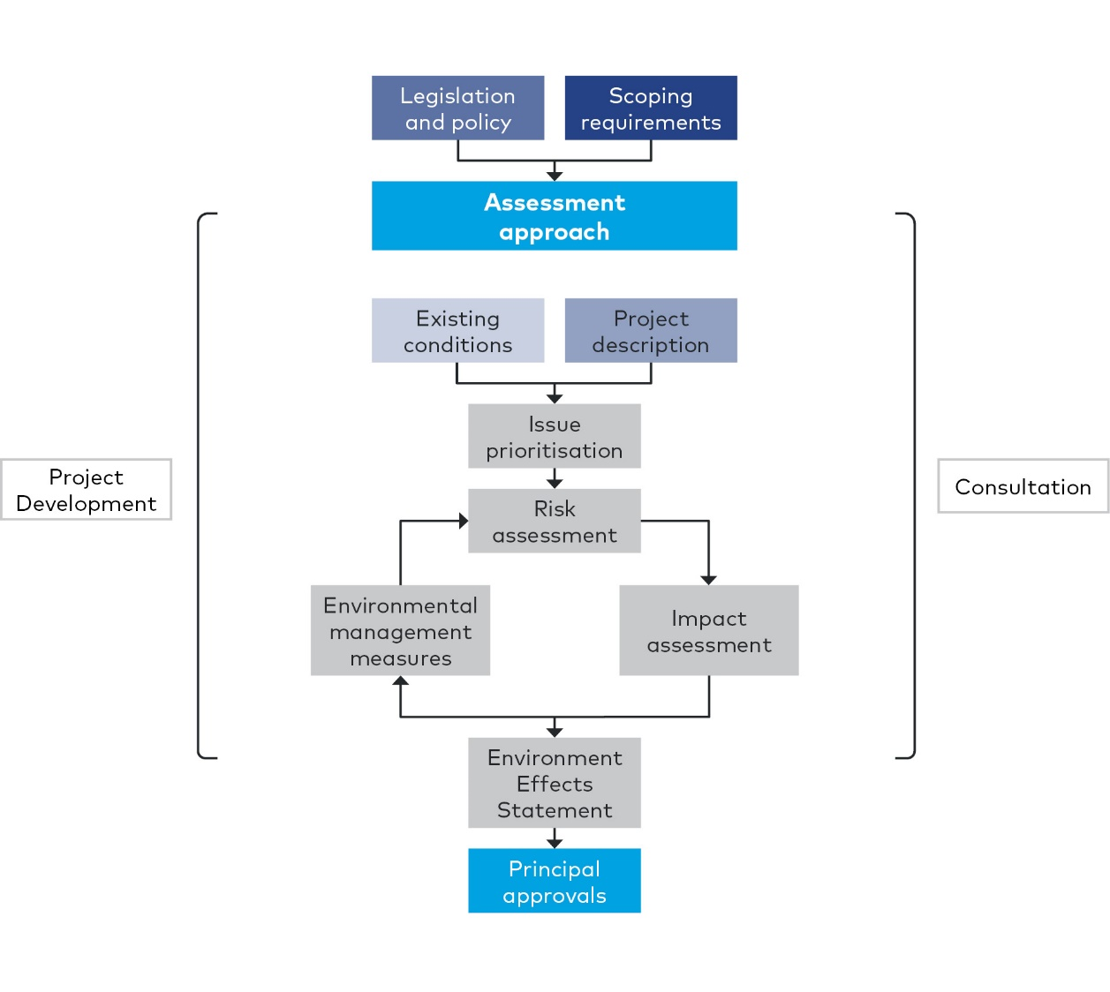

Scoping requirements and evaluation objectives
The assessment framework responds to the applicable legislation and policy and the scoping requirements, incorporating the evaluation objectives. The evaluation objectives identify desired environmental outcomes for the Project as established by the Minister for Planning.
Table 5-1 presents the Project evaluation objectives, corresponding legislation and locations of where each evaluation objective is addressed within the EES report, attachments and technical reports. This table includes an overview of key legislation. Further legislation and policy is described in each of the technical reports.
Chapter 19 Environmental management framework (EMF) is relevant for all evaluation objectives as it provides the framework for managing and monitoring the environmental effects of the Project and as such has not been included in Table 5-1.
Table 5-1 EES draft evaluation objectives and corresponding legislation
Evaluation objectives | Key legislation | Relevant EES chapter, technical report and attachment
Energy efficiency, security, affordability and safety  Provide for safe and cost-effective pipeline connection between the eastern and western sections of the Victorian Transmission System | Pipelines Act 2005 (Vic)  Public Health and Wellbeing Act 2008 (Vic)  Dangerous Goods Act 1985 (Vic)  Electricity Safety Act 1998 (Vic)  Gas Safety Act 1997 (Vic)  Gas Industry Act 2001 (Vic)  Climate Change Act 2017 (Vic)  National Greenhouse and Energy Reporting Act 2007 (Commonwealth)  Environment Protection Act 1970 (Vic) (Environment Protection Act 2017 (Vic) as amended by the Environment Protection Amendment Act 2018 (Vic) commencing on 1 July 2021) | Chapter 2 Project rationale  Chapter 4 Project description  Chapter 17 Safety  Technical report M Safety
Biodiversity and habitats  Avoid and minimise potential adverse effects on native vegetation, listed threatened and migratory species and ecological communities, and habitat for these species, as well as restore and offset residual environmental effects consistent with state and Commonwealth policies | Flora and Fauna Guarantee Act 1988 (Vic)  Wildlife Act 1975 (Vic)  Catchment and Land Protection Act 1994 (Vic)  Planning and Environment Act 1987 (Vic)  Environment Protection and Biodiversity Conservation Act 1999 (Cth)  Pipelines Act 2005 (Vic)  Melbourne Strategic Assessment (Environment Mitigation Levy) Act 2020 (Vic) | Chapter 7 Biodiversity and habitats  Chapter 18 Matters of National Environmental Significance  Technical report A Biodiversity and habitats
Water and catchment values  Maintain the functions and values of groundwater, surface water and floodplain environments and minimise effects on water quality and beneficial uses | Environment Protection and Biodiversity Conservation Act 1999 (Cth)  Environment Protection Act 1970 (Vic) (Environment Protection Act 2017 (Vic) as amended by the Environment Protection Amendment Act 2018 (Vic) commencing on 1 July 2021)  Water Act 1989 (Vic)  Catchment and Land Protection Act 1994 (Vic)  Pipelines Act 2005 (Vic)  Flora and Fauna Guarantee Act 1988 (Vic)  Fisheries Act 1995 (Vic)  National Parks Act 1975 (Cth)  Crown Land (Reserves) Act 1978 (Vic) | Chapter 8 Water (surface water and groundwater)  Chapter 9 Land stability and ground movement  Technical report B Surface water  Technical report C Groundwater  Technical report D Land stability and ground movement
Cultural heritage  Avoid, or minimise where avoidance is not possible, adverse effects on Aboriginal and historic cultural heritage values | Aboriginal Heritage Act 2006 (Vic)  Heritage Act 2017 (Vic)  Pipelines Act 2005 (Vic) | Chapter 13 Cultural heritage  Technical report I Cultural heritage
Social, economic, amenity and land use  Minimise potential adverse social, economic, amenity and land use effects at local and regional scales | Pipelines Act 2005 (Vic)  Planning and Environment Act 1987 (Vic)  Transport Integration Act 2010 (Vic)  Public Health and Wellbeing Act  2008 (Vic)  Environment Protection Act 1970 (Vic) (Environment Protection Act 2017 (Vic) as amended by the Environment Protection Amendment Act 2018 (Vic) commencing on 1 July 2021) | Chapter 11 Air quality  Chapter 12 Noise and vibration  Chapter 14 Landscape and visual  Chapter 15 Land use  Chapter 16 Social  Technical report F Noise and vibration  Technical report G Air quality  Technical report J Landscape and visual  Technical report J Landscape and visual  Technical report K Land use  Technical report L Social
Waste management  Minimise generation of wastes from the Project during construction and operation, and to prevent adverse environmental or health effects from storing, handling, transporting and disposing of waste products | Environment Protection Act 1970 (Vic) (Environment Protection Act 2017 (Vic) as amended by the Environment Protection Amendment Act 2018 (Vic) commencing on 1 July 2021)  Climate Change Act 2017 (Vic) | Chapter 10 Waste management (greenhouse gas and contamination)  Technical report E Contamination  Technical report H Greenhouse gas

Assessment approach
The EES technical studies address the EES scoping requirements, inform the Pipelines Act process and demonstrate how each evaluation objective has been met. A systematic approach was used to understand the existing environment, the potential impact of the Project on the environment and to evaluate the effectiveness of management measures to avoid, minimise or manage potential impacts.
This section describes the key steps in the development of the technical studies.

Existing conditions
The existing conditions assessment identified the current condition of the environment and the environmental context for the Project. This included identifying and characterising the significance of existing assets, values and uses that could be affected by the Project.
Each of the 13 technical studies undertook an existing conditions assessment, which collectively provided the environmental context for the Project. The geographic study area for each technical study reflected differences in the extent of potential impacts for each discipline.
The existing conditions for each of the technical studies are summarised in Chapters 7–18 and detailed in Technical reports A–M.

Risk assessment
The environmental risk assessment tool identified potential environmental effects and justified the level of effort applied to each aspect of the impact assessment. This was used as a screening tool to inform the impact assessment and to focus the assessment on the higher risks, where there is opportunity to minimise. An environmental risk assessment was conducted for the Project using an approach consistent with AS/NZS ISO 31000:2009 Risk Management Principles and guidelines.
Key steps include:
- Establishment of the context of the risk assessment: using existing conditions and relevant policy and legislation
- Risk identification: consideration of the construction and operational activities in the context of existing conditions
- Risk analysis: assign likelihood and consequence ratings for each risk to determine risk ratings in the context of standard requirements and controls proposed by the Project to manage risks  - Risk treatment: identify additional controls and management measures to mitigate identified risks (if required) through the impact assessment process  - Residual risk and impact evaluation: identify adjusted risk ratings following the application of final management measures through an iterative review process. | What is the difference between a risk and an impact?  A risk is the function of the likelihood of an adverse event occurring and the potential consequences of the event.  An impact relates to the outcome of an event in relation to an asset, value or use.

Assigning consequence of risks
Consequence refers to the maximum credible outcome of an event affecting an asset, value or use. The consequence of a risk occurring was assigned using a consequence guide specific to each technical area, based on the existing conditions and values in the study area. Consequence criteria have been developed to consider the following characteristics:
- Extent of impact
- Severity of impact
- Duration of threat.
The consequence rating criteria was developed using levels and descriptions outlined in the framework in Table 5-2. Where there was uncertainty or incomplete information, a conservative assessment was made on the basis of the maximum credible consequence. The consequence criteria was refined to the conditions of specific disciplines, where required.
Table 5-2 Consequence rating approach
Level | Qualitative and/or quantitative description
Insignificant | Negligible overall impact or no detectable impact on identified asset, value or use.  Discipline specific descriptor provided in each technical report.
Minor | Minor overall impact on existing/potential identified asset, value or use.  Short term (up to three months) localised impact which is reversible or within normal range of change.  Discipline specific descriptor provided in each technical report.
Moderate | Moderate overall impact on existing/potential identified asset, value or use.  Longer term (up to 12 months) but limited change to local setting or limited impacts at a regional level.  Discipline specific descriptor provided in each technical report.
Major | Major overall impact on existing/potential identified asset, value or use.  Long term significant changes at regional or state level, or limited impacts at a national level.  Discipline specific descriptor provided in each technical report.
Severe | Severe overall impact on existing/potential identified asset, value or use.  Discipline specific descriptor provided in each technical report.  Permanent significant changes or impacts at State or national level.

Assigning likelihood of risks
Likelihood refers to the chance of an event happening and the maximum credible consequence occurring from that event. The likelihood approach is presented in Table 5-3.
Table 5-3 Likelihood approach
Level | Description | Level
1 | Rare | The event is conceivable and may occur only in exceptional circumstances
2 | Remote | The event could occur but is not anticipated and may occur if certain abnormal circumstances prevail
3 | Unlikely | The event is unlikely but could occur if certain circumstances prevail
4 | Likely | The event will probably occur in most circumstances
5 | Almost certain | The event is expected to occur in most circumstances or is planned to occur

Risk matrix
Together the consequence and likelihood are combined to determine a risk rating for the identified risks, as shown in Table 5-4.
Table 5-4 Risk rating approach
 |  | Consequence rating
 |  | Insignificant | Minor | Moderate | Major | Severe
Likelihood rating | Almost certain | Low | Medium | High | Very high | Very high
 | Likely | Low | Low | Medium | High | Very high
 | Unlikely | Negligible | Low | Medium | High | High
 | Remote | Negligible | Negligible | Low | Medium | High
 | Rare | Negligible | Negligible | Negligible | Low | Medium

Impact assessment
An impact is defined as any change resulting from the implementation of the Project. Impacts can be positive or negative. The nature and extent of any impact is measured against the existing conditions assessment, considering the differences between the "with Project" and "without Project" scenarios.
The following factors were considered when determining the significance of potential environmental impacts of the Project:
- The likelihood that any given direct or indirect environmental impact would occur
- The magnitude, extent and duration of the impact on the environment
- The relationship between different impacts on the environment and potential cumulative impacts
- The likely effectiveness of measures to avoid, minimise and manage impacts
- Residual impacts following application of management measures
- Benchmarks and standards set by statutory requirements and environmental approvals
- The policies and guidelines that apply to the proposed projects
- Community expectations
- The principles of ecologically sustainable development as defined in the Ministerial guidelines for assessment of environmental effects (DSE, 2006).
Specific methods for impact assessment were determined by specialists for each technical report to assess the magnitude of impacts.
The impact assessments for each of the 13 technical studies are summarised in Chapters 7 to 18 and detailed in Technical reports A to M. The studies recommended environmental management measures to support environmental outcomes for the Project. Where potential impacts were identified as requiring treatment, additional or revised environmental management measures were identified or design changes were made, to reduce the potential residual impact.
The preparation of the impact assessments was an iterative process. Following the risk and impact assessment, identified impacts were reassessed with the proposed environmental management measures. Using this information, the risk assessment was revisited to determine residual risk levels and residual impacts of the Project.

Managing environmental effects
Chapter 19 Environmental management framework provides the context for managing and monitoring the environmental effects of the Project. This includes the accountabilities for managing environmental effects associated with the Project.
Chapter 19 Environmental management framework also contains the environmental management measures that must be implemented during design, construction and operation of the Project.
The 13 technical specialists considered an initial set of environmental management measures as part of the impact assessments. These were based on compliance with legislation and standard requirements typically incorporated into the delivery of major infrastructure projects. Through the risk assessment process outlined above, the initial set of environmental management measures was refined and expanded to a final set. The mitigation hierarchy has been applied to determine the final set of environmental management measures, including:
- Avoidance: measures taken to avoid creating adverse effects on the environment from the outset, such as careful spatial or temporal placement of infrastructure or disturbance
- Minimisation: measures taken to reduce the duration, intensity and extent of impacts that cannot be avoided
- Rehabilitation/restoration: measures taken to improve a degraded environment following exposure to impacts that cannot be completely avoided or minimised
- Offsets: measures taken to compensate for any residual, adverse impacts after full implementation of the previous three steps of the mitigation hierarchy.
The relevant environmental management measures are listed in each technical report and the full set is included in Chapter 19 Environmental management framework.
To monitor and evaluate compliance with the required environmental management measures and statutory approvals conditions, a number of activities have been proposed in each technical report and in Chapter 19 Environmental management framework. These include monitoring programs, auditing, and reporting activities. As described in Chapter 19 Environmental management framework (section 19.7.1), monitoring indicators, frequency, locations and monitoring parameters would be informed by regulatory requirements, the detailed construction methods, and scale of environmental risk, and monitoring programs would be subject to regular review.
The environmental management measures include specific contingency plans where these are required to support performance objectives. In addition, APA would implement incident and emergency response procedures to facilitate an efficient and effective response to unexpected environmental events that could arise during Project construction and operation, such as fuel or chemical spills (refer to section 19.7.2 of Chapter 19 Environmental management framework). APA would also investigate and respond to any complaints from the community regarding noise, waste, air emission or other pipeline construction or operation issues (refer to section 19.7.3 of Chapter 19 Environmental management framework).

Assessing cumulative impacts
Other major projects occurring within the same geographic area, and likely to be constructed or in construction within approximately the next ten years, could compound the potential impacts of the Project, potentially leading to cumulative impacts.
To assess cumulative impacts, APA considered the following key indicators:
- Geographic boundary: consideration of major projects occurring within five to ten kilometres of the construction corridor
- Timing: projects to be constructed or in construction within approximately the next ten years, noting the projects to be constructed at the same time as WORM
- Construction impacts: consideration of cumulative construction impacts, where construction for adjacent projects is occurring at the same time as WORM
- Operation impacts: consideration of permanent cumulative impacts.
These potential impacts have been addressed through the environmental impact assessment process undertaken for each technical study, as required. Key impacts identified within the cumulative impact assessments undertaken for each study include, but are not limited to, air quality (dust), noise, ground movement and impacts to assets, access, amenity values, as well as permanent removal of native vegetation.
Other projects assessed for cumulative impacts are the Outer Metropolitan Ring (OMR)/E6 transport corridors, the Sunbury Road Upgrade, the Bald-hill–Yan Yean Pipeline and the Western Victoria Transmission Network project.
APA is considering the feasibility of constructing a new power station at Wollert and has funding to undertake preliminary design and investigations to inform approvals. As this project is in the early concept phase, its potential cumulative impacts have not been assessed as part of this EES.

Integrated assessment
To fully identify and assess potential impacts, the EES has considered the existing conditions and potential impacts relevant to each aspect of the environment in isolation, as well as impacts that may result when a number of disciplines are considered together. This includes assessment of data collected for a different technical study or the reliance on one study’s result to inform the assessment within another study. These interfaces were identified through the concurrent preparation of the scopes for each specialist study and the participation of multiple specialists in the risk assessment workshop.
As a result, the environmental management measures do not operate in isolation and some technical studies have cross-referenced measures from other technical studies as relevant.

Project development
Ongoing refinement of the Project is a key input to the EES as modifications to the design can lead to mitigation of environmental impacts. Project development encompasses activities such as consideration of Project alternatives, development of the Project design and the construction methodology. These activities occur in parallel with the preparation of the EES.
Refer to Chapter 3 Project development and Chapter 4 Project description for details of this process and the description of the design assessed by this EES.

Consultation
A program of stakeholder and community engagement has been undertaken for the Project and will continue following the EES. This program commenced with consultation activities from mid-2018 before the preferred alignment was announced. The Project Consultation Plan was approved under the Pipelines Act in January 2019. A Consultation Plan was also prepared specifically for the EES phase as required by the Minister's procedures and requirements applicable to the preparation of the EES and the scoping requirements for the Project communications and engagement specific to the EES.
Consultation included providing updates on project progress, seeking input on Project design development, and identifying and responding to stakeholder and community concerns and interests.
Stakeholder and community consultation findings were considered during design development, EES risk assessment and EES preparation.
The main forms of consultation have included:
- Meetings with councils, community groups and peak bodies
- Meetings with owners and occupiers of land along the Project alignment
- Meetings and field work with the Registered Aboriginal Party WWCHAC and Traditional Owners
- Community information forums open for public attendance
- The EES Technical Reference Group (TRG) made up of councils and relevant government agencies.
Chapter 6 Community and stakeholder consultation provides further details on the stakeholder and community engagement for the Project.

Department of Environment (2013). Matters of National Environmental Significance: Significant impact guidelines 1.1., Environment Protection and Biodiversity Conservation Act 1999. Department of Environment, Australian Government.
Noting that no approval is required under this Act due to section 85 of the Pipelines Act 2005.
Noting that no approval is required under this Act due to section 85 of the Pipelines Act 2005.

