Chapter 4

Project description
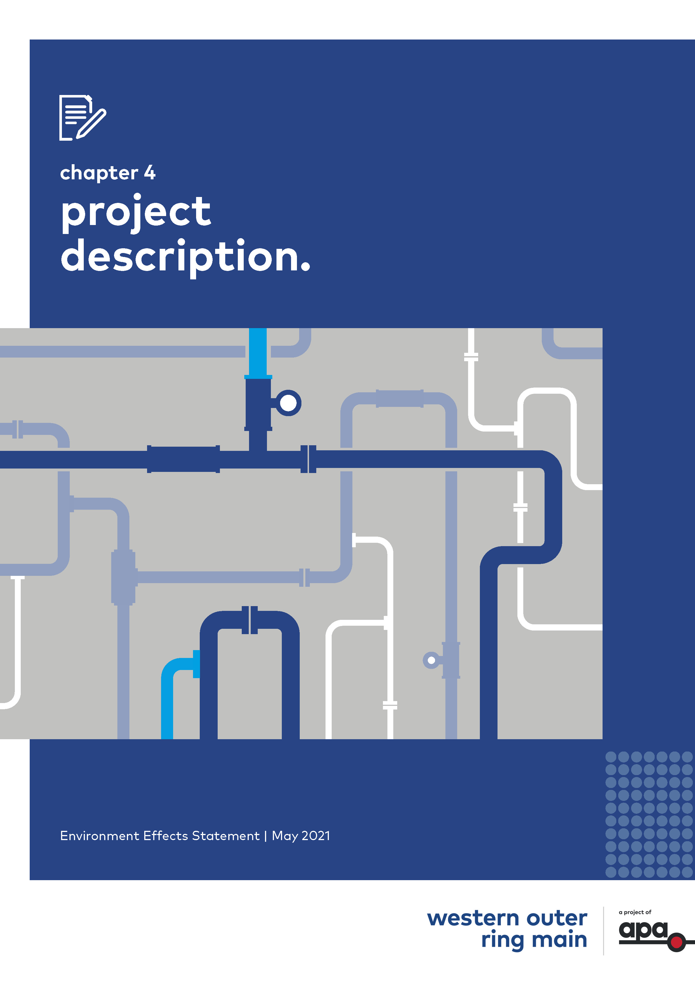

Contents
Chapter 4
4.1 Introduction 4-1
4.2 Status of Project design 4-1
4.3 Project overview 4-1
4.3.1 Project components 4-2
4.4 The pipeline 4-3
4.4.1 Pipeline design 4-4
4.4.2 Pipeline alignment 4-4
4.4.3 Cathodic protection system 4-5
4.4.4 Pipeline marker signs 4-7
4.5 Mainline valves 4-7
4.5.1 Mainline valves design 4-8
4.5.2 Mainline valves location and layout 4-8
4.6 Wollert Compressor Station upgrades 4-10
4.7 Construction 4-12
4.7.1 Indicative construction schedule 4-12
4.7.2 Project construction laydown and pipe stockpiling areas 4-13
4.7.3 Pipeline construction 4-13
4.7.12 Wollert Compressor station upgrades 4-31
4.7.13 Construction workforce and hours 4-32
4.7.14 Construction equipment for the Project 4-33
4.7.15 Construction traffic 4-33
4.8 Operation and maintenance 4-34
4.8.1 Pipeline 4-34
4.8.2 Compressor station 4-36
4.8.3 Operational workforce for the Project 4-36
4.9 Decommissioning 4-37
4.10 Waste and spoil management 4-37
4.10.1 Construction waste management 4-37
4.10.2 Operation waste management 4-38

Introduction
This chapter describes the design, construction and operation of the proposed Western Outer Ring Main (WORM) gas pipeline project (the Project), including relevant design standards. The purpose of this chapter is to set out the scope of works for which the Environment Effects Statement (EES) has been prepared for the Project.
The Project description in this chapter provides details of all Project components and should be read in conjunction with the Map Book. | Map Book  An attachment that provides detailed mapping showing the pipeline alignment, compressor station layout and construction footprint.

Status of Project design
The design of the Project is well developed. The final design details and construction methodology would be completed following Project approvals, finalisation of landholder agreements and appointment of construction contractors. Landholders and relevant stakeholders along the proposed alignment and alignment options have been engaged throughout the pipeline design process to address concerns about construction and operation of the pipeline.
It is common practice for projects to be amended and refined as they progress through the assessment process. These changes may be in response to landowner or community engagement through the development or during exhibition of the EES and the application for Pipeline Licence, detailed technical feedback received from agencies, or in response to the Minister’s assessment.

Project overview
APA is proposing to construct approximately 51 kilometres of buried high pressure gas transmission pipeline between Plumpton and Wollert, in Victoria. The Project comprises the installation of a new gas compressor and associated process control equipment and pipework within APA’s existing gas compressor station site at Wollert. The pipeline would connect the eastern and western sections of the Victorian Transmission System (VTS) between Plumpton and Wollert. Three mainline valves (MLV) would be installed along the length of the alignment. | Victorian Transmission System (VTS)  The VTS is an existing gas pipeline network comprising approximately 2,267 km of pipelines which transport gas from various inlet points to load centres throughout Victoria. Almost all the natural gas consumed in Victoria is transported through the VTS.
A schematic illustration of the Project context is shown in Figure 4-1. The alignment is shown in more detail in the Map Book.
Figure 4-1 Pipeline alignment

Project components
The Project comprises three key operational components:
- A new pipeline: The proposed pipeline would be approximately 51 kilometres in length and fully buried within a 15 metre wide easement
- Mainline valves: Three mainline valves would be located along the pipeline alignment within the proposed easement
- Wollert Compressor Station upgrade: The construction of a new Solar Centaur 50 compressor, an end of line scraper station and a regulating station is proposed within the existing APA facility at Wollert.
These operational components are described in more detail in sections 4.4, 4.5 and 4.6.

The pipeline
The Project would construct an underground high pressure gas transmission pipeline between APA’s existing Plumpton Regulating Station (approximately 38 kilometres north-west of Melbourne’s CBD) and Wollert Compressor Station (approximately 26 kilometres north-east of Melbourne’s CBD), which would provide an additional connection between the eastern and western pipeline networks of the VTS.
The pipeline would be approximately 51 kilometres long and be buried for its entire length to a minimum depth of cover of 750 millimetres (with the final depth determined as an outcome of the Safety Management Study). The pipeline would occupy an operational easement of generally 15 metres wide. The pipeline’s corrosion protection system would consist of external coating and an impressed current cathodic protection system (ICCP). Pipeline marker signs would be installed along the length of the pipeline.
Table 4-1 summarises key data for the pipeline. An overview of the pipeline is shown in Figure 4-1. Further details of the pipeline alignment are shown in the Map Book.
Table 4-1 Summary of key data for the underground pipeline
Underground pipeline key data
Length | 51.045 km
Material | American Petroleum Institute (API) Specification 5L X52 high strength steel pipe. Internally lined with epoxy and externally coated with dual layer fusion bonded epoxy with field applied joint coating
Nominal diameter | Up to 600 mm
Nominal capacity | Approximately 750 TJ/day
Pipe wall thickness | 10.31 mm standard wall thickness  12.7 mm heavy wall thickness
Pipe segment length | 18 m
Depth of cover (depth below ground surface) | Minimum of 750 mm to the top of the pipeline (deeper at crossing of third-party infrastructure and waterways). The final depth would be determined as an outcome of the Safety Management Study
Easement | Nominally 15 m wide
Design principles | In accordance with the latest version of AS2885 Pipelines – Gas and liquid petroleum
Design life | 60 years

Pipeline design
The pipeline would be designed in accordance with the Australian Standard AS2885 Pipelines – Gas and liquid petroleum. The pipeline would be bi-directional, to allow gas to flow in both directions as required.
The pipeline would be constructed of high strength steel line pipe, fully welded. Heavy wall pipes would be used where the pipeline traverses near urban environments, sensitive locations, special crossings and possible future urban development as an additional protection measure.
Above ground pipeline marker signs would be installed along the pipeline route at certain intervals and special locations to indicate the presence of the buried pipeline.
At locations where the pipeline is potentially exposed to increased erosional forces, such as watercourse crossings and floodplains, additional protection would be provided, including burying the pipeline deeper. The pipeline would also be buried deeper beneath road and railway crossings and further protected by concrete slabbing over the top of the pipeline if required.
Where feasible, major watercourses and environmentally sensitive areas may be crossed using horizontal directional drilling (HDD) or horizontal boring methods to protect surface environmental values. Further information on the pipeline construction methodology is provided in Section 4.7.3.

Pipeline alignment
The proposed pipeline alignment extends between the Plumpton Regulating Station and the Wollert Compressor Station, where it would connect to the VTS. The pipeline alignment has been selected and refined following extensive consultation to avoid and minimise, to the extent possible, the impact of construction and operation. Figures showing the pipeline alignment are presented in the Map Book. Sections of the alignment are marked as kilometre points (KP) of the pipeline, beginning at KP0 in Plumpton and heading north and north-east, ending at KP51 at the Wollert Compressor Station.
The key sections of the pipeline alignment are illustrated in Figure 4-1 and summarised as:
- From the Plumpton regulating station, just north of Taylors Road, the pipeline would follow the existing Sunbury Pipeline easement north for approximately seven kilometres to the Calder Freeway
- The pipeline route then crosses the Bendigo Rail Line and Calder Freeway and generally traverses the proposed Outer Metropolitan Ring (OMR) corridor through Diggers Rest, before deviating to the north and crossing Jacksons Creek, Sunbury Road and Deep Creek
- The pipeline then re-joins the OMR in Oaklands Junction before following it north-east through Mickleham, Merrifield and Kalkallo
- The pipeline alignment would cross the Hume Highway at the existing intersection with Gunns Gully Road before again following the OMR east, across the North Eastern rail line, to the Victorian Northern Interconnect (VNI)
- The pipeline route then follows the existing VNI easement south for approximately seven kilometres to the Wollert compressor station.
A number of route options were assessed before selecting the preferred alignment. A detailed discussion on previous pipeline route options and the alignment selection process is provided in Chapter 3 Project development.

Cathodic protection system
Each pipe length and pipe joint is coated for corrosion protection purposes. Testing is undertaken during manufacturing and installation to ensure the integrity of the coating. Following completion of construction, further testing is carried out by a direct current voltage gradient survey which involves measuring the voltage gradient in the soil over the top of the pipeline using a pair of probes.
As a secondary protection against corrosion, an impressed current cathodic protection system (ICCP system) would be used. An anode bed would be installed (buried) at approximately midway along the pipeline route (between KP 20-25). The ICCP system would be supplied with electricity from mains power. Additional anode beds may need to be added over the life of the pipeline and would be subject to separate approvals as required. Additions to the ICCP system are not expected for at least 20 years. | Impressed Current Cathodic Protection (ICCP) system  The ICCP system uses an external source (anode) to apply an electrical current through the environment and on to the pipe.
A number of upstand test-points would be required to be installed for the pipeline typically above ground. These test points consist of small pole mounted enclosures housing the ICCP system monitoring equipment as illustrated in Figure 4-2. Test-points are typically installed at marker posts and at other key features such as public roads and fence crossings.
Figure 4-2 Typical Impressed Current Cathodic Protection (ICCP) system
The pipeline may be electrically cross bonded to the existing VTS system to improve the performance of the ICCP and reduce interference between structures. The pipeline may be electrically cross bonded to other buried pipeline structures along the alignment, with permission from their owners.
Inspection of the system would be undertaken in accordance with AS2832 Cathodic protection of metals.
Refer to Figure 4-4 for example photos of the installation of the cathodic protection anode bed at another APA project during construction and operation.
Figure 4-3 Signage installed at cathodic protection anode bed location
Figure 4-4 Cathodic protection anode bed PVC stand pipes, chimneys, or upstand test points

Pipeline marker signs
Pipeline markers would be installed along the length of the pipeline to indicate the pipeline location in accordance with AS2885 and APA standards. An example of a pipeline marker is shown in Figure 4-5.
The markers would be placed:
- At a frequency to ensure continual line of sight along the alignment
- At all changes in direction of the pipeline
- At property boundary fences and either side of crossings, such as roads, railways or watercourses.
Text on the signs would describe the presence of a high pressure gas pipeline and provide the name and contact details of APA.
Figure 4-5 Example of a pipeline marker

Mainline valves
The Project would include three MLVs along the length of the pipeline alignment. A MLV is essentially a set of buried and aboveground piping, valves and equipment, in a fenced off compound.

Mainline valves design
MLVs are in-line valves to allow for isolation and depressurisation of sections of the pipeline for maintenance or during emergency conditions. The valves can be closed to isolate sections of the pipeline, and a permanent vent or temporary vent can be connected to depressurise the section.
MLVs would be finished with hardstand and chain wire fenced to exclude members of the public. The chain wired fencing would be vertical (not angled as displayed in Figure 4-6).
The height of each MLV facility (including fencing) would be approximately three metres. There would be no lighting at the MLV facilities.
A typical MLV facility is shown in Figure 4-6.
Figure 4-6 Typical mainline valve facility

Mainline valves location and layout
Three MLVs are proposed for the length of the pipeline, spaced at intervals of approximately 15 kilometres, and located within the proposed easement area. The proposed locations are shown in the Map Book and identified in Figure 4-7. The exact location of each MLV is subject to confirming design requirements and consultation with landowners.
MLV1 would be located near KP 6. It would be fenced with gates to provide ongoing access from Holden Road. The MLV1 facility would be co-located with the existing Sunbury Pipeline MLV facility contained within a jointed chain wire fenced compound of approximately 20 m (length) by 15 m (width).
MLV2 would be located at KP 22. It would be fenced with chain wire fencing with gates to provide ongoing access from Oaklands Road. The MLV2 facility would be contained within the 15 metre easement in a chain wire fenced compound of approximately 12 by 12 metres.
MLV3 would be located near KP 35. It would be fenced with gates opening to Gunns Gully Road. It would be contained in the 15 metre easement in a chain wire fenced compound of approximately 12 by 12 metres.
Figure 4-7 MLV locations

Wollert Compressor Station upgrades
The pipeline terminates at APA’s existing gas compression station at 289 Summerhill Road, Wollert. The existing site comprises:
- Wollert City Gate: Four regulator runs that reduce the gas pressure from the 6890 kPa Pakenham to Wollert pipeline system to the 2760 kPa metropolitan system, with a 3MW gas-fired water bath heater
- T74 Pressure Regulating Station: Provides bi-directional flow of gas between the Pakenham to Wollert pipeline (6,890 kPa), and the Wollert to Euroa pipeline (8,800 kPa). Two uni‑directional pressure/flow regulator runs (one duty and one stand‑by) provide pressure reduction of gas
- T119 Pressure Regulating Station: Provides pressure reduction of gas from the Wollert to Barnawartha pipeline Maximum Allowable Operating Pressure (MAOP), 10,200 kPa Maximum Operating Pressure (MOP) into the Wollert to Euroa pipeline (8,800 kPa MAOP). The facility comprises one regulator run
- Compressor Station:
  - Station A - Three Solar Turbines – Saturn 10 gas turbine driven compressor units with one lube oil cooler per unit. There is a common fin fan gas cooler, a back-up gas engine generator, instrument gas and a station vent
  - Station B - Two Solar Turbines – Centaur 50 gas turbine driven compressor units with one fin fan gas cooler and one lube oil cooler per unit. There is a station instrument air compressor system, and a station vent.
The Wollert Compressor Station upgrade includes three main components shown in Figure 4-8:
One new Solar Centaur 50 compressor
The new Solar - Centaur 50 gas turbine driven compressor unit, along with associated valves, pipework and equipment, would be installed within the existing Wollert Compressor Station, which currently contains two existing Solar - Centaur 50 and three existing Solar – Saturn 10 gas turbine driven compressor units.
End of line scraper station
The routine operation of gas pipelines require the periodic running of a pipeline inspection tool (pig) to inspect the pipe wall. Scraper stations are required to launch and receive pigs under pipeline pressure. A new scraper station is required at the Wollert end of the pipeline and would be located within the existing APA facility at Wollert.
Regulating station
When high pressure gas in a pipeline is required to be delivered at a lower pressure into another pipeline, a regulating station is required. The pressure regulating station enables flow of gas from the (proposed) high pressure WORM pipeline to the (existing) Pakenham-Wollert pipeline, which is designed for a lower operating pressure.
The Wollert Compressor Station upgrades would be contained within a fenced area to exclude members of the public. Where construction of the new facilities are located outside of the existing security fenced compound, APA would erect temporary fencing to secure the site to prevent the public from walking into the construction area until the new security facility compound fencing is installed.
The existing 315kVA Wollert Mains reticulated power supply would need to be upgraded to accommodate the additional components. Based on load demand calculation and the available transformer sizes from the electricity distributor, an upgrade to a 750kVA reticulated supply would be part of the upgrade works.
Figure 4-8 Wollert compressor site and location of additional facilities
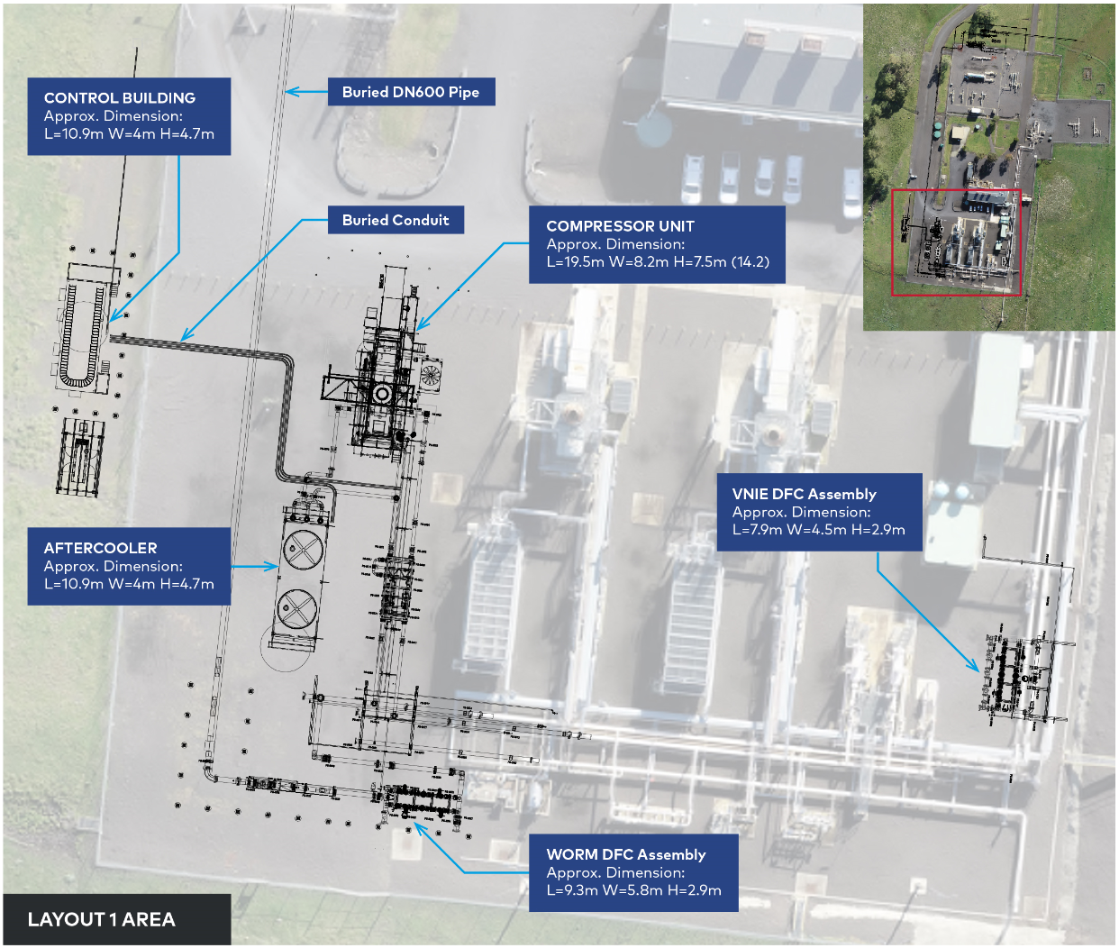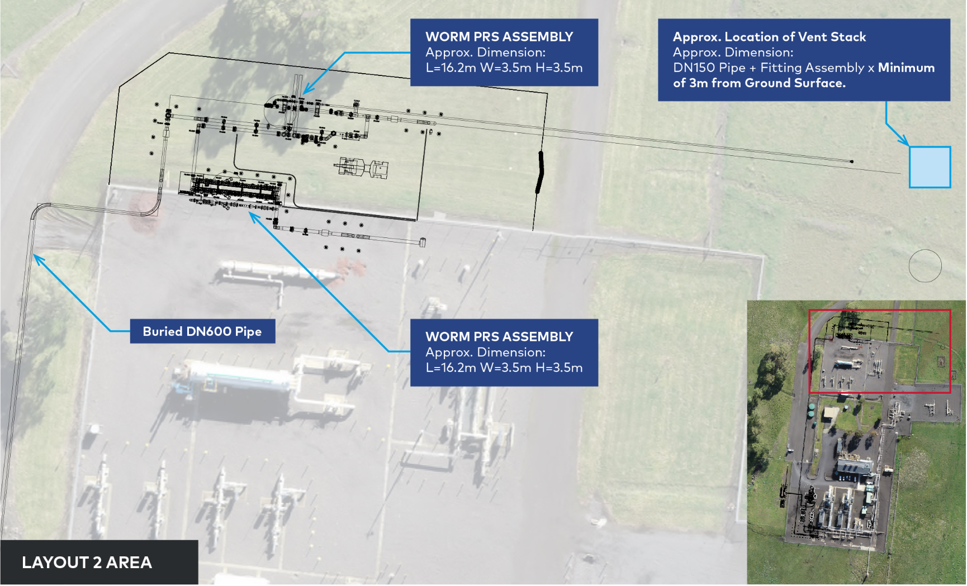

Construction
This section describes the construction of the Project, including indicative construction schedule, construction areas, methodology, the expected workforce, types of equipment, and traffic during construction for each of the components.

Indicative construction schedule
Indicative construction schedules for the Project are shown in Table 4-2. This schedule is subject to ongoing adjustments as needed to deliver the Project and subject to the grant of approvals within certain timeframes.
Subject to the staging of the works, construction for the entire Project is expected to take approximately nine months. General timeframes to complete works in any one area from site establishment to rehabilitation is nominally four to six months. Different work crews would be used for each construction activity and would occur simultaneously along various alignment locations at any given time.
Table 4-2 Indicative construction schedule
Construction activity | Work period | Approximate duration
Pipeline mobilisation | Q1 2022 | 1 month
Pipeline construction | Q1 2022 to Q3 2022 | 5 months
Pipeline rehabilitation | Q3 2022 to Q4 2022 | 3 months
Pipeline commissioning | Q4 2022 | 1 month
Pipeline demobilisation | Q4 2022 | 1 month
Wollert Compressor Station upgrade construction | Q1 2022 to Q4 2022 | Approximately 9 months
Overall timeframe | Q1 2022 to Q4 2022 | Approximately 9 months

The location where the pipeline construction would commence is anticipated to be at a section of the alignment within APA's existing Sunbury or Victorian Northern Interconnect Expansion (VNIE) easements. Multiple work fronts for open cut excavations within APA existing easements and new areas are expected. Certain sections throughout the pipeline alignment such as urban development (for example, first 3.3 kilometres north of Plumpton) would be constructed separately to the mainline construction. Staging of construction activities would be confirmed at a later phase, however, it is expected that there would be a minimum of two crews undertaking pipeline construction works consecutively with a separate work crew undertaking the Wollert Compressor Station upgrades concurrently.

Project construction laydown and pipe stockpiling areas
Two temporary laydown areas would be established for construction.
Offsite compound for pipeline works: One temporary site compound, laydown and storage area (nominally 200 metres x 200 metres) would be established for the pipeline construction. The location of the offsite compound, laydown and storage area has not been selected. APA’s Lands Team are scoping various options within Melbourne and the preference would be to select a location with an existing hardstand, where the activity is permitted under the relevant Planning Scheme. If not permitted under the relevant Planning Scheme, approvals for the use and development of the compound site for the Project would be sought separately to (and in parallel with) the EES.
Laydown for compressor station works: A temporary site laydown area and construction offices would be established for the Wollert Compressor Station construction works. This site laydown area and construction offices would be located within the existing compressor site area at Wollert.
The construction laydown areas, temporary access tracks and pipe stockpiling areas are shown in the Map book.
Preparatory works for laydown areas would include:
- Civil/site establishment works including the installation of temporary site fencing and gates, relocation of utility services and service connections (for example, electricity and potable water), surface levelling and vegetation clearing
- Establishment of environmental controls such as fencing no-go areas (such as for isolating potential sensitive habitat areas), sediment fencing and bunding for containing liquids (spill prevention).
At completion of construction, all temporary fencing, buildings and construction equipment/plant would be removed from the construction site.

Pipeline construction
The techniques used to construct the underground pipeline would include trenching and also alternate techniques such as HDD or horizontal boring. The following sections provide further detail on the underground pipeline construction activities.
Pipeline construction would comply with all relevant codes and standards including AS/NZS2885.1: Pipelines – Gas and liquid petroleum (design and construction) and the Australian Pipelines and Gas Association Code of Environmental Practice, the Pipelines Act 2005 (Pipelines Act) and Pipeline Regulations 2017 (Pipeline Regulations).
The construction would also be guided by other relevant acts and regulations, and additional Project environmental management measures specified in a Construction Environment Management Plan (CEMP) and a Construction Safety Management Plan (CSMP), prepared in compliance with the Pipelines Act and Pipeline Regulations and approved by the relevant Minister before construction. A draft CEMP and draft CSMP are provided as attachments to the application for a pipeline licence that forms part of this EES.

Construction area
The construction area would typically comprise a 30 metre wide corridor along the pipeline alignment. Most construction activity is located within this construction area. The activities and facilities within the construction corridor would include:
- Access tracks (upgrade of existing and construction of new), which would be less than 10 metres wide and usually constructed out of gravel
- Additional work areas up to 50 metres x 50 metres or 50 metres x 100 metres (such as vehicle turn-around points, additional work spaces for crossings, set up areas to accommodate HDD, laying out of pipe for HDD, stockpiling and storage areas)
- Water supply tanks and temporary dams for storing water required for dust suppression and hydrostatic testing (pressure testing) of the pipeline.
Any requirements for temporary offices, or amenities, etc. would be entirely located within the construction footprint or at the compound/laydown area. The typical layout of the construction corridor is shown in Figure 4-9.
Figure 4-9 Typical construction corridor layout for a pipeline
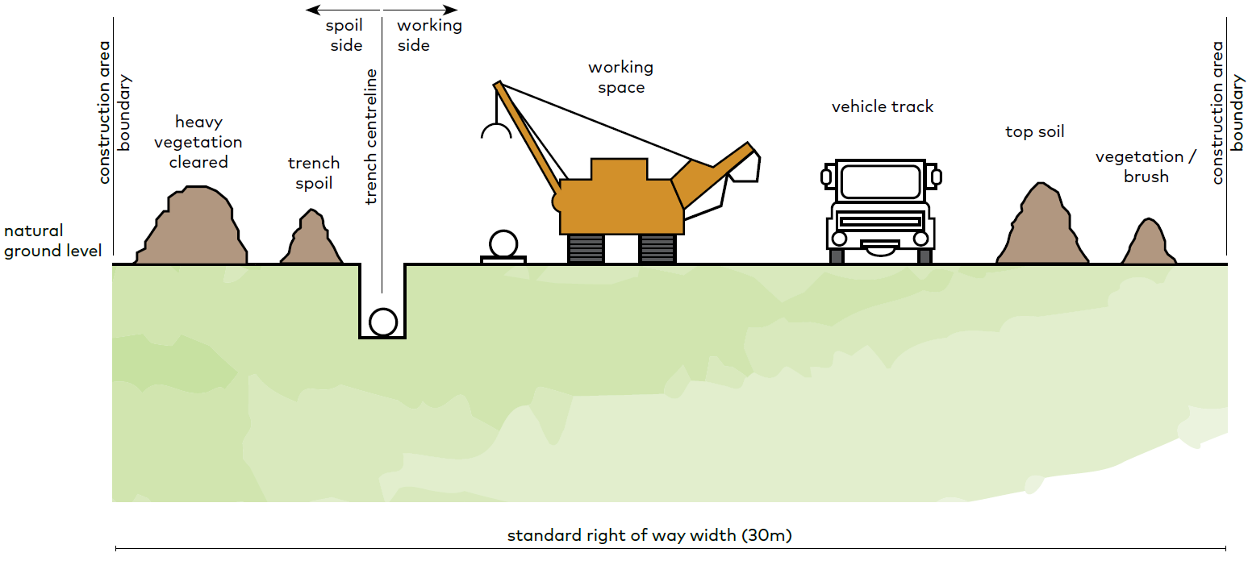

Where construction occurs within an existing APA easement, the additional construction corridor beyond the existing easement boundary would be limited to between 10 metres and 15 metres wide. This is the case for approximately 18 kilometres of the route.
Where feasible, the width of the construction area may be reduced in areas such as sensitive environments and/or watercourses to minimise disturbance to these features.
Stockpiling of soil and storage of equipment for the construction and rehabilitation of the pipeline would be managed to minimise flood risk.
Access to the construction area would predominantly be via the 30 metre corridor. Where possible, existing access tracks would be used (where feasible) to provide temporary access to the construction area. Temporary access points from existing roads would be required to provide safe entry/exit for construction traffic during construction works.
Temporary construction gateways would be installed at fence lines intersected by the construction area to provide security for farm stock during construction.
The construction corridor has been reduced in several sections along the Project to avoid and minimise impacts on significant environmental values. These include:
- Jacksons Creek (KP13.7)
- Merri Creek (KP42.9)
- Northern Growth Corridor (KP 42.5 - KP 43.3).
Further details on how the Project has considered the impacts on ecological values is provided in Chapter 7 and Technical report A Biodiversity and habitats.

Construction sequence and activities
The pipeline construction sequence and activities are described in Table 4-3 and illustrated in Figure 4-10.
Pipeline construction would generally progress in a linear manner along the alignment.
Table 4-3 Pipeline construction
Construction sequence | Activity | Description
1 | Surveying | Preliminary survey works would be mark the extent of the construction area. Markers would be placed along the alignment to identify the pipeline centreline, the boundaries of the construction area, any additional work spaces and access roads/tracks, where required.
2 | Site establishment | Preliminary activities would be undertaken to facilitate construction of the pipeline, including but not limited to:  - Setting up environmental management measures  - Proving of existing third party assets  - Use of existing access tracks (where feasible)  - Installation of temporary access points from existing roads, ancillary areas, and temporary gateways at fence crossings  - Relocation of any infrastructure within the construction area.
3 | Offsite compound | One temporary site compound, laydown and storage area (nominally 200 m x 200 m) would be established for the pipeline construction. The location of the offsite compound, laydown and storage area has not been selected. APA’s Lands Team are scoping various options within Melbourne and the preference would be to select a location with an existing hardstand, where the activity is permitted under the relevant Planning Scheme. If not permitted under the relevant Planning Scheme, approvals for the use and development of the compound site for the Project would be sought separately to (and in parallel with) the EES.
4 | Clearing and grading | Clearing and grading of the area to provide a safe and efficient area for construction. Clearing would be required to remove trees, shrubs, surface rocks and groundcover vegetation. Graders, bulldozers and excavators are generally used. Cleared topsoil would be stockpiled on the edge of the construction corridor with breaks left in stockpiles at fence lines, tracks and drainage lines to allow continued access for stock. Temporary access tracks over watercourses and access points to local roads would be constructed during this phase. Clear and grade activities would occur at approximately 1 kilometre per day.  A tree management plan would be developed and implemented for the Project.
5 | Pipe stringing | Distribution of pipe segments along the corridor in preparation for welding.
6 | Pipe bending | Where required, pipe lengths would be bent using a hydraulic bending machine to match changes in either elevation or direction of the alignment.
7 | Welding, non-destructive testing, and joint coating | Pipe segments would be welded in strings. All welding is tested to ensure quality. Areas of the weld are cleaned via grit blasting and pipe joints are coated to prevent corrosion.
8 | Trenching | Specialised trenching machines and excavators would excavate the trench to a depth of approximately two metres and approximate width of one metre. Spoil generated would be stockpiled separate from vegetation and topsoil stockpiled earlier in the construction program. Rock breaking processes such as rock saws/hammers and/or blasting is expected to be required to excavate the trench in areas of rock.  Construction is expected to progress at a rate of approximately 700 metres per day for open trenching, however, HDD and bored crossings are likely to have lower daily progress rates, and could take between two to three weeks for HDD and boring at a particular location. Additional time (two to three weeks) would be required for mobilisation, clearing and reinstatement at each location.  Where required due to groundwater levels, trenches would be dewatered. Dewatering of excavated trenches/bell holes would be managed to minimise sedimentation, including the use of sediment control devices to remove suspended solids and dissipate flow. Sediment control devices would be listed in the CEMP. Dewatering of trenches due to rainfall would be collected and treated prior to discharge into the waterways and reused where appropriate (for example for dust suppression and chemical treatment such as with flocculants and coagulants) if turbidity exceeds requirements in accordance with State Environment Protection Policy (SEPP) (Waters) as part of the CEMP.  Generally, trenches would not remain open for longer than three months, however for some excavations (for example for main line valves, hydrostatic test sections and tie-in locations) this time period may be exceeded and trench wall support would be provided in accordance with SafeWork Australia (2018).  This is considered to reduce the potential of drained soil strength conditions compromising trench stability.  When trenching through waterways (including Jacksons Creek and Merri Creek), diversion dams would be constructed of appropriate materials to minimise watercourse sedimentation, such as steel plates, sand bags or inflatable dams.  Where necessary trench breakers (either side of creek) would be used to reduce sediment transport into the drain caused by water flowing along the excavated trench.  Figure 4-11 and Figure 4-12 illustrate the construction process for open cut watercourses and provide an indication of the working area and equipment set up.  Two types of set up are proposed for construction:  - Figure 4-11 – no or minimal flow watercourse (Merri Creek)  - Figure 4-12 – higher flow watercourse (Jacksons Creek).  To prepare sites for construction, the following would be undertaken:  - Strip topsoil for construction area, leaving a certain distance away from the creek bank  - Stockpile away from creek banks  - Install sediment fencing  - Install vehicle crossing point across the creek (through access is required to walk the pipe in and enable a simpler construction process, rather than bringing equipment/pipe from either side)  - Depending on watercourse flow, start preparing the creek banks, or install diversion as per Figure 4-12.
9 | Lowering pipe into trench and backfilling | The pipe would be lowered into the trench with suitable bedding and padding material. The trench is backfilled with the previously excavated subsoil material. In areas of rock excavation, imported bedding and padding material may be required where the previously excavated subsoil is unsuitable for use.  Care is taken to maintain separation between topsoil and subsoil during this process. Subsoils are compacted to limit settlement of the trench through the operational life of the pipeline. Any excess spoil is removed from the site.
10 | Testing, commissioning and connections | The pipeline would be pressure tested (in accordance with AS/NZS 2885.5) prior to commissioning to ensure the pipeline passes strength and leak tests. This is done through hydrostatic testing where sections of the pipeline (test sections) are filled with water and then pressurised.  Following completion of hydrostatic testing and Consent to Operate from Energy Safe Victoria the pipeline would be purged with gas and commissioned.  In order to connect the new pipeline to the existing VTS, some tie-in works would be required into the existing pipeline at Plumpton.
11 | Rehabilitation and monitoring | Rehabilitation of the construction area would be undertaken in accordance with Project environmental management measures and CEMP with a view to returning land to its previous use within a reasonable timeframe, subject to seasonal constraints. Activities would include:  - Re-establishing topsoil cover (approximately 1 kilometre per day)  - Installation of pipeline signage  - Reinstating roadways and road reserves in accordance with the requirements of local councils  - Reinstating fencing and access tracks in accordance with the requirements of land owners  - Reinstating natural drainage patterns  - Application of seed and/or vegetation, where appropriate  - Installing any erosion control measures in prone areas  - Reinstating waterways to meeting Catchment Management Authority requirements  - Final site clean up  - Monitoring and reinstating rehabilitation works if required  Vegetation control, weed management, erosion and subsidence monitoring.  Rehabilitate the site following completion of creek trenching, as per the following steps:  - Backfill and prepare underlying bed and batters for rock beaching placement (where applicable)  - Place graded rock beaching to stabilise the creek bed and lower banks  - Place erosion matting protection on bed and bank areas not protected by rock beaching (e.g minor waterways, upper batters on Jacksons Creek)  - Place topsoil and reseed around banks and surrounding disturbed areas.

Figure 4-10 Pipeline construction sequence
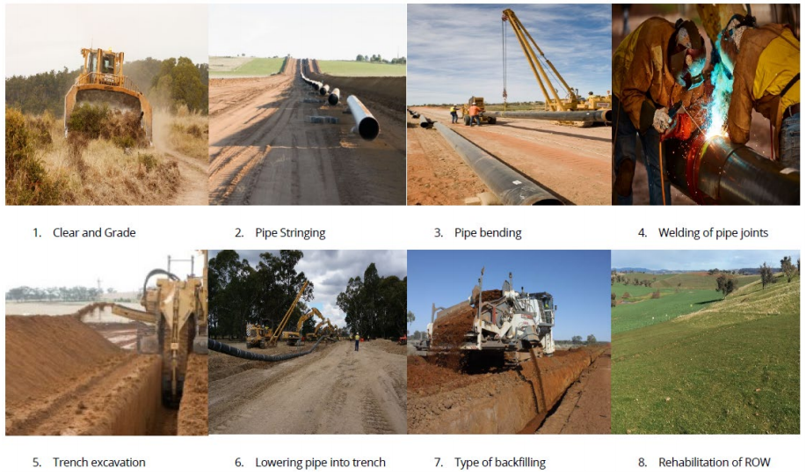

Figure 4-11 Open cut construction methodology within watercourses (no or minimal flow watercourse)
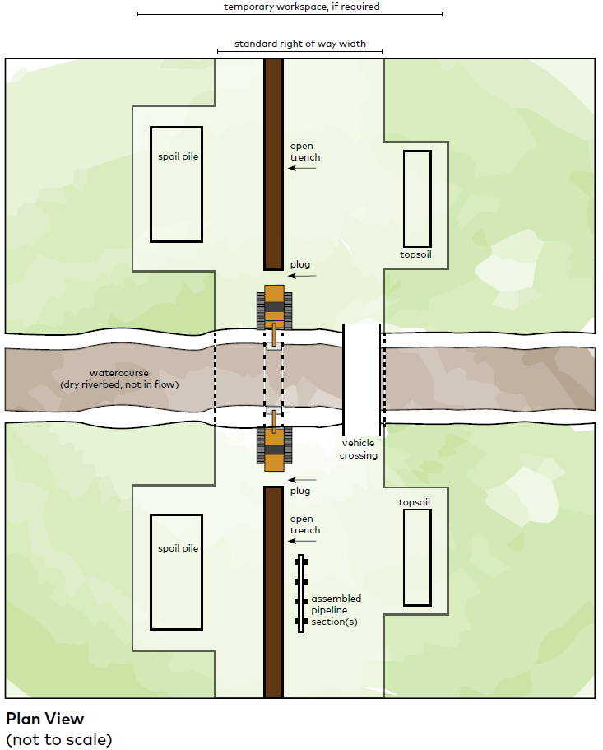

Figure 4-12 Open cut construction methodology within watercourses (high flow watercourse)
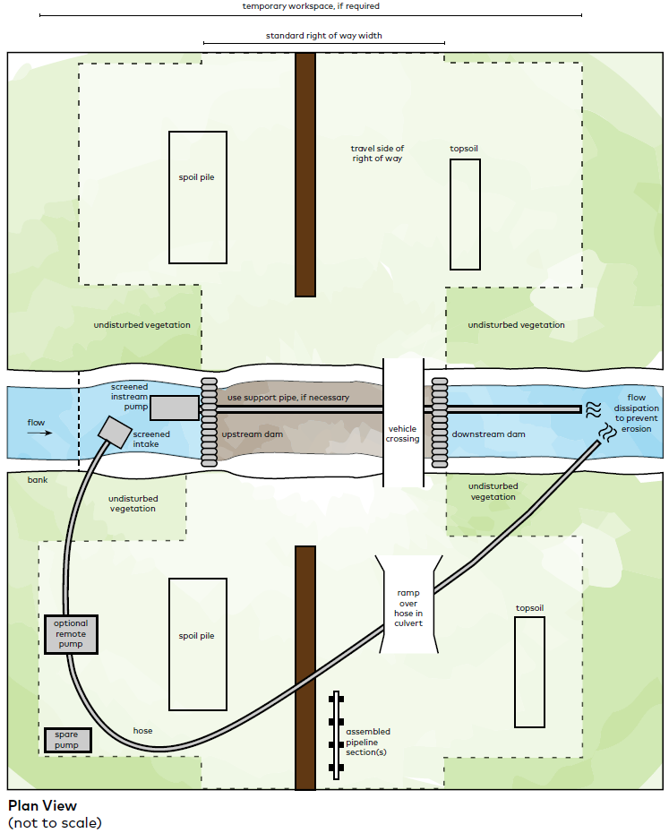

Trenchless construction
In some cases, due to the presence of areas of high ecological significance, existing assets or other constraints, the pipeline would be constructed using trenchless construction techniques such as horizontal directional drilling (HDD) or shallow horizontal boring, to avoid construction disturbance within the sensitive area.
Key areas where trenchless construction techniques would be used include:
- Selected watercourses
- Sealed road and rail crossings, to avoid disruption.
In some circumstances, trenchless construction may be a feasible option to reduce impact on significant environmental values. Trenchless construction locations shown in the Map Book which reduce biodiversity and habitat impacts include:
- Deep Creek
- Melton Highway
- Calder Freeway
- Mickleham Road
- Holden Road
- Duncans Lane
- Morefield Court
- Sunbury Road
- St Johns Road
- Oaklands Road
- Craigieburn Road
- Donnybrook Road
- Hume Freeway
- North Eastern Rail line.
Table 4-4 outlines the crossing points where trenchless construction is proposed as the preliminary construction technique.

Table 4-4 Preliminary construction techniques proposed as trenchless construction
# | Road / Creek Name | Approx location (KP) | Likely construction method at crossing
1 | Beattys Road | 2.2 | Bored
2 | Holden Road | 6.4 | Bored
3 | Morefield Court | 10.9 | Bored
4 | Bulla-Diggers Rest Road | 11.2 | Bored
5 | Wildwood Road | 17.0 | Bored
6 | St Johns Road | 19.0 | Bored
7 | Oaklands Road | 21.6 | Bored
8 | Craigieburn Road | 22.7 | Bored
9 | Mt Ridley Road | 26.4 | Bored
10 | Parkland Crescent | 26.4 | Bored/open cut
11 | Mickleham Road | 28.0 | Bored
12 | Donnybrook Road | 30.2 | Bored
13 | Gunns Gully Road | 36.8 | Bored
14 | Donnybrook Road | 46.8 | Bored
15 | Bendigo Rail Line reserve | 8.2 | Bored (Pipe jacking)
16 | North Eastern Rail Line reserve | 40.9 | Bored (Pipe jacking)
17 | Sunbury Road | 14.9 | Mini HDD
18 | Deep Creek | 16.8 | HDD
19 | Calder Freeway | 8.6 | HDD
20 | Hume Freeway | 36.9 | HDD
21 | Melton Highway | 3.1 | HDD

Pipe jacking and microtunneling
Pipe jacking and microtunneling is a non-disruptive method of installing tunnels for gas pipelines. The specific machinery and methods to achieve the certified design are yet to be finalised with the contractor, however, a general overview is provided here and illustrated in Figure 4-13.
Two pits are dug either side of the rail crossing at the required depth and distance away from the rail assets. In the larger pit, a microtunneling boring machine with hydraulic jack is placed and aligned within the launch/thrust pit. As the boring progresses, sections of concrete pipe are inserted into the bore with the hydraulic jack progressively as each section is being drilled. The microtunneling machine is recovered through the receiver pit and the full bore is filled with jacking pipe. The small annulus between the bored rock tunnel and the concrete jacked pipe is then grouted as per the design.
After the grout cures, the gas pipeline would be inserted through the tunnel of jacked pipe and kept in place with spacers. The annulus between the exterior of the pipe and the concrete jacked pipe would then also be grouted.
The bore pits are backfilled with excavated material and compacted in layers to a level consistent with surrounding soils and to a relative density sufficient to prevent further settlement under natural moisture and load conditions. Either side of the railway crossing is then rehabilitated to pre-construction condition or as otherwise agreed with the relevant landholder(s).
Figure 4-13 Typical pipe jacking arrangement
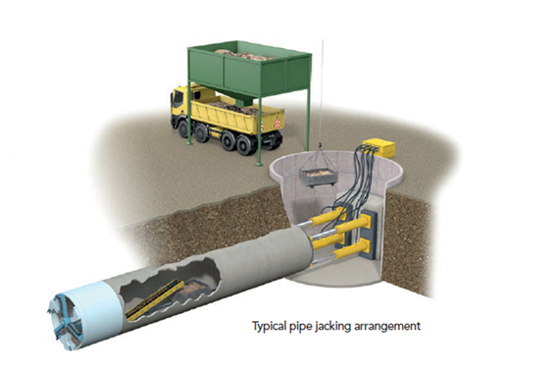

Horizontal directional drilling
HDD is generally used for the crossing of major and sensitive watercourses where standard open cut methods are less desirable from an environmental viewpoint. HDD may also be used for road, railway or third-party asset crossings as an alternative to shallow horizontal boring.
The use of HDD methodology would be subject to geology, environmental topographical, construction constraints and land access requirements. Geotechnical constraints (fissures and cracks, unconsolidated substrata and subsurface scour potential) may prevent HDD being a suitable construction methodology. Where HDD presents unacceptable environmental risks, trenchless construction methodology would be used such as shallow horizontal boring or open trenching.
The installation of a pipeline by HDD involves drilling a pilot hole at a shallow angle beneath the surface from an entry point on one side of the crossing to an exit point on the other side of the crossing, as shown in Figure 4-14.
The HDD construction methodology would require the excavation of entry and exit pits, typically an approximate size of three metres by three metres. Drilling would be conducted by a specific HDD rig operated by a specialist contractor. The size of the HDD rig and its associated footprint is based on the size of the pipe, the nature of the subsurface geology and the length of the section to be drilled.
A schematic showing the typical layout of an HDD entry and exit point is shown in Figure 4-15. The hole is enlarged by reaming to allow for the welded pipe string to be pulled back through the drill hole from the exit point to the entry point without damaging the coating.
After drilling and installation of the pipe along the HDD section, bell holes would be constructed at the entry and exit points to facilitate joining of the pipe (known as tie-in). A bell hole is an enlarged hole allowing machinery to operate within it to bore under the relevant constraint. These HDD tie-in bell holes would be approximately five metres long, five metres wide and two and a half metres deep. The pipeline string is then welded to adjoining sections of the pipeline. Once the pipe string is installed and tied into the main section of the pipeline, the entry and exit points are remediated.
Drilling fluid (typically bentonite) is used to hydraulically drive the drilling head, as a coolant, to wash in situ material (cuttings) from the drilled hole and to seal and line the hole to facilitate insertion of the pipe. Cuttings are screened, removed at the HDD rig and the drilling mud is recycled. Screened cuttings are diverted to skip bins before disposal in landfill in accordance with the Environment Protection Authority (EPA) Victoria’s waste classification and transportation requirements.
Treatment of cuttings is only required for acidic soils, which, based on surveys undertaken for the pipeline works, are likely to be encountered. When encountered, acidic cuttings can be treated to neutralise the cuttings and then disposed of in landfill or sent offsite for treatment and disposal in accordance with Environment Protection Authority Victoria's waste classification and transport requirements.
Duration of HDD construction at each HDD site is dependent on length and geological conditions (rock, unstable material, fissures and loss of mud). It is expected that each HDD would take approximately six weeks, although this would be subject to ground conditions. A shorter HDD in good conditions would take around three weeks. HDD construction may occur 24 hours a day during reaming of longer sections and pullback of the pipe string which is typically completed within a day.
Figure 4-14 Typical HDD process
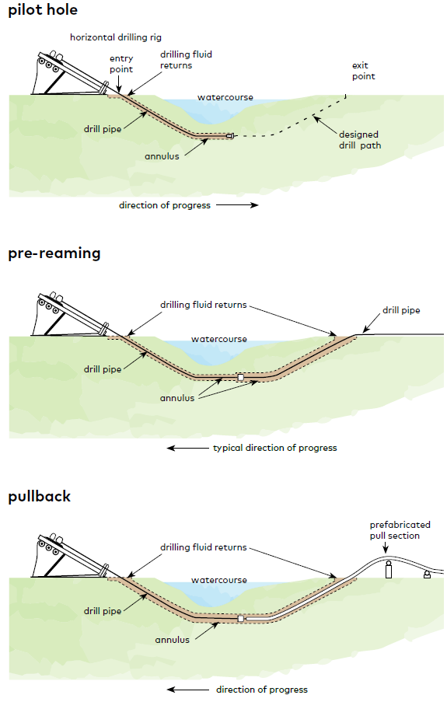
Figure 4-15 Schematic of typical layout of HDD entry and exit points
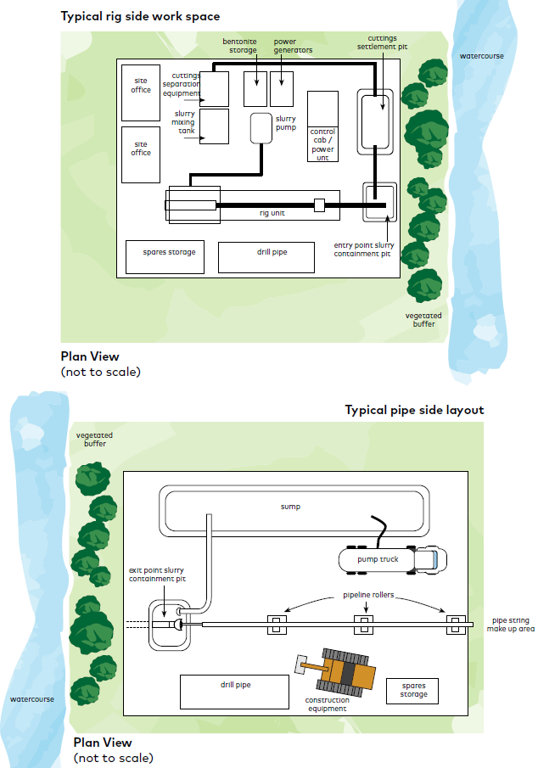

Shallow horizontal boring
The methodology for shallow horizontal boring (referred to as thrust boring or micro-tunnelling) involves constructing a horizontal bore hole for installing the pipeline beneath sensitive surface features, rails, roads and underground services or where access is required on a 24-hour basis. A typical set up for a thrust bored crossing is shown in Figure 4-16.
Bell holes are excavated on both sides of the sensitive feature to the depth of the adjacent trench and graded to match the slope of the pipeline. Bell holes would be approximately eight metres long and four metres wide. The depth would be to match the adjacent trench and graded to match the proposed slope of the pipeline.
A boring machine operates within this bell hole to tunnel under the relevant constraint. The boring machine is located within the entry pit, which uses a hydraulic ram to jack the pipe section, behind a cutting head, in a straight line through the ground to the receiving pit.
The method is not suitable for boring under features where a greater depth is required, such as a major waterway. In these instances, HDD construction methodology would be used.
Figure 4-16 Typical thrust bore site set up
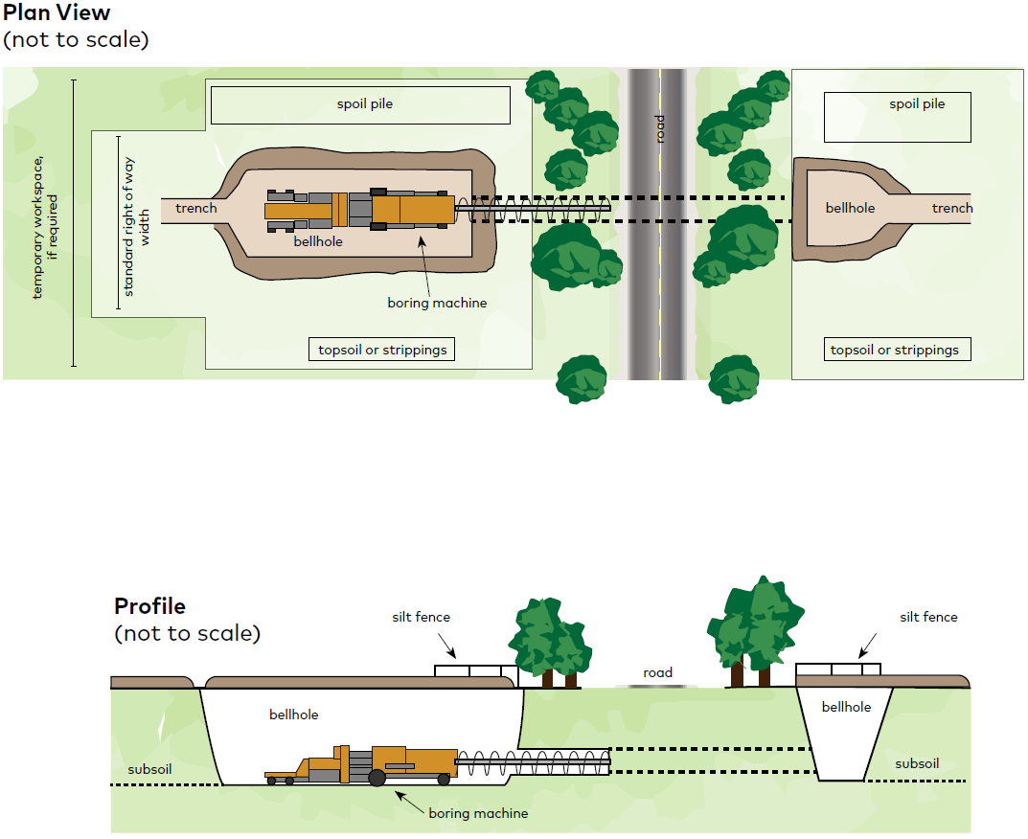

Pipeline testing and commissioning
The pipeline coating would be tested to ensure it is of a satisfactory standard before and after installation. If the pipeline fails a coating integrity test after installation, the pipeline would be excavated and repaired.
The pipeline would be pressure tested before commissioning to ensure it passes strength and leak tests in accordance with AS 2885.5. This is done via hydrostatic testing where test sections of the pipeline are filled with water and then pressurised.
Each pipeline test section would be cleaned internally by pigs propelled by compressed air or water. The test section would be filled with water and pressurised, and the pressure increased for approximately four hours to assess the strength of the test section. The pipeline would then be subjected to a leak test for a minimum of 24 hours to determine the section is leak-free. The hydrostatic testing process would take approximately eight to ten days for a single test section, with the majority of that time required to fill the test section with water.
It is anticipated the pipeline would be hydrostatically tested in a minimum of four and possibly up to eight sections of variable lengths. The exact sequence and timing of hydrostatic testing would depend on the final schedule for construction, availability of water and the final hydrostatic test design of the pipeline.
Hydrostatic testing would require approximately 10 megalitres of water in total and assumes reuse between two adjacent test sections. Break tanks would be used to transfer water between test sections. Depending on the final configuration of hydrostatic test sections and the availability of water, it is possible that chemicals to control biological growth and corrosion may be added to the hydrostatic test water.
Water for hydrostatic testing would be sourced from existing dams or existing water mains where suitable supply exists near the pipeline alignment. This water would be obtained subject to agreements and/or licences/permits with relevant landholders and authorities.
Water can be pumped into the pipe at either end of two test sections or from a central location between two test sections. This provides a high degree of flexibility in testing locations with the main consideration being the availability of water. This allows for testing locations to be selected to minimise potential amenity impacts by avoiding areas near sensitive receptors where practicable.
At the conclusion of testing, and subject to confirmation of the water quality, the water would be released into dams where water was sourced or onto adjoining land with appropriate slope, soil and groundcover characteristics. Water release would occur through a dewatering structure designed to slow the flow of water. When the dewatering process was complete, the pipeline would be dried using compressed air. Water unable to be disposed of onto adjoining land would be disposed of in accordance with relevant legislation and policy requirements.
Following pipeline testing and drying, the pipeline would be gauged using a geometry pig capable of measuring the internal surface of the pipe. Any defects would be located, assessed and rectified.
The pipeline would be commissioned following completion of hydrostatic testing and the tie-in of the MLVs. Commissioning would proceed sequentially from the point where commissioning gas was available and on completion of the sections.
Commissioning would be in accordance with the Pipelines Act and regulations and would include as a minimum the following activities:
- Instrument calibration
- Control system functionality
- Safety system testing
- Purging of air and gas filling
- Pressurisation
- Testing and commissioning of stations and valves.
Gas flow through the pipeline would occur following a Consent to Operate issued from Energy Safe Victoria.

Rehabilitation of the construction area
Rehabilitation of the construction area would be undertaken in accordance with the Project CEMP and good pipeline construction principles with a view to returning land to its previous use within a reasonable timeframe, subject to seasonal constraints.
Key activities would include:
- Re-establishing topsoil cover
- Reinstating roadways and road reserves in accordance with the requirements of local councils
- Reinstating fencing and access tracks in accordance with the requirements of land owners
- Reinstating natural drainage patterns
- Application of seed and/or vegetation, where appropriate
- Installing any erosion control measures in prone areas
- Reinstating waterways to meet Catchment Management Authority requirements.
Rehabilitation of the construction area and all temporary facilities, temporary access tracks and extra work areas would begin as soon as practicable after the completion of the construction activities, with the aim of restoration of ground cover within six months. Rehabilitation of the construction area would be undertaken in accordance with good pipeline construction principles to reinstate existing topography and appropriate vegetation in consultation with the landholder. Appropriate reinstatement methods would be included in the CEMP.
Shallow-rooted vegetation and grass would be re-established across the construction area where appropriate with its land use and in consultation with landowners. Re-establishment of native vegetation would aim to re-instate the same (or similar) native vegetation (for example native grasses) to what was removed to the satisfaction of the responsible authority or landowner. In known and assumed Golden Sun Moth and Striped Legless Lizard habitat that contain native patches of grassland, revegetation would be undertaken with appropriate native grass seed mix (for example, Wallaby Grass, Spear Grass, Kangaroo Grass) that provide habitat and food sources. Tall and deep-rooted vegetation (such as mature trees) cannot be reinstated, due to the potential to interfere with the pipeline coating and impede operational access requirements.
Cover of suitable native shrubs or vegetation of a similar structure as agreed with the relevant landholder would be reinstated in identified locations as described in Chapter 7 Biodiversity, other than directly above the pipeline and access tracks from MLVs to existing roads for ongoing maintenance and surveillance activities.
The APA guideline on landscaping within easement areas provides direction on appropriate planting within or near the operational easement area. This is outlined further in section 4.8.1.
Following completion of rehabilitation works after construction, a more intensive monitoring will occur for the first 12-24 months to ensure that reinstatement has been completed to the satisfaction of each land owner and APA. This will include easement surveillance and reinstating rehabilitation works if required (ie monitoring the progress of rehabilitation, vegetation control, weed management, erosion and subsidence monitoring). As part of routine inspections during the operational phase, monitoring is described in Section 4.8.1. Monitoring and rehabilitation would be in accordance with the CEMP approved under the Pipelines Act. Additional details of weed management and rehabilitation are included as part of the biodiversity and surface water reports.

Wollert Compressor station upgrades
The Project includes the addition of a Solar Centaur 50 compressor to the site, along with an end of line scraper station and regulating station, associated valves and pipework as shown in Figure 4-8. The Wollert Compressor Station upgrades would take around nine months to construct (Q4 2021 to Q4 2022).
The construction sequence and activities for all works at the compressor station are outlined in Table 4-5.
Table 4-5 Construction works at the Wollert Compressor Station
Construction sequence | Activity | Description
1 | Surveying | Preliminary survey works to mark the extent of the construction area.
2 | Site establishment | Preliminary activities to facilitate the construction of the compressor, regulating station and end of line scraper, including but not limited to:  - Setting up environmental management measures  - Vegetation removal  - Establishment of temporary site laydown area and construction offices  - Proving of any existing assets  - Use of temporary access roads within the APA site.
3 | Bulk earthworks | Excavation and removal of existing soil material or rock from specified areas of the construction area.
4 | Civil works | Excavations would cut into the existing surface material to facilitate construction of a concrete slab and footings to provide a firm base for the compressor and any other pipework and equipment.
5 | Mechanical works | Various components of the compressor are assembled offsite and assembled together onsite. Cranes are used to lift the compressor into place with all connecting pipework fitted.
6 | Electrical and instrumentation works | Electrical components are connected together on site via cables installed in above ground cable trays.
7 | Hydrostatic testing | Station piping would be pressure tested via hydrostatic testing (in accordance with ASME B31.3 and APA standard piping specifications), prior to commissioning, to ensure it passes strength and leak tests.
8 | Pre-commissioning and commissioning activities including tie-ins | Following completion of hydrostatic testing and Consent to Operate from Energy Safe Victoria the station piping would be purged with gas. Pre-commissioning and commissioning activities would be undertaken, which includes function testing and performance testing of all installed equipment before the facilities are commissioned.  In order to connect the new pipeline to the existing VTS some tie-in works are required into the existing pipeline at Wollert.
9 | Site completion and fencing | A hardstand area would be established around the compressor, regulating station and end of line scraper station. Installation of permanent fencing around the facility to maintain ongoing site security. Final site clean-up.

Construction workforce and hours
At the peak of the construction program, a construction workforce of up to 350 people is expected across the Project, including 70 people at the Wollert Compressor Station. The construction workforce for the pipeline would generally work between 6 am and 6 pm, seven days a week. From 6 am to 7 am, workers would generally be undertaking site set up, tool box talks, and preparation tasks rather than construction works. At some major HDD crossing and during hydrostatic testing, 24 hour operation may be required for short periods.
It is expected that there would be a minimum of two crews undertaking pipeline construction works consecutively. A separate work crew would undertake the compressor station works.
Construction crews for the pipeline would typically work a rostered cycle of 28 days on and nine days off (or 21 days on and seven days off), as per the pipeline industry standard.
For the construction of the facilities at Wollert Compressor Station, crews would typically work a rostered cycle of 21 days on and seven days off (or five weekdays and half day Saturday).
Where night works are required, task-based lighting would be used and noise assessments would determine any mitigation measures required for any nearby receptors.

Construction equipment for the Project
Indicative equipment, plant and vehicles required for the Project’s construction works is shown in Table 4-6
Table 4-6 Indicative construction equipment, plant and vehicles
Equipment, plant and vehicles
35 ton excavators | 35 ton excavator with vac lift | Graders
D7 dozer | 572 side booms | Bending machine
Prime movers (stringing trucks) | Skid truck | Mulcher
45 ton excavators with hammer | Rock chain trenchers | Trucks
Drill and blast operations (air track for drilling holes) | Light truck with welding machines | Tack rig
Light truck with generator | Light truck, compressor and grit blasting pot | Coating light truck (spray unit)
Mini HDD rig | Mud tanks | Generators (self bunded or within container)
Vac trucks | Boring machine (assume diesel powered) | Prime mover for casing pipe and steel pipes
583 side boom | Loaders | 350 padding machine
Flowcon truck | Welding truck | Coating and blasting system on truck
Fill pump | High pressure squeeze pump | Compressors
Vacuum drying unit | Crane | Tractor - reseeding
Light vehicles | Water carts (dust suppression)

Power requirements for the construction phase are minimal and would be supplied by generators.

Construction traffic
During construction of the Project, approximately 10–15 heavy vehicle movements a day are expected to occur to and from the pipeline laydown area to deliver materials to the pipeline work site. Existing roads would accommodate the anticipated low number of construction vehicle movements. Construction traffic routes between the offsite compound and the daily active work front would vary depending on the location of active works and the final off-site compound location. No road upgrades would be required.
Access to the construction area would predominantly be via the 30 metre corridor. Temporary access points from existing roads would be required to provide safe entry/exit for construction traffic during construction works. Where possible existing private access tracks would be used (where feasible) to provide temporary access to the construction corridor. Access points are in the Map Book.
During construction of road crossings, traffic control would be in place to manage through traffic and construction vehicles moving from one side of the road to the other. Traffic management plans would be prepared for work areas and submitted to the relevant road authority (council or Department of Transport) for approval.
Four roads are expected to require partial road closure during road crossing works. While there may be a reduced level of service (such as temporary lane closure), access would still be available with traffic control. At Dillon Court Road, partial road closure would also require alternative access to be provided to one property. Partial road closure would also be required at Duncans Lane Road, Parkland Crescent and Summerhill Road.
Some farm access tracks may need to be regraded and gravel installed, to allow safe access for heavy machinery. All access tracks are included as part of the construction footprint (refer Map Book).
The construction workforce would travel to site from pre-existing accommodation in the surrounding areas. If travelling by private vehicles, parking would be available within the construction area.

Operation and maintenance
The Project is expected to operate for 60 years. Operation and maintenance activities are described in the following sections, including the expected operational workforce.

Pipeline
Following the reinstatement of land as part of the pipeline construction, the land would be generally returned to its previous use. Excavating or erecting permanent structures or buildings over the underground pipeline would be prohibited in accordance with the Pipelines Act and pursuant to easement agreements with landowners.
When commissioned, the pipeline would be owned and maintained by APA. The operational footprint would be delineated by a proposed easement, with a standard width of 15 metres. During operation, there would be restrictions on the use and development of land within the 15 metre easement corridor, as outlined under Division 3 of the Pipelines Act. Restrictions would include the prohibition of excavating or erecting permanent structures, buildings, planting of large trees or shrubs over the underground pipeline, unless approved by APA.
Any planned road crossings in the future must meet the requirements of AS2885.1-2012 Clause 5.8.8 and Figure 5.8.8(B), while linear buried infrastructure should minimise crossings of the pipeline. Accordingly, any future roads and linear infrastructure should be designed to cross the pipeline at 90 degrees. Physical access to land within the pipeline easement would not be restricted beyond the above, and activities such as livestock grazing or cropping would be able to continue.
Vegetation within the easement area is restricted to shallow-rooted vegetation and grass. Tall and deep-rooted vegetation (such as mature trees) cannot be planted due to the potential to interfere with the pipeline coating and impede operational access requirements. APA's landscaping guideline sets out the scope of landscaping options for the easement area.
APA’s preferred position is that the Project’s pipeline easement is designed to be linear green spaces that ultimately become council public reserves and opens spaces. As much of the land on which the pipeline is to be constructed is private land, it would ultimately be the decision of the owner of the property on which the pipeline is constructed to progress the establishment of linear green spaces within the easement, in-line APA's Site Planning and Landscape National Guidelines (APA, 2020). APA's Site Planning and Landscape National Guidelines (APA, 2020) outline the preferred urban design and landscape outcomes for APA’s easements. In general, these guidelines are designed to enhance social outcomes and visual amenity by providing for landscaped active open space areas that typically incorporate a mix of landscaping and shared use paths, examples of which are shown in Figure 4-17.
Figure 4-17 Potential linear open space outcomes (Source: APA, 2020 - Site Planning and Landscape National Guidelines)
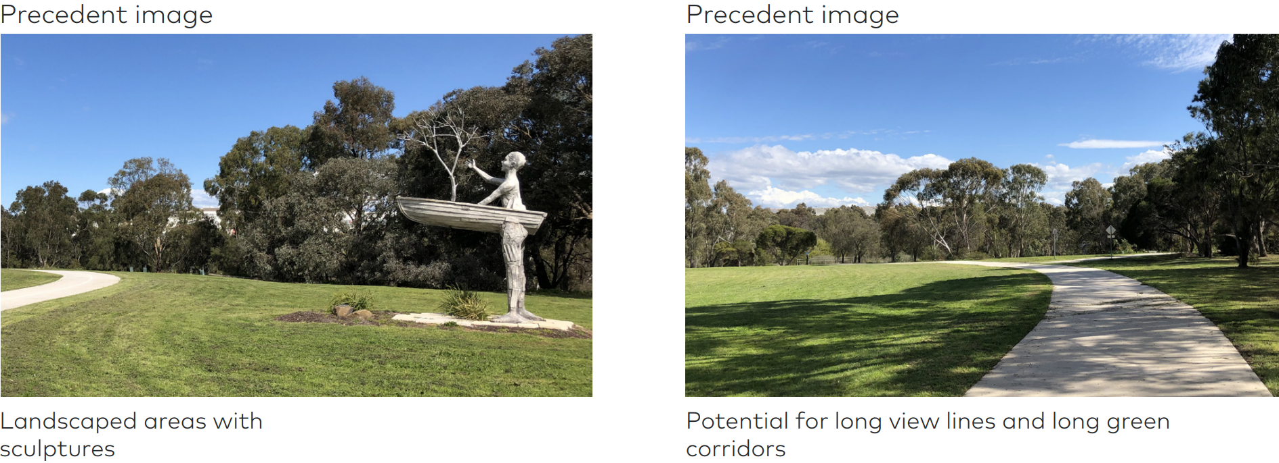
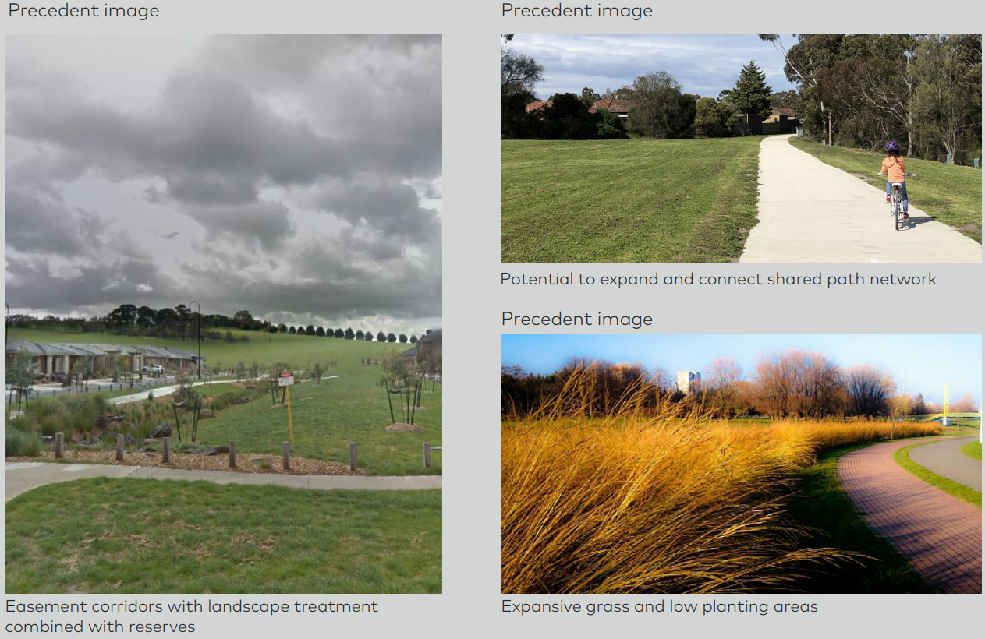
Routine corridor inspections would be undertaken in accordance with APA procedures and AS2885 to monitor the pipeline easement for any operational or maintenance issues. The ongoing corridor inspections address issues such as:
- Unauthorised excavation
- Land stability (such as subsidence, erosion)
- Revegetation
- Weed invasion
- Cover at watercourse crossings
- Third-party (such as asset owners) and landowner activities.
Inspection of the easement for issues such as erosion, weeds, subsidence, revegetation and unauthorised third party activity would be conducted by pipeline patrols. Pipeline patrols of the easement would be undertaken in consultation with landowners if direct access to the property is required using light vehicles. To minimise direct access onto properties, inspections are generally undertaken using roadside points or through use of aerial patrols.
The routine operation of gas pipelines requires the periodic running of a pig to clean and inspect the wall integrity. Pigging would be undertaken 10 years post construction, then at a frequency determined by the result of each inspection, most likely greater than 10 years.
Maintenance and inspections of the MLVs would also be conducted periodically in accordance with APA procedures. The activities usually include vegetation management, valve operation and corrective maintenance.

Compressor station
The existing Wollert compressor site is maintained by APA. Ongoing inspection and maintenance activities occur to ensure all equipment and physical operational equipment is managed. The Australian Energy Market Operator (AEMO) operates the facility for the distribution of gas in Victoria under a Service Envelope Agreement.
Maintenance and inspections at the Wollert compressor site would also be conducted periodically in accordance with APA procedures. Activities usually include weed management, valve and compressor operation and corrective maintenance.

Operational workforce for the Project
The MLV would be designed to be automated and would be operated unstaffed under normal operating conditions.
Operation of the pipeline would require an incremental increase in APA’s existing operational workforce consisting of one additional field staff.
Field staff would be responsible for day to day pipeline operations and maintenance activities, ground patrols, communication with local stakeholders and facilitation of third-party access to the easement.
Contractors operating under APA’s supervision would be responsible for activities including:
- Easement maintenance (vegetation control, weed management, erosion and subsidence monitoring)
- Specialist pigging operations
- Cathodic protection surveys for mechanical and electrical preventative and corrective maintenance
- Aerial patrols to support ongoing surveillance of the easement.
Field staff would access the pipeline to conduct operations and maintenance activities as required, in consultation with relevant landholders.
The compressor station would continue to be monitored and managed by APA’s operational control room team currently managing the Wollert site.

Decommissioning
The pipeline would be designed and built with a life span of 60 years although it could operate for longer depending on the pipeline integrity. When the pipeline and associated facilities are no longer required, they would be decommissioned in accordance with AS2885 and relevant legislative requirements at the time of decommissioning.
A detailed decommissioning or abandonment plan and rehabilitation program would be developed and implemented in consultation with landholders and the regulator at the relevant time.
Due to the life span of the facilities and the uncertainty of the surrounding environment at that time, decommissioning would be subject to separate environmental assessment and does not form part of this EES.

Waste and spoil management
The Project would generate a range of wastes, mainly through the construction phase.

Construction waste management
A range of wastes would be generated during construction activities for the Project, particularly in respect to activities along the pipeline construction area. These include:
- General wastes from transportation and storage of pipe (packaging, pallets, ropes, bevel protectors)
- Wastes from clearing the construction area (vegetation)
- Pipeline coating waste
- Drilling cuttings and excess soil and rock (excess soil, HDD bentonite)
- Laying, welding and grinding waste (for example, scrap metal, spent welding rods)
- Bitumen from streetworks
- Water from dewatering, stormwater and hydrotesting
- Machinery waste.
Cleared vegetation, topsoil and subsoil would be generated during construction of the underground pipeline. As these materials are generally returned to the trench as a fundamental part of backfilling and rehabilitation they are not considered to be wastes, and are only included in the waste inventory where there is excess soil.
Excavated soil would be stockpiled to be re-used in backfilling. The volume of material reused would vary location to location based on soil profile and quality.
In the event that the excavated material cannot be reused, the spoil would be lawfully disposed of according to the requirements of the CEMP. Further discussion on spoil and its suitability for reuse is discussed in Chapter 10 Contamination and greenhouse gas.
Project construction wastes would be reused or recycled where practicable or collected and transported by licensed waste contractors for disposal at appropriately licensed facilities. Any contaminated or hazard materials identified on site would be dealt with lawfully in accordance with the EPA Victoria's waste classification and transport requirements. Further discussion on contamination is provided in Chapter 10 Contamination and Greenhouse gas.
Subject to confirmation of the water quality, construction waste water would be returned into dams where water was sourced or onto adjoining land with appropriate slope, soil and groundcover characteristics. Water release techniques would be implemented to ensure slow flow of water occurs to minimise erosion to surrounding land. Dewatering of trenches due to rainfall would be collected and treated prior to discharge into the waterways and reused where appropriate (for example for dust suppression and chemical treatment such as with flocculants and coagulants). Dewatering of excavated trenches/bell holes would be managed to minimise sedimentation, including the use of sediment control devices to remove suspended solids and dissipate flow. Sediment control devices would be listed in the CEMP.

Operation waste management
During operation of the pipeline, wastes would include:
- Small volumes of waste oils and grease
- Dust and mill scale (steel flakes) from infrequent maintenance or pigging activities.
Waste generated from pigging is typically dust and mill scale from inside the pipe and volumes are expected to be less than one cubic metre for the entire pipeline. This waste would be collected at scraper station locations approximately every 10 years as part of maintenance activities. Pigging waste would be tested for waste classification before disposal at a suitable general solid waste or hazardous waste management facility. Pigging waste management would be undertaken in accordance with EPA waste classification and transport requirements in place at the time of spoil generation.
Project operation wastes would be reused or recycled where practicable or collected and transported by licensed waste contractors for disposal at appropriately licensed facilities in accordance with EPA waste classification and transport requirements.

