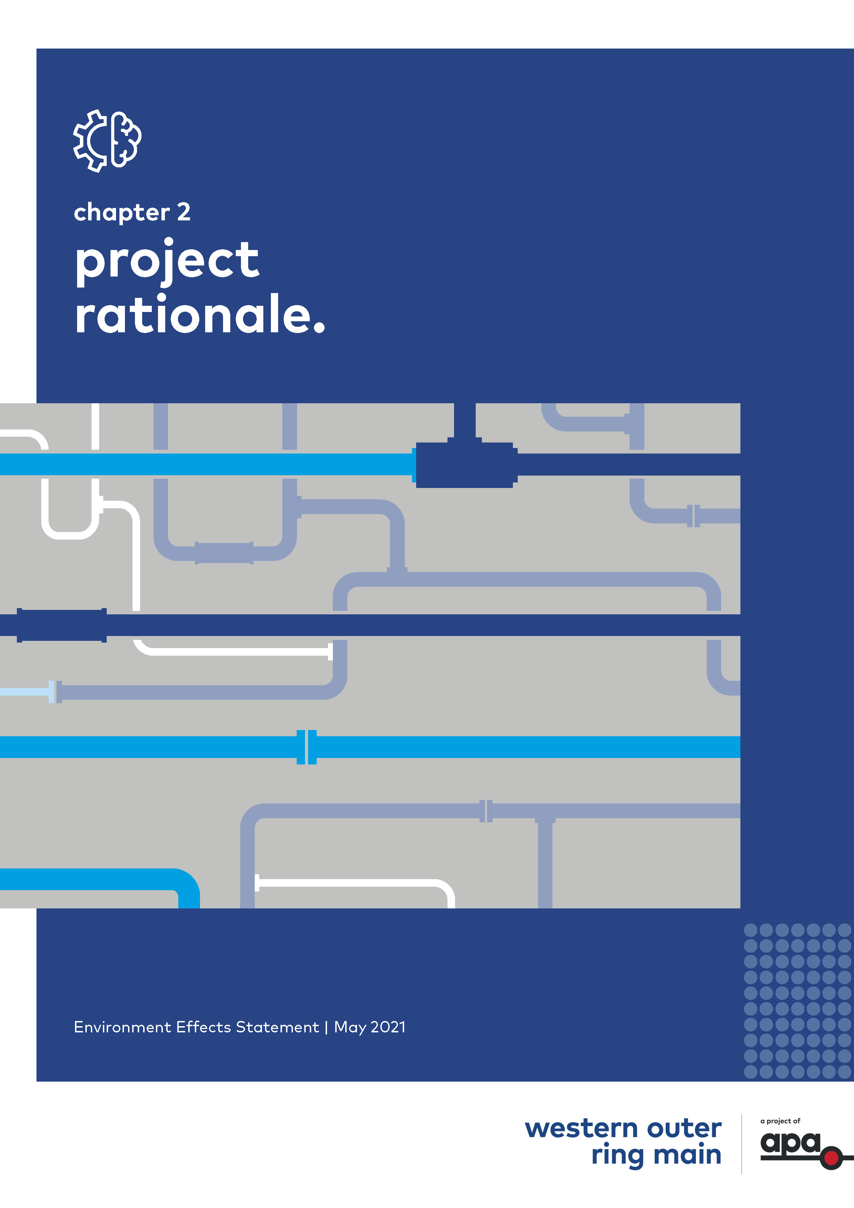Chapter 2

# Project rationale

Contents

Chapter 2

2.1 Introduction 2-1

2.2 How we use natural gas in Victoria 2-1

2.2.1 Gas consumption 2-1

2.2.2 Gas demand 2-2

2.3 The importance of gas supply for Victoria’s energy security, efficiency and affordability 2-3

2.3.1 Energy policy context in Victoria 2-3

2.3.2 Forecast gas supply shortfall during peak demand periods 2-4

2.3.3 The role of gas supply in Victoria’s energy mix 2-5

2.4 Network infrastructure constraints impacting energy security, efficiency and affordability 2-8

2.4.1 Gas storage in Victoria and the importance of gas transfer to the west 2-8

2.4.2 How Victoria’s gas supply is sourced and circulated to customers 2-9

2.4.3 Changes to gas supply and circulation routes in Victoria 2-10

2.5 The Project's contribution to Victoria’s energy security, efficiency and affordability 2-11

2.5.1 The missing link in the network 2-11

2.5.2 Improved compression efficiency 2-12

2.5.3 The Project's relationship to supply and demand 2-12

2.6 Overview of Project benefits 2-13

## Introduction

This chapter considers the need for the Western Outer Ring Main (WORM) gas pipeline project (the Project) in the context of:

* Gas usage and the importance of gas supply and transmission to support Victoria’s energy security, efficiency and affordability goals
* Recent changes in gas supply and gas circulation around the Victorian gas network
* Gas network infrastructure constraints.

Key benefits expected to be derived from the Project are also discussed in this chapter, including how the Project would support greater energy security and gas network reliability for Victorians in the future.

## How we use natural gas in Victoria

### Gas consumption

Natural gas is an essential source of energy for Victoria, with approximately two million customers using gas every day for domestic applications including cooking, heating and hot water.

Gas is also a critical fuel for a wide range of industries such as manufacturing, waste disposal and energy generation, with approximately 60,000 industrial and commercial customers using natural gas across the state. This includes the growing renewable energy industry, which uses gas-fired peaking power stations (that is, power stations that generally only run when there is high demand) to support renewable energy generation. Victoria is also a net exporter of gas to other states via the gas transmission network.

Gas consumption in Victoria averages around 200 petajoules (PJ) every year[1], making it a significant contributor to the state’s energy mix.

The Victorian economy is highly dependent on gas, with the state’s usage accounting for approximately 50 per cent of gas demand in south-eastern Australia.

Over the coming decades gas is expected to be a key contributor to Victoria's evolving energy mix, supporting the state in its transition towards a cleaner energy future. This is discussed in further detail at Section 2.3.3 of this chapter.

### Gas demand

Gas demand in Victoria is primarily driven by the residential and small commercial sectors. This differs from other states, such as Queensland, where gas demand from industrial and large commercial and gas-powered energy generators (GPGs) far outweighs demand from the residential and small commercial sectors. Victoria experiences peak demand for gas during the winter months, when consumption of hot water and use of heating increases, and broader demand pressure is placed on energy generators. As shown in Figure 2‑1, gas consumption over the Victorian winter (approximately 880 TJ/day in July) is up to three times higher than during summer.

Figure 2‑1 Seasonal gas demand variance[2]

This figure shows a bar chart of the seasonal gas demand variance by each month, as described in the text above.

To manage this seasonal variance, Victoria’s gas network allows for the transfer and storage of surplus gas during summer months, when demand is lower, in preparation for higher demand during the winter and to cover seasonal shortfalls in supply.

As shown in Figure 2‑2, gas demand is expected to reduce over coming years, with a decrease in yearly demand of 5.8 per cent[3] across Victoria’s Declared Transmission System (DTS) expected between 2021 and 2025. This is attributable to expected behavioural changes in large commercial and industrial consumption and also changes to gas-powered generation demand as a result of increased certainty in energy savings from the Victorian Energy Upgrades (VEU) program and Large Energy Users (LEU) program, and forecasted renewable energy projects expected to be commissioned.

If forecast investments in renewable energy generation are delayed or do not proceed, however, or if reliance on coal-fired generators reduces over this period, gas demand forecasts for Victoria[4] could increase.

Figure 2‑2 Total annual DTS consumption, actual 2016-20 and forecast 2021-25 (PJ/y)[5]

This figure shows a bar chart of the actual and forecast annual DTS consumption, as described in the text above.

## The importance of gas supply for Victoria’s energy security, efficiency and affordability

### Energy policy context in Victoria

The Victorian Government has identified four key energy policy objectives to guide the operation and evolution of its energy sector. These objectives are to ensure:

* An efficient and secure energy system
* That energy supplies are delivered reliably and safely
* That consumers can access energy at affordable prices
* That energy supplies and the way we use them are environmentally sustainable and less greenhouse intensive[6].

In accordance with the last objective, Victoria has committed to transitioning towards a more modern and renewable energy sector and has set targets to achieve this in the coming decades. The role of gas in this energy transition is discussed in Section 2.3.3 of this chapter. The role of the Project in achieving these objectives is summarised in Section 2.6 of this chapter.

### Forecast gas supply shortfall during peak demand periods

The Australian Energy Market Operator (AEMO) monitors, manages and undertakes forecast planning for gas systems across Australia. AEMO manage the distribution of gas flow throughout Victoria based on supply and demand requirements. AEMO in 2020[7] identified risks of a natural gas supply shortfall in Victoria in the winter months from 2024 onwards.

That predicted shortfall is due to supply constraint factors rather than changes in demand, which are discussed in further detail in Section 2.4, and include:

* Some of Victoria’s key gas sources approaching end of life or forecast to cease operation
* Uncertainty about the status of future gas supply projects for Victoria
* Network capacity constraints, which will result in inadequate transfer and storage rates over summer to meet winter peak demand.

The threat of shortfall is expected to be addressed through the commitment from Australian Industrial Energy (AIE) to construct the Port Kembla (New South Wales) liquefied natural gas import terminal and Jemena's commitment to modify the Eastern Gas Pipeline to permit reverse flow from Port Kembla into the DTS[8]. This assumption regarding available peak day supply capacity is forecasted to increase, following the expected completion of the WORM project in late 2022[9]. Any new supply projects would need to be complemented by critical capacity upgrades to Victoria’s gas infrastructure network to ensure that future gas supply could be adequately circulated across the state, and interstate, where and when it is needed. The AEMO 2021 updated forecasts have assumed that the WORM Project proceeds and would be in operation by 2023.

### The role of gas supply in Victoria’s energy mix

Victoria’s energy mix in 2018–19 by source comprised of 72.9 per cent coal, 5.3 per cent natural gas and 21.8 per cent renewable energy[10]. While coal currently remains the largest contributor to the state’s energy supplies, Victoria’s energy sector is rapidly modernising and transitioning in favour of cleaner and more sustainable sources of energy supply.

The Victorian Government has committed to reducing greenhouse gas emissions and supporting the growth of renewable energy through its policy and legislative frameworks. The Climate Change Act 2017 sets a long-term emissions reduction target of zero greenhouse gas emissions by 2050.

The Victorian Renewable Energy Target (VRET) has set a policy goal of achieving 50 per cent renewable energy generation in Victoria by 2030. This increase in energy generation share is largely expected to be balanced by a corresponding reduction in coal based energy generation, with the planned retirement of many coal-fired power generators in the coming years[11].

As shown in Figure 2‑4, despite having a comparatively smaller share of Victoria’s energy mix, natural gas will continue to play an important role in meeting Victoria’s energy needs given its ability to support the renewable energy transition and reduction of greenhouse gas emissions in the state. Natural gas remains a favoured fuel source for renewable energy generation facilities, because it produces substantially fewer greenhouse gas emissions than coal. Gas is used to support the function of renewable energy facilities by providing back-up power for a range of renewable energy generators.

Beyond 2024, the role of gas will increase in proportion to the decline in coal generation, with gas playing a particularly important role between 2030 and 2050 as the clean energy sector expands in line with VRET and broader climate change policy[12]. However, the Australian Energy Regulator (AER)'s State of the Energy Market 2020 report has identified that the energy transition underway in Australia has led to increased concerns about reliability as the clean energy sector develops[13]. The report notes that increased wind and solar generation in the national electricity market is creating more volatile supply and demand conditions in the energy sector. As the market transitions to a cleaner energy base, the energy grid must respond to sudden changes in renewable output, which indicates an increasing need for energy generation, storage and demand responses that can respond quickly to these changes. It notes that gas, hydro and batteries are well able to respond to the variability of wind and solar[14].

As shown in Figure 2‑3, new energy generation investment in Victoria at March 2020 has largely comprised wind and solar, with a small proportion of battery and gas generation also proposed, and no hydro. As wind and solar generation continues to grow, the intermittent nature of these renewables will require what the AER describes as 'firming' capacity, via gas powered plants or storage to support energy reliability and security for consumers.

As an Australian natural gas infrastructure owner and operator, APA is committed to being part of the successful transition to a lower carbon future. This commitment includes continued investment in natural gas assets to ensure a secure and reliable source of natural gas is available to support Australia's evolving energy mix, and supporting emerging technologies through investment and coordination with the renewable energy sector in new energy research and development[15].

Figure 2‑3 Announced energy generation proposals (at March 2020) by State[16]

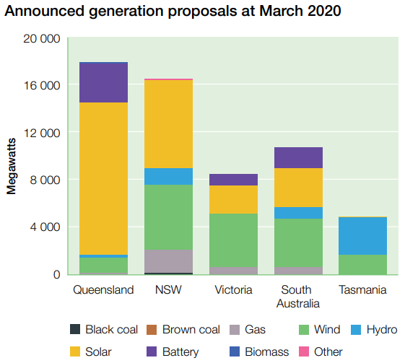

Victoria’s Renewable Energy Action Plan (2018) contains a key action to ‘[a]dvocate to deliver secure, reliable and fairly priced gas for renewable energy generation’. Through this action, the Victorian Government highlights that it will continue to use natural gas as a key fuel source to support renewable energy generation in the state[17]. This action acknowledges that the clean energy transition will take time, with natural gas expected to remain an important stabiliser for energy system reliability over the coming decades until renewables generation and utility-scale renewable energy storage and distribution infrastructure can be established.

Figure 2‑4 Victorian electricity generation, actual 2016–20 and forecast 2021–25 (GWh/year)[18]

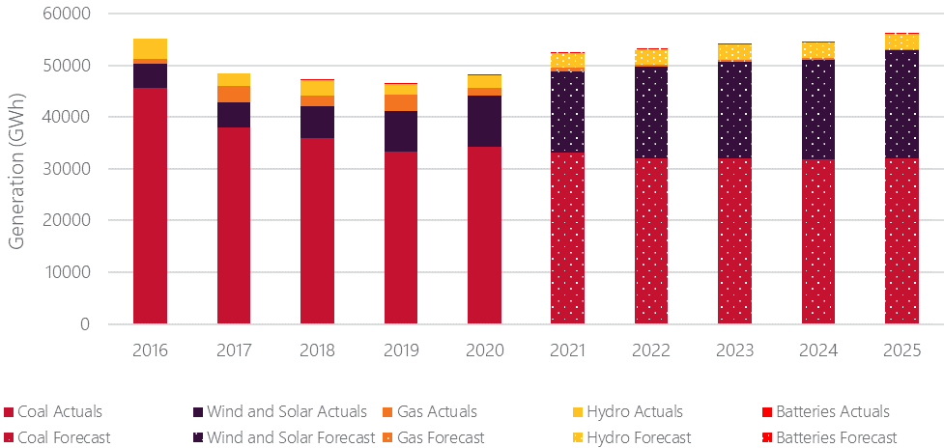

|  |
| --- |
| Renewable gas as an alternative to natural gas  Renewable gas refers to a range of renewable fuels that may be used to complement or replace natural gas in the future. These include hydrogen, methane and biogas. Research and development of renewable gas technologies is in its early stages in Australia.  APA is exploring the potential of renewable methane as a future replacement for natural gas in existing pipelines in Australia; having commenced a pilot project in early 2020 with support from the Australian Renewable Energy Agency (ARENA).  While renewable gas technologies continue to develop, natural gas is expected to remain an important transitional fuel over the coming decades, because it produces significantly fewer greenhouse gas emissions than coal and supports energy security, efficiency and affordability during the transition to a clean energy future. |

## Network infrastructure constraints impacting energy security, efficiency and affordability

### Gas storage in Victoria and the importance of gas transfer to the west

Victoria’s surplus gas supply generated in summer is transferred to and stored at two storage facilities, the Iona Underground Storage Facility (UGS) in Port Campbell in the state’s west and the Dandenong LNG storage facility (LNGSF) located in south-east metropolitan Melbourne. An overview of gas supply circulation in Victoria is shown in Figure 2‑5.

Figure 2‑5 Overview of general gas supply circulation routes in Victoria

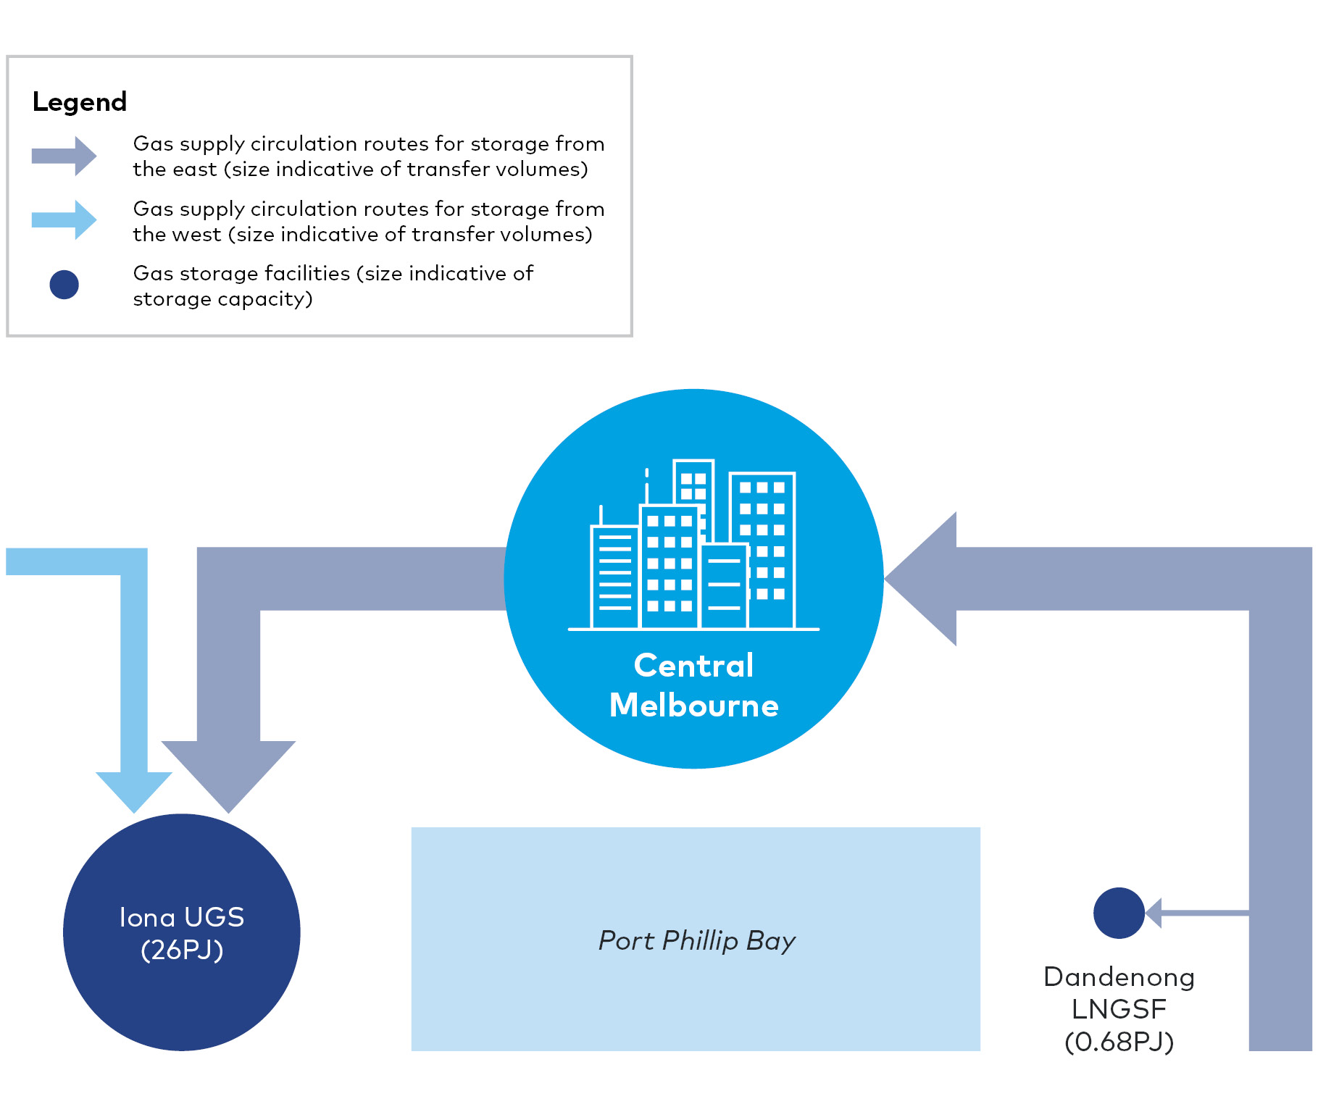

The Iona UGS is Victoria’s largest natural gas storage facility and is responsible for storing the majority of Victoria’s gas supplies. The facility has a storage reservoir capacity of 26 PJ, in comparison to the Dandenong LNGSF, which has a storage capacity of 0.68 PJ[19].

Gas stored at the Iona UGS is crucial for meeting peak gas demand in Victoria. The facility has traditionally covered the shortfall in the state’s regular gas supply over winter, ensuring Victorians continue to have sufficient access to natural gas throughout the year. However, sufficient storage volumes must be achieved at the facility over summer before winter arrives, in order to cover this shortfall.

AEMO has advised that there will be an increased reliance on gas storage at the Iona UGS to meet peak winter demand as a result of forecast supply changes[20]. However, these supply changes, in addition to current capacity constraints in the state’s gas distribution network, have meant that surplus gas from supply sources particularly in Victoria’s east and north cannot be circulated to the Iona UGS in the west quickly enough to meet storage volume requirements for the following winter.

This Project seeks to improve network capacity and transfer of gas supply to the Iona UGS during the summer, to ensure secure and reliable gas supply for Victorians when they need it most.

### How Victoria’s gas supply is sourced and circulated to customers

Most of the gas that currently supplies Victoria originates from the Gippsland Basin, which is an offshore gas field near Lakes Entrance on the eastern side of the state. Smaller volumes of gas are also sourced from other offshore fields including the Bass Basin near Lang Lang, also in Victoria’s east, and the Otway Basin near Port Campbell on the western side of Victoria.

Once onshore, natural gas is processed and then supplied to customers via a series of high pressure transmission pipelines known as the Victorian Transmission System (VTS), as well as a number of lower pressure distribution networks. The VTS is owned and maintained by APA.

The VTS comprises approximately 2,267 kilometres of high pressure pipelines separated into three main branches:

* The Longford Dandenong Pipeline (LDP) in Victoria’s east, which moves gas from the Gippsland Basin and Bass Basin to Melbourne
* The Victorian Northern Interconnect (VNI) in Victoria’s north, which moves gas interstate between Victoria and New South Wales
* The South West Pipeline (SWP) in Victoria’s west, which moves gas from the Otway Basin and the Iona UGS to Melbourne.

Supporting the VTS is an approximately 93 km long high pressure pipeline connection linking the LDP in the east and the VNI in the north, called the Pakenham to Wollert Gas Pipeline (also known as the Outer Ring Main). This link enables gas to be sent under high pressure between the east and north of Victoria with great efficiency, circulating larger volumes of gas to customers across the network in a timely and cost-effective manner.

An equivalent high pressure pipeline connection between the SWP (and Iona UGS) in the west and the balance of the VTS does not exist, and remains a missing link in Victoria’s high pressure gas pipeline network.

This creates bottlenecks for gas circulation to and from the west of Victoria and the Iona UGS, as gas needs to flow through the low pressure gas distribution network as it crosses central Melbourne. The low pressure network circulates gas at a slower rate than the high pressure network, and is constrained by pipeline capacity limits. Gas pressure also needs to be converted at network transition points between the high and low pressure networks, adding further time to the transfer of gas to and from the west of Victoria.

Without a high pressure pipeline connection from the west through to the east and north, the ability to efficiently move gas to and from the Iona UGS and SWP remains significantly constrained by the existing low pressure network and is a key contributor to forecast gas supply shortages in the coming years (refer Section 2.3.2).

### Changes to gas supply and circulation routes in Victoria

Supply challenges due to the lack of a high pressure pipeline link between Victoria’s west and the eastern and northern parts of the state are further compounded by forecast changes to gas supply locations and circulation routes across Victoria.

While gas supplies for the Iona UGS come from both the Otway (west) and Gippsland and Bass Basins (east), gas production from the Otway Basin has declined significantly in recent years. In the 2020 VGPR Update gas supply from existing offshore gas fields in the Otway Basin was predicted to deplete in 2023, reducing annual gas production in Port Campbell (where the Iona UGS is located) from 32 PJ in 2022 to 1 PJ in 2023[21]. The commitment to redevelop existing fields within the offshore Otway Basin has resulted in a forecasted increase of Port Campbell's production from 44 PJ in 2021 to 67 PJ in 2023, before declining to 52 PJ in 2025[22].

Gas supply is also expected to decline from the Gippsland Basin in the state’s east as some gas fields within this basin reach the end of their life by 2024. Despite this decline, Gippsland’s annual supply in 2024 is still forecast to be around 201 PJ, and as such will continue to be the major source of gas supply for Victoria and the Iona UGS for the future. Furthermore, anticipated future gas supply projects in Victoria are expected to result in further supply sources being established in the state's east, noting while the Crib Point project may not proceed but is only one of a number of potential supply source projects in the east[23]. If these supply projects proceed, this would add a further critical gas supply point to Victoria’s east and would require greater gas volumes to be transferred from the state's east to west.

If the bottlenecks in the current gas circulation network are not remedied before 2023, the maximum volume of gas that can be transferred across the existing gas network from Victoria's east to the Iona UGS may not be sufficient to ensure gas supply security for Victoria in peak demand periods from winter 2023 onwards.

## The Project's contribution to Victoria’s energy security, efficiency and affordability

### The missing link in the network

WORM responds to the forecast changes in supply source locations and would directly support the timely transfer of higher volumes of gas from the east to the west of the state.

To ensure Victoria’s gas transmission network can keep up with peak demand in the future, the Project proposes to connect the SWP to the VNI and fill in this missing link in Victoria’s high pressure gas transmission network. This would allow gas to be circulated across Victoria with greater efficiency by allowing increased transfer capacity from one side of the state to the other.

Figure 2‑6 represents the existing gas network servicing Victoria and shows the proposed WORM high pressure pipeline connection that would be constructed to address current network constraints.

Figure 2‑6 Overview of Victoria's gas infrastructure network and the WORM

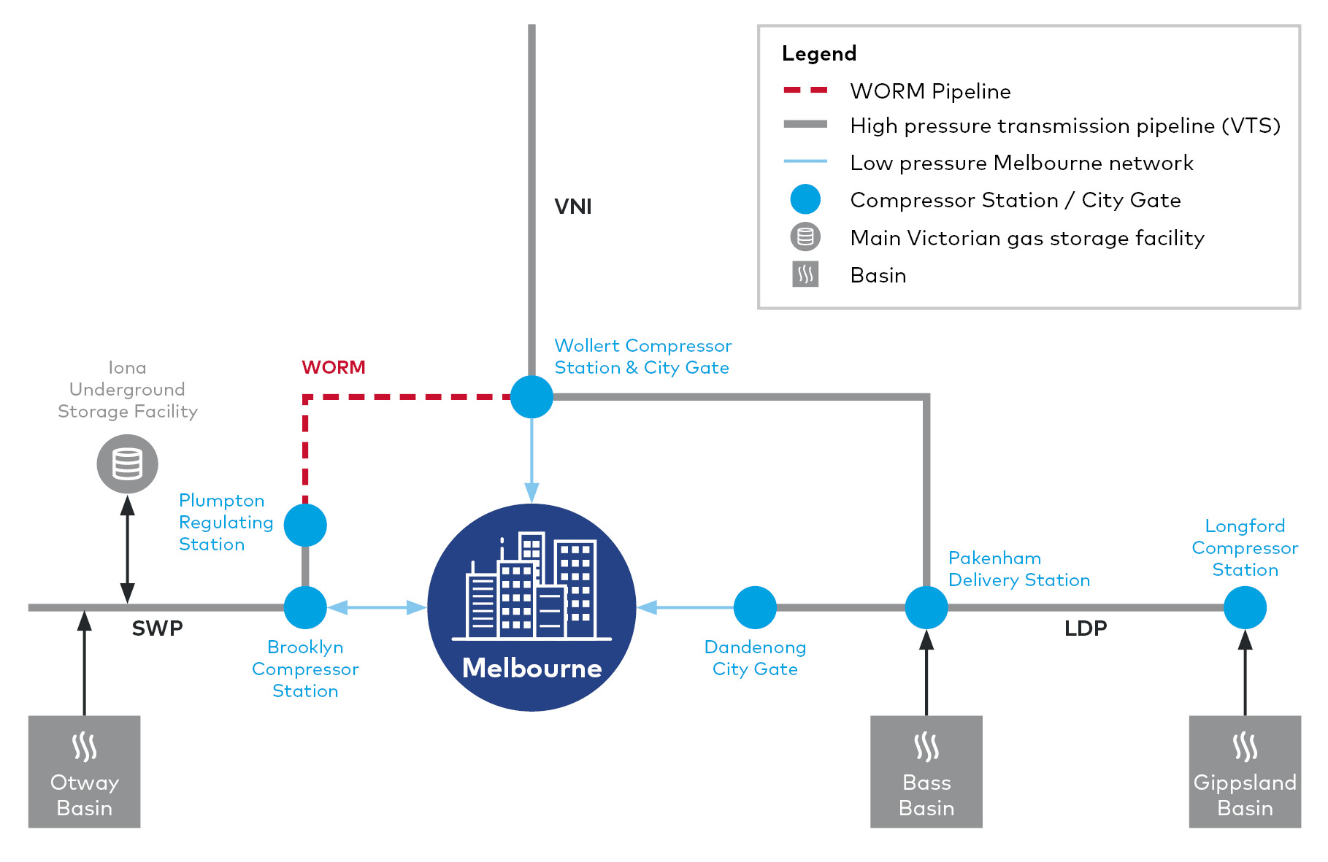

### Improved compression efficiency

To support the operational efficiency of the new high pressure pipeline once it is connected to the VTS, upgrades to the Wollert Compressor Station are also proposed as part of the Project.

The additional compressor and a regulating station proposed at Wollert would allow for increased volumes of gas (approximately an additional 100 Tj per day) to be compressed and transferred to the Iona UGS via WORM and then SWP.

This upgrade would require significantly less compression to achieve gas transfer to Iona UGS, compared with the current network arrangement, which depends on two or more compressor stations at Brooklyn. This efficiency significantly reduces power consumption, as well as compressor maintenance costs[24]. The saving in fuel gas used in compressors equates to a saving in greenhouse gas emissions from the network of approximately 10,700 tCO2-e a year[25].

### The Project's relationship to supply and demand

While the Project responds directly to a forecast tightening of the supply–demand balance of gas in Victoria, its wider purpose is to play a facilitative role in improving gas security by enhancing the operational efficiency of the existing gas transmission network which is a current supply constraint.

The Project would improve the transfer of gas volumes circulated around the state, increasing the efficiency with which gas can be transported to destinations including the Iona UGS, Victorian customers and export facilities when it is required.

The infrastructure upgrades proposed as part of the Project would not increase gas generation rates in Victoria; this would be the function of planned future gas supply projects. Similarly, the Project is not expected to influence gas demand in Victoria. Rather, the Project would enhance the network’s ability to meet existing and forecast demand requirements, both within Victoria and across south-east Australia more broadly, by improving the efficiency of transmission of the existing gas supply.

## Overview of Project benefits

The Project would provide critical infrastructure for Victoria’s gas supply, transmission and consequent security, efficiency and affordability. Key benefits would include:

* Improving Victoria’s gas network capacity and performance, allowing for greater volumes of gas to be efficiently transferred and stored. This would:
  + Increase energy security and resilience during peak demand periods by
    - Ensuring sufficient gas supply can be stored at the Iona UGS to address anticipated gas supply shortages in Victoria during times of peak demand
    - Reducing the chance of unplanned outages or ‘plant trips’ at major gas processing plants in Longford or Port Campbell, by better balancing of gas pressure across the western, northern and eastern parts of the network[26]
    - Providing assurance that surplus gas supply under gas contracts can be physically injected into the VTS, enabling gas contracts to be maintained
  + Increase capacity within the VTS, which would support future growth in Victoria in terms of gas supply, consumption, power generation and export volumes
* Gaining efficiencies in the operation and management of the VTS by
  + Allowing gas to flow interchangeably from the eastern and western parts of the gas network without the need for direct operator intervention, which is currently required at gas pressure transition points with the low pressure network
  + Improving operational efficiency in the network by adding an additional compressor unit at Wollert to increase capacity into the Iona UGS. This would require significantly less compression than the current arrangement and would save at least $3 million a year in fuel gas costs while also reducing compressor maintenance costs[27]
  + Reducing greenhouse gas emissions from the network by approximately 10,700 tCO2-e a year[28] as a result of operational efficiencies and reduced fuel requirements that would be achieved with the Project.

The project is expected to involve a capital investment estimated at $167.3 million (excluding GST), with the annual operating cost of the Project and the additional Wollert compressor estimated at $600,000.

The Project is expected to generate up to 500 jobs during the design, procurement, approvals and construction phases. The majority of the construction workforce would be specialists sourced from Victoria and interstate. A minimal incremental increase in APA’s existing operational workforce would be required for the operation phase.

1. AEMO (2021), Victorian Gas Planning Report March 2021, page 4.
2. AEMO (2021), Victorian Gas Planning Report, figure 8.
3. AEMO (2021), Victorian Gas Planning Report, page 18.
4. AEMO (2021), Victorian Gas Planning Report, page 25–26.
5. AEMO (2021), Victorian Gas Planning Report, figure 6.
6. DELWP Energy Website - <https://www.energy.vic.gov.au/about-energy/key-objectives>.
7. AEMO (2020), Victoria Gas Planning Report Update, page 6.
8. AEMO (2021), Victoria Gas Planning Report, page 3.
9. AEMO (2021), Victoria Gas Planning Report, page 3.
10. Victorian Renewable Energy Target – 2018-19 Progress Report, Table 1, page 7.
11. Department of Jobs, Precincts and Regions (2019), Statement of Future Uses of Brown Coal, <https://earthresources.vic.gov.au/__data/assets/pdf_file/0008/457361/Statement-on-future-uses-of-brown-coal.pdf>.
12. Ernst & Young (on behalf of the Department of Environment, Land, Water and Planning) (2017), Modelling of the Victorian renewable energy target scheme scenarios, Section 5 Modelling outcomes, <https://www.energy.vic.gov.au/__data/assets/pdf_file/0021/83091/EY-modelling-report-VRET.pdf>.
13. AER (2020), State of the Energy Market, page 43, <https://www.aer.gov.au/system/files/State%20of%20the%20energy%20market%202020%20-%20Full%20report%20A4.pdf>.
14. AER (2020), State of the Energy Market, page 37, <https://www.aer.gov.au/system/files/State%20of%20the%20energy%20market%202020%20-%20Full%20report%20A4.pdf>.
15. APA (2020) Climate Change Position Statement.
16. AER (2020), State of the Energy Market, figure 2.21, https://www.aer.gov.au/system/files/State%20of%20the%20energy%20market%202020%20-%20Full%20report%20A4.pdf. Note that as the Gas Import Jetty (Crib Point) project was not confirmed at March 2020, it does not form part of this reported new energy generation.
17. Victorian Government, Renewable Energy Action Plan, Action 18.
18. AEMO (2021), Victoria Gas Planning Report, figure 14.
19. AEMO (2021) Victorian Gas Planning Report, page 10.
20. AEMO (2021) Victorian Gas Planning Report update, page 87.
21. AEMO (2020) Victorian Gas Planning Report update, page 26.
22. AEMO (2021) Victorian Gas Planning Report, page 38.
23. AEMO (2021) Victorian Gas Planning Report, page 32.
24. APA WORM business case submission, page 9–10.
25. Fuel saving of $3 million reported in the APA WORM business case submission. With average price of natural gas in the previous 12 months of 6.18 per GJ equating to a saving of 485,437 GJ per annum. This equates to a saving of approximately 25,015tCO2-e per annum based on National Greenhouse Accounts emission factor for natural gas distributed in a pipeline.
26. APA WORM business case submission, page 9.
27. AEMO (2017) Submission to AER on the APA VTS Access Arrangement 2018–2022 – Western Outer Ring Main.
28. Refer footnote 25 for calculation of greenhouse emissions savings.