Chapter 16

# Social

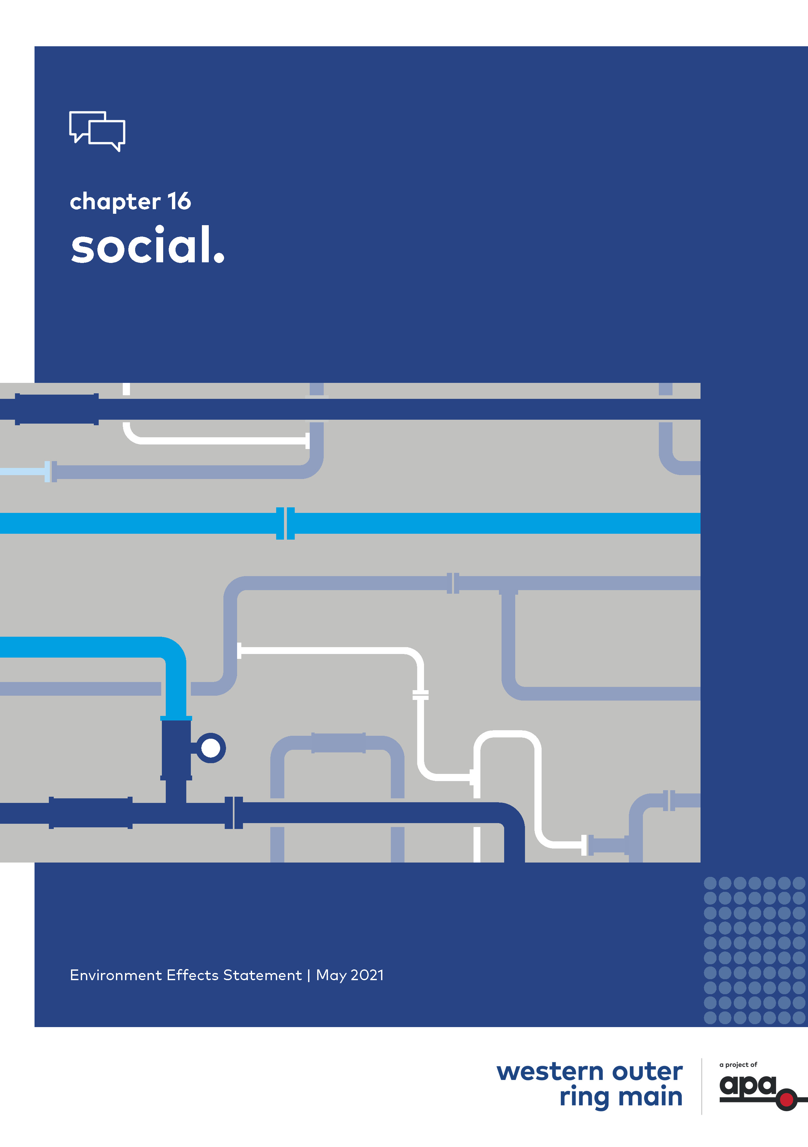

Contents

Chapter 16

16.1 Introduction 16-1

16.2 Method 16-2

16.3 Existing conditions 16-3

16.3.1 Local study area (within 1 km) 16-4

16.3.2 Regional study area (LGA areas) 16-5

16.4 Risk assessment 16-19

16.5 Construction impact assessment 16-22

16.5.1 Economic impacts (benefits) 16-23

16.5.2 Landholders and properties intersected by the Project 16-23

16.5.3 Residential amenity 16-26

16.5.4 Transport and access 16-30

16.5.5 Community infrastructure 16-30

16.5.6 Summary of residual construction impacts 16-33

16.6 Operation impact assessment 16-33

16.6.1 Economic impacts 16-33

16.6.2 Landholders and properties intersected by the Project 16-34

16.6.3 Residential amenity 16-35

16.6.4 Transport and access 16-36

16.6.5 Community infrastructure 16-36

16.6.6 Summary of residual operation impacts 16-36

16.7 Cumulative impact assessment 16-37

16.8 Environmental management 16-38

16.8.1 Environmental management measures 16-38

16.8.2 Monitoring 16-47

16.9 Conclusion 16-47

## Introduction

This chapter provides an assessment of the potential social impacts associated with the construction and operation of the Western Outer Ring Main gas pipeline project (the Project). This chapter is based on the impact assessment presented in Technical report L Social.

|  |  |
| --- | --- |
| The Project is located within a predominately rural environment which extends into planned residential developments in some locations. Within this context, the construction and operation of the Project has the potential to have social impacts on individuals and social groups in the area of the Project.  In line with the EES scoping requirements, the social impact assessment (SIA) sought to understand the potential social changes brought about by the construction and operation of the Project, and identify ways to enhance the positive impacts and avoid, minimise or manage the negative impacts on people and communities that may occur due to these changes. | What are social impacts and why are they important?   1. Social impacts are the experience (positive or negative) of a change from the Project to the social profile of individuals or groups. 2. Potential social changes brought about by the Project can include social changes to visual amenity and character of an area, and access and connectivity to an area. |

The EES scoping requirements set out the following evaluation objective relevant to the SIA:

* To minimise potential adverse social, economic, amenity and land use effects at local and regional scales.

The assessment focused on understanding community values, demographic characteristics and community infrastructure facilities to gain an understanding of the conditions in the Project area, then assess the potential effects on those social conditions as a result of the Project.

Other aspects closely related to the social impact evaluation objective include noise and vibration, air quality, landscape and visual, and land use impacts. These are addressed in the following reports and chapters:

* Technical report F and Chapter 12 Noise and vibration
* Technical report G and Chapter 11 Air quality
* Technical report J and Chapter 14 Landscape and visual
* Technical report K and Chapter 15 Land use.

This chapter provides an assessment of the social impacts of the Project on individuals and social groups.

## Method

The SIA consisted of the following key tasks:

* Review of relevant legislation and policy at a national, state and local level.
* Establishment of a study area to capture the areas subject to social-economic changes from the construction and operation of the Project. The study area is defined by two areas (refer Figure 16‑1):
  + The local study area made up of 137 parcels intersected by the Project's construction corridor and a surrounding buffer of approximately 1 km either side of the construction corridor. Community infrastructure facilities and dominant social features and values within proximity to the Project (1 km from Project) were identified, as these are considered to be potentially affected by changes in noise, air quality, visual amenity and land use.
  + The regional study area is the four local government areas (LGA) of Melton, Hume, Mitchell and Whittlesea within which the Project is located.
* Desktop assessment and baseline data review of a wide range of policies, databases, strategies and reports.
* Consultation for the purpose of the SIA was undertaken between August 2020 and December 2020. Given the COVID outbreak in Victoria at this time, all SIA consultation meetings were held via telephone or online. Consultation was undertaken with council representatives, Victoria Police, environmental groups associated with creeks which identify as community infrastructure facilities, and a selection of landholders who either reside, lease or own parcels intersected by the Project. The selection of stakeholders and landholders was based on their characteristics, including geographic spread and land use. Six representative landholders were consulted to inform the SIA. More broadly, APA is engaging with all landholders, as well as local residents, councils, interest groups and communities as detailed in EES Chapter 6 – Project communications and community engagement and the Environment Effects Statement Consultation Plan. The outcomes of that engagement undertaken during the preparation of the SIA has also informed the SIA.
* Characterisation of existing conditions within the social area:
  + Local study area: land use and key features, amenity and character, and access and connectivity to the area
  + Regional study area: regional profile, community values, demographic characteristics, employment and training, potentially vulnerable populations and community infrastructure facilities.
* A risk-based assessment of potential impacts to prioritise the focus of the SIA that is consistent with Australian/New Zealand Standard AS/NZS ISO 31000:2018 Risk Management Process.
* The impact assessment then focused on the key risks and/or where additional management or mitigation measures may be required or beneficial. The impact assessment focused on four themes:
  + Landholders and properties intersected by the Project
  + Residential amenity and character
  + Transport and access
  + Community infrastructure facilities.
* Impacts were assessed based on significant criteria developed for the SIA which consider the sensitivity of the existing conditions and values to change, and the intensity, duration and likelihood of the change. The impact significance criteria are set out in Table 16‑1.
* Development of Environmental Management Measures (EMMs) in response to the SIA. Refer to Chapter 19 Environmental management framework and Section 10 of Technical report L Social for the full list of EMMs.
* Assessment of the residual impacts of the Project assuming implementation of the environmental management measures.
* Specifying the monitoring required to evaluate whether the Project meets the environmental management measures and detailing contingency measures as required.

Table 16‑1 Social impact significance criteria

|  |  |  |
| --- | --- | --- |
| 1. Level of significance | 1. Landholders and properties intersected by the Project, residential amenity and character, transport and access | 1. Community facilities |
| 1. Insignificant | 1. Short term1 or minimal impact easily reversible adverse change where those affected could be expected to easily adapt or cope. | 1. No change to access or usage of a recreational or community facility. |
| 1. Minor | 1. Reversible adverse change where those affected could be expected to have substantial capacity to adapt or cope. | 1. Minor (short term or minimal impact) reduction to access or usage of a recreational or community facility. |
| 1. Moderate | 1. Adverse change where those affected could be expected to have some capacity to adapt or cope. | 1. Moderate reduction to access or usage of a recreational or community facility. |
| 1. Major | 1. Irreversible change at a Project level where those affected could be expected to have limited capacity to adapt or cope. | 1. Permanent major reduction to access or usage of a recreational or community facility of regional significance. |
| 1. Severe | 1. Irreversible change at a regional level where an extended population is affected which could be expected to have little or no capacity to adapt or cope. | 1. Permanent complete loss of a recreational or community facility of State significance. |

1 Short term is considered to be less than six months.

## Existing conditions

The following sections outline the existing conditions of the Project study area in relation to social characteristics of the community. The social characteristics were assessed with the following focus:

* Local study area: understanding land use and key features, amenity and character, and access and connectivity to the area
* Regional study area: understanding community values, demographic characteristics, and community infrastructure facilities.

Figure 16‑1 Social study area

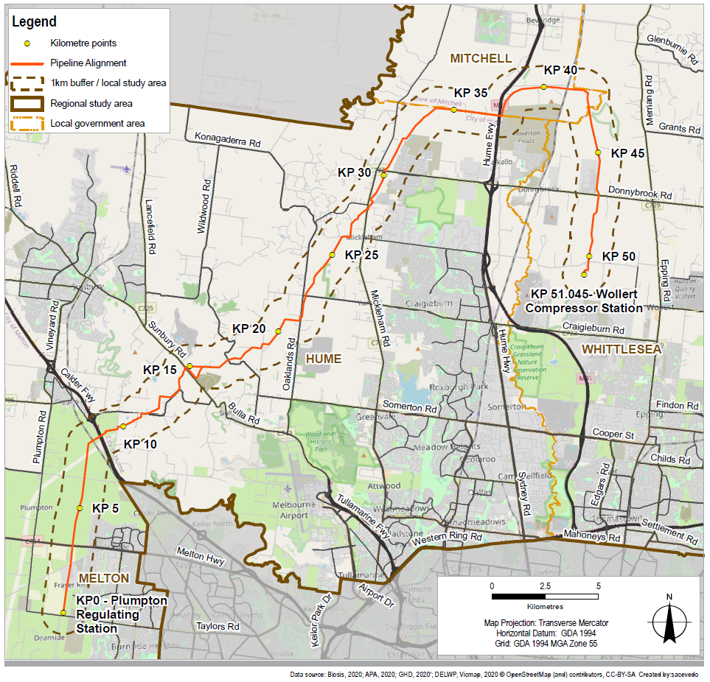

### Local study area (within 1 km)

The Project intersects 137 parcels of land through the areas of Melton, Hume, Mitchell, and Whittlesea with 85 unique landowners. The land intersected by the Project is predominantly located within the Green Wedge, Farming, and Rural Conservation zones (119.4 ha), with the remainder of the construction corridor located within the Urban Growth Zone (53.9 ha), Public Use Zone (7.8 ha), Road Zone (1.6 ha) and Special Use Zone (0.2 ha).

|  |  |
| --- | --- |
| Given the dominance of zones that support rural uses, the majority of parcels (75 of the 137 parcels) that the Project intersects are rural residential or agricultural parcels. These parcels vary in intensity of use and type of agricultural activity, including established cropping and grazing businesses and equestrian training or breeding. The majority of agricultural parcels intersected by the Project would more appropriately be classified as hobby farms with small herds of cattle or sheep or market gardens (City of Hume Council Plan 2017-2020[1]). These properties are often not the primary source of income for landholders and users of the property, but may supplement income, or contribute more broadly to people’s lifestyle. | What is a green wedge?   1. A green wedge is a non-urban area of metropolitan Melbourne that is outside of the urban growth boundary and is protected by zoning that restricts uses to agriculture and other lower-density uses such as infrastructure, quarries, and environmental conservation areas. 2. These areas provide opportunities for the community to connect with the natural environment, in addition to hosting extractive resources (for example, sand and stone) that are important for Melbourne’s future growth. |

Forty-five parcels of land host current residents and two parcels of land host places of worship. Similar to broader practices in Melbourne’s Green Wedge (City of Hume Council Plan 2017-2020), 43 parcels of land intersected by the Project have no current residents and for 49 parcels this is not applicable (for example road parcels). The exception to the rural residential and agricultural parcels is emerging growth areas in Plumpton and Mickleham, which are characterised by new residential development or paddocks zoned for future urban development. The Project intersects 12 parcels of land that are being converted into residential development or are understood to be future residential development parcels. Eleven of the 39 parcels that are currently used for agriculture are understood to have either been sold to residential developers or developers have a registered interest. It is also noted that there are two sections of the alignment located within an existing APA easement between KP 0 – KP 9 and between KP 42 – KP 51.

Reflecting the predominantly rural-residential and agricultural land uses in the local study area, amenity and character in much of the area is characterised by single storey rural residences with farm buildings featured in natural and agricultural landscapes. Where the local study area is located in established or emerging residential areas, built form predominantly features detached residential development. Amenity and character are discussed further according to each local government area (LGA), also referred to as municipalities, in Section 16.3.2 and in Technical report J – Landscape and visual.

There are 19 roads that are intersected by the alignment, along with the Hume Freeway at the northern end of the alignment and Calder Highway at the southern section of the alignment. The Project traverses land in current and future Precinct Structure Plans (PSPs) which provide for future change to land use or community infrastructure. Chapter 15 and Technical report K Land use provides further discussion of current and future land use within the local study area.

### Regional study area (LGA areas)

The following sections provides a summary of the area's regional significance, as detailed in Plan Melbourne 2017–2050. They describe the social characteristics of each LGA, focusing on community values, demographic characteristics, potentially vulnerable populations and community infrastructure facilities.

#### Regional profile

The SIA has drawn on the Victorian Government's metropolitan strategy Plan Melbourne 2017–2050 to identify regionally relevant land use, infrastructure and the potential for regional impacts. *Plan Melbourne* identifies places of state significance that will be the focus for investment and growth, alongside areas that will support Melbourne’s growth to 2050. The regional study area has been assessed against the places of significance identified in Plan Melbourne:

|  |  |
| --- | --- |
| * No health and education precincts are intersected by the Project alignment or the local or regional study areas * No metropolitan activity centres are intersected by the Project alignment, however, there are five centres (Lockerbie, Beveridge, Mickleham, Sunbury South and Plumpton) which are located within a 2 km radius of the Project alignment | What is a Metropolitan Activity Centre?   1. A Metropolitan Activity Centre acts as an employment, housing and service centre for regional catchments. |

* Portions of the Northern State Industrial Precinct are located near the Project alignment and local and regional study areas. This Precinct is not registered as a current industrial land use under Plan Melbourne but is identified for future industrial development.

There are growth areas to the north of Hume, Mitchell and Whittlesea. Growth areas have at least 25 years supply of greenfield residential land with around 15 years’ land supply that is either zoned or has a Precinct Structure Plan and is therefore ‘development ready’. In Hume and Melton, there are green wedge areas which are to support and host Melbourne’s food production, critical infrastructure, recreation and tourism.

More broadly, the LGAs are characterised by population growth. Despite this, rural landscapes predominate in much of these LGAs, and are valued by the community.

#### Community values

This section provides a description of the community values for each LGA, with a focus on those features closer to the Project alignment. Community values that are relevant to the social assessment include land use and key features, amenity and character, and connectivity.

##### Melton LGA (KP 0 to KP 8.8)

The City of Melton (Melton) features a mixture of urban and industrial areas, particularly in the south-east and west, centred around Melton. It also features large areas of rural, agricultural and natural landscapes, an example of which is shown in Figure 16‑2. These areas are valued as open rural landscapes that provide for rural lifestyles (Western Plains North Green Wedge Management Plan [2]).

Figure 16‑2 View north across flat to gently undulating farmland from Taylors Road, Plumpton

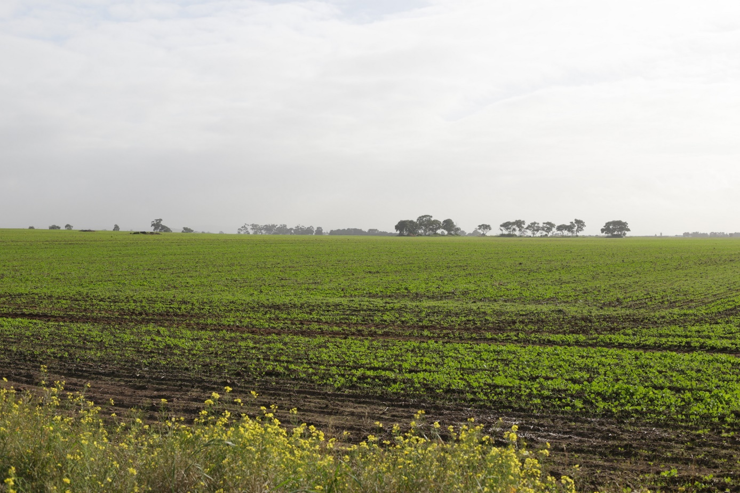

Melton contains large areas of Melbourne’s Green Wedge, to the north, south and west. Melton also contains established urban areas, which include the Metropolitan Activity Centres of Melton in the west and Caroline Springs in the east, and growth areas which include the Metropolitan Activity Centres of Plumpton, Rockbank North, Rockbank, Hopkins Road, and Toolern, and the small townships of Caroline Springs, Diggers Rest, Rockbank and Toolern Vale.

The southern end of the construction corridor traverses land classified as the eastern plains, which provide for expansive rural vistas. The Project traverses the Western Plains North Green Wedge, located in the north-east of Melton and rural land located within the growth area, earmarked for residential development. Part of the Project is located within Plumpton, within the existing APA easement where the Project would be located. The easement is identified in the Plumpton Precinct Structure Plan, where the easement is identified as linear open space including plans for a shared use path.

The traditional custodians of the City of Melton are the Kulin Nation.

The road network in Melton includes primary north-south routes and primary east-west routes including Western Freeway and Melton Highway. Traffic and transport infrastructure and management are a priority for council (Melton Advocacy Priorities[3]), with traffic raised as an issue for around one quarter of respondents to the 2019 Annual Community Satisfaction Survey.

Public transport between Melton and metropolitan Melbourne is primarily provided by the Melton metropolitan train line. Melton has a lower rate of public transport use than Greater Melbourne, with 10.1 per cent of residents travelling to work by public transport, compared to 16.3 per cent in Greater Melbourne (2016 Census). No off-road trails for cyclists and pedestrians are located in proximity to the Project.

##### Hume LGA (KP 8.8 to KP 37.2)

The City of Hume (Hume) is located approximately 15 km north of the Melbourne CBD. Hume is characterised by established suburbs in the south-east, developing residential suburbs (collectively referred to as the Hume Corridor) in the north-east and the Sunbury township in the north-west. Hume hosts the Melbourne International Airport. Hume has a number of Metropolitan Activity Centres including three that are located within 2 km of the Project alignment: Lockerbie (~1.9 km), Mickleham (~1 km) and Sunbury South (1.5 km).

Hume contains a rich natural heritage, with key features including creeks, escarpments and hill tops. Although farming was a historically dominant activity, it has declined in the green wedge due to a range of factors, including poor quality of soil, low levels of rainfall, and an ageing population (City of Hume Council Plan 2017-2020).

The Project traverses land located between the Hume Corridor and Sunbury, which is predominantly rural land, zoned within Melbourne’s Green Wedge, and is valued as a distinct rural landscape (City of Hume Council Plan 2017-2020) (Figure 16‑3). The Project alignment is also located adjacent to some urban residential developments, including Merrifield (within Mickleham) which has recently been developed (Figure 16‑4), and areas earmarked for future residential development, including Lindum Vale and Cloverton Estate.

Figure 16‑3 View east of a dwelling on Duncans Lane, Diggers Rest

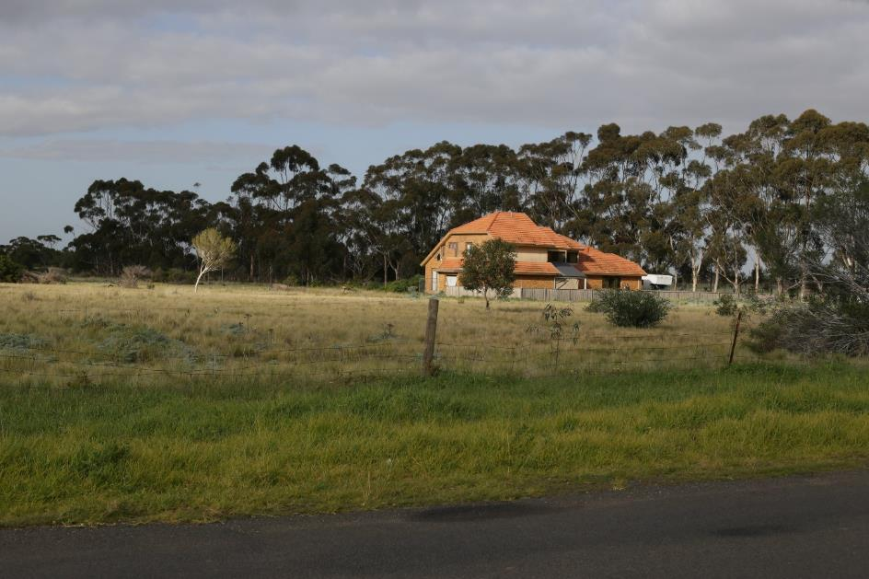

Figure 16‑4 View south-west of dwellings along Inkerman Crescent, Mickleham

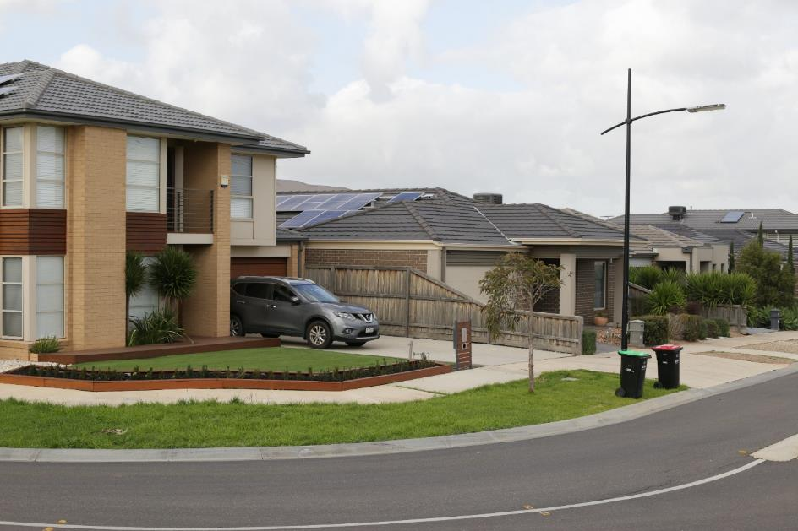

The traditional custodians of the City of Hume are the Wurundjeri Woi Wurrung peoples, which includes the Gunung Willam Balluk clan.

The road network in Hume includes a number of primary north-south routes including the Hume Freeway and a number of primary east-west routes. The City of Hume’s Draft Rural Strategy notes that there is community concern about the impact of urban growth on the rural road network, which could potentially result in conflict between different road users (for example, cyclists, drivers, and agricultural road users). However, modelling undertaken by Council found that the rural road network does have the capacity to support rural and nearby communities (City of Hume Council Plan 2017–2020).

The City of Hume is serviced by the Craigieburn and Sunbury lines. Hume had a lower rate of public transport usage than Greater Melbourne in 2016, with 10.4 per cent of residents travelling to work by public transport, compared to 16.3 per cent in Greater Melbourne.

##### Mitchell LGA (KP 37.2 to KP 42.9)

Mitchell Shire (Mitchell) includes a number of historic and developing townships with rural and agricultural land, and significant natural landscapes, including the Goulburn River. Mitchell features a diversity of landscapes, from steep to rolling hills, volcanic plains, and floodplains association with major rivers and creeks (Mitchell Planning Scheme). Mitchell has two Metropolitan Activity Centres, Beveridge and Wallan, which are both located in Melbourne’s northern growth corridor. Beveridge is located approximately 1.7 km from the Project.

The Project traverses a small portion of land to the south-eastern corner of Mitchell, intersecting predominantly agricultural land which features typical rural landscapes. The area the Project traverses is subject to the Lockerbie North Precinct Structure Plan which identifies the area to be developed as an additional and complementary urban area to the Beveridge township. However, the area close to the construction corridor is not expected to be developed for some time.

The traditional custodians of the Mitchell Shire are the Taungurung and Wurundjeri peoples.

The road network in the Shire includes a number of primary east-west routes and primary north-south routes including the Northern Highway, Goulburn Valley Freeway, and Hume Freeway. Public transport between the urban areas in the Mitchell Shire and metropolitan Melbourne is primarily provided by the North East rail line. However, public transport accessibility and connections from Mitchell Shire to metropolitan Melbourne is considered to be a liveability issue for residents[4]. As a consequence, Mitchell has a lower rate of public transport usage than Greater Melbourne, with only 5.2 per cent of residents travelling to work by public transport, compared to 16.3 per cent in Greater Melbourne.

##### Whittlesea LGA (KP 42.9 to KP 51)

The City of Whittlesea (Whittlesea) is located in the northern suburbs of Melbourne, containing a number of townships. Whittlesea is on the land of the Wurundjeri Willum Clan.

Over 32,000 hectares of Whittlesea is rural land, equating to around 70 per cent of Whittlesea's area. Much of this rural land is located in the northern part of the municipality, where it is part of the green wedge, supporting agricultural production, conservation and biodiversity areas and rural living (Whittlesea Green Wedge Management Plan[5]). Whittlesea is largely characterised by a mixture of high growth urban areas, alongside significant agricultural and natural landscape, and heritage places.

The Whittlesea Hills (Eden Hills sub-area) is a distinctive rural land character area (Whittlesea Planning Scheme) that features light wooded rolling hills and open pastures (Figure 16‑5). Epping Central is the City’s established Metropolitan Activity Centre with a range of commercial, service and infrastructure assets.

The Project intersects a small portion of land to the west of the municipality, being the suburbs of Beveridge and the western part of Donnybrook. These suburbs are predominantly rural although small areas of urban development are emerging or identified for future development, including the Donnybrook-Woodside Precinct.

The road network in Whittlesea includes a number of primary north-south routes including the Hume Freeway and a number of primary east-west routes including the M80 Ring Road. According to Council, the road network capacity is constrained and challenged (Whittlesea Planning Scheme). Traffic management was one of the top three issues raised by 43.4 per cent of respondents to the 2018 Community Attitudes and Liveability Survey[6].

Public transport between the urban areas in the south of Whittlesea and metropolitan Melbourne is primarily provided by the Mernda rail line. The North East rail line also runs through Whittlesea and includes Donnybrook Station located close to the Project alignment. Whittlesea has a lower rate of public transport usage than Greater Melbourne, with 11 per cent of residents travelling to work by public transport, compared to 16.3 per cent in Greater Melbourne.

Figure 16‑5 View south-west along the Project alignment from Wildwood Road

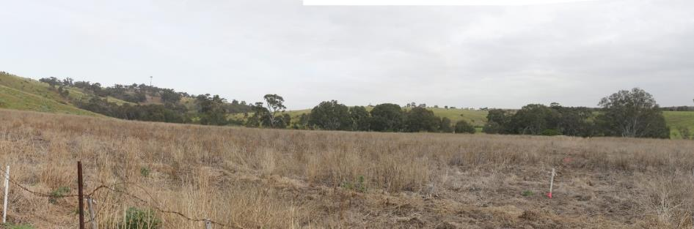

#### Demographic characteristics

This section details the key demographic indicators relevant for understanding the Project's social impacts. These include:

* Population trends and projections
* Cultural diversity and proficiency in spoken English
* Employment and training profile
* Profile of potentially vulnerable populations.

##### Population trends and projections

Each LGA in the regional study area has experienced population growth between 2009 and 2019 at a higher rate than those in Greater Melbourne and Victoria overall. The regional study area contains large portions of Greater Melbourne’s growth areas and therefore, the regional study area is expected to cater for considerable population growth between 2018 and 2036. Table 16‑2 sets out recent and projected populate growth.

Table 16‑2 Population trends and projections, 2019

|  |  |  |
| --- | --- | --- |
| LGA | Population increase between 2009 and 2019 | Projected population increase between 2018 and 2036 |
| 1. Melton | 1. 65.0% | 1. 111.9% |
| 1. Hume | 1. 40.0% | 1. 53.3% |
| 1. Mitchell | 1. 40.1% | 1. 120.5% |
| 1. Whittlesea | 1. 58.3% | 1. 63.2% |
| 1. Greater Melbourne | 1. 13.3% | 1. 37.8% |

##### Cultural and ethnic diversity and proficiency in English[7]

Small populations of people in the regional study area stated that they were Indigenous in the 2016 Census, generally in line with the State proportion of Indigenous people at 0.8 per cent and slightly higher than that of Greater Melbourne (0.5 per cent). The exception to this was Mitchell, where 1.6 per cent of the population identified as Indigenous at the 2016 Census.

A large proportion of the population of the regional study area were born overseas, generally consistent with Greater Melbourne (40.2 per cent) although Melton (36.5 per cent) and Mitchell (20.9 per cent) have a lower percentage born overseas than Greater Melbourne.

In Hume (44.9 per cent) and Whittlesea (44 per cent) almost half of the population stated that a language other than English was spoken at home. This compares with Melton and Greater Melbourne where almost a third (32.3 per cent) of the population stated that a language other than English was spoken at home. In Mitchell this is less common, with only 7.2 per cent stating that a language other than English is spoken at home.

##### Employment and training profile

An employment and training profile was established through a review of the latest unemployment data and 2016 Census data for dominant industries of employment and highest level of educational attainment.

For all LGAs, restrictions to slow the spread of COVID-19 have resulted in ‘unprecedented interventions in the labour market’[8] and an increase in unemployment from March 2020 through to October 2020 for Greater Melbourne[9]. However, at the time of writing, recent unemployment data, particularly at the LGA level had not been released by the Australian Government.

Year 12 is predominantly the highest level of educational attainment across the LGAs, with the exception of Mitchell where the predominant highest level of attainment is Certificate III/IV. The most dominant industry of employment across all LGAs is healthcare and social assistance. Other dominant industries include retail trade (Melton, Hume and Whittlesea), transport, postal and warehousing (Melton and Hume), and construction (Mitchell and Whittlesea).

##### Potentially vulnerable populations

Vulnerability relates to how a group will be impacted by a change due to their sensitivity to change and their ability to adapt to change.

The Index of Relative Socio-Economic Disadvantage (IRSD) summarises information about the socio-economic conditions of people and households within an area. The IRSD includes a range of data points, including income, education, employment, occupation, and housing. The IRSD divides a population of the state into ten equal groups. The lowest scoring 10 percent of these groups are given a decile number of 1, which indicates the highest level of disadvantage, and the highest scoring 10 percent of areas are given a decile of 10, which indicates the lowest level of disadvantage.

Relative disadvantage ranges from low to high across the LGAs with a range from decile 3 to 8 closer to the Project as shown in Figure 16‑6.

Across the four LGAs, Melton and Mitchell had 4.9 per cent of the population have 'profound or severe core activity limitations' and require assistance with daily tasks, which is in line with Greater Melbourne (4.9 per cent). Whittlesea (5.7 per cent) and Hume (6.3 per cent) had slightly higher populations of people with 'profound or severe core activity limitations' who require assistance with daily tasks,

Figure 16‑6 Socio-economic Index for Disadvantage, 2016

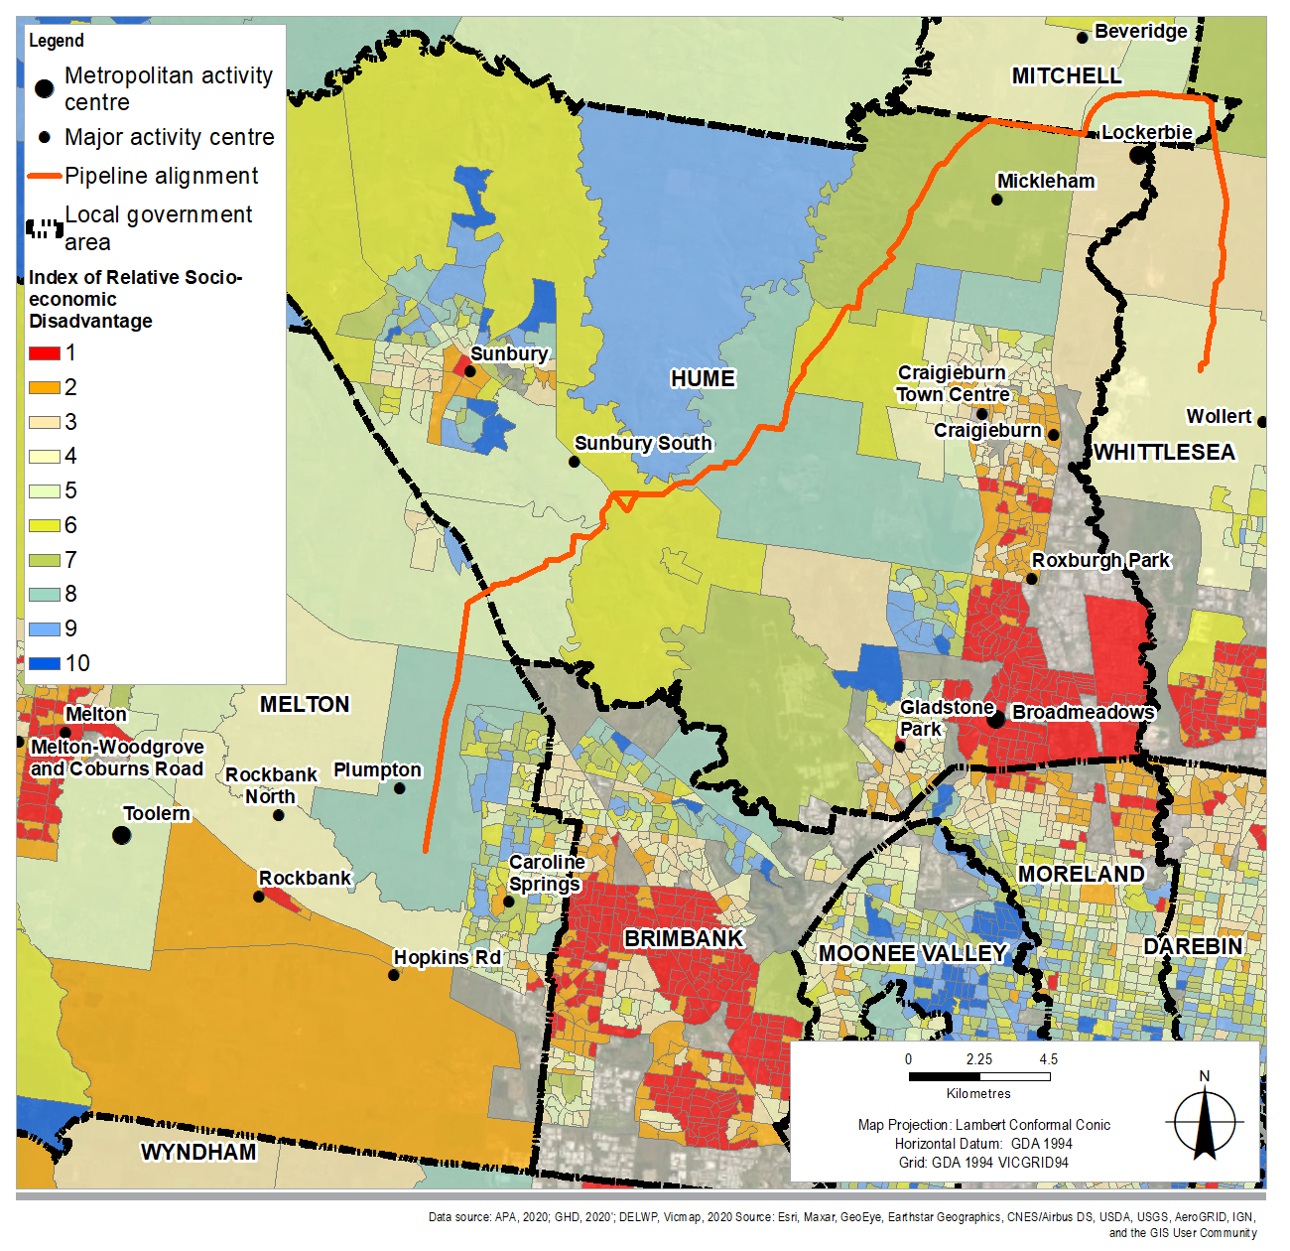

The regional study area hosts large areas of Melbourne's growth areas, which have a tendency to attract younger families. As a consequence, all LGAs profiled have a higher proportion of children under 15 years and smaller proportions of people aged above 65 years than that of Greater Melbourne and Victoria overall.

#### Community infrastructure facilities

Community infrastructure facilities (facilities) located in the local study area (1 km buffer of the Project alignment) that may be impacted by the Project’s activities include:

* Open space and natural areas that have high amenity values and provide for passive recreation opportunities
* Small parks and linear reserves that service residential catchments in urban growth areas
* Cultural facilities such as places of worship and community centres
* Educational and early childcare facilities.

There are a total of 13 facilities located within 500 metres of the Project:

* Melton municipality has one facility (natural drainage space that is a tributary of Kororoit Creek)
* Hume municipality has eight facilities, being the Cao Dai Temple of Victoria and seven open space and natural areas, including Jacksons Creek, Deep Creek and Emu Creek
* Mitchell municipality has two facilities (Merri Creek and Broadhanger Equestrian)
* Whittlesea municipality has two creeks (Darebin Creek and Curly Sedge Creek).

Some of the creeks are noted to have considerable environmental, visual amenity and cultural (Indigenous and non-Indigenous), recreational and biodiversity values for their local areas but may not be publicly accessible at the location where the Project intercepts them.

There are a total of 19 facilities located between 500 metres and 1 km from the Project. They are:

* Melton has ten facilities including reserves, gardens, parks and bike paths
* Hume has nine facilities including a sports club, place of worship, community centre, three education and early childhood facilities and three open space and natural areas.

The following figures illustrate the community infrastructure facilities within a 1 km buffer for each LGA. In addition, the following key community infrastructure is located outside the 1 km study area, with their catchment intercepted by the Project:

* Two hospitals located at 8.7 km and 10.3 km from the Project
* Police services, Country Fire Service (CFA) service and ambulance services within each LGA.

Figure 16‑7 Melton community infrastructure facilities within 1 km of the Project

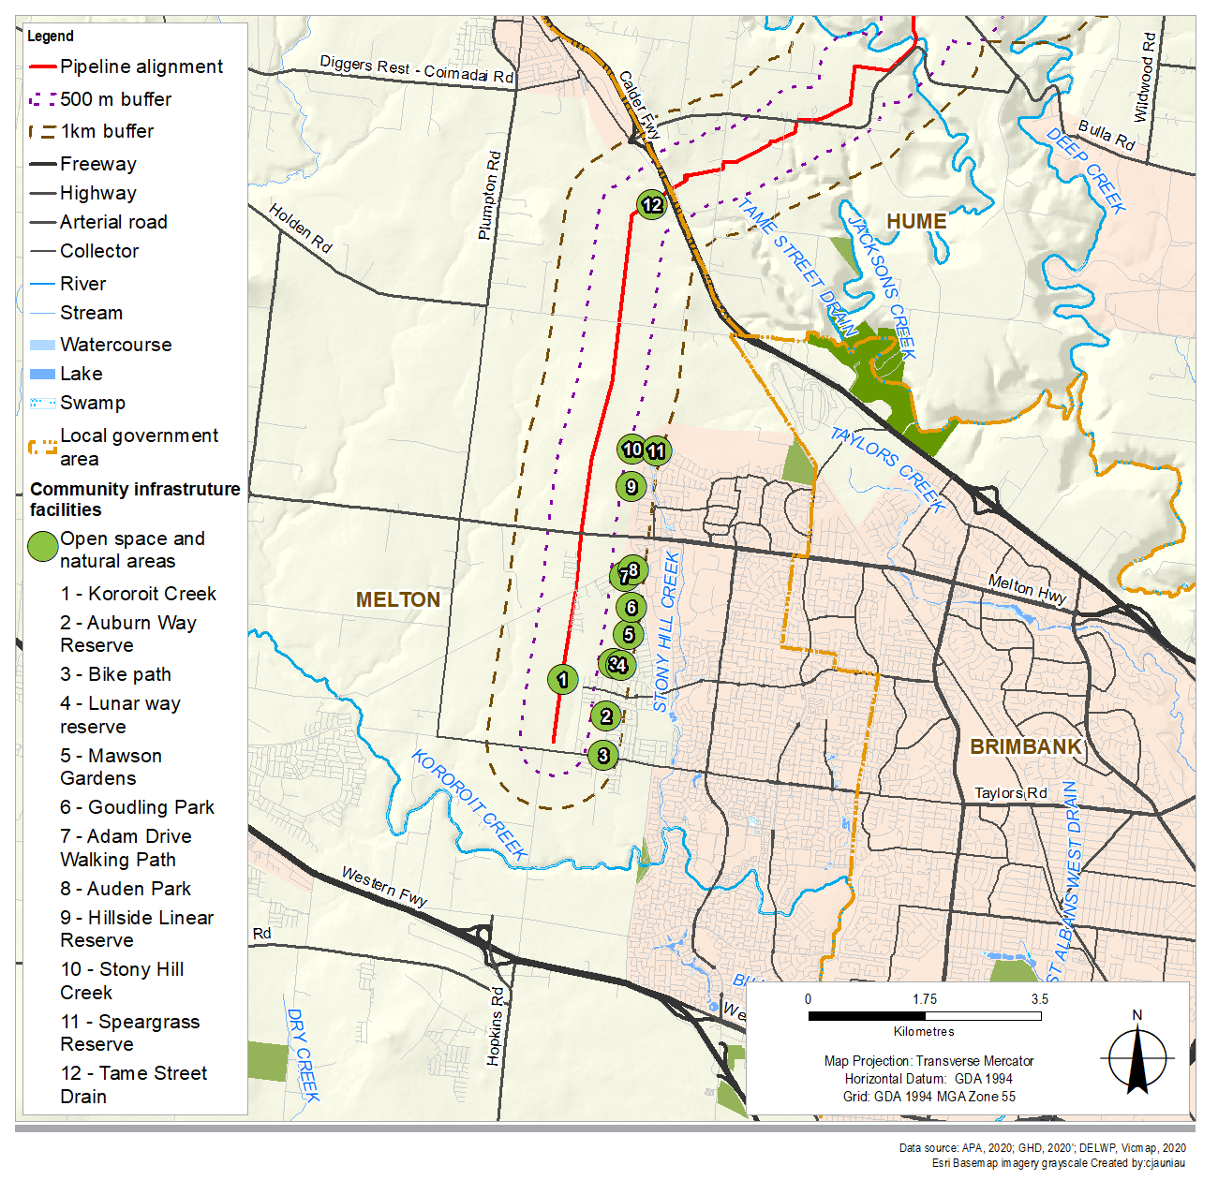

Figure 16‑8 Hume community infrastructure facilities within 1 km of the Project (Part 1)

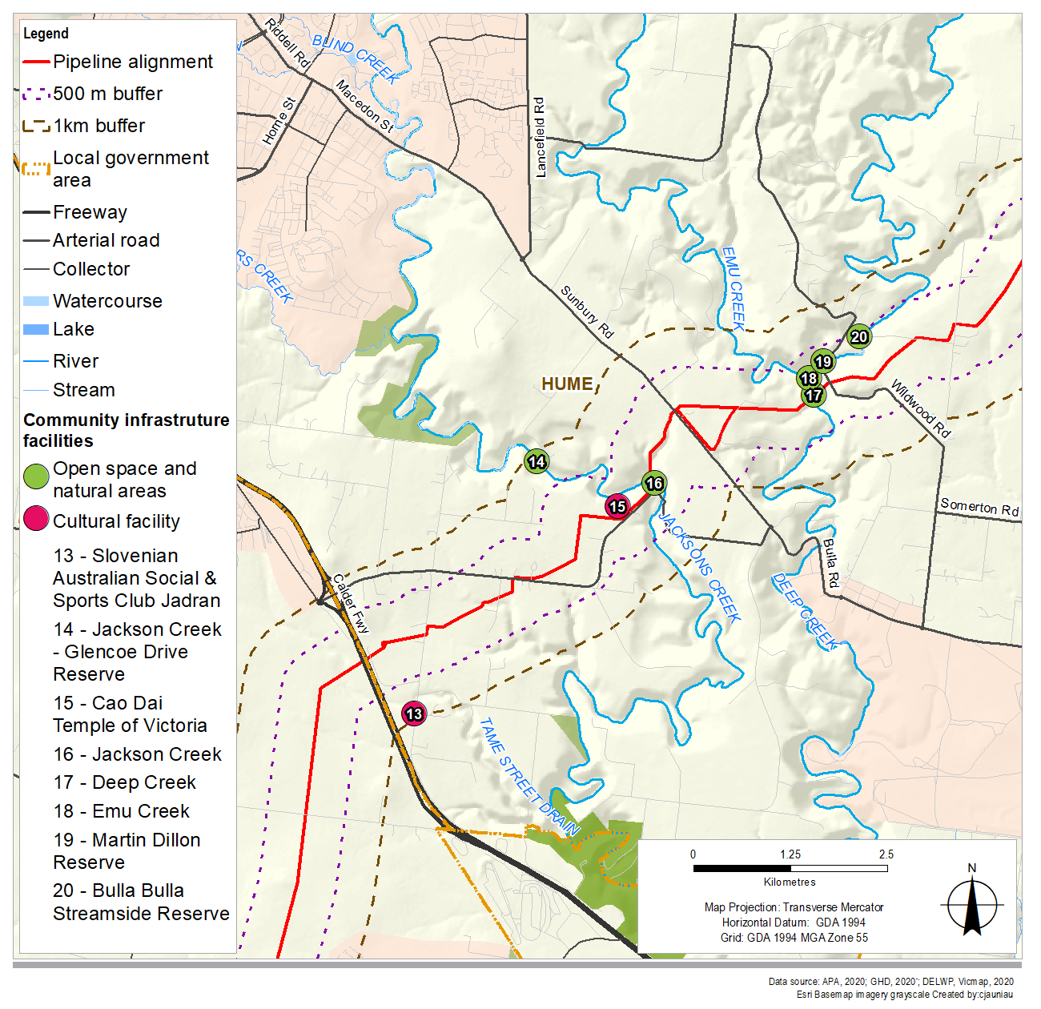

Figure 16‑9 Hume community infrastructure facilities within 1 km of the Project (Part 2)

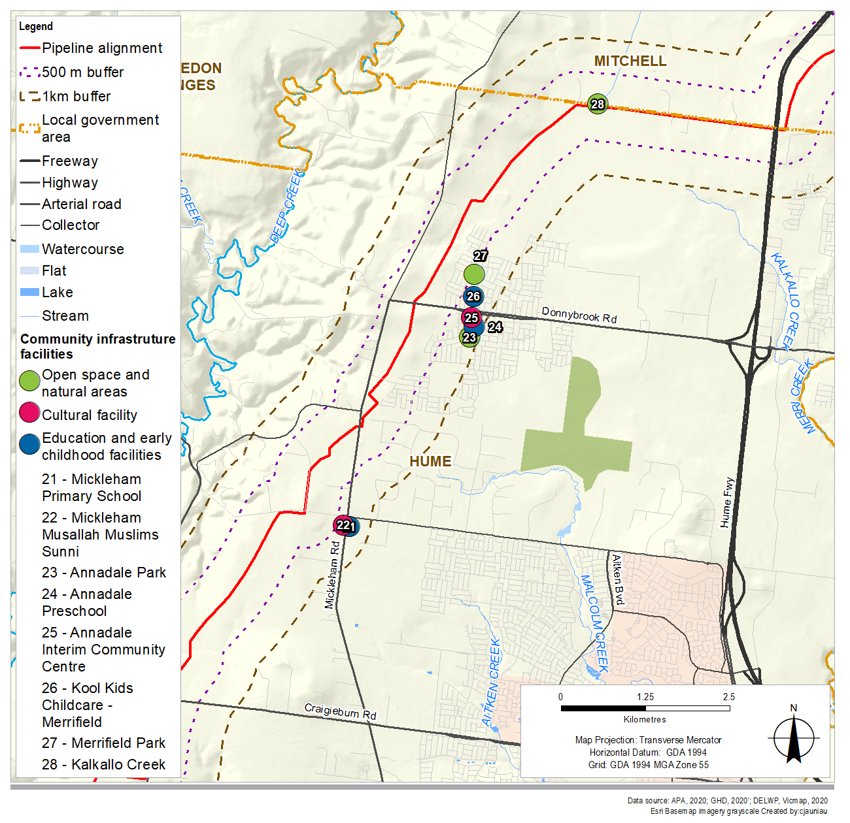

Figure 16‑10 Mitchell community infrastructure facilities within 1 km of the Project

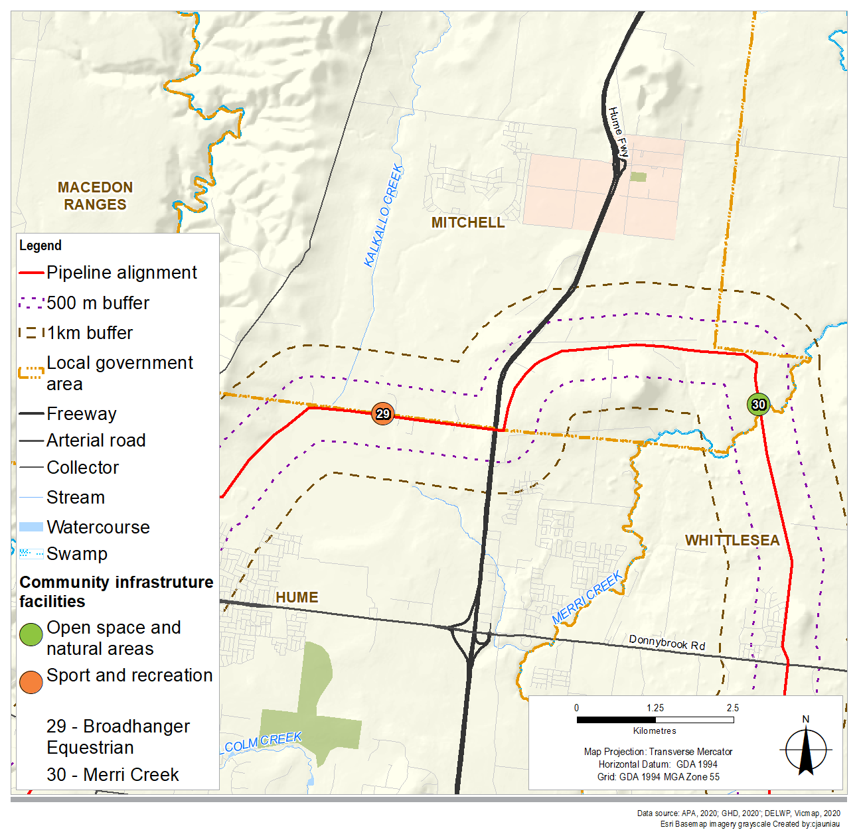

Figure 16‑11 Whittlesea community infrastructure facilities within 1 km of the Project

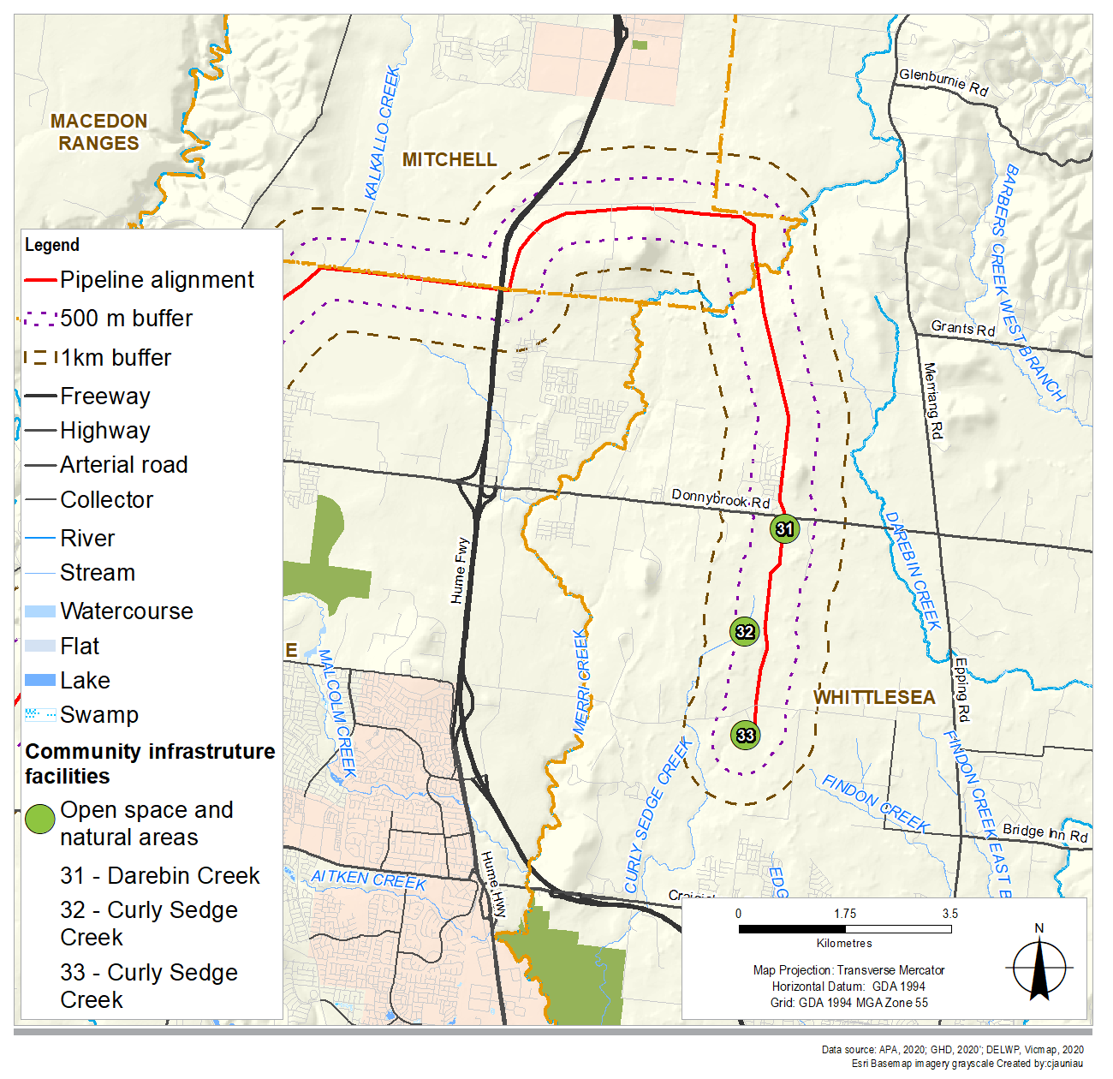

## Risk assessment

The risk assessment identified the risks for social impacts as a result of the Project's construction and operation and guided the assessment of social impacts. Other technical chapters, such as *Noise* and vibration (Chapter 12) and *Air quality* (Chapter 11) assess risks to the environment of excessive noise or dust, while the social assessment considers the risk of change to social values as a result of those changes in amenity. The risk assessment identified and assessed five construction risks and one operation risk. Two of the construction risks were identified to have a medium risk rating.

These risks were concerned with the temporary changes to amenity for residents and the community (S1) and community facilities and recreation areas (S3) as a result of the Project’s construction activities. The initial medium risk rating reflects the potential for the changes in amenity to result in changes to people’s day to day lives, such as the temporary reduction in use of backyards (S1) or temporary reduction in use of community facilities (S3).

Other risks were assessed to have a low risk rating. All risks identified during the risk assessment were considered in the impact assessment.

A summary of the risk assessment results for social impacts is presented in Table 16‑3. Table 16‑5 identifies the environmental management measures proposed to address social impacts. Other chapters and technical reports also assess relevant risks and mitigation measures for those two construction risks with medium risk ratings:

* Technical report F and Chapter 12 Noise and vibration
* Technical report G and Chapter 11 Air quality
* Technical report J and Chapter 14 Landscape and visual
* Technical report K and Chapter 15 Land use
* Chapter 19 Environmental management framework.

Table 16‑3 Risk assessment of social impacts

|  |  |  |  |  |  |  |
| --- | --- | --- | --- | --- | --- | --- |
| 1. Risk ID | 1. Works area 2. (Pipeline/ MLV/ Compressor) | 1. Risk pathway | 1. Initial mitigation measures | 1. Initial risk rating | 1. Additional mitigation measures | 1. Residual risk rating |
| 1. Construction | | | | | | |
| 1. S1 | 1. All | 1. Temporary construction social impacts on amenity values for residents located close to the alignment. Impacts could include noise, vibration and dust emissions. | 1. Standard construction management measures as outlined in noise, air quality, landscape and visual and land use chapters incorporated into the approved Construction Environmental Management Plan: EMMs AQ1, AQ3, AQ4, B7, LV1, LV2, LV5, NV1, NV2, NV3, NV4, NV5. NV6, NV7. | 1. Medium | 1. Additional measures as per other technical chapters and reports:  * Noise and vibration * Air quality * Landscape and visual * Land use.   Engage with affected stakeholders on timing and nature of the Project’s activities and potential impacts (EMM S6). | 1. Low |
| 1. S2 | 1. Pipeline | 1. Property damage (caused by construction activities, which could impact agri-business and reduce property productivity). | 1. Relevant elements of existing property specific biosecurity plans which landholders operate under. | 1. Low | 1. No additional measure identified. | 1. Low |
| 1. S3 | 1. All | 1. Temporary construction impacts on amenity values for community facilities and recreation areas. Temporary impacts could include noise, vibration, visual change and dust emissions which could impact social values. | 1. Standard construction management measures as outlined in noise, air quality, landscape and visual and land use chapter incorporated into the approved Construction Environmental Management Plan: EMMs AQ1, AQ3, AQ4, B7, LV1, LV2, LV5, NV1, NV2, NV3, NV4, NV5. NV6, NV7. | 1. Medium | 1. Additional measures as per:  * Noise and vibration * Air quality * Landscape and visual * Land use.  1. Engage with facility managers on timing and nature of the Project’s activities and potential impacts (EMM S6). | 1. Low |
| 1. S5 | 1. All | 1. Property access and severance (construction activities disrupt access to properties). | 1. Construction activities undertaken in accordance with the relevant elements of existing landholder biosecurity plans (eg, weed management) which landholders operate under. | 1. Low | 1. No additional measure identified. | 1. Low |
| 1. S6 | 1. All | 1. Demand on landholder time to engage and negotiate with Project employees may reduce time available for property management. | 1. Landholder communication measures. 2. Property access agreements with landholders. | 1. Low | 1. No additional measure identified. | 1. Low |
| 1. Operation | | | | | | |
| 1. S4 | 1. Pipeline/MLV | 1. Permanent reservation of land for the easement leads to permanent impacts on accessibility and use of that land on residents and properties. | 1. Site access and property management measures in consultation with landholders. Compensation for interest in land. | 1. Low | 1. No additional measure identified. | 1. Low |

## Construction impact assessment

This section presents a discussion of the construction impacts associated with the Project in relation to social cohesion and communities and are grouped according to five main themes:

* Economic impacts
* Landholders and properties intersected by the Project
* Residential amenity
* Transport and access
* Community infrastructure.

The sections below describe and assess the potential social impacts of the Project associated with the themes listed above. Residual impact conclusions are based on the implementation of the recommended environmental management measures. Refer to Table 16‑5 at Section 16.8.1 for a full list of recommended environmental management measures, Table 16‑6 for a list of environmental management measures relevant to social impacts from other technical reports (air quality, land use, landscape and visual and noise) and to Technical report L Social for further discussion on the environmental management measures.

### Economic impacts (benefits)

The Project construction would bring regional economic benefits through employment and purchasing of goods and services. At the peak of the construction program, a construction workforce of up to 350 people is expected across the Project, including 70 people at the Wollert Compressor Station. The construction workforce would include workers ranging from unskilled labour to specialised gas pipeline technicians.

In line with EMM S5, through its construction contractors, APA would give preference where practicable to maximise workforce recruitment from within the regional study area and the remaining workforce would be sourced from elsewhere. Where practicable, APA would give preference to maximise procurement of goods and services from the regional study area.

Project-related employment and business opportunities are expected to be short term and limited to a small number of people and businesses due to the nature of the Project.

The implementation of EMM S5 seeks to avoid the economic impacts by reducing the likelihood of impacts associated with construction works on local employment and businesses. Based on this assessment, the residual impacts during construction are assessed as insignificant.

The potential benefits are anticipated to be insignificant to minor, including local employment and business opportunities during construction, and the potential future development of the Project's easement as linear open space in locations with current or future residential communities. APA is undertaking discussions with councils and key stakeholders regarding any potential initiatives that can be supported by the Project. APA would provide reasonable opportunity for subcontractors and labour from regions local to the site to be engaged on the construction works.

### Landholders and properties intersected by the Project

#### Changes in the value of land affected by the easement

The Project would impact the construction corridor area which traverses mainly agricultural land uses (93 per cent) with most of the land along the route being used for grazing, intermittent hay production and some cropping activities. The construction corridor intercepts 137 parcels of which the major uses are rural residential (36 parcels), agricultural (39 parcels), future development site (eight parcels) and infrastructure (38 parcels).

Consultation found that some landholders were concerned that their property values would be affected by the establishment of the easement. However, it was also noted by some landholders during consultation that the compensation for establishing an easement on the property and changes associated with the Project’s construction was viewed as an opportunity to supplement incomes.

There is limited published research on the effect of gas pipelines on property values. Available research has found that it is unlikely that there is a relationship between proximity to a pipeline and the sale price or value of a property[10].

Landholders will be entitled to compensation for the establishment of the easement on their property and impacts associated with construction, including any damage that occurs, as detailed in EMM LU3. EMM LU3 seeks to minimise and offset the impact by compensating landholders. APA would seek voluntary compensation agreements based on a fair valuation of land and impacts. Relevant external advice from valuation professionals would be obtained. APA would also agree to cover reasonable expenses incurred by landholders related to legal and valuation advice during negotiations.

#### Land use change on agricultural and rural residential land uses and businesses – impacts on landholders and properties

The construction corridor intersects properties that have a variety of agricultural and rural residential land uses, including hobby farms. The land use change that would occur as a result of the Project’s construction would temporarily reduce the area of land available for grazing, cropping, or other productive activities. In addition, the Project’s construction and associated land use change has the potential to increase or change agricultural landholders' property management requirements. There is potential reduction to landholders' and their employee's incomes.

Generally, the construction corridor runs along property boundaries or follows the alignment of existing tracks or infrastructure including the existing gas pipeline easements. However, there are a number of areas where the construction corridor intersects properties and may sever properties or alter accessibility across a property during the construction period. In these cases, the level of disruption to agricultural and rural residential land uses and businesses for individual property owners would increase. The most noteworthy impact of the Project on agricultural production is the temporary removal of agricultural production on certain properties along the construction corridor during the construction period. Following rehabilitation of the construction corridor, normal agricultural activities and production would be able to resume. Compensation for any productivity loss would be paid to landowners of agricultural properties.

The Project would impact 164 hectares of agricultural land located within the construction corridor with an overall annual production estimated at $122,018 ($744 per hectare). It is worth noting that these values may overestimate the actual gross value of production as it is based on gross income for major agricultural enterprises. Without mitigation, the unmitigated economic impact on agriculture at the construction stage (estimated at a conservative $0.2 million) is equivalent to 0.13 per cent of the annual value of agricultural production within the regional study area. This is based on conservative assumptions on commercial agricultural use and a 12 month interruption period.

Physical and financial impacts are recognised in the compensation process. Landholders will be entitled to compensation for the establishment of the easement on their property and temporary changes associated with construction, including any damage that occurs, as detailed in EMM LU3. APA would seek to agree a fair value for compensation based on advice from external valuation professionals and would also agree to cover reasonable expenses incurred by the landholder related to legal and valuation advice during negotiation.

Compensation for the easement would be based on the market value of property’s registration of an easement. With compensation in place, the reduction in land available for usual property activities is unlikely to impact on landholders who use their property to generate a primary or secondary income.

To minimise property damage and disruption due to Project construction, the construction activities would be undertaken in accordance with agreements made with landowners and occupiers regarding the use of existing roads or tracks, the selection of new access routes and any property-specific measures to implement during construction (EMM S4). Particular measures would also be undertaken to minimise agricultural impact including:

* Third party infrastructure including farm infrastructure identified and marked on the ground. Reinstatement of all fences, gates and tracks (EMM S19)
* Biosecurity management measures (EMM S13)
* Reinstatement of land as soon as possible to original contours (EMM S14)
* Appropriate compaction and soil amelioration (EMM S16)
* Avoiding impacts on landholder national vendor declarations (EMM S23).

The Project’s construction activities are unlikely to result in unplanned disruptions or unplanned increases in property management activities for landholders. The implementation of EMMs LU3, S2 and S4 will minimise and offset the impacts during construction by compensating landholders, minimising agricultural impacts and minimising property damage and disruption. With the implementation of these measures, the residual impacts during construction are assessed as minor.

#### Landholder and resident wellbeing

The planning and construction of the Project would require landholders to engage with APA and their representatives to establish land access processes and negotiate easement compensation, among other things. The time required to engage with the Project, along with changes to amenity and privacy may result in stress, anxiety, and frustration for some landholders, which may be heightened for those who do not wish to host the Project.

As detailed in EMM S2 and EMM S4, prior to any works commencing on a property, agreements with landowners and occupiers would be established regarding access to the construction area, stock management, overland flow management, biosecurity, replication of facilities and infrastructure, and replacement of damaged infrastructure, which would assist to alleviate landholder's concerns.

The Project’s approved Consultation Plan (EMM S6) provides for ongoing engagement with landholders as well as the broader community in relation to the timing and nature of the Project’s activities and potential impacts.

With implementation of EMMs S2 and S4, the Project will minimise the impacts during construction by establishing agreements with landowners prior to construction works commencing. Based on this assessment, the residual impacts during construction are assessed as minor.

### Residential amenity

The Project's construction activities are likely to result in temporary changes in visual amenity and character, air quality and noise amenity, including increased dust and noise, for residents located along the construction corridor and within the local and regional study areas.

Generally, construction activities and equipment and associated changes in local amenity would move within and along the construction corridor and would likely last at any one location for three to six months, with the intensity of the activities varying during this period. Therefore, the change in amenity will be temporary and will vary from time to time.

Typical construction works may occur for up to 11 hours per day, seven days a week, over a period of nine months. Construction is expected to progress at a rate of approximately 700 metres per day for open trench construction, however, horizontal direct drilling (HDD) is likely to have lower daily progress rates. The majority of the works would be undertaken during the daytime, however, evening and night-time works may be required for HDD, boring and hydrostatic testing as once commenced, these activities need to be continuous until the outcome is achieved. Therefore, the change in amenity as a result of the Project’s construction activities would be temporary and will vary.

The degree of amenity change (visual, noise and air quality) is largely dependent on the proximity of residents to the Project and the type and intensity of Project work being undertaken. However, it is noted the degree to which residents would experience social impacts due to amenity changes would vary between individuals based on various factors. The location of sensitive receptors in relation to the Project can be summarised in Table 16‑4.

Table 16‑4 Location of sensitive receptors in relation to the Project

|  |  |  |  |
| --- | --- | --- | --- |
| 1. Distance from Project (metres) | 1. Number of sensitive receptors | 1. Distance from Project (metres) | 1. Number of sensitive receptors |
| 1. 0–25 | 1. 0 | 1. 101–200 | 1. 53 |
| 1. 26–50 | 1. 6 | 1. 201–300 | 1. 130 |
| 1. 51–75 | 1. 9 | 1. 301–400 | 1. 154 |
| 1. 76–100 | 1. 11 | 1. 401–500 | 1. 118 |

Source: Technical report G – Air quality

The following section considers the potential for changes in amenity when construction activities are at their peak (worst case).

#### Visual amenity and character

The Project’s construction activities would result in a temporary change in visual amenity and character within and surrounding the construction corridor, particularly where the construction corridor intersects rural, and rural residential land, residents would experience greater changes to visual amenity and character. Where the Project intersects development land, the change in amenity would not be as great, as many of these areas are currently exposed to residential construction activities.

Construction works that may have social implications due to visual change include the removal of existing vegetation within the construction corridor, construction sites and night-time lighting. Without mitigation, these activities could temporarily result in direct views of construction activities and sites from nearby residences, impacting people's enjoyment of their properties, particularly their backyards or outdoor spaces.

Additionally, without mitigation the Project’s construction may result in a loss of privacy, due to the presence of construction workers and removal of vegetation. This may be the case particularly for landholders and residents of rural or rural residential properties, which typically have higher levels of residential privacy than urban or suburban areas. The extent of loss of privacy would depend on the nature and duration of activities undertaken on the property in proximity to the dwelling.

Construction activities will be undertaken in line with EMM LV1, with tree removal avoided where possible and to minimise visual impacts during construction. These measures include removing machinery and materials as soon as they are no longer required and completing restoration and rehabilitation as soon as practicable. In addition, EMM LV5 includes a number of measures to reduce visual impacts, such as replacing trees where tree removal is required (in consultation with landholder), to reduce the change in visual character in areas where there is high existing amenity or sensitivity of residents, such as rural residential areas.

Lighting from night-time construction activities may occur at hydro testing sites, however, this is expected to be limited in duration. Night-time lighting would occur at some HDD sites for approximately one and a half weeks during construction at each location, however, light fixtures would be designed in a manner to minimise the impact from light spill to nearby residences. The closest residential dwelling to the HDD site at Deep Creek is estimated to be 350 metres away to the north-east. Without mitigation, the glow from night-time lighting for construction could be visible from indoors or outdoors at this dwelling. Other HDD sites are located at roads which generally have existing lighting and/or construction works are more common. Residents may be prompted to close their curtains or blinds, which would reduce the impacts from the night lighting. There would be no night-time lighting from construction of the Project near residential areas elsewhere along the Project alignment.

In line with EMM LV2, light generated during night construction activities such as HDD will be managed in general accordance with the requirements in Australian Standard AS/NZS 4282:2019 Control of the obtrusive effects of outdoor lighting to minimise off-site light spill. With implementation of EMM LV2, the Project will minimise the impacts during construction by minimising off-site light spill. Based on this assessment, the residual impacts during construction are assessed as minor.

#### Noise and vibration

Construction activities including clear and grade, stringing and bending, excavation, welding, tunnelling, backfilling and blasting have the potential to increase noise levels, which could have potential social impacts on residents.

According to the modelling detailed within Technical report F Noise and vibration, there are a number of areas where the Project’s construction noise is predicted to exceed the daytime and night-time construction noise management levels and where vibration may be perceptible by nearby residents where there is no mitigation. There are 14 sensitive receptors within 50 metres of the construction corridor. Suburban areas of Hillside, Fraser Rise, and Mickleham are likely to experience the highest level of noise from Project construction, as these locations are closest to the construction corridor. These locations also have the highest number of sensitive receptors. Residences on isolated rural residential properties along the Project corridor may also be exposed to daytime, evening and night-time exceedances of the noise levels established for the Project where there is no mitigation, as detailed in Technical report F Noise and vibration. Where there is no mitigation, vibration that would occur as a result of the Project’s construction works, in particular excavation, may be perceptible by nearby residents. This is particularly the case for residential areas surrounding Donnybrook Road and Mt Ridley Road, within the suburb of Mickleham, and within rural residential properties intersected by the Project.

As detailed in Technical report F – Noise and vibration, environmental management measures would be implemented to reduce the Project’s noise and vibration emissions in accordance with Project criteria (EMM NV10). Good practice noise minimisation measures would be adopted through the Construction Noise and Vibration Plan including using the lowest noise and vibrations practicable, machinery not having loud beeper reversing alarms, and limiting works to standard construction hours where possible. Additional measures may be used in some circumstances such as engineering controls or barriers.

Technical report F – Noise and vibration concludes that with the implementation of on-site management measures (EMM NV1, NV2 and NV4) it is expected that noise could be reduced to meet the project noise criteria in EMM NV10. Controls would be implemented suited to the individual locations and circumstances and it is expected that on-site management measures could reduce the noise levels by around 5 dB(A) (for general mitigation practices) to as much as 50 dB(A) where noise barriers or enclosures are used. However, in some locations the contractor may decide to use off-site mitigation measures to minimise noise impacts and meet the project noise criteria, and this may include alternative temporary accommodation (EMM NV7). These alternate options may be employed for a number of reasons including timing and duration of impact, feasibility of installing mitigation (eg barriers) or a receptor’s sensitivity to the noise impact.

Although the Project’s construction noise levels would be reduced and managed by environmental management measures, a considerable change in day and night noise levels could potentially lead to a reduction in people's enjoyment of their properties, particularly in areas where the construction corridor is close to residences. This could result in residents temporarily spending less time outdoors and closing windows while indoors, which may reduce the flow of breeze particularly in summer.

Increased noise also has the potential to disrupt everyday home activities, such as relaxing and sleeping, which may reduce people's ability to enjoy their properties and participate in work and community activities. There may be some social groups who are more vulnerable to changes in the noise environment and have less capacity to adapt to change, particularly vulnerable groups of residents such as people with disabilities, the elderly, children, and shift workers, who have higher vulnerability to noise changes due to (but not limited to) their greater likelihood to rest during the day when noise limits are higher. However, any change in amenity would be temporary, as the construction process would move relatively quickly through the construction corridor, at a rate of approximately 700 metres per day.

Based on this assessment, the residual impacts during construction are assessed as minor.

#### Air quality

Construction activities that have the potential to impact air quality, intermittent dust and odour include clearing and grading, open trench construction, pipe lowering and backfilling. These impacts on air quality may reduce the amenity for residents living near these activities during construction, which may impact their ability to use their properties. They may also impact on people with existing respiratory issues. A change in air quality may reduce people's enjoyment of their property, including spending less time outdoors, may increase cleaning required for indoor and outdoor areas, and may prompt residents to close windows while indoors.

There are no residences immediately adjacent to the construction corridor. As detailed in Technical report G Air quality, there are 15 individual rural residences between 35 metres to 75 metres from the corridor where dust emissions would exceed the criteria without the implementation of mitigation measures. During consultation, the potential for the Project’s dust emissions to impact on community members with existing respiratory issues was raised as a concern.

A number of environmental management measures are proposed to minimise dust (AQ1, AQ3 and AQ4) to appropriate levels. Standard management measures include weather monitoring, watering, covering loads and compacting stockpiles. If all available methods of dust stabilisation fail to suppress dust and dust emissions are evident at resident locations (as identified by real-time reactive monitoring, as required), the APA Construction Manager would temporarily modify or suspend dust generating activities until conditions subside.

With implementation of EMMs AQ1, AQ3 and AQ4, the Project will minimise the impacts on air quality during construction by minimising dust generation near sensitive receptors. With appropriate mitigation, it is anticipated that air quality criteria would be achieved. Based on this assessment, the residual impacts during construction are assessed as minor.

#### Combined amenity impacts

During the Project’s construction, some nearby residents may experience changes to the environment, including character and privacy, noise and air quality. Without mitigation, the combined amenity impacts are likely to occur for residents adjacent to construction activities and may lead to some residents temporarily experiencing reduced enjoyment of their property, particularly their backyards and outdoor spaces.

Given the potential for social impacts to occur following the implementation of environmental management measures, communication with residents would be implemented through the Project Consultation Plan (EMM S6) and include:

* Notification of upcoming construction works
* A complaints system to manage any complaints
* Translated materials and translated meetings are offered for stakeholders and the wider community be. promoted where appropriate for specific project communications.

Residual impacts on enjoyment of outdoor areas would remain, particularly where the construction corridor is located close to dwellings. However, these changes would be intermittent and limited in duration. To manage potential amenity impacts associated with construction, the Project will implement EMMs (AQ1, AQ3, AQ4, LV1, LV2 NV1, NV2, NV3, NV4 and S6) to mitigate impacts for air quality, visual, and noise and vibration according to the mitigation hierarchy. This will minimise these impacts on residents, particularly those close to the construction corridor. Based on this assessment, the residual impacts during construction are assessed as minor.

### Transport and access

Construction works would generate approximately 10-15 heavy vehicle movements per day to and from the construction corridor, with construction at different locations mobilising and demobilising throughout that time. Construction workers travelling to the construction corridor would contribute additional traffic to the road and traffic network. Additional traffic movements are minimal and unlikely to result in any adverse impact on the road network.

The Project’s construction is expected to require traffic control and partial road closures temporarily at a number of roads that service predominantly rural populations. These include Morefield Court and a number of roads that were identified as primary routes through the study areas, including Holden Road, Bulla-Diggers Rest Road, Sunbury Road, Wildwood Road, Oaklands Road, Craigieburn Road, Mickleham Road and Donnybrook Road. The majority of these primary routes are located in the Hume LGA, where the growth in population has led to community concern regarding the capacity of the rural road network. Potential Project induced changes to some of these routes were noted as a concern during community consultation. These changes to the road network may result in temporary delays and temporary increases in travel times.

Traffic Management Plans (TMPs) would be developed and implemented (EMM S3) to manage potential impacts on local access during construction. TMPs are approved by the relevant road authority which may be either the council or Department of Transport and would be in place prior to the commencement of construction.

Following the implementation of EMM S3, the Project will minimise the impacts on the transport network by the implementation of TMPs. This is expected to result in temporary and minor increases in travel times for people within the regional study area. The residual impact is assessed as minor.

### Community infrastructure

Community infrastructure facilities serve an important function to meet social needs and enhance community wellbeing. Construction impacts can impact the ability of facilities to continue providing community services due to changes to amenity and character, and changes in access and connectivity. Community facilities identified within proximity to the construction corridor are open space, natural areas and sports facilities, cultural facilities, education and early childhood facilities, emergency services, and health facilities and services.

Without mitigation, the Project’s construction would generate temporary noise and amenity impacts, especially in areas adjacent to construction activities and within 500 metres of the construction corridor.

Due to construction activities moving within and along the construction corridor, impacts would likely last between three to six months at any location, with the intensity of the impact also varying. Therefore, any change in amenity will be temporary and will vary from time to time.

With the implementation of EMMs (AQ1, AQ3, AQ4, NV1, LV1, LV2, NV2, NV3 and NV4), the Project would minimise noise, vibration, air quality and landscape and visual impacts on community facilities and recreation areas during construction. As discussed in Section 16.5.3, while modelling has not been undertaken to determine the residual impacts, the noise assessment that has been undertaken for the Project has considered it is feasible that construction noise could be reduced to be at or below the recommended noise criteria (EMM NV10) with the implementation of on-site management measures.

In addition, the Project’s Consultation Plan (EMM S6) would engage with facility managers, potentially affected stakeholders and the broader community in relation to the timing and nature of the Project’s activities and potential impacts. Based on this assessment, the residual impacts during construction are assessed as minor.

#### Open space, natural areas and sports facilities

Construction works will result in changes in amenity at open spaces and facilities located within 500 metres of the construction corridor, which may make use of these facilities temporarily unappealing. Locations within 500 metres of the construction corridor include Tame Street Drain in Diggers Rest, Martin Dillon Reserve in Bulla, and Bulla Bulla Streamside Reserve in Bulla. The modelling undertaken for Technical report F Noise and vibration indicates that without mitigation, construction noise criteria would be exceeded at Tame Street Drain and Martin Dillon Reserve. However, consultation found that Tame Street Drain has limited community use and neither reserve in Bulla provide open space for residential catchments. Therefore, temporary changes in amenity at these community infrastructure facilities would not affect the local community’s access to open spaces.

Construction works may impact one sporting facility located within 500 metres of the construction corridor – Broadhanger Equestrian (Beveridge). The daytime noise criterion would be met at this facility, however, works may potentially make it temporarily difficult to hear training discussions outdoors.

Construction works are not expected to impact the amenity and changes in use of users of open space and facilities located further than 500 metres from the construction corridor. Without mitigation, a small number of open spaces and recreational areas would experience short term and intermittent change in noise amenity, which may reduce use for a short period. However, with the implementation of EMMs AQ1, AQ3, AQ4, NV1, LV1, LV2, NV2, NV3, NV4 and on-site management measures (NV10), the Project would minimise the amenity impacts on users and the noise and vibration criteria would be met. Based on this assessment, the residual impact during construction is assessed as minor.

#### Cultural facilities

Cultural facilities are considered sensitive to changes in the noise environment, based on aspects of their function valuing low noise levels, such as places of worship or because they often cater to vulnerable groups, such as children or aged populations who may be sensitive to increased noise levels and may have less capacity to adapt to changes in the noise environment. Increased noise may impede people's ability to engage in conversation, listen to religious ceremonies or engage in contemplative practice.

The Cao Dai Temple of Victoria (Diggers Rest) and Annadale Interim Community Centre (Mickleham) are located within 500 metres of the Project’s construction corridor. The modelling undertaken for Technical report F Noise and vibration indicates that without mitigation, construction noise criteria would be exceeded at the Cao Dai Temple.

Additionally, the frontage of the parcel of the Cao Dai Temple is intersected by the Project's construction corridor which could lead to a temporary loss of access or diminished access to the facility. The Project would minimise the impact with the implementation of EMM S4 to seek agreements with the landowner prior to any works commencing, including measures to provide access during construction. EMM S4 will ensure construction does not cause any unplanned access disruptions for the Cao Dai Temple and other cultural facilities.

The Mickleham Musallah Muslims Sunni is located approximately 610 metres from the Project’s construction corridor. Users may experience similar changes to the noise environment to those detailed above; however, it is noted that noise reduces over distance and at this distance noise impacts are expected to be minor.

Given the vulnerability of users and sensitivity of activities undertaken, community use of cultural facilities may temporarily reduce. However, with the implementation of EMMs AQ1, AQ3, AQ4, NV1, NV2, NV3 and NV4 to minimise noise, vibration and air quality impacts on cultural facilities, the Project would minimise the impacts during construction to users of the facilities and enable services to continue. The noise assessment undertaken for the Project has considered it is feasible that construction noise could be reduced to be at or below the recommended noise criteria (EMM NV10) with the implementation of on-site management measures (NV10).

Under the Project’s Consultation Plan (EMM S6) APA would engage with facility managers in relation to the timing and nature of the Project’s activities and potential impacts. Based on this assessment, the residual impacts during construction are assessed as minor.

#### Education and early childhood facilities

Childcare facilities may be particularly sensitive to changes in the noise environment. There are no childcare facilities within 500 metres of the construction corridor. Noise criteria would be met within 500 metres. There are childcare facilities located within 1 km from the construction corridor. It is expected that all facilities would continue to provide services. Given the vulnerability of users and sensitivity of activities undertaken, activities undertaken may be altered (for example, reduced use of outdoor areas). However, given the closest childcare facility is located over 500 metres from the construction corridor, and with the implementation of EMMs AQ1, AQ3, AQ4, NV1, NV2, NV3, NV4 to minimise impacts, the residual impacts during construction are assessed as minor.

#### Emergency services

Emergency services facilities are located within the regional study area, but as they are a considerable distance (over 1 km) away from the Project's construction corridor, they are not expected to experience amenity impacts. The Project’s construction could result in minor travel delays on selected roads which could potentially impact emergency response times. However, consultation with emergency services found that there are limited concerns with the potential for minor travel delays to impact on emergency services. As part of the Project’s Traffic Management Plans (EMM S3), measures would be included to prevent impacts on emergency services access. In addition, emergency services would be notified about construction activities in accordance with the Project Consultation Plan (EMM S6).

With implementation of EMMs S3 and S6, the Project will minimise any impacts on emergency facilities so they would continue to provide services to the community with limited change in service provision. Based on this assessment, the residual impacts are assessed as minor.

#### Health facilities and services

There are two hospitals in the regional study area, however, they are located 8.7 km and 10.3 km from the construction corridor. Changes in amenity would not affect these hospitals. The potential for any impact on emergency access to health facilities is discussed in Section 16.5.4. Temporary and minor increases in travel times for people in the regional study area may result in a minor residual impact.

### Summary of residual construction impacts

The assessment of social impacts of the Project has considered the potential for changes in amenity when construction activities are at their peak (worst case).

The Project has avoided some potential construction impacts by locating the alignment away from residential areas and community facilities. Economic benefits for the local community are possible through Project procurement. There would be a temporary reduction in area of land available for rural residential and agricultural use (164 hectares) and increased or changed agricultural property management requirements due to Project access and removal of that land from the enterprise during the construction period. Landholders would be fairly compensated for any temporary disruptions to use of land.

A comprehensive suite of measures would be adopted to minimise impacts on residential amenity with a focus on minimising construction noise, dust, lighting and visual impacts. There may be a reduction in the local amenity leading to reduced use of a small number of nearly community facilities and reduced enjoyment of people’s properties, particularly outdoor areas.

Residual social impacts would be experienced at a higher intensity by people who may be sensitive to potential changes in amenity, including children and people with existing respiratory conditions. If required, residual noise and dust impacts would be further managed through monitoring and contingency measures (refer Section 16.8.2).

As a result of Project location, construction methodology and EMMs, the overall residual construction impacts would be minor.

## Operation impact assessment

This section presents a discussion of the operational impacts associated with the Project in relation to social cohesion and are grouped according to five main themes:

* Economic impacts
* Landholders and properties intersected by the Project
* Residential amenity
* Transport and access
* Community infrastructure.

Residual impact conclusions are based on the implementation of the recommended environmental management measures. Refer to Section 16.8.1 for a full list of recommended environmental management measures and to Technical report L Social for further discussion on the environmental management measures.

### Economic impacts

Overall, it is expected that the operation of the Project would have a very minimal impact on employment and business. It is expected that one additional field staff will be required for the operations and maintenance workforce as part of the VTS. Operational requirements for regional purchasing are likely to be limited and incidental in nature.

The Project would address forecast shortfalls and have the VTS operate more efficiently to mitigate against the economic impact of a shortfall. The benefit of avoiding a shortfall is significant but not quantifiable in dollar terms.

### Landholders and properties intersected by the Project

#### Land use change on agricultural and rural residential land uses and businesses – impacts on landholders and properties

After construction, the pipeline would be buried and any other affected land and structures would be remediated and reinstated to its previous use. Those landholders would be able to resume their previous agricultural and rural residential activities. Any landholders with new easements created would be compensated for the easement established over their property, in line with EMM LU3. There would be some permanent restrictions on land uses within the 15 metre easement corridor, including excavation, planting of large trees or shrubs or establishing buildings which could restrict future development plans for the landholder. The reduction in land available for usual property activities is unlikely to impact on those landholders who use their property to generate a primary or secondary income. Further discussion regarding the Project's land use impacts is provided in Technical Report K – Land use.

The land required for the three mainline valves would be acquired by APA and property owners would be compensated to market value for the purchase of the land.

Routine maintenance and inspections, including the movement of vehicles within and across properties, and weed clearance if required, will be undertaken for the mainline valves and pipeline corridor. These maintenance activities have the risk of introducing and spreading weeds to properties which could increase their operating costs. Weed management would occur throughout Project operation in line with the Operation Environment Management Plan (OEMP) developed for the Project. Pending consultation with landowners, steps would be taken to prevent the growth and spread of regionally controlled weeds, eradicate regionally prohibited weeds, and prevent spread of established pest species within the Project Area. Routine inspections of the easement and facilities would include vegetation and weed inspection, pending consultation with landowners.

Any risks caused by routine maintenance and inspections would be mitigated by EMM S4, with site access and maintenance tasks required to be undertaken in consultation with landholders where access is required to the easement to confirm biosecurity and access requirements (EMM S13). The Project’s operation activities are unlikely to result in unplanned disruption or unplanned increases in property management activities for landholders.

With the implementation of EMMs LU3, S4 and S13, the Project will minimise the ongoing impacts during operation. Based on this assessment, the residual impact during operation is assessed as minor. Avoidance is not considered practically achievable given the anticipated routine maintenance and inspections that would be required for the Project’s ongoing operation.

#### Landholder and resident wellbeing

During the Project's operation, APA activities within the Project easement will consist of maintenance and inspections. There will be limited interaction with landholders and insignificant effects on their wellbeing. With implementation of EMM S4, site access or maintenance tasks would be undertaken in consultation with landholders where access is required to the easement, minimising the impacts during operation. Operational hazards from the pipeline for community wellbeing are discussed in Technical Report M - Safety. Based on this assessment, the residual social impact on landholder and resident wellbeing is assessed as insignificant.

### Residential amenity

The degree to which residents would experience potential social impacts due to changes in amenity and character would vary between individuals. The assessment considers social implications discussed in other technical reports, including Technical report F Noise and vibration, Technical report G Air quality, and Technical report J Landscape and visual.

#### Visual amenity and character

After construction, land would be reinstated and revegetated as per EMM B7, creating insignificant effects on visual amenity and character of the area. The condition of the easement area will be monitored throughout the operation phase. Following completion of rehabilitation works after construction, a more intensive monitoring would occur for the first 12 months to ensure that reinstatement has been completed to the satisfaction of each land owner and APA. This would include any weed control or reseeding requirements (where required). Monitoring of the easement would continue during the operation phase of the Project.

Without mitigation, there may be some visual impacts from the removal of vegetation from roadsides, although these changes are common in the landscape, as described in Technical report J Landscape and visual. The implementation of EMM LV6 would mitigate the impacts during operation. EMM LV6 requires tree removal affecting public places or existing screening of private residences from road reserves to be replaced in consultation with the affected landholder and/or responsible authority. The implementation of EMM S4 would ensure that ongoing maintenance works, while intermittent and limited in nature, would be undertaken in consultation with landholders. Based on this assessment, the residual impacts from operation to landholders’ privacy are assessed as insignificant.

#### Noise and vibration and air quality

The Project involves the expansion of the existing Wollert Compressor Station which is located in a rural area more than 700 metres from dwellings or other sensitive receptors.

The expansion of the existing facility would meet applicable noise limits (refer Technical report F Noise and vibration). Given this and the distance from any sensitive receptors, it is unlikely that the Wollert facility expansion would result in social impacts, such as a reduction in the use and enjoyment of outdoor spaces in nearby residential areas. Maintenance activities would generate minimal noise and are not expected to result in any social impacts.

The operational air emissions associated with the Wollert Compressor Station would meet relevant criteria (refer Technical report G – Air quality). Given the compressor station is located in a rural area and some distance from dwellings or other sensitive receptors, it is unlikely that any permissible change in air quality would result in a social impact. It is considered that impacts would be avoided. Maintenance activities are not expected to result in the generation of dust emissions and were not assessed.

#### Combined amenity impacts

The Project’s operational activities within the easement are expected to be intermittent and limited in nature. It is unlikely to change the amenity of the environment, including character and privacy, noise and air quality, to the extent that people would experience a social impact, such as reduced enjoyment of their property, particularly their backyards and outdoor spaces. The combined amenity impact is assessed as insignificant.

### Transport and access

The operation of the Project is expected to generate minimal traffic. The social impact would be negligible and has not been further assessed.

### Community infrastructure

The Project’s operational activities are limited and not likely to impact the functional use of existing community infrastructure, access to community infrastructure or enjoyment of it.

The Project is within an existing APA easement in some locations, which has been incorporated into precinct structure plans for developing communities such as Koroit and Plumpton. The new easement is expected to be incorporated into any future precinct structure plans that it intersects, as detailed in Technical Report K – Land use. Where the Project's easement is located in precinct structure plan areas, APA's Site Planning and Landscape National Guidelines allows for the future enhancement of the easement for linear open space. In general, these guidelines are designed to provide for landscaped open space areas that typically incorporate a mix of landscaping and shared use paths providing potential enhancement of social outcomes. Based on this assessment, the residual impacts during operation are assessed as insignificant. As much of the land on which the pipeline is to be constructed is private land, it would ultimately be the decision of the owner of the property on which the pipeline is constructed to progress the establishment of linear green spaces within the easement, in-line APA's Site Planning and Landscape National Guidelines.

### Summary of residual operation impacts

The nature of the Project in operation phase and the standard operational management measures would result in insignificant residual impacts for residential amenity, transport and community infrastructure. There is the potential to enhance social outcomes in some areas (within PSP) though provision of landscaped open space areas.

Landholders would be subject to the ongoing operation of the easement within their properties. There would be some permanent restrictions on land uses within the 15 metre easement corridor, including excavation, planting of large trees or shrubs or establishing buildings, which could restrict future development plans for the landholder. However, there would not be any reduction in ability to use land for generation of a primary or secondary income. Any change to land use would be compensated. Routine maintenance and inspections introduce a risk of spreading weeds to properties, but site access and maintenance tasks would be undertaken in consultation with landholders where access is required to the easement including for biosecurity requirements. The residual operational impacts for landholders are assessed as insignificant.

## Cumulative impact assessment

This section provides a discussion of the potential social impacts of the Project with two other projects that may be constructed at the same time as the Project:

* Melbourne Water’s Yan Yean to Bald Hill pipeline project, which coincides with the Project construction activities at KP 40–42
* Major Road Projects Victoria’s (MRPV) Sunbury Road upgrade project, which traverses the WORM construction corridor at KP15.

Details in terms of sequencing of works and types of activities for these projects are not yet known; however, should construction activities occur at the same time as the Project, without mitigation, there is potential for cumulative social impacts on landholders, residential amenity, transport and community infrastructure.

Landholders and properties intersected by the Project: there are four properties that are intersected by both the Project and the Yan Yean to Bald Hills pipeline project. Without mitigation, properties/landholders that host multiple projects may experience prolonged or additional impacts discussed in this chapter, including:

* Reduction in land available for usual property activities
* Unplanned disruption or increases in property management activities
* Landholders would experience issues relating to construction twice due to the multiple projects.

Residential amenity: as identified in Technical report G Air quality, there are three sensitive receptors that may be affected by cumulative effects of the Project and the Yan Yean to Bald Hill pipeline project. There are eleven sensitive receptors that may be affected by the cumulative effects of the Project and the Sunbury Road upgrade. Residences that host or are near areas where the Project’s construction overlaps with that of other developments may experience exceedances of noise and air quality criteria, as detailed in Technical Report F Noise and vibration and Technical Report G Air quality. These changes in amenity, along with the reduction in privacy from multiple construction fronts, may reduce people's enjoyment and use of their properties, particularly their outdoor areas.

Transport and access: there would be an increase in construction traffic in roads close to each construction area. This may result in increased queuing and traffic delays for residents.

Community infrastructure facilities: there are no community infrastructure facilities identified near to the three projects considered in this section. However, emergency services are time sensitive and would need to plan for possible cumulative impacts on transport and access.

Should construction location and timing coincide, APA would work with MRPV and Melbourne Water to manage potential cumulative impacts associated with construction (EMM NV9). The Project would be undertaken in accordance with the environmental management measures discussed above for air quality, and noise and vibration (AQ1, AQ3, AQ4, NV1, NV2, NV3 and NV4) to minimise impacts on residents. In addition, EMM S3 (TMPs) would need to take account of any other projects. Targeted and combined communication with residents would be considered if applicable under the Project Consultation Plan (S6).

With implementation of environmental management measures to manage construction impacts, any cumulative impacts would be mitigated according to the mitigation hierarchy. Based on this assessment, the residual cumulative impacts during construction are assessed as minor.

Future projects that would occur only during the operation phase are not expected to result in any cumulative social impact and have not been assessed further. This includes the OMR/E6 transport corridor and the Western Victorian Transmission Network Project.

## Environmental management

### Environmental management measures

Table 16‑5 lists the environmental management measures (EMMs) relevant to social impacts. In developing the environmental management measures, the mitigation hierarchy has been applied, that is, an obligation to first avoid, minimise, restore and only after exhausting those measures, offset the remaining residual impacts.

It is the nature of construction projects and the operation of pipelines that the complete avoidance of social impacts is not possible. However, avoidance of social impacts has been achieved where possible through alignment selection by avoiding land where rehabilitation would not be feasible or impacts would be higher (for example, commercial, residential, industrial and community land uses). Chapter 3 Project development summarises five potential route options identified for the Project, which have been under consideration since at least 2007.

Where avoidance could not be achieved due to the nature of the Project, existing conditions and/or type of impacts, minimisation is the next level in the proposed mitigation hierarchy. Social impacts from construction projects are typically minimised by implementing a CEMP, Project Consultation Plan, and Traffic Management Plans. Even where construction impacts are minimised or avoided, land rehabilitation would also be undertaken.

Application of the mitigation hierarchy for each environmental management measure is identified in Table 16‑5.

Table 16‑5 Social environmental management measures

|  |  |  |  |
| --- | --- | --- | --- |
| 1. EMM # | 1. Environmental Management Measure | 1. Stage | 1. Mitigation hierarchy |
| 1. S1 | 1. Reduce community disruption: 2. Construct the Project in accordance with EMMs AQ1, AQ3, AQ4, B7, LV1, LV2, LV5, NV1, NV2, NV3, NV4, NV5, NV6, and NV7 to minimise noise, vibration, air quality, and landscape and visual amenity impacts to residents directly adjacent to the alignment, community facilities and recreation areas. | 1. Construction | 1. Minimisation |
| 1. S2 | 1. Minimise property impacts: 2. Minimise the risk of property damage due to construction of the Project by carrying out construction activities in accordance with the mitigation measures detailed in the Agricultural Impact Assessment (Appendix-C). Refer EMM S7 to EMM S23. | 1. Construction | 1. Refer EMM S7 to EMM S23 |
| 1. S3 | 1. Community and residential access and connectivity: 2. The following must be implemented to manage potential impacts to local access roads during construction:    1. Approved Traffic Management Plans (TMPs) to mitigate risks to workers and the public arising from the movement of construction vehicles on public roads and at site access points    2. Stakeholder and communications arrangements in accordance with the Project Consultation Plan (Refer to EMM S6)    3. Measures to prevent impacts to emergency services access. | 1. Construction | 1. Minimisation |
| 1. S4 | 1. Land access: 2. Prior to any works commencing on a property, develop agreements with the landowners and occupiers regarding the use of existing roads or tracks, the selection of new access routes and any property-specific measures to implement during construction and operation, such as  * Access across the construction area * Relocation/duplication of facilities and infrastructure.  1. Inform land owners and occupiers of the construction commencement, and details of the proposed construction program, in accordance with the Project Consultation Plan (EMM S6). | 1. Construction 2. Operation | 1. Minimisation |
| 1. S5 | 1. Source workers, supplies and services during construction from the regional study area as far as reasonably practicable. 2. Support regional employment and purchasing by requiring the main construction contractor to detail mechanisms to provide for regional employment and purchasing during the tender phase. The adequacy of this plan must be a consideration in the selection of the preferred construction contractor. Once engaged, contractors must be required to report on performance against set criteria. | 1. Construction | 1. Avoidance |
| 1. S6 | 1. Develop and implement a Project Consultation Plan to facilitate ongoing consultation with relevant stakeholders throughout the Project’s planning and construction. The Plan must include:  * The approach to communicating and engaging with the community and potentially affected stakeholders in relation to:   + The likely timing and nature of the Project’s construction activities and potential impacts.   + Changes to transport conditions. * The mechanisms and timing for communicating Project updates for all stakeholders through multiple channels (website, newsletters, local media) * The approach for communicating and engaging with vulnerable groups, including community groups and residents that do not speak English. Translation services will be promoted as and where appropriate for specific project communications. * Measures to evaluate the effectiveness of the communication and engagement under the Plan. * Arrangements for receipt and management of feedback and complaints, including timeframes for responding to complaints. | 1. Construction | 1. Minimisation |
| 1. S7 | 1. Consult with relevant landholders regarding property-specific measures to implement during construction and operations including:    1. Access across the construction corridor during construction    2. Stock management    3. Biosecurity. | 1. Design and construction | 1. Minimisation |
| 1. S8 | 1. Undertake all reasonable steps to enter into an agreement with each landholder on fair and reasonable terms. Agreements must include commitments to agreed measures to minimise the impact of the Project on landholder activities. | 1. Design and construction | 1. Minimisation |
| 1. S9 | 1. Compile and maintain a schedule of Landholder Agreements, documenting actions to be carried out on each property. | 1. Design and construction | 1. Minimisation |
| 1. S10 | 1. All third party services within the easement, including on farm infrastructure, must be identified and marked on the ground in advance of open trench construction activities. | 1. Design and construction | 1. Minimisation |
| 1. S11 | 1. Manage interfaces with all identified third party services and water lines so that their operation can continue during pipeline construction, wherever reasonably practicable. | 1. Construction | 1. Minimisation |
| 1. S12 | 1. Develop and implement biosecurity management measures for the construction phase of the Project in accordance with the Catchment and Land Protection Act 1994. | 1. Construction | 1. Minimisation |
| 1. S13 | 1. Implement biosecurity management measures in accordance with the VTS Operational Environmental Management Plan that has been prepared for use during the operation of the Victoria section of the VTS only in accordance with the Pipelines Act 2005 and Pipelines Regulations 2017. | 1. Operations | 1. Minimisation |
| 1. S14 | 1. Progressively commence and complete reinstatement as soon as reasonably practicable post-construction. | 1. Construction | 1. Minimisation |
| 1. S15 | 1. Reprofile the construction corridor to original contours or to new, stable contours (where it is not reasonably practical to re-profile to original contour) in line with contractor construction specification. | 1. Construction | 1. Minimisation |
| 1. S16 | 1. Apply soil amelioration and fertiliser where required as determined by soil assessments and tailored to rehabilitation requirements in consultation with the landholder. | 1. Construction | 1. Minimisation |
| 1. S17 | 1. Compact the trench backfill as per APA’s performance specification and/or contractor’s construction specifications. Degree of compaction to take into account design load limits on the pipe whilst minimising changes to pre-construction groundwater conditions. | 1. Construction | 1. Minimisation |
| 1. S18 | 1. Implement compaction relief by ripping or scarifying areas of the construction corridor which have been compacted by construction activities. Particular attention must be given to areas subject to regular watering and high traffic volume. | 1. Construction | 1. Minimisation |
| 1. S19 | 1. Reinstate all access tracks, fences and gates post construction in consultation with landholders and any relevant third parties. | 1. Construction | 1. Minimisation |
| 1. S20 | 1. Install permanent access gates post construction, where required at fence intersections and for access to MLV compounds which will be completely fenced. | 1. Construction | 1. Minimisation |
| 1. S21 | 1. Where seeding is adopted to facilitate prompt revegetation and soil stabilisation, consider the following principles:    1. Formulate seed mixtures with consideration of the vegetation composition of the areas adjacent to the construction corridor and in consultation with the relevant landholder.    2. Sterile seed stock (cover crop) may be used to provide short term surface stability.    3. Disperse seed evenly dispersed over the disturbed area.    4. Seeding to take place as soon as reasonably practicable after reinstatement of the soil profile.    5. A suitable fertilizer may be applied depending on soil conditions and any landholder requirements. | 1. Construction | 1. Minimisation |
| 1. S22 | 1. Monitor the condition of the construction corridor and other disturbed areas post construction with remedial measures undertaken, as required, with the aim that all disturbed areas are re-profiled to a stable landform consistent with original contours and drainage lines, or proposed new stable contours, and vegetated with a self-sustaining, non-pest species groundcover. | 1. Construction and operation | 1. Minimisation |
| 1. S23 | 1. Implement reasonable and practicable measures to avoid impacts to landholder national vendor declarations and other requirements under applicable livestock production assurance programs due to the use of herbicides, pesticides and other chemicals during construction and operations. Such measures must be informed by consultation with Meat and Livestock Australia. | 1. Construction and operation | 1. Avoidance |
| 1. LU3 | 1. Impacts to land tenure and access 2. Provide compensation for the reservation of the easement and acquisition of land for the Project in accordance with Pipelines Act 1985 and Land Acquisition and Compensation Act 1986. 3. Consult relevant stakeholders in relation to construction access and operational activities in accordance with the Project Consultation Plan and Project EMMs S3 and S5. | 1. Design, construction and operation | 1. Minimisation |

In addition to the social impact environmental management measures, Table 16‑6 summarises the recommended air quality, land use, landscape and visual, and noise environmental management measures that are also relevant to social impacts. For full details, refer to the relevant technical chapter and Chapter 19 Environmental management framework.

Table 16‑6 Summary of air quality, land use, landscape and visual, and noise environmental management measures

|  |  |  |  |
| --- | --- | --- | --- |
| 1. EMM # | 1. Environmental Management Measure | 1. Stage | 1. Mitigation hierarchy |
| AQ1 | 1. Construction dust management 2. Implement management and control measures during construction activities to minimise dust including:  * Water carts to be used on unsealed work areas as required * Crushed rock to be placed on existing permanent unsealed access tracks where agreed with relevant stakeholders – especially in areas where housing abuts, or may abut by the time construction occurs, the construction corridor * Water spray units to be used, where required, on soil stockpiles and during the loading and unloading of dust generating materials, ie Soil/sand/fill and aggregates * Vehicle loads to be covered when carrying dust (or litter) generating material * Vehicle speed within the construction area must be restricted to 30 km/hr * Dust suppression activities must consider weather patterns, ground cover, ground conditions eg type and moisture content of soil present, and type of activities being conducted as well as proximity to sensitive receptor locations * Undertake a sufficient level of compaction on stockpile surfaces to minimise dust.  1. If all available methods of dust stabilisation fail to suppress dust and dust emissions are evident beyond the site boundary at identified sensitive receptor locations (as identified by real-time reactive monitoring, as required), the contractor must temporarily modify or suspend dust generating activities until conditions subside. 2. Controls must be implemented if dust is observed to be causing a hazard (such as a wind barrier (eg shade cloth) where residences are adjacent). If dust levels cannot be contained works must be modified or stopped until dust hazard is reduced to a manageable level. 3. Construction dust monitoring 4. Reactive dust monitoring instruments must be used during construction where isolated rural residences or rows of housing that abut the construction corridor are within the impact ‘footprint’ distances identified in Table 23 of Technical Report G Air Quality. Instruments must be consistent with those detailed in the Protocol for Environmental Management: Mining and Extractive Industries and be capable of sending a SMS text message to the contractor. These instruments must be deployed for each work day subject to where the daily workfront is in relation to the specific areas where sensitive receptors are located. | 1. Construction | 1. Minimisation |
| AQ3 | 1. Odorous soils management 2. In the event that odorous soils (as a result of contamination or acid sulfate soils) are uncovered during construction, standard soil management measures must be undertaken, as outlined in EMM C1 (Implement spoil management measures). | 1. Construction | Minimisation |
| AQ4 | 1. Operational odour management 2. Implement the VTS Pipeline Integrity Management Plan during operation. The VTS Pipeline Integrity Management Plan details the activities that will be taken to ensure the integrity of the VTS pipelines, including avoiding leaks of odours during operation. These are considered measures to minimise fugitive gas emissions. Measures that must be implemented include:  * Regular pipeline inspections and patrols * Pipelines to be constructed as per AS2885 or standards at time of construction * The pipeline to be identified in the ground via danger marker tape and above ground via pipeline marker sign on the easement * Cathodic protection system to be installed for corrosion resistance, with 24/7 monitoring and 12 month detail survey * Insulation of a series of sacrificial anodes along the pipe for corrosion resistance * Remote SCADA monitoring * Third party engagement ie when working around pipeline, emergency services, government, civil contractors * In line integrity pigging as determined by Pipeline Risk Assessments.   Design and construct the Wollert Compressor Station to include a stack that is capable of venting emergency or routine maintenance gas (unburnt natural gas) higher into the atmosphere than simply allowing fugitive emissions at ground level. The existing emergency flaring stack must be used for this purpose. | 1. Operation | 1. Avoidance 2. Minimisation |
| LU3 | 1. Impacts to land tenure and access 2. Provide compensation for the reservation of the easement and acquisition of land for the Project in accordance with Pipelines Act 1985 and Land Acquisition and Compensation Act 1986.   Consult relevant stakeholders in relation to construction access and operational activities in accordance with the Project Consultation Plan and Project EMMs S3 and S5. | 1. Construction and operation | 1. Minimisation |
| LV1 | 1. Avoid tree removal as far as reasonably practicable. Through detailed design and selection of construction methods, identify and demarcate trees to be retained within the construction corridor that provide screening to private property residences prior to commencement of construction. Protect trees to be retained in accordance with AS-4970 Protection of trees on development sites. | 1. Design and construction | 1. Avoidance |
| LV2 | 1. Prior to construction, undertake an arborist report on trees that screen private residences from road reserves to be retained immediately bordering the construction corridor where trimming would be required. The arborist assessment must consider any potential impacts on trees from proposed construction activities in accordance with AS-4970 Protection of trees on development sites. | 1. Construction | 1. Avoidance |
| LV5 | 1. Where trees and shrubs within the approved construction area are lost and affect public places or existing screening of private residences from road reserves, replace trees and shrubs where practicable, reasonably requested and in consultation with the affected landholder and/or responsible authority. Undertake planting in accordance with the relevant bushfire management overlays for the area. | 1. Construction | 1. Minimisation |
| 1. NV1 | 1. Manage construction noise and vibration in accordance with Chapter 4 (Noise and vibration) of EPA Victoria Publication 1834 Civil construction, building and demolition guide. 2. Prepare and implement a Construction Noise and Vibration Plan that includes the following general good practice measures:  * Use lowest-noise and vibration work practices and equipment that meet the requirements of the job * Use broadband reversing alarms on construction vehicles and machinery in preference to 'beeper' reversing alarms. The site will be planned to minimise the need for reversing of vehicles. * Turn off equipment and vehicles when not being used * Take care not to drop spoil and construction materials that cause peak noise events * Ensure equipment is operated in accordance with manufacturers requirements * Limit works to the 'normal working hours' (as defined in EPA Publication 1834) as far as reasonably practicable * Minimise the use of loud equipment, generation of unnecessary noise and vibration, and the movement of vehicles on the construction corridor as far as reasonably practicable * Outline designated vehicle routes, parking locations and delivery hours to minimise noise impact on sensitive receptors * Undertake all reasonable and practicable actions to comply with the construction noise and vibration criteria as identified in EMM NV10. | 1. Construction | 1. Avoidance 2. Minimisation |
| 1. NV2 | 1. Where the construction noise and/or vibration levels are predicted or measured to exceed applicable criteria (as identified in EMM NV10) after implementing the general noise mitigation practices, further mitigation measures must be considered and implemented as far as reasonably practicable. These measures may include:  * Adopting engineering noise controls at the source (eg silencer, mufflers, enclosures) by all practical means using current technology * Selection of quieter equipment * Installation of onsite barriers such as hoardings or temporary screens to provide a noise barrier between any particularly noisy construction works and the residences * Restricting the hours that the very noisy activities can occur (respite periods). | 1. Construction | 1. Avoidance 2. Minimisation |
| 1. NV3 | 1. Develop a detailed blast study and impact management plan in accordance with AS 2187.2 – 2006 Explosives- storage and use and other relevant documents to confirm blasting impacts and implement any further management measures required. | 1. Construction | 1. Avoidance 2. Minimisation |
| 1. NV4 | 1. As far as reasonably practicable, increase the distance between a sensitive receptor and the noise/vibration source to reduce impacts. This can be achieved through strategic placement of stationary equipment (eg generators used for specific works) within the construction corridor to maximise the distance between source and receptor. | 1. Construction | 1. Avoidance 2. Minimisation |
| 1. NV5 | 1. As far as reasonably practicable limit works to the 'normal working hours' (as defined in EPA Publication 1834). Identify activities required to be undertaken outside of normal working hours. 2. The Construction Noise and Vibration Plan must include a clear rationale for defining works as 'low-noise', ‘managed impact’, or ‘unavoidable’ (as defined in EPA Publication 1834) and response strategies to mitigate the impacts of these works. | 1. Construction | 1. Avoidance 2. Minimisation |
| 1. NV6 | 1. Where the residual noise and vibration impact (after mitigation measures are being implemented) exceeds the recommended construction noise and vibration criteria or construction works are planned close to the sensitive receptors, notify residents in advance about upcoming construction works. 2. Send notification letters to residents of noise affected dwellings prior to the commencement of works which include information on:  * Date and time of the noise intensive works * Expected durations of the noisiest activities * Use and provision of individual protective measures such as earplugs (for short duration impacts of 1 to 2 nights only and on a case-by case basis)  1. Implement a complaints management register that documents:  * Name of persons receiving complaint * Name of person making the complaint * Date and time of complaint * Nature of the complaint * Actions taken to rectify the issue * Actions to minimise risk of repeated occurrence * Name of person responsible for undertaking the required actions * Communication of response to the complaint  1. Implement a complaint system that includes the following measures:  * Establish a community liaison phone number and permanent site contact number so that noise related complaints can be received and addressed in a timely manner * Determine whether any unusual activities were taking place at the time of the complaint that may have generated higher noise levels than usual and whether they may be attributed to the construction site activities * Implement additional mitigation measures where required and reasonably practicable. | 1. Construction | 1. Minimisation |
| 1. NV7 | 1. Where the residual impact is predicted to exceed the recommended noise or vibration criterion for an extended period (after other mitigation measures have been implemented), discuss information on the impact with affected residents. 2. Depending on the circumstances, off-site measures to minimise noise impact must be considered including alternative temporary accommodation or other respite option. | 1. Construction | 1. Minimisation |
| 1. NV10 | 1. Undertake all reasonable and practicable actions to comply with the construction noise criteria:  |  |  |  | | --- | --- | --- | | 1. Sensitive receptor | 1. Period | 1. Noise criteria, LAeq | | 1. Residential | 1. EPA normal working hours 2. Mon-Fri: 7 am – 6 pm 3. Sat: 7 am – 1 pm | 1. 75 | | 1. Educational institutions | 1. 60 | | 1. Parks and recreational areas | 1. 65 | | 1. Community and commercial buildings | 1. 70 | | 1. Residential | 1. Evening and weekend 2. Mon-Fri: 6 pm – 10 pm 3. Sat: 1 pm – 10 pm 4. Sundays and public holidays 7 am – 10 pm | 1. Noise level at any residential premises not to exceed background (LA90, dB) noise by:  * 10 dBA or more for up to 18 months | | 1. Residential | 1. Night-time 2. Mon-Sun: 10 pm – 7 am | 1. Noise inaudible within a habitable room of any residential premises. 2. Background +0 dB(A) (external) |  1. Implement management measures if vibration from construction is predicted to exceed the standards for structural damage as identified in the following:  |  |  |  |  |  |  | | --- | --- | --- | --- | --- | --- | | Group | Type of structure | Vibration velocity (PPV) in mm/s | | | | | At foundation at a frequency of (1) | | | Vibration at horizontal plane of highest floor (all frequencies) | | < 10 Hz | 10 Hz –0 Hz | 50 Hz–00 Hz | | 1. 1 | 1. Buildings used for commercial purposes, industrial buildings and buildings of similar design | 1. 20 | 1. 20–40 | 1. 40–50 | 1. 40 | | 1. 2 | 1. Dwellings and buildings of similar design and/or occupancy | 1. 5 | 1. 5–15 | 1. 15–20 | 1. 15 | | 1. 3 | 1. Structures that because of their particular sensitivity to vibration, do not correspond to those listed in Lines 1 or 2 and have intrinsic value (eg heritage-listed) | 1. 3 | 1. 3–8 | 1. 8–10 | 1. 8 |  1. Implement management measures if vibration from construction is predicted to exceed the standards for structural damage to existing underground pipelines:  |  |  | | --- | --- | | 1. Pipe material | 1. Guideline value on pipe (mm/s) | | 1. Steel (including welded pipes) | 1. 100 | | 1. Clay, concrete, reinforced concrete, pre-stressed concrete, metal (with/without flanges) | 1. 80 | | 1. Masonry, plastic | 1. 50 |  1. Implement management measures if vibration from construction exceeds the human perception of 0.3 mm/s at sensitive receptors. | 1. Construction | 1. Avoidance and minimisation |

### Monitoring

APA will monitor and review the impacts and effectiveness of the Project’s environmental management measures during the construction phase and collect relevant data. Key aspects for monitoring include:

* Monitoring and performance criteria for air quality, noise and vibration, and landscape and visual as set out in chapters 11, 12 and 14
* The development of negotiated land access agreements for each affected landholder and monitoring as advised in the Agricultural Assessment
* The number/value of goods and services sourced within the regional study area
* The number of complaints resolved within the timeframes outlined within the Project Consultation Plan
* The number of complaints based on complaint type (for example, noise, air quality, traffic).

Contingency measures relevant to managing social impacts are outlined in Chapter 7 Biodiversity, Chapter 11 Air quality and Chapter 12 Noise and vibration. Those contingency measures would be implemented should there be adverse residual effects on the noise environment and air quality. Contingency measures are incorporated into the relevant environmental management measures to set out actions to be taken should noise or vibration exceed project criteria as outlined in EMM NV10 (refer EMM NV2, NV6, NV7) or dust levels (refer AQ1) be observed.

In addition to the contingency measures, the complaints data collected in accordance with EMM S6 will be collated and reported as part of the monthly Project reporting process. This will be used to inform a review of the efficacy of existing management and mitigation measures. A general compliance report will be made available publicly on our Project website (www.apa.com.au/worm). This may be in the form of a tally table with general categories and record of complaints or incidents.

## Conclusion

This chapter has identified and assessed existing conditions, impacts and mitigation to social cohesion for the Project.

The overall intensity of social impacts would vary between individuals and communities depending on their circumstances and levels of socio-economic advantage and vulnerability.

The key findings of the assessment are:

* The Project construction would bring regional economic benefits through employment and purchasing of goods and services, although these benefits are expected to be short term and limited to a small number of people and businesses due to the nature of the Project.
* The construction of the Project would result in temporary residual land use changes to properties located along the alignment, within the construction corridor, and along access corridors. There are a number of areas where the construction corridor intersects properties and would act to separate functioning areas of those properties during the construction period, disrupting agricultural and rural residential land uses and businesses for individual property owners. However, following rehabilitation of the construction corridor, normal agricultural activities and production would resume.
* There would be some permanent restrictions on land uses within the 15 metre easement corridor, including excavation, planting of large trees or shrubs or establishing buildings, which could restrict future development plans for the landholder. However, there would not be any reduction in ability to use land for generation of a primary or secondary income and any change to land use would be compensated.
* During the Project’s construction, some nearby residents may experience residual changes to amenity, including character and privacy, noise and air quality (dust), which may lead to some residents temporarily experiencing reduced enjoyment of their property. The assessment of social impacts of the Project has considered the potential for changes in amenity when construction activities are at their peak (worst case).
* The Project’s construction is expected to require traffic control and partial road closures for a number of roads which would result in temporary and minor increases in travel times
* Construction works would impact open spaces and sporting facilities located within 500 metres of the construction corridor, reducing enjoyment of recreational activities in those locations. However, the Project is not expected to impact open space areas that provide for residential catchments or are the only available open space for a community. Therefore, it is not expected that community's access to open spaces would materially reduce as a result of Project activities. Construction works could result in reduced access to the Cao Dai Temple, however, access would be maintained, and works could have residual noise impacts on the amenity and use of the Temple
* APA operational activities within the Project easement will consist of maintenance and inspections which will require only limited interaction with landholders and have insignificant effects on their wellbeing. The operational activities would generate minimal traffic, and are not likely to have any residual impact on amenity of community infrastructure.

The potential residual social impacts as a result of the Project's construction would be minor given the short duration and temporary nature of the proposed construction activities, and due to the proposed implementation of environmental management measures to mitigate and minimise any potential adverse social impacts on use of land or facilities by landholders or the community.

Application of the Project’s environmental management measures would minimise construction impacts associated with amenity values for residents, community facilities and recreation areas located close to the alignment. The environmental management measures would also minimise access impacts of the Project at a local and regional scale. Should there be any adverse residual effects on land and amenity during construction, including noise and air quality, contingency measures would be implemented.

During operation, with the pipeline being located underground and the operation activities being minimal, the residual social impact on character and privacy, noise and air quality would be negligible.

In response to the EES evaluation objective described at the beginning of this chapter, effects of the Project on social cohesion have been assessed and environmental management measures have been identified to minimise or avoid impacts on social values.

1. City of Hume, 2020. Council Plan 2017-2021 (2020/21 Actions).
2. City of Melton, 2014. Western Plains North Green Wedge Management Plan.
3. City of Melton, 2019. Melton Advocacy Priorities.
4. Mitchell Shire Council, 2018. Improving Public Transport in Mitchell Shire.
5. City of Whittlesea, 2011. Whittlesea Green Wedge Management Plan 2011–2021.
6. Metropolis Research, 2018. City of Whittlesea 2018 Community Attitudes and Liveability Survey.
7. ABS, 2017. 2016 Census of Population and Housing. General Community Profile. Catalogue number 2001.0.
8. ABS, 2020. 6202.0 - Labour Force, Australia, Jun 2020. Australian Bureau of Statistics.
9. ABS, 2020. 6291.0.55.001 - Labour Force, Australia, Detailed - Electronic Delivery, Jul 2020.
10. Diskin, B., Friedman, J., Peppas, S., & Peppas, S, 2011. *The effect of natural gas pipelines on residential value*. Right of Way, January (24–27).   
    McElveen, M. A., Brown, B. E., & Gibbons, C. M, 2017. *Natural Gas Pipelines and the Value of Nearby Homes: A Spatial Analysis.* Journal of Housing Research, 26(1), 27–38.  
    Wilde, L., Loos, C., & Williamson, J, 2012. *Pipelines and property values: An eclectic review of the literature. Journal of Real Estate Literature*, 20(2), 245–259.