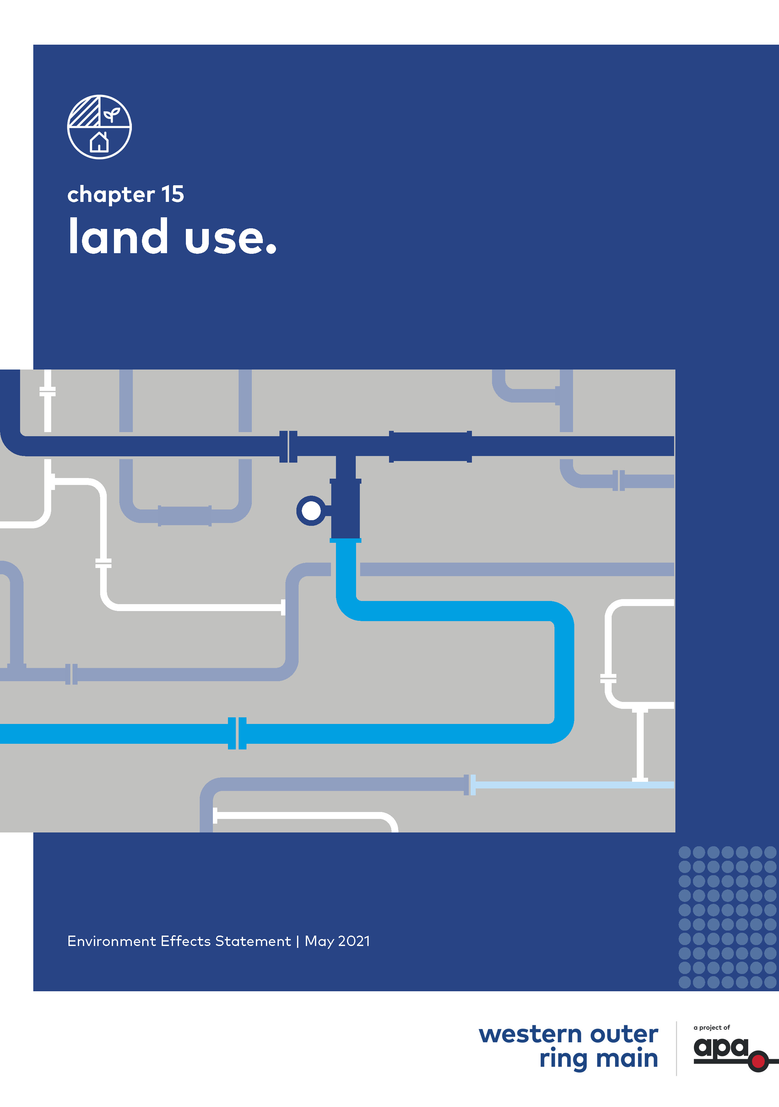Chapter 15

# Land use

Contents

Chapter 15

15.1 Introduction 15-1

15.2 Method 15-2

15.3 Existing conditions 15-5

15.3.1 Overview 15-5

15.3.2 Section 1 – Plumpton to Calder Highway 15-10

15.3.3 Section 2 – Calder Highway to Mickleham Road 15-11

15.3.4 Section 3 – Mickleham to Donnybrook 15-12

15.3.5 Section 4 – Donnybrook to Wollert Compressor Station 15-13

15.4 Risk assessment 15-13

15.5 Land use planning policy and strategies assessment 15-15

15.5.1 Planning Policy Framework (PPF) 15-15

15.5.2 Assessment of Project against policy 15-17

15.6 Construction impact assessment 15-18

15.6.1 Construction activities Section 1 to Section 4 15-19

15.6.2 Construction impacts – Section 1 to Section 4 15-22

15.6.3 Construction residual impacts summary 15-28

15.7 Operation impact assessment 15-28

15.7.1 Section 1 – Plumpton to Calder Highway 15-30

15.7.2 Section 2 – Calder Highway to Mickleham Road 15-34

15.7.3 Section 3 – Mickleham to Donnybrook 15-37

15.7.4 Section 4 – Donnybrook to Wollert Compressor Station 15-42

15.7.5 Operation residual impacts summary 15-44

15.8 Cumulative impact assessment 15-44

15.9 Environmental Management 15-45

15.9.1 Environmental Management Measures 15-45

15.9.2 Monitoring 15-46

15.10 Conclusion 15-47

## Introduction

This chapter provides an assessment of the land use impacts associated with the construction and operation of the Western Outer Ring Main gas pipeline project (the Project). This chapter is based on the assessment presented in Technical report K Land use.

The Project has the potential to impact on existing and reasonably foreseeable land uses or land use policies during its construction and operation phases. Land use impacts can occur:

* When a new use or development has an adverse effect on the use, form, function, amenity or appearance of the existing land use, its environment and/or the character of a place or location
* Where a new use or development has an impact on the potential future use of nearby land due to off-site impacts
* Where a change in an existing use or development now or in the future may have an impact on an introduced and now established project

|  |  |
| --- | --- |
| * The Project would be located across four local government areas (Hume City, Melton City, Mitchell Shire and Whittlesea City) and across a range of different existing land uses such as residential, agricultural, open space, commercial, industrial and extractive industries, and community facilities * Just under half (approximately 44 per cent) of the Project (Kilometre Point (KP) 0 – KP 3.2, KP 28.16 – KP 28.57 and KP 32.07 – KP 51.04) is located within the Urban Growth Boundary (UGB). There is also land reserved for the Outer Metropolitan Ring (OMR)/E6 Transport corridor, through a Public Acquisition Overlay that is applicable to land within and adjacent to a portion of the Project | What is a Precinct Structure Plan (PSP)?   1. A PSP is a master plan that provides guidance for integrated planning of a local area, typically located within a growth area. PSPs provide strategic context for new urban development and generally include plans for projected land use, employment, community facilities, transport, native vegetation, heritage, open space, and utilities. |

It is important to understand how the Project could impact existing and reasonably foreseeable land uses so that appropriate mitigation measures can be developed to avoid, minimise and manage impacts during the construction and operation of the Project.

The EES scoping requirements set out the following evaluation objectives relevant to the land use assessment:

* Minimise potential adverse social, economic, amenity and land use effects at local and regional scales.

To assess the potential effects on land use as a result of the Project, a land use impact assessment was undertaken. The assessment included a review of existing land use types and activities in the vicinity of the Project and a detailed review of existing planning provisions relevant to the Project to gain an understanding of the conditions in the study area.

Other aspects closely related to the land use evaluation objective include flora and fauna, air quality, noise and vibration, landscape and social impacts. These are addressed in the following reports:

* Technical report A and Chapter 7 Biodiversity and habitats
* Technical report B and Chapter 8 Water
* Technical report G and Chapter 11 Air quality
* Technical report F and Chapter 12 Noise and vibration
* Technical report J and Chapter 14 *Landscape and visual*
* Technical report L and Chapter 16 Social.

## Method

|  |  |
| --- | --- |
| The land use assessment involved the following key tasks:   * Review of relevant legislation and policy at a national, state and local level * Establishment of a study area for land use. This was defined as a 659 metre radius from the centreline of the pipeline alignment (refer Figure 15‑1). This study area includes a 30 metre wide temporary construction corridor and an operational easement generally 15 metre wide. * The study area includes the Measurement Length (ML) calculated as part of the Safety Management Study (refer Chapter 18 Safety). The land use study area has divided the Project into four sections related to the location of Project components, municipal boundaries, the extent of the UGB, and current and planned PSPs * Desktop assessment and baseline data review of a wide range of land use planning policies, databases, strategies and reports. This included the assessment of:   + Publicly accessible aerial imagery overlaid with the Project and ground level photography   + Publicly available strategic planning documentation, including current and future Precinct Structure Plans within the study area   + The legislative context and land tenure applicable to the study area | What is the pipeline Measurement Length?   1. Pipelines are designed in accordance with Australian Standard AS 2885 Pipelines – Gas and liquid petroleum. AS 2885 requires APA to take account of the current and reasonably foreseeable land uses along the proposed pipeline corridor, for the design life of the pipeline, as a central input to pipeline design. 2. The area of land around the pipeline where APA must consider the existing and reasonably foreseeable land uses for the purpose of pipeline design considerations is referred to as the Measurement Length (ML). 3. The ML is determined primarily by the Maximum Allowable Operating Pressure and the pipeline diameter. The ML is the area of consequence in the extremely unlikely event of a full loss of containment of the gas (full-bore rupture of the pipeline) plus the gas being ignited. 4. The ML defines the area where land use classifications as defined in AS 2885 must be identified and is the geographical extent of the Safety Management Study considerations. 5. The ML can be defined as the area where risks associated with the pipeline are assessed and consequently designed out or mitigated to as low as reasonably practical to minimise any such event from occurring. 6. The ML is not a buffer or separation distance from the pipeline, but the area of study and assessment. |

* Characterisation of existing land use conditions, including reasonably foreseeable land uses as described in the various PSPs that intersect with or adjoin the alignment
* A risk-based review of potential impacts to prioritise the focus of the impact assessment
* Assessment of the potential land use and built form impacts during construction and operation of the Project
* Development of environmental management measures (EMMs) in response to the impact assessment. Refer to Chapter 19 Environmental management framework for the full list of environmental management measures
* Assessment of the residual impacts of the Project assuming implementation of the environmental management measures
* Specifying the monitoring required to evaluate whether the Project meets the environmental management measures and detailing contingency measures as required.

|  |
| --- |
| What is the Area of Consequence?   1. In planning for WORM, APA has reviewed credible threats and has designed the pipeline to respond to the existing and reasonably foreseeable environments identified in the ML. The Project has been designed in accordance with AS/NZS 2885.1, which specifies minimum design requirements (such as wall thickness and depth of cover) based on the surrounding existing and reasonably foreseeable land use classification. The classification scheme is used to determine the pipeline design requirements according to whether the pipeline is to be installed in rural, semi-rural, suburban or urban areas. Further information regarding the design and safety requirements applicable to the Project is provided in Chapter 17 Safety. 2. As a result of this, an event resulting in the full loss of containment (a full bore rupture) is not considered to be a credible scenario and the worst case scenario is a pipeline puncture. In a similar way to establishing the ML for a full bore rupture, the area potentially impacted in this scenario was assessed based on likely puncture size and the risk of gas escaping and igniting. This area is known as the Area of Consequence and is significantly smaller than the ML. 3. The Area of Consequence for the WORM pipeline has been determined to be 65 metres each side of the pipeline. 4. The Notification Area, within which APA would seek ongoing visibility of Sensitive Use related planning applications to assess if they are compatible with the pipeline design, would match the Area of Consequence. Under AS/NZS 2885, a sensitive use includes residential aged care, child care, education and hospital facilities (residential housing is not a sensitive use). 5. APA would still also monitor land use within the ML for the design life of the pipeline, in accordance with AS 2885. |

At the time of preparing Technical report K Land use, the ML was advocated to be the notification area to be incorporated into plans and policies of any future PSPs along the alignment. APA has now undertaken further assessment and determined that the notification area will be the reduced Area of Consequence based on the highest credible consequence.

The Area of Consequence for the WORM pipeline has been determined to be 65 metres each side of the pipeline, which is significantly less than the ML. The Notification Area, within which APA seeks ongoing visibility of Sensitive Use related planning applications to assess if they are compatible with the pipeline design, will be the Area of Consequence.

APA will continue to have statutory responsibilities pursuant to AS 2885 outside the area of consequence and within the ML.

Figure 15‑1 Land use study area and approved PSPs

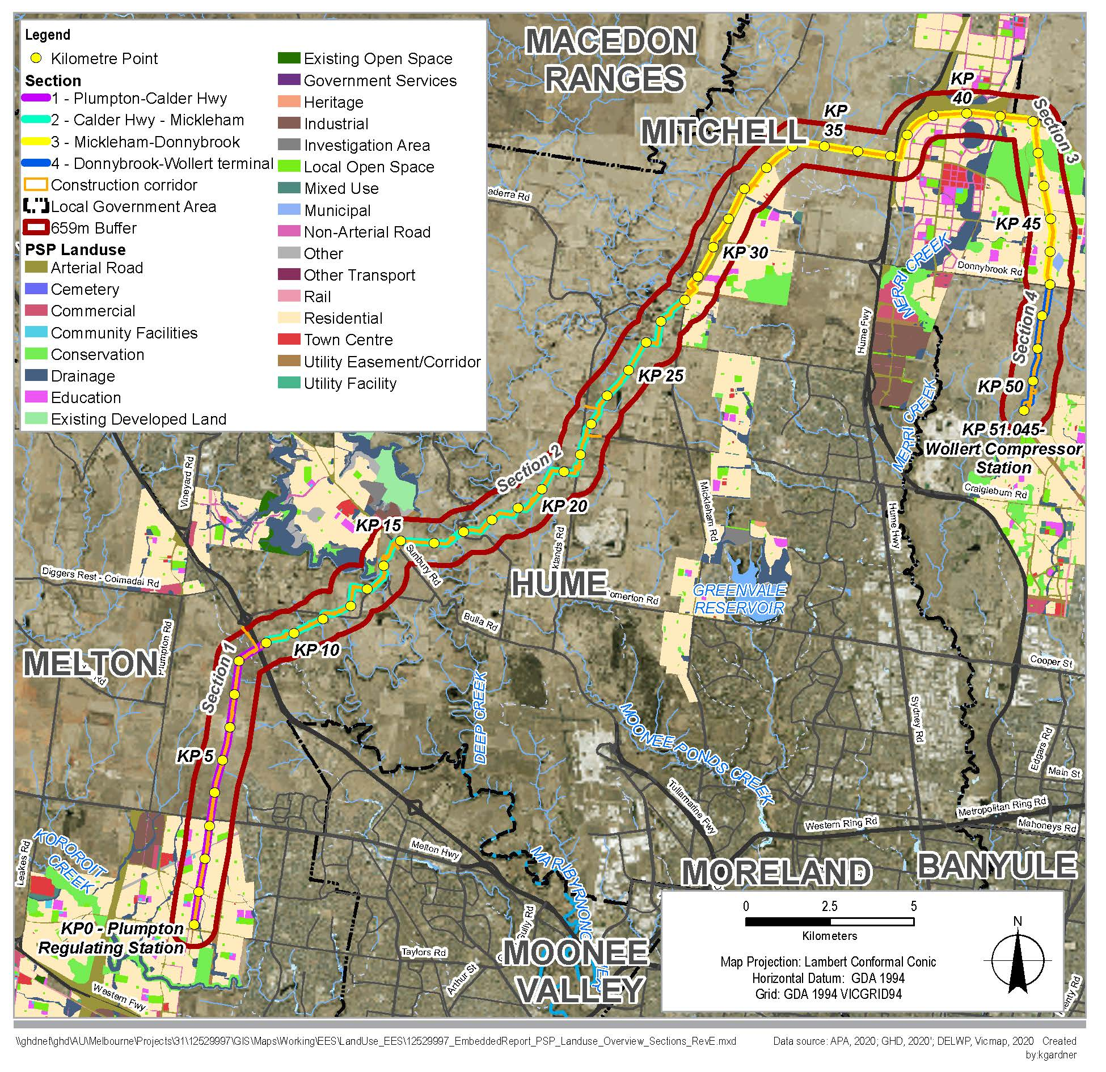

## Existing conditions

### Overview

The following section outlines the existing conditions of the Project study area in relation to land use.

The Project is located across four local government areas (Melton, Hume, Mitchell and Whittlesea) as shown in Figure 15‑1. The land use assessment included consideration of local policies within the Melton, Hume, Mitchell and Whittlesea planning schemes (refer to section 15.5.2).

For the purposes of the land use assessment, the Project has been divided into four sections:

* Section 1 – Plumpton to Calder Highway (KP 0–9)
* Section 2 – Calder Highway to Mickleham Road (KP 9–28)
* Section 3 – Mickleham Road to Donnybrook (KP 28–46.9)
* Section 4 – Donnybrook to Wollert Compressor Station (KP 46.9–51.0).

Each component of the Project and the corresponding existing land uses and PSP within each of the relevant local government areas are shown in Table 15‑1.

Table 15‑1 Project components and existing land use and PSP in local government areas

|  |  |  |  |
| --- | --- | --- | --- |
| Local government area | Project components | Extent | Existing land uses/PSPs |
| 1. Melton | 1. Pipeline, MLV1 | 1. KP 0–KP9 | * Low-density detached rural residential properties * Agricultural land * Local roads and highways * OMR/E6 Transport corridor * Low voltage electricity assets, along with various water, telecommunications, liquified natural gas and sewer assets * Kororoit PSP * Plumpton PSP * Taylors Hill West PSP |
| 1. Hume | 1. Pipeline, MLV2 | 1. KP9–KP34 | * Low density residential * Agricultural land * Open space and recreation * Small number of extractive industry-based land uses * Minimal community facilities * Numerous local roads and highways * OMR/E6 Transport corridor * Low voltage electricity assets, along with various water, telecommunications, liquified natural gas and sewer assets * Lindum Vale PSP * Merrifield West PSP * Sunbury South PSP * Lockerbie PSP * Merrifield North Employment PSP (proposed) |
| 1. Mitchell | 1. Pipeline, MLV3 | 1. KP34–KP43 | * Residential * Agricultural land * Open space and recreation * Various community facilities * Numerous minor local roads and highways * OMR/E6 Transport corridor * Low voltage electricity assets, along with various water, telecommunications, liquified natural gas and sewer assets * Lockerbie PSP * Lockerbie North PSP * Donnybrook Woodstock PSP * Merrifield North Employment PSP (proposed) * Beveridge South West PSP (proposed) * Northern Freight PSP (proposed) |
| 1. Whittlesea | 1. Pipeline, Wollert Compressor Station | 1. KP43–KP51.04 | * Minimal residential properties * Agricultural land * Number of quarries and extractive industry-based land uses * Small number of minor local roads and highways * High and low voltage electricity assets, along with various water, telecommunications, liquified natural gas and sewer assets * Lockerbie PSP * Shenstone Park PSP (proposed) * Northern Freight PSP (proposed) |

Land uses within each of the Project study areas largely comprise a range of residential, agricultural, open space, commercial, industrial and quarrying, community facilities, and transport and infrastructure-based land uses. Land across all sections is generally within a growth area subject to a current or future PSP, or within a green wedge. Existing and proposed PSPs are of particular relevance in setting out planned redevelopment and consideration of the Project's integration into those plans. Table 15‑2 summarises the proportion of planning zones present across the Project.

Where the Project is located within an existing pipeline easement (KP 0–KP 9 and KP 42–KP 51.04), land use strategies in the applicable PSPs account for the existing pipelines, both from a planning perspective and for broader land use patterns. However, the existing gas pipeline easement relates to the existing pipeline rather than the provision of this Project. PSPs with existing gas pipelines are the Plumpton, Kororoit, and Donnybrook-Woodstock PSPs.

The existing APA pipeline easement in which the WORM is to be installed between approximately KP 0–KP 9 relates to the Sunbury pipeline that has a ML of 173 metres and is included in the Plumpton PSP. KP 42–KP 51 contains 2 pipelines, which are the Victorian Northern Interconnect Expansion (VNIE) and the Wollert to Wodonga pipeline. The Wollert to Wodonga pipeline is the oldest of the 2 pipelines (constructed in 1976) and has a ML of 273 metres, whereas the VNIE is approximately 5 years old and has a ML of 495 metres. As the VNIE is a no rupture pipeline an area of consequence significantly less than the ML of the Wollert to Wodonga pipeline would be applicable.

The Area of Consequence for the WORM pipeline has been determined to be 65 metres each side of the pipeline, which is significantly less than the Measurement Length. The Notification Area, within which APA seeks ongoing visibility of Sensitive Use related planning applications to assess if they are compatible with the pipeline design, will be the Area of Consequence. The notification area for the WORM would be significantly less than the existing pipelines described above.

Table 15‑2 Planning zones across all sections

|  |  |  |  |
| --- | --- | --- | --- |
| 1. Zone | | 1. Area (%) | |
| 1. Green Wedge Zone (incorporating Green Wedge A Zone) | 1. 50.9% | |
| 1. Urban Growth Zone (incorporating various schedules) | 1. 29.6% | |
| 1. Farming Zone | 1. 11.1% | |
| 1. Public Use Zone (incorporating utility and transport) | 1. 4.3% | |
| 1. Rural Conservation Zone | 1. 3.6% | |
| 1. Road Zone | 1. 0.4% | |
| 1. Special Use Zone | 1. 0.1% | |
| 1. Total | 1. 100.0% | |

Source: GHD, 2020

APA is working with the Victorian Planning Authority (VPA) in order that PSPs currently in preparation (such as the Merrifield North Employment PSP) would incorporate a pipeline easement and related notification processes (discussed further in Section 15.6).

The Project traverses two green wedges: the Western Plains North green wedge; and the Sunbury green wedge. A review of publicly available future Planning Scheme Amendments (PSAs) identified two PSAs proposed within the study area: the future Merrifield North Employment PSA (Section 3) and the Shenstone Park PSA (Section 4).

A description of land uses and planning controls including zones and overlays within each section is discussed below. The planning zones and overlays that are applicable to each section of the Project are discussed in more detail and illustrated within section 6 of Technical report K Land use.

Figure 15‑2 Planning zones within Sections 1 and 2

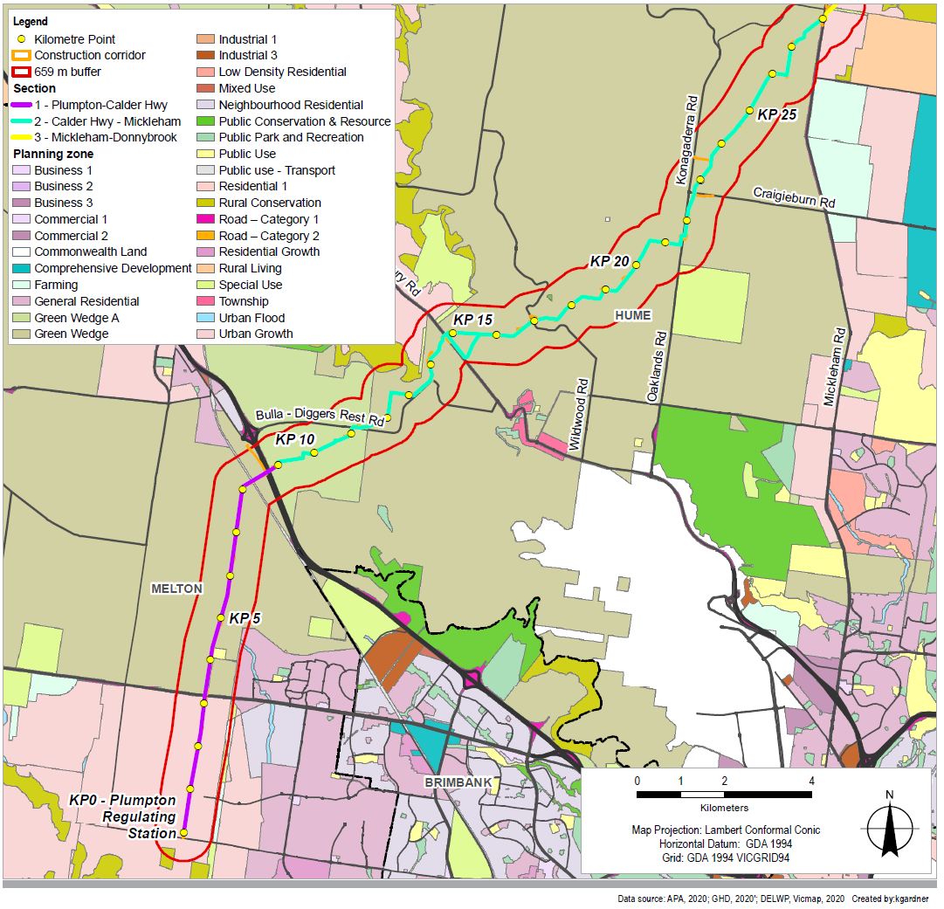

Figure 15‑3 Planning zones within Sections 3 and 4

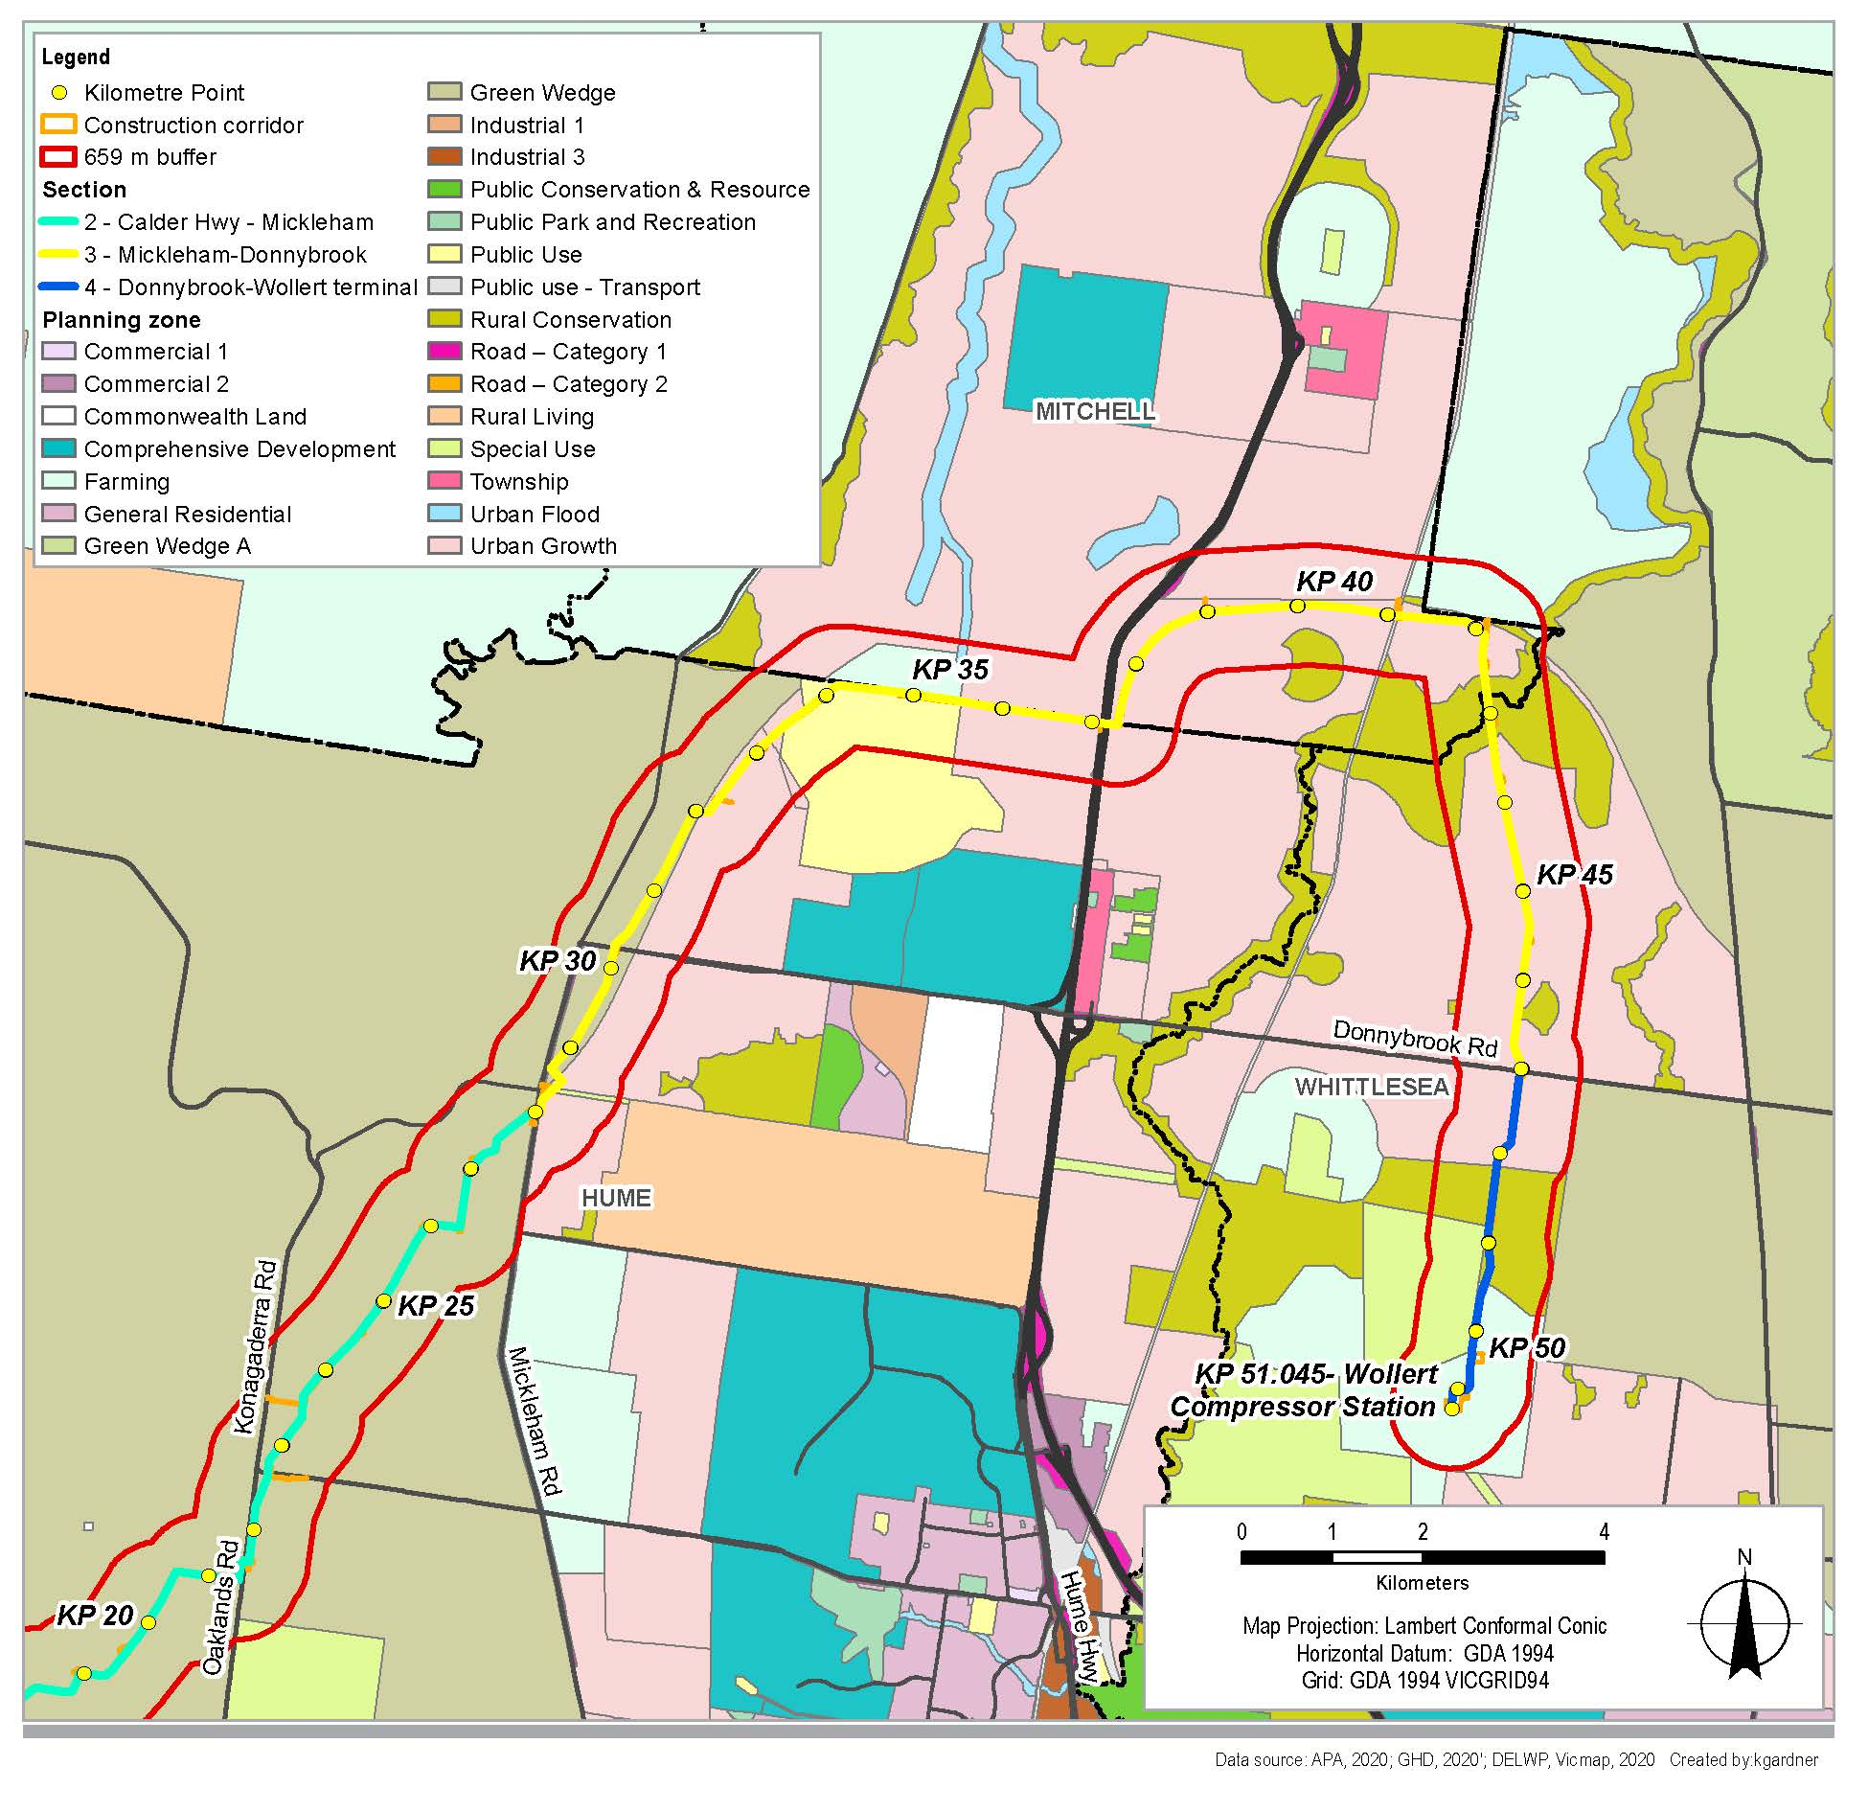

### Section 1 – Plumpton to Calder Highway

|  |  |
| --- | --- |
| This section is characterised by land within the UGB and the western growth corridor to the south of the Melton Highway, and land within the Western Plains North green wedge between the Melton Highway and the Calder Highway. Other features include the Melbourne-Bendigo rail corridor, managed by VicTrack. All land within this section is within the City of Melton and subject to the Melton planning scheme. | What is Green Wedge?   1. A green wedge is a non-urban area of metropolitan Melbourne that is outside of the urban growth boundary, and is protected by zoning that restricts uses to agriculture and lower-density uses such as infrastructure, quarries, and environmental conservation areas. Areas within a designated green wedge are also provided with protections in the planning framework to prevent them from urban encroachment. |

Despite the delineation between areas within the green wedge and land within the growth corridor, land uses within this section are currently uniformly agricultural and rural-residential in nature, with little to no commercial, industrial, open space land uses or community facilities. This uniformity is not anticipated to continue into the future, given the planned residential development within the western growth corridor, and the approval of the Kororoit and Plumpton PSPs. Land within the green wedge is not currently projected to undergo further development in the future.

Section 1 of the Project would be constructed entirely within an existing APA gas pipeline easement. The Kororoit and Plumpton PSPs account for the existing easement and the pipeline location considers the land uses provided for within the PSPs. Land within this section is predominantly privately held, with the exception of public road reserves and the Melbourne-Bendigo rail reserve.

Figure 15‑4 shows the view north across flat to gently undulating farmland from Taylors Road, Plumpton

Figure 15‑4 View north across flat to gently undulating farmland from Taylors Road, Plumpton

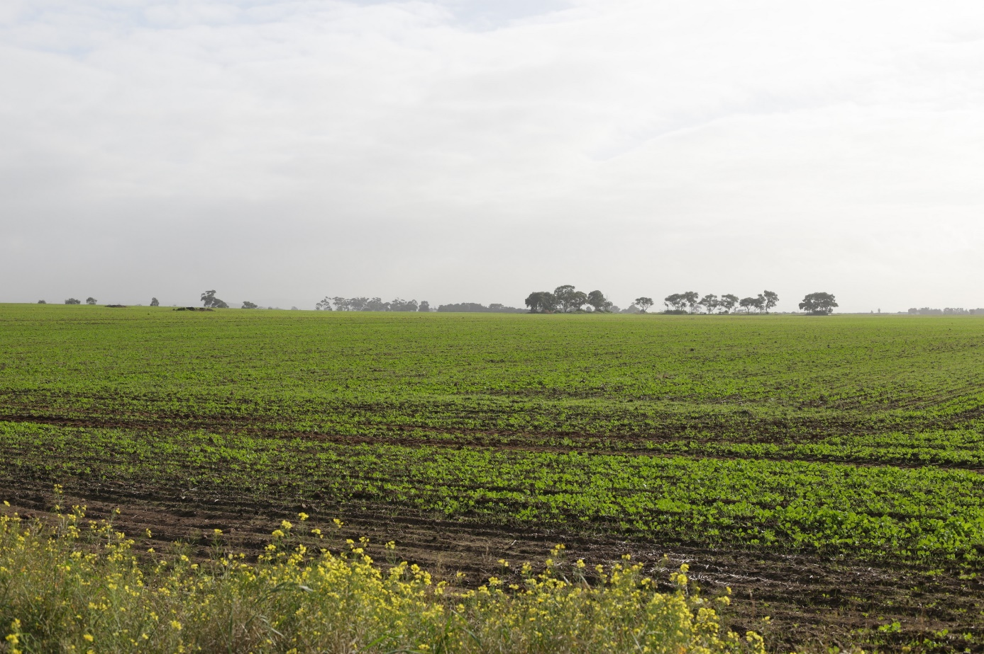

### Section 2 – Calder Highway to Mickleham Road

From the Calder Highway to Mickleham Road, the Project is located entirely within the Sunbury green wedge, though the Project does pass within 500 metres of land within the Sunbury South PSP. This portion of green wedge is entirely within the City of Hume, and the council is currently preparing a Green Wedge Management Plan for the area (not publicly available at time of writing).

Land within the broader study area is almost wholly included within the Green Wedge Zone. Exceptions to this is a small section to the east of Diggers Rest (Green Wedge A Zone), a section associated with the Sunbury South PSP (Rural Conservation Zone and Urban Growth Zone – Schedule 9) and an area included within a Special Use Zone, Schedule 1 (Earth and Energy Resources Industry), associated with the Oaklands Junction quarry.

The Melbourne Airport Environs Overlay covers a large area within this section. The purpose of this overlay is to protect Melbourne Airport’s operations from inappropriate development, and its application constrains further urban development within areas subject to this overlay.

Land within Section 2 is undulating, with steep creek valleys associated with several waterways, some of which are intersected by the Project (Jacksons Creek and Deep Creek). Land uses are primarily rural and agricultural in nature, with some low-density residential uses located to the east of Diggers Rest, at the locality of Wildwood, and north of the township of Bulla. Industrial and extractive industry-based land uses are also present in close proximity to the Project in the form of refuse, recycling and waste transfer stations and quarries. Land within Section 2 is predominantly privately held, however, there is some Crown land at waterways and along roads.

Figure 15‑5 shows the view east of a dwelling on Duncans Lane, Diggers Rest.

Figure 15‑5 View east of a dwelling on Duncans Lane, Diggers Rest

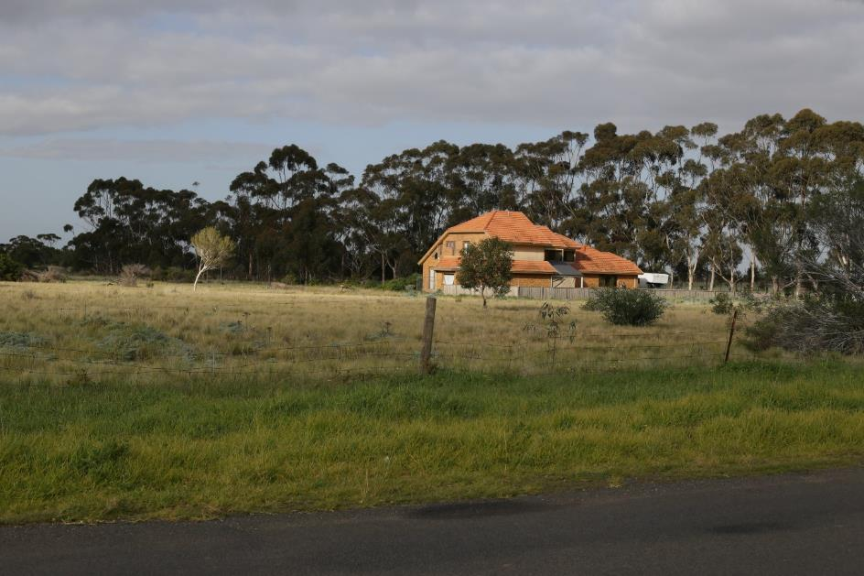

### Section 3 – Mickleham to Donnybrook

The section from Mickleham to Donnybrook traverses the Hume, Mitchell and Whittlesea Councils. The Project is located within the Whittlesea green wedge to the east and proximate to the Sunbury green wedge to the west) and is otherwise wholly within Melbourne’s northern growth corridor. The Project also crosses the North Eastern rail line reserve and the Hume Freeway within Section 3.

|  |  |
| --- | --- |
| At this location, the route is primarily located within or adjacent to the future OMR/E6 Transport corridor, which is subject to a Public Acquisition Overlay. Within the Donnybrook-Woodstock PSP, the route is within an existing gas pipeline easement. The PSP includes the existing easement but it does not specifically anticipate the additional pipeline proposed with this Project using the land. | What is the OMR/E6 Transport corridor?   1. The OMR/E6 Transport corridor is a 100 kilometre long high-speed transport link for people and freight in Melbourne’s north and west. The area required for the future development and use of the transport link is identified in the planning scheme in a public acquisition overlay. |

Land uses in Section 3 are currently predominantly rural and agricultural in nature, however, they will gradually transition to urban residential in the future. A number of PSPs have been approved or are in development within this section, including the Lindum Vale, Merrifield West, Merrifield North, Lockerbie North, Lockerbie, Donnybrook-Woodstock and Shenstone Park PSPs.

Land within Section 3 is predominantly privately held, with the exception of a parcel of land north of Kalkallo, roadways, the North Eastern rail line reserve, and Merri Creek. There is a child-care centre (Kool Kidz Childcare Merrifield) located approximately 640 metres from the centre of the pipeline alignment (near KP 30), north of Donnybrook Road.

Figure 15‑6 shows the view south-west of dwellings along Inkerman Crescent, Mickleham.

Figure 15‑6 View south-west of dwellings along Inkerman Crescent, Mickleham

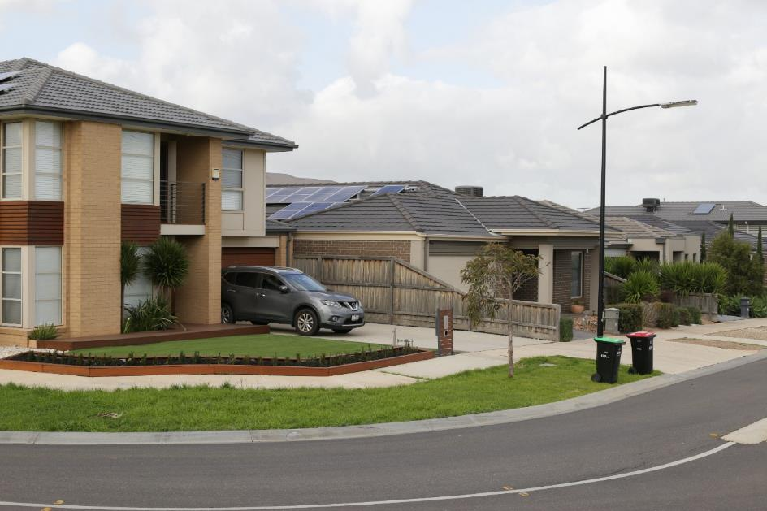

### Section 4 – Donnybrook to Wollert Compressor Station

This section extends approximately 3.8 km from Donnybrook Road through to the terminus of the Project at Wollert, entirely within the City of Whittlesea. At this section, the route is within an existing gas pipeline easement or land where APA has existing tenure (Wollert Compressor Station).

Section 4, while within the urban growth boundary, is not subject to any current PSPs, and is zoned Urban Growth Zone, Rural Conservation Zone – Schedule 1, Special Use Zone – Schedule 4, Green Wedge Zone and Farming Zone. Land uses within the area are currently agricultural or extractive industry-based along with the existing APA Wollert Compressor Station, with an absence of commercial, industrial, community and open space uses.

Shenstone Park PSP is currently in development for the area subject to the Urban Growth Zone. Land within this section is entirely privately held, with the exception of roadways.

Figure 15‑7 shows the view south-west along the Project alignment from Wildwood Road.

Figure 15‑7 View south-west along the Project alignment from Wildwood Road

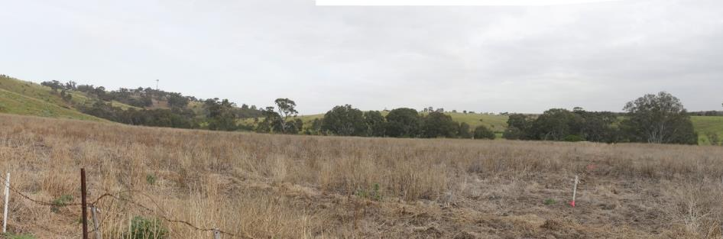

## Risk assessment

The risk assessment identified the risks associated with land use as a result of the Project's construction and operation in accordance with the method described in Chapter 5 Evaluation and assessment framework.

The initial risk assessment identified three risks, associated with both construction and operation. Additional management/mitigation measures to treat risks were introduced for risks with an initial risk rating of medium or higher as shown in Table 15‑3. All risks identified throughout the land use and planning assessment resulted with a low residual risk rating.

Risk ID LU1 describes potential land use changes that impact on areas subject to a PSP, where the pipeline easement has not previously been taken into account within the approved and gazetted PSP. In this instance, LU1 has been assigned a medium initial risk rating as the Project may result in inconsistencies with the PSP where development cannot proceed as described within the PSP. For example, if the Project intersected with a planned development area, any proposed development or construction would not be able to be constructed within the pipeline easement, and sensitive uses may be restricted within the Area of Consequence of the pipeline. There are PSPs within Section 3 of the study area that do not include the proposed alignment for the Project.

Risk ID LU2 identifies potential interruptions to existing land uses during both construction and operation phases. Such interruptions may include construction removing a portion of land from agricultural production during construction, while limitations may result in land being unable to be used for land uses that would require structures to be placed within the easement (such as sheds for agricultural land uses). LU2 has been assigned a medium initial risk rating due to the nature of and duration of the changes affecting current and potential land uses.

Risk ID LU3 relates to the impacts to existing and reasonably foreseeable land uses as a result of land and or easements that would be required to be reserved for the Project. The risk rating for LU3 was considered to be a low risk due to the minimal extent of land acquisition and the rigour and standardisation of the easement agreement process, and did not require further additional mitigation measures.

A summary of the risk assessment results for land use impacts is presented in Table 15‑3. Table 15‑10 identifies the EMMs proposed to address land use impacts.

Table 15‑3 Risk assessment

|  |  |  |  |  |  |  |  |
| --- | --- | --- | --- | --- | --- | --- | --- |
| 1. Risk ID | | 1. Risk pathway | | 1. Initial mitigation measures | 1. Initial risk rating | 1. Additional mitigation measures | 1. Residual risk rating |
| 1. Construction and Operation | | | | | | | |
| 1. LU1 | 1. Pipeline | | 1. Inconsistencies with PSPs through construction of the pipeline in growth areas where the Project has not been planned for resulting in planned land uses (ie residential, commercial, community) not able to proceed as planned. | 1. Consistency with approved PSPs to be addressed through design to AS/NZS 2885[1], Pipelines Licence application process and liaison with VPA on PSPs. | 1. Medium | 1. EMM LU1 – Minimise impacts to PSPs and growth areas | 1. Low |
| 1. LU2 | 1. All | | 1. Presence of pipeline and easement causes restrictions or interruptions to continuation of existing and planned land uses including limiting access and causing amenity issues through noise and dust. | 1. Consistency with existing and reasonably foreseeable land uses to be addressed through inclusion in PSPs and consistency with existing land uses through design to AS/NZS 2885, Pipelines Licence application process and liaison with VPA on PSPs. | 1. Medium | 1. EMM LU2 – Continuation of existing land uses and mitigation measures relating to air quality, noise, social. 2. EMM LU4 – Traffic management plans | 1. Low |
| 1. LU3 | 1. Pipeline and MLV | | 1. Land acquisition for MLVs and presence of easements causes severance of land uses and limits access. | 1. EMM LU3 – Compensation and access in consultation with stakeholders | 1. Low | 1. No additional measure identified | 1. Low |

## Land use planning policy and strategies assessment

### Planning Policy Framework (PPF)

The PPF seeks to ensure the objectives of planning in Victoria are fostered through appropriate land use and development policies and practices which integrate environmental, social and economic factors in the interests of net community benefit and sustainable development. The PPF is the same in all Victorian Planning Schemes and regard must be given to these provisions when considering development projects. Consideration was given to the relevant clauses of the PPF in the planning, siting and design phases of the Project. The Project then had regard for the intent of the PPF with the objective of minimising impacts on key areas such as landscape, environment, amenity, high quality agricultural land, transport and safety.

The key state-wide and regional policies that apply to the land use considerations of the Project are listed in Table 15‑4.

Table 15‑4 PPF clauses

|  |  |
| --- | --- |
| 1. Clause | 1. Sub-clause |
| 1. Clause 11 Settlement | 1. Strategies under this clause generally seek to promote orderly development to allow for population growth, notably while protecting green wedges, while providing for structure planning to ensure adequate supply of urban land and development sequencing in growth areas. Relevant subclauses:  * Clause 11.01–1R Green Wedges and Settlement (Metropolitan Melbourne) * Clause 11.02–2S Supply of urban land * Clause 11.03–2S Growth areas. |
| 1. Clause 12 Environment and Landscape Values | 1. This clause acknowledges the importance of protecting ecological systems, biodiversity and conservation areas with identified environmental value, including strategically valuable biodiversity sites. Clause 12.05-1S specifically acknowledges Merri Creek as an environmentally sensitive area with environmental and recreational values that may be threatened by development. Relevant subclauses:  * Clause 12.05–2S Landscapes * Clause 13.03–1S Floodplain management * Clause 13.04–2S Erosion and landslip * Clause 13.04–2S Salinity * Clause 13.05–1S Noise abatement * Clause 13.06–1S Air quality. |
| 1. Clause 13 Environmental Risks and Amenity | 1. Relevant strategies under this clause relate to preventing and mitigating noise, dust, erosion and other potentially detrimental impacts from construction and operation of the built environment. Relevant subclauses:  * Clause 13.03–1S Floodplain management * Clause 13.04–2S Erosion and landslip * Clause 13.04–2S Salinity * Clause 13.05–1S Noise abatement * Clause 13.06–1S Air quality * Clause 13.07–1S Land use compatibility * Clause 13.07–2S Major Hazard Facilities. |
| 1. Clause 14 Natural Resource Management | 1. This clause generally seeks to protect agricultural, water, irrigation and earth resources. Relevant subclauses:  * Clause 14.01–1R Protection of agricultural land – Metropolitan Melbourne * Clause 14.02–1S Catchment planning and management * Clause 14.03–1S Resource exploration and extraction. |
| 1. Clause 15 Built Environment and Heritage | 1. Recognises that planning should ensure all land use and development appropriately responds to its surrounding landscape and built form character and cultural context and should protect places and sites with significant heritage, architectural, aesthetic, scientific and cultural value. Relevant subclauses:  * Clause 15.01–1S Urban design * Clause 15.01–3S Subdivision design * Clause 15.02–1S Energy and resource efficiency * Clause 15.03–1S Heritage conservation * Clause 15.03–2S Aboriginal cultural heritage. |
| 1. Clause 17 Economic Development | 1. This clause recognises that planning should contribute to the economic wellbeing of the state, and should provide for a strong and innovative economy. |
| 1. Clause 18 Transport | 1. This clause seeks to ensure planning provides for an integrated and sustainable transport system. Relevant subclauses:  * Clause 18.01–2S Transport system * Clause 18.04–1R Melbourne Airport * Clause 18.05–1S Freight links. |
| 1. Clause 19 Infrastructure | 1. Strategies under this clause seek to encourage timely, orderly and cost-effective provision of various forms of infrastructure, including gas pipelines. Relevant subclauses:  * Clause 19.01–1S Energy supply * Clause 19.01–3S Pipeline Infrastructure. |

### Assessment of Project against policy

Growth areas within the UGB are anticipated to feature increasing residential development and population growth as land within the northern and western growth corridors is developed into the future, with the structure of future development planned through PSPs. Land within growth areas is typically zoned Urban Growth Zone. Population increase in defined growth areas is described as a key land use pressure in each municipality and aligns with Plan Melbourne and the Planning Policy Framework (PPF). The proportion of the Project area within the Urban Growth Zone is 29.6%.

Green wedges, which are located outside of the UGB, are predominantly used for agricultural and resource-based land uses, with some lower density residential uses associated with agricultural uses. Land outside of the UGB is typically zoned Green Wedge Zone (GWZ) and is otherwise subject to the provisions of Clause 51.02 Metropolitan Green Wedge Land: Core Planning Provisions. GWZs recognise and protect green wedge land for its agricultural, environmental, historic, landscape, recreational and tourism opportunities and mineral and stone resources. The pipeline alignment selected for the Project avoids impacts to agricultural land, cultural heritage and vegetation as far as practicable (refer to Section 15.6 of this chapter and Chapter 16 Social, Chapter 13 Cultural heritage and Chapter 7 Biodiversity and habitats). Land uses within the green wedge are not anticipated to change significantly into the future. However, intense growth being undertaken within the UGB adjacent to green wedge areas is noted as presenting a potential land use conflict. The proportion of the Project within the GWZ is 50.9 per cent (refer to Table 15‑2).

The Project is generally consistent with the above land use categories, or the underlying land use policies. Notably, it is supported by policy within Plan Melbourne, the PPF and Municipal Strategic Statement (MSS) of each municipality, in that it addresses a key gap in the VTS, while not prejudicing existing agricultural land uses within green wedges.

Land use across the study area is influenced by the formal UGB, continued population growth and the need for infrastructure to support this, the need to preserve agricultural land in peri-urban areas, and finite environmental values.

The Project is generally consistent with relevant land use policy. With the pipeline alignment incorporated into future PSPs, the Project would have a low impact on land use planning policy across the Project area.

APA would retain an ongoing responsibility in the ML pursuant to AS/NZS 2885, which requires APA to monitor land use change within this area. APA would seek to be notified of planning applications for sensitive uses within the Area of Consequence. The assessment and determination of such applications would be undertaken on a case by case basis. This assessment may involve a Safety Management Study (SMS), and APA may respond with permit conditions.

## Construction impact assessment

This section presents a discussion of the construction impacts associated with the Project in relation to land use and are grouped according to the four sections identified in the study area. Potential impacts on land use within Sections 1 to 4 during construction, and relevant mitigation measures, are described in Table 15‑5.

Prior to construction, APA would secure land access for the pipeline construction and easement, and acquire land for the three MLVs. Acquisition of land for the Project MLVs is a small area with each being approximately 0.02 hectare. While part of the Project is within an existing easement area (between KP 0–KP 8.8 and KP 41.1–KP 51), a new easement would be reserved for the area between KP 8.8 and KP 41.1. EMM LU3 provides for compensation for land to be agreed and paid to directly affected landholders and provided in accordance with the Pipelines Act 2005 (Pipelines Act) and the Land Acquisition and Compensation Act 1986. Engagement with directly affected landholders commenced in 2018 and would continue with individual negotiations through to agreement.

The proposed pipeline would have no ongoing impact on land use within the ML and outside the Notification Area/Area of Consequence. This is because the proposed pipeline is designed to respond to reasonably foreseeable land uses – so that those land uses can proceed unimpeded. The only scenario in which there is potential for the proposed pipeline to influence future land uses is the case of sensitive uses (as defined in AS 2885) proposed within the Notification Area. AS 2885 defines sensitive uses as those that may increase the consequence of a pipeline failure due to its use by members of the community that may be unable to protect themselves from the consequence of a pipeline failure. AS 2885 requires the pipeline alignment and the associated ML to avoid sensitive land uses in the first instance. If avoidance cannot be achieved, the proponent must design the pipeline appropriately. APA’s position is that the land uses listed below, as defined in the Victoria Planning Provisions, should be located outside of the Notification Area on account of being sensitive uses:

* Aged Care Facilities
* Retirement villages
* Child-care/family day care centres
* Cinema based entertainment facility
* Schools or other educational establishments
* Prisons/corrective institutions
* Hospitals and medical centres
* Place of assembly or worship
* Higher density residential uses (above 50 dwellings per hectare).

Any planning applications for sensitive uses within the Notification Area should be referred to APA. The assessment and determination of such applications would be undertaken on a case by case basis. Applications for sensitive uses are likely to require a Safety Management Study (SMS) be undertaken at the time.

### Construction activities Section 1 to Section 4

#### Section 1 – Plumpton to Calder Highway

The Project components proposed within Section 1 include the following:

* Pipeline: Buried pipeline, to be constructed within a 30 metre wide construction corridor, generally constructed through open trench construction, with trenchless construction used to avoid interruptions to selected roads and railways including:
  + Beattys Road
  + Holden Road
  + Bendigo Rail Line reserve
  + Calder Freeway
  + Melton Highway.

Mainline Valve: MLV1 would be constructed to the north of Holden Road and would be co-located with existing infrastructure for the Sunbury Pipeline in a chain wire fenced compound (approximately 20 metre x 15 metre). The land for the MLV compound would be located within the easement area but would be subdivided and acquired by APA in consultation with local authorities.

In Section 1, the pipeline would be generally located within the existing APA easement for the Sunbury Pipeline. Potential impacts on land use within Section 1 during construction, and relevant mitigation measures, are described in Table 15‑5.

A key mitigation measure during construction within Section 1 is the agreement of access with landowners to minimise impacts on the continuation of land uses in the section (primarily agricultural), including negotiation of compensation under the legislative framework. A specific mitigation measure (EMM LU2) is included to ensure the process is undertaken as a priority. Property access and biosecurity arrangements would be established with agricultural properties (refer social environmental management measures).

Additional mitigation measures to reduce and minimise impacts would include reinstatement of fencing and other infrastructure required for access, the implementation of Traffic Management Plans to manage disruptions to roads during construction and using trenchless construction methods to avoid disruptions to major roads and railway corridors (EMM LU4).

#### Section 2 – Calder Highway to Mickleham Road

The Project components proposed within Section 2 includes the following:

* Pipeline: Buried pipeline, to be constructed within a 30 metre wide construction corridor, generally constructed through open trench construction, with trenchless construction used to avoid interruptions to selected roads and waterways including:
  + Morefield Court
  + Bulla-Diggers Rest Road
  + Wildwood Road
  + St Johns Road
  + Oaklands Road
  + Craigieburn Road
  + Mt Ridley Road
  + Mickleham Road
  + Sunbury Road
  + Deep Creek.
* Mainline Valve: MLV2 would be constructed to the east of Oaklands Road and would be in a chain wire fenced compound (approximately 12 metre x 12 metre). The land for the MLV compound would be located within the easement area but would be subdivided and acquired by APA.

In Section 2, the pipeline would be generally located within agricultural properties. Potential impacts on land use within Section 2 during construction, and relevant mitigation measures, are described in Table 15‑5.

The primary impact on Section 2 during construction relates to the temporary removal of land from agricultural production, which is expected to occur at any one location for a period of four to six months. Construction of the Project is expected to progress at a rate of approximately 700 metres per day for open trench construction, however, HDD and bored crossings would likely have lower daily progress rates, and could take between two to three weeks at a particular location. The construction phase of the Project is expected to be completed within 9 months. Rehabilitation progress along the Project would occur at a rate of approximately 1 km per day (this rate is only for reinstatement of topsoil, does not include reseeding). It is anticipated that the Project would have a low impact on farming operations, however, additional mitigation measures to reduce and minimise impacts would be introduced such as ensuring the reinstatement of fencing and other infrastructure required for access (EMM LU2), property access and biosecurity arrangements with agricultural properties (social environmental management measures), the implementation of Traffic Management Plans to manage disruptions to roads during construction, and using trenchless construction methods to avoid disruptions to major roads and waterways (EMM LU4).

#### Section 3 – Mickleham to Donnybrook

The Project components proposed within Section 3 includes the following:

* Pipeline: Buried pipeline, to be constructed within a 30 metre wide construction corridor, generally constructed through open trench construction, with trenchless construction used to avoid interruptions to selected roads, railways and waterways including:
  + Donnybrook Road
  + Gunns Gully Road
  + North Eastern Rail Line reserve
  + Hume Freeway.
* Mainline Valve: MLV3 would be constructed to the south of Gunns Gully Road and would be in a chain wire fenced compound (approximately 12 metre x 12 metre). The land for the MLV compound would be located within the easement area but would be subdivided and acquired by APA.

In Section 3, the pipeline construction would be predominately co-located with the Public Acquisition Overlay (PAO) for the future OMR/E6 Transport corridor, or within existing road reserves, before joining the Victorian Northern Interconnect (VNI) existing easement.

Potential impacts on land use within Section 3 during construction, and relevant mitigation measures, are described in Table 15‑5.

In Section 3, the Project is within an urban growth area and located close to existing residential properties. Temporary amenity impacts caused during construction would be managed through a Project Consultation Plan (EMM S6) and mitigated through EMMs relating to construction dust and noise impacts (EMM AQ1, AQ3, AQ4, NV1, NV2, NV3, NV4, NV5).

Additional mitigation measures to reduce and minimise impacts would include reinstatement of fencing and other infrastructure required for access, property access and biosecurity arrangements with agricultural properties (social environmental management measures), the implementation of Traffic Management Plans to manage disruptions to roads during construction, and using trenchless construction methods to avoid disruptions to major roads such as the Hume Highway (EMM LU4).

#### Section 4 – Donnybrook to Wollert Compressor Station

The Project components proposed within Section 4 includes the following:

* Pipeline: Buried pipeline, to be constructed within a 30 metre wide construction corridor, generally constructed through open trench construction, with trenchless construction used to avoid interruptions to Donnybrook Road
* Wollert Compressor Station upgrade: The pipeline terminates at the existing APA Wollert Compressor Station at 365 Summerhill Road, Wollert.

In Section 4, the pipeline would be within the existing VNI easement. Potential impacts on land use within Section 4 during construction, and relevant mitigation measures, are described in Table 15‑5.

Amenity impacts within Section 4 would be low due to the distance of the Project from residential properties and the location of the pipeline within an existing easement. A key mitigation measure during construction is the arrangement of access with landowners to minimise impacts on the continuation of land uses in the section (primarily agricultural), including negotiation of compensation under the legislative framework. A specific mitigation measure (EMM LU3) is included to ensure the process is undertaken as a priority. Property access and biosecurity arrangements would be established with agricultural properties (refer social environmental management measures).

At Section 4, the Project crosses Conservation Area 34a Northern Growth Corridor: Growling Grass Frog Corridor (between KP 42 and KP 44) and 28b – Summerhill Road (East), Wollert (between KP 48 and KP 50) under the MSA. The construction corridor follows the existing VNIE pipeline easement within Conservation Area 34a. The extent of the construction corridor within conservation area 34a and within the existing VNIE easement is 2.39 hectares, with 0.59 hectares being outside of the existing easement. With regard to Conservation Area 28b – Summerhill Road (East), Wollert, this area is largely within the existing VNIE pipeline easement. The extent of the construction corridor within conservation area 28b and within the existing VNIE easement is 1.78 hectares, with 0.53 hectares being outside of the existing easement. On this basis, it is considered that the Project would not result in a change to the current use of the land at these locations. For discussion of conservation and biodiversity impacts, refer to Technical report A Biodiversity and habitats.

A Works in Conservation Area (WICA) approval is required for any works proposed in a Conservation Area. WICA applications are submitted for DELWP’s consideration, with some applications also requiring Commonwealth approval prior to commencement of the development. At these conservation areas APA reviewed the alignment to identify locations where the Project Area could be narrowed or bored to avoid impacts to ecological values, yet still meet constructability constraints and landowner considerations.

In addition, although not under a formal conservation arrangement, the properties at 910 Craigieburn Road, 430 Oaklands Road and 380 Oaklands Road have been identified by Hume City Council as locations where conversation investment has occurred. APA has revised the alignment at 910 Craigieburn Road (at KP 23) to avoid several large trees and the construction corridor has been narrowed to minimise the impact to native vegetation. The width of the construction corridor has been reduced at 430 Oaklands Road to minimise impact to native vegetation. No native vegetation has been identified within the construction corridor at 380 Oaklands Road.

For works within conservation areas of the MSA, fencing must be compliant with relevant DELWP guidelines specific to these areas in accordance with EMM B1, B16 and B18. Additional mitigation measures to reduce and minimise impacts would include reinstatement of fencing and other infrastructure required for access, the implementation of Traffic Management Plans to manage disruptions to roads during construction, and using trenchless construction methods to avoid disruptions to major roads and railway corridors (EMM LU4).

### Construction impacts – Section 1 to Section 4

Potential impacts on land use during construction, and relevant mitigation measures, are described in Table 15‑5. By applying the mitigation measures described in Table 15‑5, the residual land use impacts during construction are assessed as low in each section (Section 1 to Section 4).

Table 15‑5 Construction impacts to Sections 1–4 and mitigation measures

|  |  |  |  |  |  |
| --- | --- | --- | --- | --- | --- |
| 1. Possible impact and land use | 1. Discussion | 1. Relevant mitigation measures | 1. Residual impact | 1. Study area | |
| Continuation of land uses (Risk ID LU2) | | | |  |
| 1. Section 1 and Section 4 2. The continuation of land uses along the Project in Section 1 (primarily agricultural, with some residential development occurring adjacent to the Project area) would be interrupted by temporary occupation during construction. 3. There is no residential land located within the existing easement in which the pipeline is to be located, however there is land within the construction footprint in Section 1 that has been identified for residential uses within the Plumpton PSP. 4. The continuation of land uses along the Project in Section 4 (currently agricultural) would be interrupted temporarily by occupation during construction. | 1. The impact to the continuation of land uses in Section 1 and Section 4 is expected to be minor and temporary. 2. Construction of the pipeline would occur predominantly along an existing pipeline easement in Section 1 and Section 4. The construction corridor would be approximately 30 metres wide and the Project would utilise the existing easement. 3. The Agricultural Impact Assessment (Appendix C of Technical Report L – Social Impact Assessment) found that there would be some temporary impacts (lasting one year or less) to agricultural production during construction. 4. Subject to the staging of the works, construction of the entire Project is expected to take approximately 9 months. General timeframes to complete works in any one area from site establishment to rehabilitation is nominally four to six months. However, the construction programme is expected to move at a rate of approximately 700 metres per day. | 1. Under EMM LU3, construction access and operational activities would be undertaken in consultation with relevant stakeholders, in accordance with the Project Consultation Plan (EMM S6) and Project EMMs S3 and S5. 2. Access would be negotiated with private landowners, fencing would be reinstated after construction (with temporary fencing utilised during construction where required), and any construction impacts to land would be rehabilitated in accordance with a CEMP. 3. As per the Agricultural Impact Assessment, impacts to agricultural land uses are predominately mitigated through EMM S2. including measures for consultation with relevant landholders regarding property-specific avoidance and minimisation measures (including access, biosecurity and continuation of property use) as well ensuring that compensation is provided to directly affected landholders. 4. Some of the land within the construction corridor is identified for future residential uses in Section 1 within the Plumpton PSP (ie land within the construction footprint which is outside of the existing easement), however development in this section is being coordinated with any Project construction activities to avoid and minimise any impact to urban construction activities. | 1. With the implementation of EMMs to minimise impacts on agricultural operation and compensation agreements in place, the Project would have a low impact on agricultural operations. 2. There will be no impact on continuation of residential land uses. Future residential land uses can be constructed within the Area of Consequence provided it is outside the easement. | 1. 1, 4 |
| 1. Section 2 and Section 3 2. The continuation of land uses along the Project in Section 2 (primarily agricultural) and Section 3 (agricultural and a small section is located in residential) may be interrupted temporarily by occupation during construction. 3. It is noted that part of Section 3 (from KP 42–43) is within an existing pipeline easement. | 1. The impact to the continuation of land uses in Section 2 is expected to be minor and temporary. 2. The Agricultural Impact Assessment (Appendix C of the Social Impact Assessment) found that there would be some temporary impacts (lasting one year or less) to agricultural production during construction. 3. Subject to the staging of the works, construction for the entire Project is expected to take approximately 9 months. General timeframes to complete works in any one area from site establishment to rehabilitation is nominally four to six months. However, construction activity itself is expected to move at a rate of approximately 700 metres per day. 4. Construction of the pipeline would predominantly be undertaken via open trench construction and backfill within a 30 metre corridor. | 1. Under EMM LU3, construction access and operational activities would be undertaken in consultation with relevant stakeholders, in accordance with the Project Consultation Plan (EMM S6) and EMMs S3 and S5. 2. Access would be negotiated with private landowners and fencing reinstated after construction (with temporary fencing utilised during construction where required). Rehabilitation of land would also occur post-construction. 3. As per the Agricultural Impact Assessment, impacts to agricultural land uses are predominately mitigated through EMM S2. including measures for consultation with relevant landholders regarding property-specific avoidance and minimisation measures (including access, biosecurity and continuation of property use) as well ensuring that compensation is provided to directly affected landholders. 4. It is noted that the construction corridor does not impact any land that is currently occupied by residential land uses in Section 3, nor does it intersect with any land reasonably anticipated to be developed for residential land uses during the construction timeframe. As such, physical limits to continuation of residential land uses are not anticipated. | 1. With the implementation of EMMs to minimise impacts on agricultural operation and compensation agreements in place, the Project would have a low impact on agricultural operations. Approximately 100 m of residential land would be impacted by the Project, that would be subject to easement requirements. 2. There will be no impact on continuation of residential land uses. Future residential land uses can be constructed within the Area of Consequence provided it is outside the easement. | 1. 2, 3 |
| 1. Traffic movement and restrictions (Risk ID LU2) 2. The Project construction has the potential to impact traffic movements where the pipeline crosses sealed roads and railway lines. This includes but is not limited to the Melton Highway, Holden Road, Calder Freeway and the Bendigo railway line in Section 1; Calder Highway, Bulla-Diggers Rest Road, and Sunbury Road in Section 2; Mickleham Road, Gunns Gully Road, Donnybrook Road, the Hume Freeway, and the North Eastern rail line reserve in Section 3; Donnybrook Road and Summerhill Road in Section 4. | 1. Construction access would be required within some existing road reserves during construction for pipeline laying purposes, which may cause residual temporary impacts to traffic flow and access. | 1. To avoid impacts on traffic where the pipeline crosses selected sealed roads and railway lines, trenchless construction techniques would be used (through boring or HDD). 2. Impacts on traffic and roads would be managed via a Traffic Management Plan in consultation with the relevant authority (ie council or Department of Transport (DoT). Road closures would be minimised through trenchless construction methods where the pipeline intersects with key roads. | 1. The mitigation measures (as described in EMM LU4) mean the Project would result in a negligible residual impact on transport and infrastructure land uses in all sections. | 1. 1, 2, 3, 4 |
| 1. Amenity impacts (Risk ID LU2) 2. The Project may cause amenity impacts on surrounding residential and agricultural land uses, including noise, dust and vibration during construction, particularly within established residential areas that abut the Project at the western extent of Section 3 (near the Merrifield West PSP). There is a childcare centre (Kool Kidz Childcare Merrifield) located approximately 640 metres from the centre of the pipeline alignment (near KP 30), north of Donnybrook Road in Section 3. | 1. Chapter 11 Air quality states that dust would be generated from construction activities such as clearing and grading, open trench construction, lowering and backfilling. There are no residences within 35 metres of the construction corridor (primary impact zone for dust) but there are residences within 75 metres where there is potential for dust to exceed the relevant EPA criteria during some construction activities. 2. According to the noise assessment undertaken for the Project and detailed within Chapter 12 Noise and vibration, vibration that would occur as a result of the Project’s construction works and in particular excavation may be perceptible by nearby residents. Vibration from blasting activities may also be perceptible by residents. A Management Plan would be developed to manage blasting on the Project. | 1. Amenity impacts would be managed and minimised where possible, in accordance with the Construction Environment Management Plan (CEMP) and in accordance with specific mitigation measures identified through the *Air quality* and *Noise* and vibration chapters (refer to EMM LU2). 2. These environmental management measures would minimise potential dust impacts through identified separation distances to residencies where dust impacts could occur and implementing measures such as watering or wind barriers where required due to weather conditions and activities in progress.   Environmental management measures would minimise noise and vibration impacts through monitoring construction activities and noise levels, consulting with affected residents, and implementing measures such as noise barriers where required due to location and activities.  For three childcare centres located between 500 m to 1 km from the construction corridor, the noise assessment (Chapter 12 *Noise and vibration*) indicates that noise level changes are expected to be minor at this distance. To mitigate these impacts, the Project would be undertaken in accordance with EPA Publication 1834 Civil Construction, Building and Demolition Guide (EMM LU2, NV1).   1. Further discussion of social impacts to residential land uses caused by amenity impacts is included in Chapter 16 Social. | 1. Amenity impacts on established land uses during construction would be minor and temporary. Dust, noise and vibration impacts would be minimised through the environmental management measures adopting specific measures related to construction activities and location. 2. Residual impacts are considered to be low. | 1. 1, 2, 3, 4 |
| 1. Impacts on waterways (Risk ID LU2) 2. The Project crosses some waterways within Section 2, including Jacksons Creek, Deep Creek and Emu Creek, and Merri Creek in Section 3 within an existing pipeline easement.   Construction of the Project could impact the waterways and existing vegetation identified within Environmental Significance Overlays and Vegetation Protection Overlays and result in inconsistencies with planning policy involving open space and conservation land uses if not appropriately managed. | 1. Construction of the Project could impact the waterway and existing vegetation identified within Environmental Significance Overlays and Vegetation Protection Overlays. The objectives of these overlays are to protect and enhance the diversity, integrity and health of the local native riparian, escarpment and plains vegetation associated with waterways, and provide for the retention, restoration and revegetation of local native plant species. 2. Where the pipeline may be constructed using open trenching across waterways, the construction period including rehabilitation works is likely to span up to two weeks for most waterways. For open trenching at complex waterways the works are likely to span between two to four weeks. Further details of construction methodology, sequence and activities are outlined in EES Chapter 4 Project Description. 3. Specific impacts on waterways such as the potential for erosion, changes in waterway quality and riparian values are outlined in Chapter 7 Biodiversity and habitats and Chapter 8 Water. | 1. Construction at Deep Creek in Section 2 would be conducted via HDD and in accordance with the CEMP, which would avoid land use risks at this location. At other waterways, where HDD or boring is not possible due to geotechnical and other construction limitations, trenched construction would be undertaken in accordance with a CEMP to manage impacts on the waterway and surrounds. Open trench construction would be used to cross Jacksons Creek, and the crossing at Merri Creek in Section 3 would also be trenched. 2. The possible use of trenchless construction techniques, such as HDD, were considered for these locations. Assessment indicated that crossing these waterways using a trenchless construction technique would not be feasible, the rationale for which is detailed within Chapter 8 Water and EES Chapter 3 Project Development.   Where trenched construction is proposed, diversion dams would be constructed of appropriate materials which would minimise watercourse sedimentation, using steel plates, sandbags or inflatable dams.   1. The pipeline alignment selected for the Project has sought to avoid impacts on vegetation as much as possible. Vegetation required to be impacted by the Project would be further avoided, minimised or rehabilitated through environmental management measures identified in Chapter 7 Biodiversity and habitats. EMM B1 includes measures such as ensuring that all vegetation clearing works are confined to the defined construction area and the loss of native vegetation would be further minimised wherever feasible, through detailed design and construction planning that considers narrowing the construction corridor where practicable. | 1. With the relevant EMMs applied during construction, residual impacts are anticipated to be minor and once the pipeline is in place, there are not expected to be any residual ongoing impacts to waterway land uses. | 1. 2, 3 |

### Construction residual impacts summary

With the implementation of mitigation measures, residual impacts on land use during construction include:

* Temporary, minor impacts on agricultural land uses. The continuation of agricultural land uses along all sections of the Project would be interrupted by occupation during construction. The Agricultural Impact Assessment (Chapter 16 Social) found that there would be some temporary impacts (lasting one year or less) on agricultural production during construction. EMM S2 includes measures for consultation with relevant landholders regarding property-specific avoidance and minimisation measures (including access, biosecurity and continuation of property use) as well ensuring that compensation is provided to directly affected landholders. The residual impacts to agricultural land uses during construction would be low following the implementation of environmental management measures.
* Temporary, minor impacts on the amenity of surrounding land uses, particularly to established residential areas, including noise, dust and vibration during construction. These residual impacts would be managed and minimised in accordance with the CEMP by implementing specific mitigation measures to manage dust, noise and vibration during construction (as identified through the air quality, noise and vibration assessments, refer to EMM LU2). The residual amenity impacts on established land uses during construction would be low following the implementation of environmental management measures.

Other residual impacts on land use are not expected or were assessed as negligible.

## Operation impact assessment

This section presents a discussion of the operational impacts associated with the Project in relation to land use and are grouped according to the four sections identified in the study area. During operation, the Project is controlled through the provisions of the Pipelines Act. There would be restrictions on the use and development of land within the 15 metres easement corridor, as outlined under Division 3 of the Pipelines Act. Restrictions would include the prohibition of excavating or erecting permanent structures, buildings, large trees or shrubs over the underground pipeline. These activities would be prohibited in accordance with the Pipelines Act and pursuant to easement agreements with landowners. Future road crossings constructed must meet the requirements of AS/NZS 2885, while linear buried infrastructure should minimise crossings of the pipeline. Generally, this means future roads and linear infrastructure should cross the pipeline at 90 degrees. Physical access to land within the pipeline easement would not otherwise be restricted.

Future sensitive uses such as aged care, child care, education or hospital facilities would also be managed within the pipeline Area of Consequence of 65 metres. Existing PSPs identifying APA gas pipelines and relevant ML include notification provisions so APA is notified of relevant applications. The assessment and determination of such applications would be undertaken on a case by case basis and this assessment may involve a Safety Management Study (SMS).

APA is working with VPA to ensure the new pipeline easement and Area of Consequence is appropriately included in new PSPs currently in development. In locations where the new pipeline is proposed in existing PSPs, the pipeline is designed in accordance with AS/NZS 2885 with consideration to current land use. A location analysis was completed within the SMS for the Project, which used location classes based on population density and the existing and reasonably foreseeable land uses to determine current land use. APA seeks to minimise impacts on existing or new PSPs and growth areas by providing for development planned in PSPs to continue, while allowing safety to be assessed case by case where relevant for sensitive uses as defined in AS 2885 that are proposed to be located within the Area of Consequence.

The pipeline easement provides an opportunity to increase open space and amenity within new urban areas. With the ongoing pressure to urbanise peri-urban and rural areas, green corridors can add value for growing communities. While APA would encourage the establishment of active open space within its easements, it would ultimately be the decision of the landowner as to whether to landscape noting this would be in accordance with APA's Site Planning and Landscape National Guidelines. The easement could accommodate a range of public spaces including shared use paths for pedestrians and cyclists and landscape furniture such as seats and fitness equipment that would benefit the community in line with the PSPs.

APA's Site Planning and Landscape National Guidelines (APA, 2020) outline the preferred urban design and landscape outcomes for APA’s easements. In general, these guidelines are designed to enhance social outcomes and visual amenity by providing landscaped active open space areas that typically incorporate a mix of landscaping and shared use paths, examples of which are shown in Figure 15‑8. This document would also be used to guide developers on appropriate rehabilitation and landscaping along the pipeline easement, which would provide an opportunity for linear green open space. While APA would encourage the establishment of active open space within its easements, it would ultimately be the decision of the landowner as to whether to landscape noting this would be in accordance with APA's Site Planning and Landscape National Guidelines.

Figure 15‑8 Potential linear open space outcomes

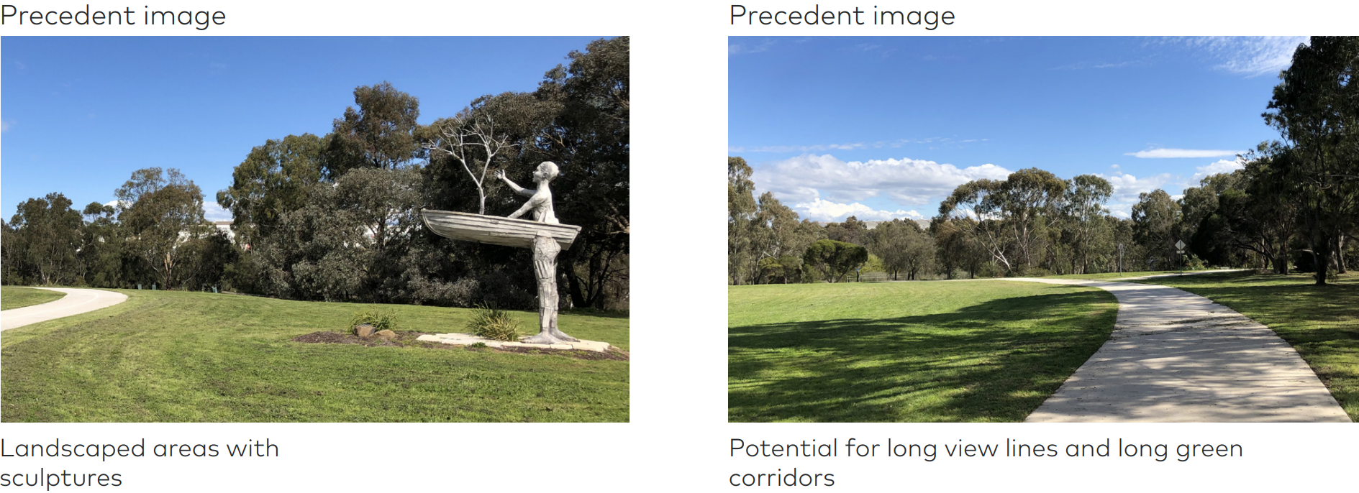

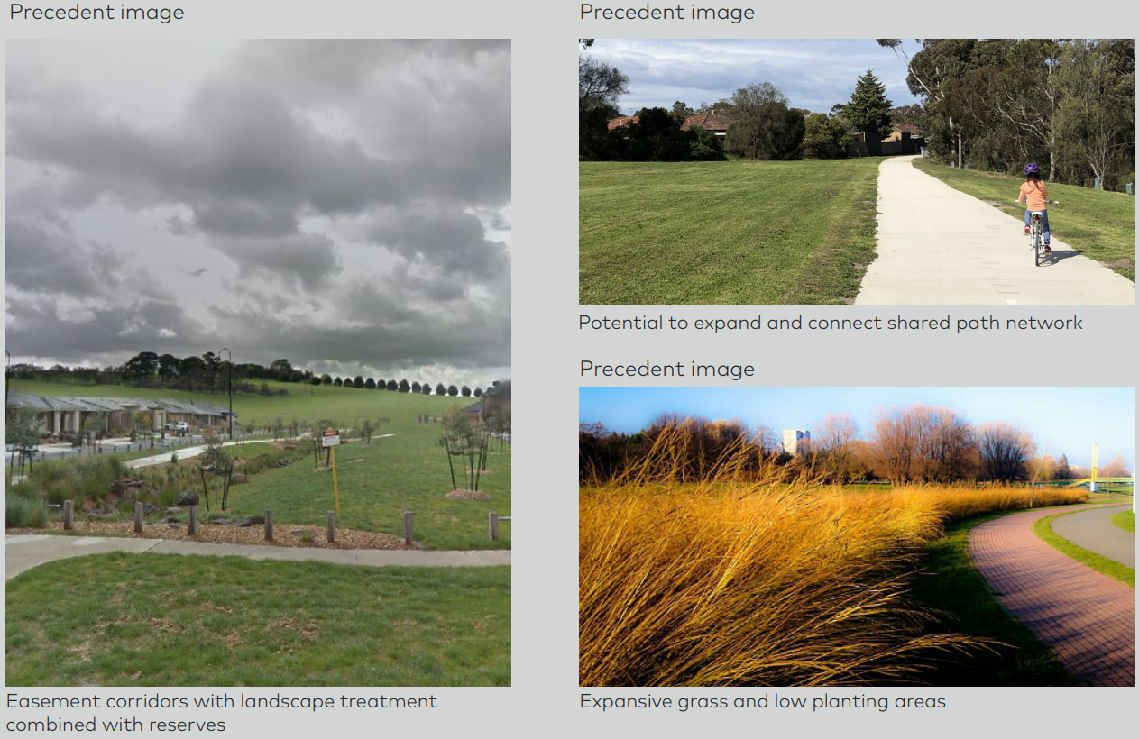

Source: APA, 2020 – Site Planning and Landscape National Guidelines.

### Section 1 – Plumpton to Calder Highway

The Project at this location is not expected to impact existing and reasonably foreseeable land uses, as an existing pipeline has been accounted for in the Plumpton PSP. Additional limitations on land uses within the green wedge are not expected to occur due the existing easement at Section 1.

As the pipeline is within an existing easement within Section 1, any impacts on agricultural land use caused by the presence of a gas pipeline are existing and would not be amplified by the Project. Additional traffic movements caused by maintenance and inspections is considered to be negligible in the context of background traffic volumes and are considered to be consistent with the general use of the road network.

The primary impact associated with operation in Section 1 is the use of land for the purposes of MLV1. This use of land is minimal in area and compensation for the reservation of the land required would be provided in accordance with the Land Acquisition and Compensation Act 1986 as a priority where applicable. APA currently has an easement over the land on which MLV1 is proposed. APA would seek to reach a commercial agreement with the owner of the land for the acquisition of the MLV site. As an easement exists over the MLV footprint already, if APA cannot reach an agreement with the landowner, no further action would be taken and the existing easement would serve as APA's interest in the land on which the MLV1 is located.

Potential impacts on land use within Section 1 during operation, and relevant mitigation measures, are described in Table 15‑6. By applying the mitigation measures the residual impacts across Section 1 during operation is assessed as low.

Table 15‑6 Operational impacts to Section 1 and mitigation measures

|  |  |  |  |
| --- | --- | --- | --- |
| 1. Possible impact | 1. Land use typology impacted | 1. Relevant mitigation measures | 1. Residual impact |
| 1. Consistency with PSPs (Risk ID LU1) 2. While the Project at this location directly intersects with the Plumpton PSP, it is within an existing pipeline easement which has been factored into the PSP and its underlying plans and objectives. Therefore the Project at this location is not expected to impact existing and reasonably foreseeable land uses within this PSP during operation, as the existing pipeline has been accounted for. | 1. Residential, open space (future) | 1. The Project provides for consistency with the Plumpton PSP, which is in accordance with EMM LU1. 2. The pipeline is designed in accordance with AS/NZS 2885 with consideration to land use in the PSP. 3. Therefore, there are no impacts to consistency with PSPs in Section 1. | 1. As the impact has been avoided, no residual impacts are anticipated. |
| 1. Continuation of existing land uses and limitations on future construction in easements (Risk ID LU2) 2. The presence of the pipeline easement would limit the use of land within the easement, as construction of agricultural buildings (eg sheds) with digging and earthworks are only permitted within the easement with written approval from APA. 3. However, within Section 1, the Project is within an existing pipeline easement. Therefore the Project at this location is not expected to further impact existing and reasonably foreseeable land uses. | 1. Agricultural | 1. As the pipeline is within an existing easement within Section 1, operational impacts to agricultural land uses caused by the presence of a gas pipeline are generally pre-existing and would not be amplified by the Project. 2. The Agricultural Impact Assessment (Chapter 16 Social) found that normal agricultural production along the easement would be able to resume during operation of the Project. Impacts on agricultural land uses are predominately mitigated through EMM S2, and it is anticipated that the Project would have a low impact on farming operations. | 1. There are expected to be minimal residual impacts, with no additional limitations being placed on the use of land along the alignment due to the existing pipeline easement at this location. |
| 1. Impacts to land tenure through acquisition (Risk ID LU3) 2. One MLV would be constructed in Section 1, within private agricultural land to the north of Holden Road. The land for the MLV compound would be acquired by APA. Acquisition of land could result in severance of land, reduced accessibility, and permanent loss of productive agricultural land. | 1. Agricultural | 1. The land required for the MLV1 is minor and small in size, and would be located within the existing easement, and co-located with the existing Sunbury Pipeline MLV. 2. Compensation will be agreed and paid to directly affected landholders. (EMM LU3). 3. Generally the impact on agricultural land uses for acquisition for the MLV is considered to be low, considering the provision of appropriate compensation and the minimal area required. 4. It is noted that the monetary unmitigated economic impact on agriculture at the construction stage is estimated at $0.2 million for the full construction corridor across all sections, which is equivalent to 0.0013% of the annual value of agricultural production within the regional study area, as determined by the Agricultural Impact Assessment. However, this value would be mitigated through appropriate landowner compensation in accordance with EMM LU3. | 1. Following landowner agreement and compensation, there is not expected to be residual impacts from acquisition. |
| 1. Increases to traffic during operation (Risk ID LU2) 2. A minimal increase in traffic may occur due to ongoing gas pipeline maintenance and inspections during the operation phase, compared to operation for the existing pipeline easement. | 1. Transport and infrastructure | 1. Additional traffic movements caused by maintenance and inspections is considered to be negligible in the context of background traffic volumes and are considered to be consistent with the general use of the road network, with no further mitigation required. | 1. No residual impacts are anticipated. |
| 1. Constraints to existing and future roads and utilities (Risk ID LU2) 2. It is expected that there would be some impacts on planning for future roads and utilities in Section 1, as all infrastructure (including but not limited to roads, drainage, or utility) would be required to cross the APA gas pipeline at 90 degrees, unless with the consent of APA, and be engineered to protect the integrity of the pipeline. 3. The Project may also constrain the design and construction of the OMR/E6 Transport corridor, which the Project crosses at the northern extent of Section 1. | 1. Transport and infrastructure | 1. Known future roads and utility infrastructure at this section is generally planned within the Plumpton PSP, which incorporates the existing pipeline easement into its plans and objectives. The pipeline is therefore not considered to present further limitations to road and utility design in Section 1. 2. A risk assessment has been undertaken by APA and the DoT (DoT) to assess the potential impact of the WORM pipeline on the future development of the OMR/E6 Transport corridor, based on the preliminary OMR/E6 concept design undertaken by DoT. The risk assessment has considered the Project alignment, design and construction methodology. Consequently, APA and the DoT have agreed upon specific requirements for the Project and these have been incorporated into a draft Coordination Deed, to be executed by APA and the DoT prior to the commencement of construction. The Coordination Deed includes requirements relating to the depth of cover to the pipeline in the OMR/E6, backfill requirements and consideration of a reduced pipeline easement within the OMR/E6 Transport Corridor.Public Acquisition Overlay as requiredOMR/E6 Transport corridor. | 1. The residual impact would relate to the pipeline constraining or preventing the construction of the OMR/E6 Transport corridor. 2. Given APA and the DoT are finalising specific requirements to be incorporated into a Coordination Deed for the Project to mitigate the potential impacts, and are involved in ongoing discussions, it is anticipated that the residual impact to the OMR/E6 Transport corridor would be minor. |

### Section 2 – Calder Highway to Mickleham Road

The Project in this section would be located in a new easement and could result in some limitations to agricultural land uses and roads. These impacts would be mitigated through rehabilitation measures post-construction, which would occur within six months of construction. Once the pipeline and the MLV2 is constructed, the agricultural land uses would be able to continue along the Project, though agricultural buildings (for example, sheds) would then be prohibited within the easement.

Potential impacts on traffic caused by maintenance and inspection activities are considered to be negligible in the context of background traffic volumes and considered to be consistent with the general use of the road network.

Potential impacts on land use within Section 2 during operation, and relevant mitigation measures, are described in Table 15‑7. By applying the mitigation measures, the residual impact on land use in Section 2 during operations is assessed as low.

Table 15‑7 Operational impacts to Section 2 and mitigation measures

|  |  |  |  |
| --- | --- | --- | --- |
| 1. Possible impact | 1. Land use typology impacted | 1. Relevant mitigation measures | 1. Residual impacts |
| 1. Continuation of existing land uses and limitations on future construction in easements (Risk ID LU2) 2. The presence of the pipeline easement would limit the use of land within the easement, as construction of agricultural buildings (eg sheds) with digging and earthworks would only be permitted within the easement with written approval from APA. | 1. Agricultural | 1. Impacts to agricultural land uses within Section 2 would be mitigated through rehabilitation post-construction, which would occur within six months of construction (EMM LU2). Grain crops, grazing and livestock husbandry would be able to continue along the Project, though agricultural buildings (eg sheds) would be prohibited within the easement. 2. The Agricultural Impact Assessment found that normal agricultural production along the easement would be able to resume during operation of the Project. Impacts on agricultural land uses are predominately mitigated through EMM S2, and it is anticipated that the Project would have a low impact on farming operations. | 1. Residual impacts are expected to be minor. 2. It is not anticipated there would be significant impacts on development of land within Section 2, which is located entirely in the green wedge, where further development and subdivision is heavily restricted. |
| 1. Impacts on land tenure through acquisition (Risk ID LU3) 2. One MLV would be constructed in Section 2, and the land for the MLV compound would be acquired by APA. 3. The land required for MLV2 is relatively small and gated access during operation would be maintained via Oaklands Road. Acquisition of land could result in severance of land, reduced accessibility, and permanent loss of productive agricultural land. | 1. Agricultural | 1. The land required for the MLV2 is minor, small in size and adjacent to a property boundary. 2. Compensation will be agreed and paid to directly affected landholders (EMM LU3). 3. Generally the impact on agricultural land uses for acquisition for the MLV is considered to be low, considering the provision of appropriate compensation and the minimal area required. 4. It is noted that the monetary unmitigated economic impact on agriculture for the full construction corridor at the construction stage is estimated at $0.2 million across all sections, which is equivalent to 0.0013% of the annual value of agricultural production within the regional study area, as determined by the Agricultural Impact Assessment. However, this value would be mitigated through appropriate landowner compensation in accordance with EMM LU3. | 1. Following landowner agreement and compensation, there is not expected to be residual impacts from acquisition. |
| 1. Increases to traffic during operation (Risk ID LU2) 2. A minimal increase in traffic may occur due to ongoing gas pipeline maintenance and inspections during the operation phase. | 1. Transport and infrastructure | 1. Additional traffic movements caused by maintenance and inspections is considered to be negligible in the context of background traffic volumes and are considered to be consistent with the general use of the road network, with no further mitigation required. | 1. No residual impacts are anticipated. |
| 1. Constraints to existing and future roads and utilities (Risk ID LU2) 2. It is expected that there would be some impacts on planning for future roads and utilities in Section 2, as all infrastructure (including but not limited to roads, drainage, or utility) would be required to cross the APA gas pipeline at 90 degrees, unless with the consent of APA, and be engineered to protect the integrity of the pipeline. 3. The Project may also constrain the design and construction of the OMR/E6 Transport corridor, which the Project crosses or travels alongside for much of Section 2. | 1. Transport and infrastructure | 1. The Project would present some constraints to future road and utility planning in Section 2, as the Project is not within an existing easement at this location. This impact is considered to be minor, as the presence of a pipeline would not prevent the construction of future roads or utilities. 2. APA is conducting ongoing discussions with the DoT to appropriately co-locate the Project easement adjacent to the future OMR/E6 Transport corridor where possible. 3. A risk assessment has been undertaken by APA and the DoT to assess the potential impact of the WORM pipeline on the future development of the OMR/E6 Transport corridor, based on the preliminary OMR/E6 concept design undertaken by DoT. The risk assessment has considered the Project alignment, design and construction methodology. Consequently, APA and the DoT have agreed upon specific requirements for the Project and these have been incorporated into a draft Coordination Deed, to be executed by APA and the DoT prior to the commencement of construction. The Coordination Deed includes requirements relating to the depth of cover to the pipeline in the OMR/E6 Transport corridor backfill requirements and consideration of a reduced pipeline easement within the OMR/E6 Transport corridor. | 1. The residual impact would relate to the pipeline constraining or preventing the construction of the OMR/E6 Transport corridor. 2. Given APA and the DoT are finalising specific requirements to be incorporated into a Coordination Deed for the Project to mitigate the potential impacts, and are involved in ongoing discussions, it is anticipated that the residual impact to the OMR/E6 Transport corridor would be minor. |

### Section 3 – Mickleham to Donnybrook

Similarly to Section 1, the eastern extent of the Project would be within an existing pipeline easement and is therefore not expected to impact existing and future land uses as an existing pipeline has been accounted for in the Donnybrook-Woodstock PSP. Additional limitations on land uses within the green wedge are not expected to occur due the existing easement at this location.

While the Project is not included in some PSPs in Section 3 (Lindum Vale, Merrifield West, Lockerbie North and Lockerbie), the pipeline would be designed to meet the current and reasonably foreseeable land use. The Project easement and Area of Consequence would also be incorporated and shown in proposed PSPs and a notification obligation for sensitive uses as defined by AS2885 within the Area of Consequence would be included within the planning scheme (EMM LU1), which would mitigate impacts on planned land uses. Planned future PSPs along the Project (including Merrifield North and Beveridge South West PSPs) would incorporate the proposed easement (EMM LU1).

Communication with landowners as part of easement management would be ongoing, and compensation would be provided in accordance with the Pipelines Act or the Land Acquisition and Compensation Act 1986 (EMM LU3). Land to be acquired for MLV3 is approximately 0.02 hectare and would not result in landlocking or discontinuation of surrounding land.

The Project has been refined in negotiation with the DoT so that the future use of land for the OMR/E6 Transport corridor is not prejudiced by the Project.

Grain crops, grazing and livestock husbandry would be able to continue along the Project, though agricultural buildings (eg sheds) would be prohibited within the easement.

Additional traffic movements caused by maintenance and inspections are considered to be negligible in the context of background traffic volumes and are considered to be consistent with the general use of the road network.

The Pipeline would not be expected to impact Melbourne Airport throughout operation.

Potential impacts on land use within Section 3 during operation, and relevant mitigation measures, are described in Table 15‑8. By applying the mitigation measures, the residual impact on land use in Section 3 during operations is assessed as low.

Table 15‑8 Operational impacts to Section 3 and mitigation measures

|  |  |  |  |
| --- | --- | --- | --- |
| 1. Possible impact | 1. Land use typology impacted | 1. Relevant mitigation measures | 1. Residual impacts |
| 1. Consistency with PSPs (Risk ID LU1) 2. The Project is not incorporated into a number of PSPs within Section 3, including the Lindum Vale, Merrifield West and Lockerbie PSPs. 3. There is a risk that the Project may result in inconsistencies with the PSP where development related to sensitive uses cannot proceed as described within the PSP. Development would not be allowed within the pipeline easement without the approval of APA. 4. It is noted that in the Merrifield West PSP, a shared use path may need to be removed temporarily for construction of the pipeline, though this could be reinstated post-construction (and typically shared use paths are an acceptable land use to be located along a pipeline). 5. Additionally, uses that may not typically be encouraged in the 659 m pipeline ML (such as schools or other community facilities) may have been planned for in the PSPs. This is the case within both the Merrifield West and Lockerbie PSPs. There is a child care centre (Kool Kidz Childcare Merrifield) located approximately 640 metres from the centre of the pipeline alignment (near KP 30), north of Donnybrook Road. 6. However, it is noted that schools and community facilities are not prohibited within the pipeline ML, and indeed they are planned for within the pipeline ML in the Donnybrook-Woodstock PSP, which takes the pipeline into account. 7. While the Project at this location directly intersects with the Donnybrook-Woodstock PSP, it is within an existing pipeline easement. This has been factored into the PSP and its underlying plans and objectives. Therefore, the Project at this location is not expected to impact existing and reasonably foreseeable land uses within this PSP during operation, as the existing pipeline has been accounted for. | 1. Residential, community facilities | 1. The inconsistency with PSPs in Section 3 would be primarily mitigated through EMM LU1, which states that the pipeline reinstatement would, as far as practicable, minimise impacts on PSPs and growth areas by providing for consistency with approved and future PSPs, which would be achieved by:  * Co-locating the Project with other utility and transport infrastructure projects to avoid impacts on net developable land * Where the pipeline has not been provided for in an existing PSP, the pipeline is designed in accordance with AS/NZS 2885 with consideration to the PSP land use. APA seeks to minimise impacts on existing or new PSPs and growth areas by providing for development planned in PSPs to continue, while allowing safety to be assessed case by case where relevant for sensitive uses, and working with VPA to incorporate the easement and relevant notification provisions * If co-location with infrastructure projects is not possible at a particular location, the Project should avoid parcels that have or would be developed for residential or community land uses. It is preferable that the Project be located where land can be appropriately rehabilitated (eg agricultural land uses, or alongside roads and/or other linear infrastructure) * APA is undertaking ongoing consultation and discussion with the VPA to ensure the Project is appropriately provided for in all future PSPs along the Project. Additionally, APA's landscaping guidelines provide for a number of uses that would accommodate any future PSPs.  1. With the above measures taken into consideration, the residual impact on consistency with PSPs is low. | 1. With the relevant environmental management measures and measures within PSPs, the residual impact is expected to be minor. |
| 1. Continuation of existing land uses (direct and indirect) and limitations on future construction in easements (Risk ID LU2) 2. The presence of the pipeline easement would limit the use of land within the easement, as construction of buildings and planting of deep-rooted vegetation would be prohibited within the pipeline easement. 3. The inclusion of a pipeline easement may also constrain future subdivision and development of land across the Project. | 1. Agricultural, residential | 1. Impacts on existing agricultural land uses within Section 3 would be mitigated through rehabilitation post-construction, which would occur within six months of construction (EMM LU2). Grain crops, grazing and livestock husbandry would be able to continue along the Project, though agricultural buildings (eg sheds) would be prohibited within the easement. 2. The Agricultural Impact Assessment found that normal agricultural production along the easement would be able to resume during operation of the Project after a nominal timeframe of 12 months post-construction. Impacts on agricultural land uses are predominately mitigated through EMM S2 and it is anticipated that the Project would have a low impact on farming operations. 3. Additionally, it is also noted that agricultural land uses are unlikely to persist in Section 3 in the future as the area is within the urban growth boundary. The land is likely to transition to residential and commercial uses in the future, which are planned for through PSPs (see above for discussion). Indirect impacts to planning for these land uses may occur, but can be managed with low risk through PSPs. 4. However, the location of the Project (being predominately parallel with existing or future roads) means the easement is unlikely to prejudice future residential or commercial construction. Limitations to roads and utility construction are discussed below. | 1. Residual impacts are expected to be minor with the environmental management measures applied. |
| 1. Impacts to land tenure through acquisition (Risk ID LU3) 2. One MLV would be constructed in Section 3, and the land for the MLV compound would be acquired by APA. 3. The land required for MLV3 is minor and small in size at 15 m^2, the MLV would sit up against the cadastral boundary of the property to minimise any impacts. The MLV would also include gated access during operation that would be maintained via Gunns Gully Road. Acquisition of land could result in severance of land, reduced accessibility, and permanent loss of productive agricultural land. | 1. Agricultural | 1. The land required for the MLV3 is minor and small in size. 2. Compensation will be agreed and paid to directly affected landholders (EMM LU3). 3. Generally, the impact on agricultural land uses for acquisition for the MLV is considered to be low when considering the provision of appropriate compensation and the minimal area required. 4. It is noted that the monetary unmitigated economic impact on agriculture for the full construction corridor at the construction stage is estimated at $0.2 million across all sections, which is equivalent to 0.0013% of the annual value of agricultural production within the regional study area, as determined by the Agricultural Impact Assessment. However, this value would be mitigated through appropriate landowner compensation in accordance with EMM LU3. | 1. Following landowner agreement and compensation, there is not expected to be residual impacts from acquisition. |
| 1. Increases to traffic during operation (Risk ID LU2) 2. A minimal increase in traffic may occur due to ongoing gas pipeline maintenance and inspections during the operation phase. | 1. Transport and infrastructure | 1. Additional traffic movements caused by maintenance and inspections is negligible in the context of background traffic volumes and are considered to be consistent with the general use of the road network, with no further mitigation required. | 1. No residual impacts are anticipated. |
| 1. Constraints to existing and future roads and utilities (Risk ID LU2) 2. It is expected that there would be some impacts on planning for future roads and utilities in Section 3, as all infrastructure (including but not limited to roads, drainage, or utility) would be required to cross the APA gas pipeline at 90 degrees, unless with the consent of APA, and be engineered to protect the integrity of the pipeline. 3. The Project may also directly or indirectly constrain the design and construction of the OMR/E6 Transport corridor, which the Project runs parallel with for much of Section 3. | 1. Transport and infrastructure | 1. The Project would present some constraints to future road and utility planning in Section 3, as the Project is predominately not within an existing easement at this location. This impact is considered to be minor, as the presence of a pipeline would not prevent the construction of future roads or utilities, and the Project has been considered in the road and utilities planning in the large Donnybrook-Woodstock PSP. 2. APA is conducting ongoing discussions with the DoT to appropriately co-locate the Project easement adjacent to the future OMR/E6 Transport corridor where possible. 3. A risk assessment has been undertaken by APA and the DoT to assess the potential impact of the WORM pipeline on the future development of the OMR/E6 Transport corridor, based on the preliminary OMR/E6 concept design undertaken by DoT. The risk assessment has considered the Project alignment, design and construction methodology. Consequently, APA and the DoT have agreed upon specific requirements for the Project and these have been incorporated into a draft Coordination Deed, to be executed by APA and the DoT prior to the commencement of construction. The Coordination Deed includes requirements relating to the depth of cover to the pipeline in the OMR/E6 Transport corridor, backfill requirements and consideration of a reduced pipeline easement within the OMR/E6 Transport Corridor Public Acquisition Overlay as required OMR/E6 Transport corridor. | 1. The residual impact would be minor and manageable in planning for future roads and utilities. 2. Given APA and the DoT are finalising specific requirements to be incorporated into a Coordination Deed for the Project to mitigate the potential impacts, and are involved in ongoing discussions, it is anticipated that the residual impact to the OMR/E6 Transport corridor would be minor. |

### Section 4 – Donnybrook to Wollert Compressor Station

The Project proposed in Section 4 would be within an existing pipeline easement and is not expected to have an impact on existing and reasonably foreseeable land uses during its operation, including the Phillips Quarry. Additionally, the proposed Wollert Compressor Station upgrades would be located within APA owned land adjacent to their existing facilities.

Potential impacts on land use within Section 4 during operation, and relevant mitigation measures, are described in Table 15‑9. By applying the mitigation measures, the residual impact on land use in Section 4 during operations is assessed as negligible.

Table 15‑9 Operational impacts to Section 4 and mitigation measures

|  |  |  |  |
| --- | --- | --- | --- |
| 1. Possible impact | 1. Land use typology impacted | 1. Relevant mitigation measures | 1. Residual impacts |
| 1. Consistency with PSPs (Risk ID LU1) 2. While the Project in Section 4 directly intersects with the draft Shenstone Park PSP, it is within an existing pipeline easement which has been factored into the PSP and its underlying plans and objectives. Therefore, the Project at this location is not expected to impact existing and reasonably foreseeable land uses within this PSP during operation, as the existing pipeline has been accounted for. | 1. Residential, open space (future) | 1. The Project provides for consistency with the Shenstone Park PSP, which is in accordance with EMM LU1. 2. The pipeline is designed in accordance with AS/NZS 2885 with consideration to land use in the PSP. 3. Therefore, there are no impacts to consistency with PSPs in Section 4. | 1. No residual impacts are anticipated. |
| 1. Continuation of existing land uses (Risk ID LU2) (direct and indirect) and limitations on future construction in easements. 2. The presence of the pipeline easement would limit the use of land within the easement, as construction of agricultural buildings (eg sheds) with digging and earthworks only permitted within the easement with written approval from APA. 3. However, within Section 4, the Project is within an existing pipeline easement and existing APA owned land at the Wollert Compressor Station. Therefore, the Project at this location is not expected to further impact existing and reasonably foreseeable land uses. | 1. Agricultural | 1. As the pipeline is within an existing easement within Section 4, operational impacts to land uses caused by the presence of a gas pipeline and upgrades to Wollert Compressor Station are generally pre-existing and would not be amplified by the Project. 2. The construction of the upgrades to Wollert Compressor Station are also expected to be low scale in intensity and do not represent a departure from the existing land use conditions at the site. | 1. No residual impacts are anticipated. |
| 1. Increases to traffic during operation (Risk ID LU2) 2. A minimal increase in traffic may occur due to ongoing gas pipeline maintenance and inspections during the operation phase. | 1. Transport and infrastructure | 1. Additional traffic movements caused by maintenance and inspections is considered to be negligible in the context of background traffic volumes and are considered to be consistent with the general use of the road network, with no further mitigation required. | 1. No residual impacts are anticipated. |
| 1. Constraints to existing and future roads and utilities (Risk ID LU2) 2. There may be some impacts on planning for future roads and utilities in Section 4, as all infrastructure (including but not limited to roads, drainage, or utility) would be required to cross the APA gas pipeline at 90 degrees, unless with the consent of APA, and be engineered to protect the integrity of the pipeline. | 1. Transport and infrastructure | 1. The Project is within an existing easement at Section 4 and has been considered in future road planning under the Shenstone Park PSP. As such, the operation of the pipeline would not present any additional road or utility planning constraints in Section 4. | 1. No residual impacts are anticipated. |

### Operation residual impacts summary

With the implementation of mitigation measures, residual impacts on land use during operation include:

* Limits to the use of land within the pipeline easement in Section 2, as construction of agricultural buildings (eg sheds) with digging and earthworks would only be permitted within the easement with written approval from APA. Land within this section is located entirely in the green wedge, where further development and subdivision is heavily restricted. The residual impact at this location would be minor.
* Potential inconsistencies with PSPs, given the Project is not incorporated into a number of PSPs within Section 3, including the Lindum Vale, Merrifield West and Lockerbie PSPs. There is a risk that the Project may result in inconsistencies with a PSP, where development cannot proceed as described within the PSP. Additionally, uses that may not typically be encouraged in the 65 m Area of Consequence (such as schools or other community facilities) may have been planned for in the PSPs. The potential for inconsistencies with PSPs in Section 3 could be mitigated through co-locating the pipeline with existing infrastructure, locating, designing and constructing the pipeline in accordance with AS 2885 with consideration to current land use, and generally locating the pipeline in areas that are not scheduled for sensitive land uses (EMM LU1).Given the reduced Area of Consequence, the potential for conflict is minimal and the resulting residual impact would be minor.
* Minor ongoing limitations on land uses where an easement is not already present, as there would be restrictions on the use and development of land within the 15 m easement corridor. Restrictions would include the prohibition of erecting permanent structures, buildings, planting of large trees or shrubs over the underground pipeline. Excavation activities around the pipeline is a managed activity that requires the appropriate APA approvals to proceed. These activities would be prohibited by the Pipelines Act 2005 and pursuant to easement agreements with landowners. These residual impacts are considered to be minor.
* Minor impacts on planning for future roads and utilities, as all infrastructure (including but not limited to roads, drainage, or utility) would be required to cross the APA gas pipeline at 90 degrees, unless with the consent of APA, and be engineered to protect the integrity of the pipeline. These residual impacts are considered to be of minor consequence, as the presence of a pipeline would not prevent the construction of future roads or utilities.

## Cumulative impact assessment

The Project is located within peri-urban Melbourne, with approximately half of the Project being located within the UGB and the remaining area being within the green wedge. This area of Melbourne is undergoing significant change in land use structure which would continue for the foreseeable future, including causing pressure on peri-urban green wedge areas. There are a number of large scale linear infrastructure and utility projects planned in close proximity to the Project.

The following four major projects have been identified relevant to the EES (refer Chapter 5 Evaluation and assessment framework):

* OMR/E6 Transport corridor (approved, not commenced)
* Western Victorian Transmission Network Project (currently not approved)
* Bald Hill to Yan Yean Pipeline Project (approved, planning in progress)
* Sunbury Road upgrade (approved, planning in progress).

Impacts on land use have been lowered where possible by locating the Project within existing pipeline easements (therefore not contributing to cumulative impacts), by co-locating where possible and appropriate with other linear infrastructure, and avoiding sensitive land uses in residential areas. It is considered that the Project presents a minimal increase on cumulative impacts to land use caused by the projects listed above.

## Environmental Management

### Environmental Management Measures

Table 15‑10 lists the environmental management measures (EMMs) relevant to the land use and planning assessment. All environmental management measures apply to both construction and operation phases.

In developing the environmental management measures, the mitigation hierarchy was applied with an obligation to first avoid, minimise, restore and only after exhausting those measures, offset the residual impacts that remain. Avoidance of all potential impacts on land uses is generally not considered feasible due to the nature of land use as a concept (by moving the alignment from one land use, the Project would likely impact another), and the nature of construction limitations (it is not financially or technically feasible to bore the entire length of the pipeline, therefore necessitating open trench construction).

However, minimisation of impacts has been achieved where possible, primarily during alignment selection by avoiding land where rehabilitation would not be feasible (for example, commercial, residential, industrial and community land uses), and by implementing a CEMP, Project Consultation Plan, and Traffic Management Plans. Where construction impacts cannot be minimised or avoided through HDD or boring, land rehabilitation would be undertaken.

With the implementation of the mitigation measures and associated monitoring and contingency measures, the residual risk to land use is considered to be low across all risks identified in Section 15.4.

Table 15‑10 Environmental management measures

|  |  |  |
| --- | --- | --- |
| 1. EMM # | 1. Environmental Management Measure | 1. Mitigation hierarchy |
| 1. LU1 | 1. Impacts to Precinct Structure Plans (PSPs) and growth areas 2. Minimise impacts as far as reasonably practicable to PSPs and growth areas by providing for consistency with approved and PSPs that are yet to be approved. This must include:  * Co-locating the alignment with other utility and transport infrastructure projects to avoid impacts on net developable land where practicable * Where the pipeline has not been provided for in an existing PSP:   + designing the pipeline in accordance with AS 2885 with consideration to current land use * Incorporating the proposed easement and notification area based on the Area of Consequence into any future PSPs along the alignment * Rehabilitating land within existing PSPs in accordance with EMM LU2 * Providing for future uses along the pipeline (eg shared use paths) in accordance with the APA Site Planning and Landscape National Guidelines (APA 2020). | 1. Avoidance and Minimisation |
| 1. LU2 | 1. Continuation of existing land uses 2. Construct and operate the Project in accordance with EMM AQ1, AQ3, AQ4, NV1, NV2, NV3, NV4, NV5 to minimise amenity impacts and support the continuation of existing land uses during construction and operation phases. 3. Rehabilitate land in accordance with the Project CEMP. 4. Continuation of agricultural land uses must be managed in accordance with EMM S2. 5. Inform landowners and occupiers of the construction commencement, and details of the proposed construction programme, in accordance with the Project Consultation Plan. | 1. Minimisation |
| 1. LU3 | 1. Impacts to land tenure and access 2. Provide compensation for the reservation of the easement and acquisition of land for the Project in accordance with Pipelines Act 1985 and Land Acquisition and Compensation Act 1986. 3. Consult relevant stakeholders in relation to construction access and operational activities in accordance with the Project Consultation Plan and Project EMMs S3 and S5. | 1. Minimisation |
| 1. LU4 | 1. Interruptions to roads and railways 2. Develop and implement Traffic Management Plans in accordance with EMM S3. 3. Use trenchless construction methods to avoid disruptions to major roads and railway lines as far as reasonably practicable. | 1. Avoidance and Minimisation |

### Monitoring

Ongoing monitoring and contingency measures for land use and planning include:

* APA would consult with the relevant authority (for example, DoT, council) including any agreed monitoring or contingency measures for co-location with other infrastructure projects
* Following completion of rehabilitation works after construction, a more intensive monitoring would occur for the first 12 months to ensure that reinstatement has been completed to the satisfaction of each land owner and APA. This would include any weed control or reseeding requirements (where required)
* Monitoring and contingency measures for road disruptions would be incorporated, if required, as part of the Traffic Management Plans
* Consultation with any affected residents would be undertaken in accordance with the Project Consultation Plan and feedback from the community or stakeholders monitored in accordance with that Plan.

With easement agreements entered into with relevant landowners, APA would conduct activities in accordance with the agreement which may include relevant monitoring and contingency measures.

## Conclusion

This chapter has identified and assessed existing conditions, potential impacts and mitigation to land use for the Project.

The Project's construction related activities would result in temporary impacts on existing land uses within the construction corridor, predominantly agricultural land uses, which would be managed through the application of the proposed environmental management measures. A CEMP would ensure that the land is appropriately rehabilitated after construction is complete. Access to private properties may also be temporarily impacted during construction, and would be negotiated with private landowners through the Project's Consultation Plan and framework for compensation. Any predicted noise and dust impacts to agricultural and residential land uses would be managed through the Project CEMP, with monitoring and contingency measures also included. The residual impacts on agricultural land uses and access as a result of temporary changes during construction would be low. The residual impacts to amenity as a result of construction are also considered to be low.

The Project crosses two conservation areas being Conservation Area 34a Northern Growth Corridor: Growling Grass Frog Corridor (between KP 42 and KP 44) and 28b – Summerhill Road (East), Wollert (between KP 48 and KP 50) under the MSA. The construction corridor follows the existing VNIE pipeline easement within Conservation Area 34a and mostly for Conservation Area 28b. Native vegetation within Merri Creek would be impacted by the Project, whereas native vegetation was not found to be present at the creek crossing in Conservation Area 28b. The extent of the construction corridor within the conservation areas is minor and therefore it is considered that the Project would not result in a change to the current use of the land at these locations. At these conservation areas, APA reviewed the alignment to identify locations where the Project Area could be narrowed or bored to avoid impacts to ecological values, yet still meet constructability constraints and landowner considerations.

In addition, although not under a formal conservation arrangement, the properties at 910 Craigieburn Road, 430 Oaklands Road and 380 Oaklands Road have been identified by Hume City Council as locations where conservation investment has occurred. APA has revised the alignment at 910 Craigieburn Road (at KP 23) to avoid several large trees and the construction corridor has been narrowed to minimise the impact to native vegetation. The width of the construction corridor has been reduced at 430 Oaklands Road to minimise impact to native vegetation. No native vegetation has been identified within the construction corridor at 380 Oaklands Road.

Once the easement for the Project has been registered, there would be restrictions on the use and development of land within the 15 m easement corridor in accordance with the Pipelines Act and pursuant to easement agreements with landowners. Land use impacts during the operation phase of the Project would include ongoing minor limitations on land use within the green wedge, where an easement was not already present, with land unable to be used for structures or large vegetation. However, cropping and grazing would be able to continue within the easement. The potential impacts on the future use of land have largely been mitigated through the use of existing pipeline easements and co-location with other linear infrastructure where appropriate. Engagement with directly affected landholders commenced in 2018 and would continue with individual negotiations through to agreement.

Impacts to PSPs and growth areas would be mitigated by protecting the pipeline with an easement and identifying the easement in PSPs along the Project. In locations with existing PSPs, the pipeline is designed in accordance with AS/NZS 2885 with consideration to PSP land use. There would be an ongoing requirement that future sensitive uses would be managed within the pipeline Area of Consequence with the easement and Area of Consequence identified in PSPs. Notification provisions in planning schemes would enable APA to assess any potential implications for sensitive uses in that area near the easement. The operational easement would provide an opportunity to increase open space and amenity within new urban areas to benefit the local community in line with the PSPs.

The Project is consistent with relevant state and local land use planning policy, and impacts on land use during construction and operation are considered to be low with the application of the relevant environmental management measures. In response to the EES evaluation objective described at the beginning of this chapter, effects of the Project on land use have been assessed and environmental management measures have been identified to minimise or avoid impacts on land use values.

1. AS/NZS 2885 Pipelines - Gas and liquid petroleum Design and construction.