Chapter

# Air quality

Contents

Chapter 11

11.1 Introduction 11-1

11.2 Method 11-2

11.3 Existing conditions 11-2

11.3.1 Sensitive receptors 11-3

11.3.2 Meteorology 11-4

11.3.3 Background air quality and air pollution indicators 11-6

11.4 Risk assessment 11-8

11.5 Construction impact assessment 11-10

11.5.1 Construction dust emissions 11-10

11.5.2 Non-dust related emissions 11-15

11.5.3 Construction residual impacts summary 11-16

11.6 Operation impact assessment 11-16

11.6.1 Combustion-related air emissions 11-17

11.6.2 Odour emissions 11-22

11.6.3 Operation residual impacts summary 11-22

11.7 Cumulative impact assessment 11-22

11.8 Environmental management 11-23

11.8.1 Environmental management measures 11-23

11.8.2 Monitoring 11-25

11.9 Conclusion 11-26

## Introduction

This chapter provides an assessment of air quality associated with the construction and operation of the Western Outer Ring Main gas pipeline project (the Project). This chapter is based on the assessment presented in Technical Report G Air Quality.

Air quality impacts must be considered during both the construction and operation phases of the Project in terms of potential impacts on amenity, and to community and environmental health for nearby sensitive receptors. This includes potential dust impacts during construction of the Project. Construction dust is required to be managed in accordance with the reasonably practicable (given the proportionate risk) guidelines of *Civil Construction, Building and Demolition Guide* (Environment Protection Authority (EPA) Publication 1834)[1] and supporting guidance documents. For the operation phase, an assessment of air quality impacts associated with the upgrade of the Wollert Compressor Station is required to assess potential air quality impacts on the local community. This is achieved using the State Environment Protection Policy (Air Quality Management) (SEPP AQM)[2].

The EES scoping requirements set out the following evaluation objectives relevant to air quality:

* Minimise potential adverse social, economic, amenity and land use effects at local and regional scales
* Minimise generation of wastes from the Project during construction and operation, and prevent adverse environmental or health effects from storing, handling, transporting and disposing of waste products
* Avoid and minimise potential adverse effects on native vegetation, listed threatened and migratory species and ecological communities, and habitat for these species, as well as restore and offset residual environmental effects consistent with state and Commonwealth policies.

To assess the potential effects on air quality as a result of the Project, an air quality impact assessment was undertaken. The assessment considered sensitive receptors for the construction and operational phases of the Project. The study area used during the construction phase assessed sensitive receptors within 500 metres of the Project alignment. The study area used to assess the operation phase (with dispersion modelling) is 2.5 kilometres around the Wollert Compressor Station. Potential impacts on sensitive receptors were assessed based on modelling of construction and operation scenarios.

Other environmental aspects closely related to the air quality evaluation objectives include potential ecological and social effects resulting from dust generated by the Project during the construction phase. Dust deposition levels are short lived during construction, at levels which are likely to be dissipated during rain events and therefore unlikely to cause ecological or social impacts. The potential biodiversity and social impacts and relevant mitigation measures are addressed in the following reports:

* Technical Report A: Biodiversity and habitats and Chapter 7 *Biodiversity*
* Technical Report L: Social and Chapter 16 *Social*.

## Method

The air quality assessment comprised the following key tasks:

* Review of relevant legislation and policy at a national, state and local level
* Establishment of a study area for air quality, which involved separate study areas, but partially overlapping at the compressor station, for the construction and operation phases of the Project
  + The study area for operation of the Wollert Compressor Station refers to a dispersion modelling domain extent of 2.5 kilometres around the Compressor Station
  + The construction phase study area was defined as a 500 metre buffer either side of the construction corridor
  + Figure 11‑1 outlines the construction and operation study area for air quality
* Desktop assessment of relevant legislation and policy at Commonwealth, state and local level and review of relevant baseline air quality data and reports
* Characterisation of existing conditions, including sensitive receptors, local meteorology and background concentrations of substances in ambient air
* A risk-based review of potential impacts to prioritise the focus of the impact assessment
* Assessment of the potential air quality impacts during construction and operation of the Project through indicative modelling of emissions associated with the Project construction (that is, dust from pipeline construction) and prescriptive modelling of emissions associated with the operation of the Wollert Compressor Station. The assessment also considered odour air quality impacts from construction (for example, disturbance of contaminated soil) and operation activities (for example, fugitive natural gas emissions)
* Development of environmental management measures (EMMs) in response to the impact assessment. Refer to Chapter 19 Environmental management framework for the full list of environmental management measures and Section 10 of Technical Report G Air Quality.

## Existing conditions

|  |  |
| --- | --- |
| The following section outlines the existing air quality in the Project study area.  Existing air quality conditions are established by considering meteorological data, background concentrations of substances in the ambient air and location of nearby sensitive receptors. | What is air quality and ambient air?   1. Air quality refers to the concentration of substances such as gases and particles in the ambient air. 2. The level of substances in air quality affects the health and amenity of human and environmental sensitive receptors. 3. For the purposes of this assessment, ambient air is also referred to as background air quality. It is the average air quality that occurs at a location without Project activities. |

### Sensitive receptors

A desktop assessment was undertaken to identify sensitive receptors located within 500 metres of the construction corridor, and within a 2.5 kilometre radius of the Wollert Compressor Station.

EPA Publication 1518 *Recommended Separation Distances for Industrial Residual Air Emissions* [3] defines sensitive receptors as including residential premises, child care centres, pre-schools, primary schools, education centres or informal outdoor recreation sites.

A total of 484 sensitive receptors were located within the construction and operation study areas. The proposed construction corridor and Wollert Compressor Station mostly traverse low-density populated rural areas, including isolated rural residences, and road reserves. The construction corridor also traverses near existing and proposed residential areas in Hillside, Fraser Rise and Mickleham. The closest housing in these areas were identified approximately 150 metres from the construction corridor.

The closest sensitive receptors to the Project are six individual rural residences located in the range of 35 metres to 50 metres from the construction corridor. There are no housing or other sensitive receptors currently located within 35 metres of the construction corridor. The closest residences to the compressor station are two rural residences located approximately 700 metres to the north-east.

Figure 11‑1 provides a summary of sensitive receptors within 50 metres and 75 metres of the construction corridor and within the operation study area. Air quality impacts as a result of construction dust (without mitigation) would not affect receptors beyond 75 metres. Receptors have been shown within 50 metres and 75 metres as the relevant separation distances associated with different phases and activities of the construction period. Further information on the sensitive receptors identified in Figure 11‑1, and all sensitive receptors within the study area, are provided in Technical Report G Air Quality, Appendix C. The implications of distance of the sensitive receptors within construction and operation study areas is described in sections 11.5 and 11.6.

As outlined in detail in the Technical report L *Social*, other sensitive receptors within 500 metres of the construction corridor are a small number of outdoor recreation sites.

A review of the planning zones applicable to the identified sensitive receptors was undertaken to determine the primary character of the land, whether it is residential, industrial or rural, and determine the types of uses that may occur in that zone. Sensitive receptors were found to be located in zones that provide for urban growth, green wedge and farming uses.

Based on the above, most of the identified receptors are considered residential or rural-residential for the purposes of the air quality assessment. Isolated rural residences are expected in Farming Zones while a higher density of housing is possible in residential developments in Urban Growth Zones. As a result of the nature of the majority of identified sensitive receptors, the air quality assessment covers the worst case potential impacts and mitigation, including other less sensitive land uses by default.

Figure ‑ Air quality study area and sensitive receptors

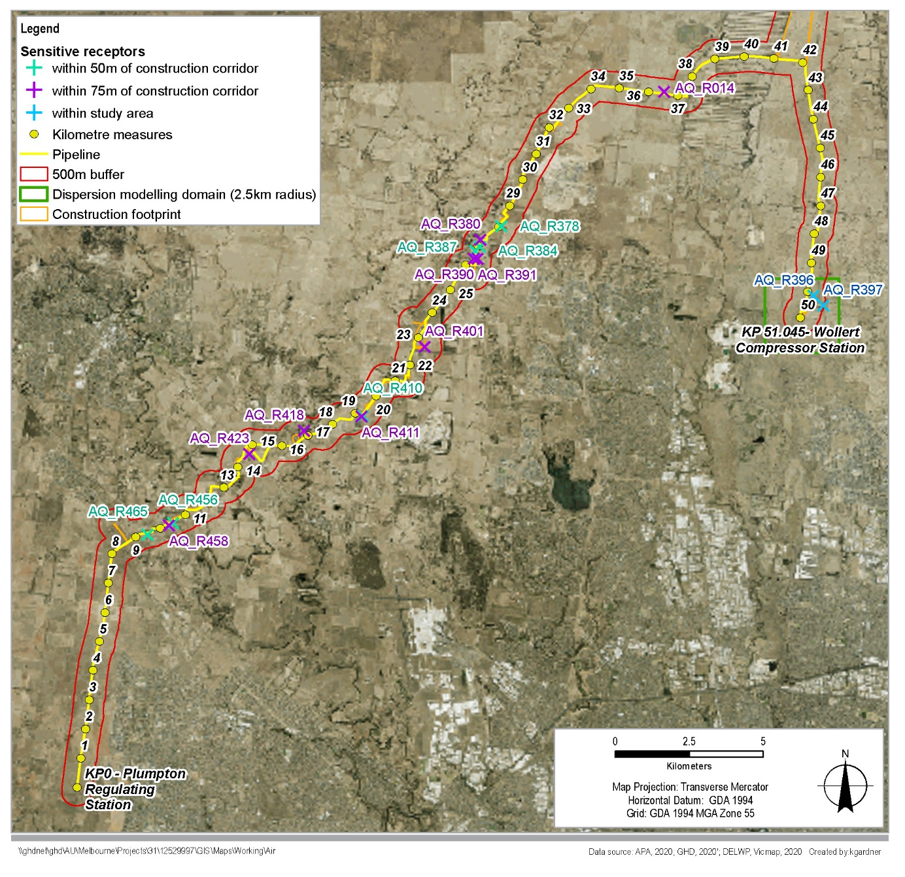

### Meteorology

Understanding the local meteorology at representative locations near the construction corridor and Wollert Compressor Station informed modelling of potential off-site exposure to dust generated during construction of the pipeline and emissions from operation of the Wollert Compressor Station. In particular, the typical distribution of wind speed and wind direction can highlight key issues with distribution and concentration of emissions as they are dispersed from the source to receptor locations.

The Bureau of Meteorology (BoM) operated automatic weather station (AWS) at Melbourne Airport is considered representative of the Project area due to the weather station’s proximity and similar exposure to prevailing winds.

Seasonal wind roses for 2015 to 2019 are shown in Figure 11‑2. The wind roses show the wind direction and speed distribution. The overall predominant wind direction is from the north. The seasonal data shows the wind speed is generally highest from the north in winter, while autumn is generally the calmest season and wind is generally predominantly from the north in all seasons (with some southerly contributions during summer).

Figure ‑ Wind roses for Melbourne Airport (annual and seasonal)

|  |  |
| --- | --- |
|  | |
| **Annual  (average wind speed = 5.4 m/s)** | |
| A diagram showing the summer seasonal wind speeds at Melbourne Airport, as described in the text above. | A diagram showing the autumn seasonal wind speeds at Melbourne Airport, as described in the text above. |
| **Summer (average wind speed = 5.1 m/s)** | **Autumn (average wind speed = 5.1 m/s)** |
| **A diagram showing the winter seasonal wind speeds at Melbourne Airport, as described in the text above.** | A diagram showing the spring seasonal wind speeds at Melbourne Airport, as described in the text above. |
| **Winter (average wind speed = 5.8 m/s)** | **Spring (average wind speed = 5.5 m/s)** |

### Background air quality and air pollution indicators

EPA Victoria air quality monitoring stations across metropolitan Melbourne provide ambient air quality data for the region.

The adopted background concentrations from the EPA Victoria Footscray Air Quality Monitoring Station have been used as a conservative estimate for the Project area, given the Project site is situated in a less urbanised/industrial area. Overall, data from this monitoring station was considered to be the most representative of conditions experienced in the Project area and the northern and western areas of Metropolitan Melbourne in general. The EPA Victoria Melton Air Quality Monitoring Station measures ozone and PM2.5 so was not suitable for background concentrations associated with construction dust (PM10), which is most relevant for the Project.

Within the pipeline construction corridor, existing ambient (background) sources of air emissions are expected from agricultural activities, motor vehicles emissions traversing along the main roads, industrial emissions (including from Melbourne Airport), sand and rock quarries, landfills, the existing compressor station and other light industry.

The consideration of background air quality has focused on the pollutants most likely to be changed by the construction or operation of the Project.

During the construction phase of the Project, dust as particulate matter (PM10 concentrations in particular) is the pollutant of most concern. Particulate matter can be subdivided into particle sized ranges, with – 0 to 10 micron (one millionth of a metre) being termed PM10.

Vehicle exhaust gases from mobile plant emissions (excluding particulate matter) during the construction phase also have the potential to impact on air quality, with key pollutants including carbon monoxide (CO), nitrogen oxides (NOx), and volatile organic compounds (VOCs) such as benzene. However, the impact was not considered further and is likely to be negligible given the limited number of vehicles, the short term construction period at any one location and the low background concentrations of key pollutants.

During the operational phase, air pollutants of relevance to the Wollert Compressor Station include nitrogen dioxide (NO2), carbon monoxide (CO) and Volatile Organic Compounds (VOCs).

The background air quality concentrations adopted for the assessment are shown in Table 11‑1.

|  |
| --- |
| Key air pollution indicators explained   1. Nitrous oxides (NOx) – Nitrogen oxides are a product of combustion such as in motor vehicle and industrial combustion processes. Excessive NO2 can damage human respiration and plant health. 2. Carbon monoxide (CO) is a colourless, odourless gas produced by the incomplete combustion of fuels containing carbon. Exposure to CO in very high concentrations can cause carbon monoxide poisoning, and chronic exposure can cause memory loss, confusion and depression. 3. Particulate matter refers to the many types and sizes of particles suspended in the air we breathe. PM10 (particles with an aerodynamic diameter less than or equal to 10 micrometres) and PM2.5 (particles with an aerodynamic diameter less than or equal to 2.5 micrometres) can have health implications. PM10 often arises from wind-blown dust and material transfer of bulk (soil) materials. PM2.5 can be emitted through combustion activities or from chemical reactions between other pollutants in the atmosphere. 4. Volatile Organic Compounds (VOCs) are carbon-based chemicals that easily evaporate at room temperature and are hazardous to human health. Many common household materials and products give off trace levels of VOCs, which include benzene, formaldehyde and Polycyclic Aromatic Hydrocarbons (PAHs). |

For the Wollert Compressor Station, the background air quality concentrations represent the highest 70th percentile concentration of one year’s observed hourly concentrations measured from 2018. This is required for the operational phase as particulate matter is assessed in SEPP AQM on an hour-by-hour basis for stack sources. For background concentrations in relation to pipeline construction, 24-hourly averaged data from Footscray AQMS from 2018 was used in order to determine the 24-hour 70th percentile values.

A daily background average is used for the construction assessment in accordance with the criteria adopted from the Mining PEM[4], which are 24-hour averages for particulate matter. The Mining PEM is the most relevant of the available PEMs when assessing area-scale emissions from major construction sites (in the absence of a specific PEM for area-based sources). A 70th percentile is used as a proxy concentration as the measured Footscray data are too far away to be site-specific and only marginally site-representative (urban rather than the Project’s site in a peri-urban location).

Table ‑ Representative background air quality concentrations

|  |  |  |  |
| --- | --- | --- | --- |
| 1. Pollutant | 1. Averaging period | 1. Background concentration (70th percentile) (ug/m) | 1. Source |
| 1. Construction | | | |
| 1. PM10 | 1. 24 hour | 1. 21.2 | 24 hour averaged hourly Footscray AQMS data |
| 1. Operation | | | |
| 1. CO | 1. 1 hour | 1. 380 | Hourly Footscray AQMS data |
| 1. NO2 | 1. 1 hour | 1. 15.1 | Hourly Footscray AQMS data |
| 1. PM10 | 1. 1 hour | 1. 21 | Hourly Footscray AQMS data |
| 1. PM2.5 | 1. 1 hour | 1. 8.8 | Hourly Footscray AQMS data |

## Risk assessment

The risk assessment identified the risk pathways associated with air quality as a result of the Project's construction and operation in accordance with the method described in Chapter 5 Evaluation and assessment framework.

To determine key risks associated with air quality, the key sources of air pollution were assessed, including dust and odour emissions from construction activities and emissions resulting from operation of the Wollert Compressor Station. Table 11‑2 presents a summary of the four construction risks and two operation risks identified and assessed as part of the air quality impact assessment. Section 11.8 provides further information on environmental management measures applicable to the air quality impact assessment.

Table 11‑6 identifies the environmental management measures proposed to address air quality impacts.

Table ‑ Air quality risk assessment

|  |  |  |  |  |  |  |
| --- | --- | --- | --- | --- | --- | --- |
| 1. Risk ID | 1. Works area | 1. Risk pathway | 1. Initial mitigation measures | 1. Initial risk rating | 1. Additional mitigation measures | 1. Residual risk rating |
| 1. Construction | | | | | | |
| 1. AQ1 | 1. Pipeline | 1. Construction dust from site clearance and rehabilitation activity (such as bulldozers and graders in site clearance and construction site establishment). | 1. EMM AQ1 – 2. Standard dust mitigation measures. | 1. Medium | EMM AQ1  Additional mitigation measures as required such as a wind barrier (for example, shade cloth to slow down winds) as outlined in EPA Publication 1834 along upwind boundary when next to residences.   1. Rapid response to community raised complaints. | 1. Low |
| 1. AQ2 | 1. Pipeline | 1. Dust from low-impact construction activities result in the generation of dust that deteriorates the existing air quality environment (that is, a scenario where no sensitive receptors are located within separation distances). | 1. EMM AQ1 | 1. Negligible |  | 1. Negligible |
| 1. AQ3 | 1. Pipeline | 1. Dust from high-impact construction activities result in the generation of dust that deteriorates the existing air quality environment (that is, a scenario where sensitive receptors are located within separation distances). | 1. EMM AQ1 | 1. Medium | EMM AQ1  Additional mitigation measures as required such as a wind barrier (for example, a shade cloth to slow down winds) as outlined in EPA Publication 1834 along upwind boundary when next to residences.   1. Rapid response to community raised complaints. 2. Timing activity abutting residential locations to be when dust activity monitoring suggests no off-site impact above SEPP AAQ criteria | 1. Low |
| 1. AQ5 | 1. Pipeline | 1. Odour from construction activities including disturbance of contaminated soil, resulting in amenity impact for nearby residents. | 1. EMM AQ3 – 2. Standard soil management measures for odourous soils | 1. Negligible |  | 1. Negligible |
| 1. Operation | | | | | | |
| 1. AQ4 | 1. Compressor | 1. Operation of compressor station results in impacts on the air quality environment. | 1. EMM AQ2 – achieve SEPP AQM | 1. Low |  | 1. Low |
| 1. AQ6 | 1. Compressor | 1. Odour from operation of the compressor station releases fugitive emissions of natural gas, resulting in amenity impact for nearby residents. | 1. EMM AQ4 – Design and maintenance avoids odorous gas leaks | 1. Negligible |  | 1. Negligible |

## Construction impact assessment

This section presents a discussion of the construction impacts associated with the Project in relation to air quality.

Air quality impacts during construction are predominantly associated with construction activities related to the pipeline. Construction activities associated with the Wollert Compressor Station are generally limited to activities that are unlikely to generate emissions, such as mechanical works, electrical and instrumentation works, hydrostatic testing, commissioning, and site completion. Construction activities such as site clearance are minor in scale in relation to those associated with the pipeline.

Discussion of air quality impacts associated with construction of the pipeline are grouped according to the following main themes:

* Construction dust emissions (particulate matter as PM10 concentrations as the major contributor to health impacts and an indication that dust fallout is occurring)
* Non-dust-related air emissions (odour from excavated soils and combustion emissions from construction equipment, vehicles and plant).

Environmental management measures are discussed as they relate to these air quality impacts. Refer to Chapter 19 Environmental management framework for the full list of environmental management measures and Section 10 of Technical report G Air Quality.

### Construction dust emissions

Pipeline construction stages include clearing and grading, open trenching construction, backfilling and rehabilitation.

Construction air quality impacts would be predominantly due to dust emissions (PM10) generated from site clearing, excavation, drilling, pipe stringing and lowering, and vehicle movements (Risk ID AQ1, AQ2, AQ3) undertaken over the construction stages.

Emission rates were developed in line with the NPI EET Manual for Mining[5] with dispersion modelling undertaken using the EPA Victoria regulatory model, AERMOD[6].

For each construction stage, indicative orientations of the construction corridor were modelled based on the predominant orientations along the construction corridor. Four key orientations were identified: north-south (orientation 1), east-west (orientation 2), north-northeast to south-southwest (orientation 3) and east-northeast to west-southwest (orientation 4). Refer to Figure 11‑3 for a visual representation of the orientations.

As such, all sections of the construction corridor that are oriented in the same direction have the same predicted model result. The modelled construction stages can also be adopted across the corridor as construction proceeds.

Figure ‑ Visual representation of the orientations of the construction corridor

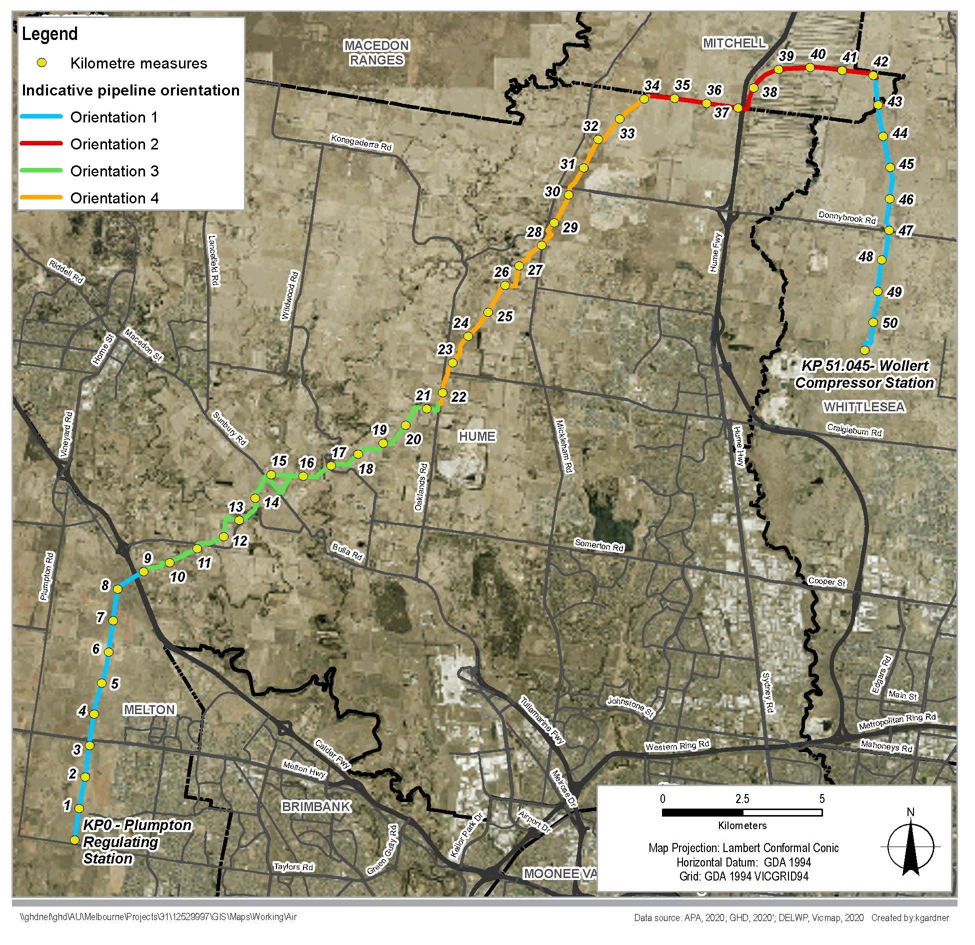

|  |  |
| --- | --- |
| When no dust mitigation is in place, sensitive receptors near to the construction corridor may be subject to dust concentrations which exceed the SEPP AAQ[7] criteria consistent with assessments of extractive industry found in the Mining PEM.  A distance between the construction corridor and sensitive receptors identifies where mitigation is required to maintain dust concentrations within the SEPP AAQ assessment criteria level.  Different distances from the construction corridor would apply, depending on orientation of the construction corridor and the (windward/leeward) side of the corridor. For example, impacts are predicted to be slightly lower to the west of the construction corridor compared to the east, based on the predominant meteorological wind conditions. | What is the SEPP AAQ?   1. The State Environment Protection Policy (Ambient Air Quality) 2006 (SEPP AAQ) sets broad air quality objectives and goals for the whole of Victoria. 2. SEPP AAQ standards apply to regional air quality, rather than individual sources of particulate matter. 3. The AAQ responds to health objectives and provides a guide to acceptable impacts within health criteria. 4. The Environmental Reference Standard to be implemented on 1 July 2021 and which will supersede the SEPPs will have largely the same objectives and the same criteria as the current SEPP AAQ. |

Table 11‑3 outlines separation distances required to meet the SEPP AAQ criteria, applicable to the orientation and phase of construction.

The duration of pipeline construction is approximately five months followed by three months for the rehabilitation. This is for the entire Project, with construction and rehabilitation activities being completed in four to six months in one location. The clear and grade progresses along the corridor at approximately 1 kilometre per day. The open trench construction works follow and progresses along the pipeline corridor at approximately 700 metres per day (HDD and bored crossings are likely to have lower daily progress rates, and could take between two to three weeks at a particular location). There would typically be a gap in works with rehabilitation undertaken later and progressing at approximately 1 kilometre per day.

Activities involving excavation of earth undertaken during the open trenching construction phase of the Project are predicted to have the largest air quality impact. Open trench construction involving blasting (explosives used to crack rock) will result in very limited airborne dust or fumes, as the explosive charges are small and embedded deep within blast holes. The (worst case day) modelling shows that if no standard dust mitigation is put in place, a separation distance of no more than 75 metres from the construction corridor is required before dust concentrations caused as a result of open trench construction are within the assessment PM10 criteria level. A total of 15 sensitive receptors are currently located within 75 metres of the construction corridor.

Table ‑ Summary of pipeline construction results with respect to criteria

|  |  |  |  |  |  |  |
| --- | --- | --- | --- | --- | --- | --- |
| Orientation | Applicable KP | Applicable orientation/ direction | Distance from edge of construction corridor (m) required to meet the SEPP (AAQ) criterion | | | |
| Phase 1: Clear and grade | Phase 2: Open trench construction | Phase 3: Activities associated with backfilling of trench | Phase 4: Rehabilitation of construction corridor |
| 1. 1 | 1. KP 0 to 8 | 1. East | 1. 35 | 1. 61 | 1. 42 | 1. 35 |
| 1. KP 42 to 51 | 1. West | 1. 35 | 1. 75 | 1. 49 | 1. 35 |
| 1. 2 | 1. KP 34 to 42 | 1. North | 1. 35 | 1. 73 | 1. 48 | 1. 35 |
| 1. South | 1. 32 | 1. 74 | 1. 42 | 1. 32 |
| 1. 3 | 1. KP 8 to 21 | 1. South-southeast | 1. 35 | 1. 75 | 1. 45 | 1. 35 |
| 1. North-northwest | 1. 35 | 1. 73 | 1. 45 | 1. 35 |
| 1. 4 | 1. KP 21 to 34 | 1. East-southeast | 1. 35 | 1. 74 | 1. 45 | 1. 35 |
| 1. West-northwest | 1. 35 | 1. 73 | 1. 45 | 1. 35 |

Shorter separation distances from the construction corridor are required for backfilling (no more than 50 metres) and clearing and site rehabilitation phases (no more than 35 metres), before dust emissions would potentially exceed the SEPP AAQ criteria. No sensitive receptors are located within 35 metres of the construction corridor. Six sensitive receptors are within 50 metres of the corridor.

Table 11‑4 includes a breakdown of sensitive receptors within the construction study area that are located within distances required to meet SEPP AAQ criterion.

Table ‑ Summary of sensitive receptors within construction study area (500 metre buffer)

|  |  |
| --- | --- |
| 1. Number of sensitive receptors | 1. Distance from construction boundary (m) |
| 1. 0 | 1. 0-35* |
| 1. 6 | 1. 35-50* |
| 1. 9 | 1. 35-75* |
| 1. 469 | 1. 75-500 |

* Distance from edge of construction corridor (m) required to meet the SEPP AAQ criterion, which includes separation distances of up to 35 metres, 50 metres and 75 metres from the construction boundary.

|  |  |
| --- | --- |
| Activities undertaken during the clear and grade and rehabilitation construction phases have the potential to result in minor air quality impacts on sensitive receptors when standard dust mitigation is in place (Risk ID AQ1). Any impact on health is considered to be negligible as SEPP AAQ can be achieved and the SEPP sets the criteria to meet government health objectives. There would be a low chance of nuisance for residents within the separation distance compared to background levels, such as elevated dust on windows or in outdoor areas.  Standard dust mitigation includes measures outlined in the Construction Environmental Management Plan (CEMP) and via appropriate dust monitoring measures (EMM AQ1). The use of additional mitigation measures where residences are adjacent, such as a wind barrier (for example, shade cloth to slow down winds) can assist in lowering the risk of adverse impact. Where control measures do not successfully stabilise dust, an additional control is also to reduce or suspend works for a period (eg during adverse weather events, such as gusty and dry winds when sensitive receptor locations are downwind). | What is standard dust mitigation?   1. Standard dust mitigation includes measures such as:  * Watering exposed areas * Crushed rock on agreed unsealed access tracks * Restricting vehicle speeds * Covering vehicle loads * Sufficient compaction on stockpile surfaces * Dust suppression activities to consider weather patterns, ground cover, ground conditions and type of activities being conducted in proximity to sensitive receptors.  1. The Environmental Management Measure EMM AQ1 refers to standard dust mitigation to be followed in the Construction Environmental Management Plan (CEMP) and via appropriate dust monitoring measures. 2. Standard mitigation measures are considered industry-leading practice that is reasonably practicable and proportionate to the risk - as described in EPA Publication 1834: *Civil construction, building and demolition guide* and other guidance from EPA Victoria. |

Air quality impacts on sensitive receptors as a result of construction activities depends on proximity and quantity of sensitive receptors to the construction corridor. A range of measures, both standard dust mitigation and additional measures if required, would be applied under EMM AQ1 suited to the conditions, location and distance to sensitive receptors.

The APA construction schedule is for pipeline construction starting in Q4 2021 with the phase 1 to phase 3 construction activities described above to occur over the summer and autumn months. As shown in Figure 11‑2, these periods generally have lower wind levels than the annual average, therefore lower impacts would occur and the separation distances would provide conservative protection.

In a scenario where no sensitive receptors are within the separation distances outlined above (Risk ID AQ2), impacts on air quality as a result of construction activities are considered to be negligible when standard dust mitigation is in place.

Using standard dust mitigation measures (EMM AQ1), a medium air quality impact is expected when isolated rural residences are located within the separation distances (Risk ID AQ3). Moderate health consequences may be expected, due to elevated dust concentrations in the event background concentrations were also high. The implementation of additional mitigation measures would reduce the likelihood, intensity or extent of dust effects and would result in low impact on air quality for sensitive receptors in this scenario. Additional mitigation measures would include a real-time reactive monitor at the isolated rural residences within the separation distance and the ability to reduce or suspend works for a period (for example, during adverse weather events, such as gusty and dry winds and when the monitor exceeds pre-set trigger levels).

Similar to the scenario above, with the use of standard dust control measures, medium air quality impacts are also expected when housing abuts the construction corridor or when multiple sensitive receptors are located within the separation distances (Risk ID AQ3).

Additional mitigation measures in this scenario that would result in low impacts on air quality include reducing or suspending work activities in the immediate area for a period when real-time monitors ‘alarm’ and installing a series of instruments where a row of housing backs onto the construction corridor boundary. In higher density sensitive receptor areas, a gravel treatment of vehicle routes and a wind barrier (for example, a shade cloth to slow down winds) on the upwind construction corridor boundary would also assist to reduce dust (EMM AQ1). There is no current housing abutting or within 35 metres of the construction corridor and these additional treatments would only be required if new housing is established prior to construction.

In all cases, a rapid response to community dust-related concerns would be implemented.

### Non-dust related emissions

Non-dust related air emissions from construction works include odour emissions from excavated soils which may be contaminated (Risk ID AQ5) and combustion emissions from construction equipment, vehicles and plant.

Potential air quality impacts as a result of construction vehicle combustion emissions are likely to be negligible based on the limited number of vehicles, the short term construction period at any one location, the low background concentrations of key pollutants (including carbon monoxide (CO), nitrogen oxides (NOx), and volatile organic compounds (VOCs)) and the distances between significant sources. Furthermore, construction equipment would be maintained in a serviceable condition so that exhaust emissions were reduced to meet manufacturer specifications. Construction vehicle combustion emissions have not been considered further as part of the air quality assessment.

Odour emitting soils are generally associated with contamination and oxidisation of acid sulfate soils. It is unlikely that odorous soils would be encountered based on the findings detailed in Chapter 10 *Contamination and greenhouse gas*. In the event that odorous soils were uncovered, ground disturbance activities would cease, and the site assessed to determine appropriate management actions in consultation with suitably qualified personnel. EMM AQ3 outlines that if odorous soils were found to be contaminated, standard soil management measures would be undertaken, as outlined in EMM C1 (spoil management measures).

### Construction residual impacts summary

With the implementation of mitigation measures, residual impacts on air quality during construction are summarised as follows:

* Residual impacts associated with construction dust where management measures are not successful in completely eliminating dust.

The residual impacts are considered to be minor as the beneficial uses of the air environment are protected through achieving the relevant criteria under AAQ, even when background dust levels are elevated during construction. This is achieved by implementing measures that minimise the duration and intensity of impacts, as detailed in the CEMP including controlling the timing of construction activity or physical controls to avoid the Project contributing more dust when background levels are elevated. With achievement of AAQ, no health impacts are predicted. However, there may be minor nuisance to residents within 75 metres if background levels are elevated, such as more dust on windows or outdoor furniture. With construction progressing at 700 metres per day for open trenching, the impact on an individual rural residence will be for a short duration. The duration of other construction activities (such as boring and Horizontal Direct Drilling (HDD)) can be longer, however, it is expected that the dust emissions associated with horizontal boring and HDD, and associated minor civil works, will be less than those associated with open trench construction as dust emissions will be localised to the entry and exit pits.

* Residual air quality impacts associated with construction vehicle combustion emissions is minimal, due to the scale of vehicles involved and low background concentrations of key combustion emissions.
* The potential residual air quality impacts associated with encountering odorous soils is minimal, due to implementation of soil management measures detailed in the CEMP.

## Operation impact assessment

This section presents a discussion of the operational impacts associated with the Project in relation to air quality.

Air quality impacts during operation are predominantly associated with compressor engine operation at the Wollert Compressor Station. Operation of the pipeline is generally limited to activities that are unlikely to generate emissions and have not been assessed further.

Discussion of air quality impacts associated with operation of the Wollert Compressor Station are grouped according to the following main themes:

* Combustion-related air emissions
* Odorous air emissions.

Environmental management measures are discussed as they relate to these air quality impacts. Refer to Chapter 19 Environmental management framework for the full list of environmental management measures and Section 10 of Technical report G Air Quality.

### Combustion-related air emissions

Operation of the Wollert Compressor Station has the potential to impact air quality, given it would emit various pollutants from the gas-fired engines used to pump gas through the VTS, as required (Risk ID AQ4). A Diesel Engine Alternator (DEA) would be installed to replace a gas-fuelled backup generator and would be an emissions source in emergency operations only, with regular weekly maintenance (firing) occurring.

Emissions are not considered to be generated during commissioning of the proposed upgrades or routine maintenance, due to the nature of activities undertaken during these phases. Emissions generated during emergency venting will be mainly limited to methane emissions. Methane is not a listed substance in the SEPP (therefore exceedances don't apply), but emissions are expected to be minor. Commissioning, startup and shutdown of equipment (Clause 23 of SEPP AQM) and emergency venting are not considered part of routine emissions (ie normal operation) that need to be modelled.

Products of combustion during operation would be emitted through either a vent on the existing Station A building or standalone stacks. Refer to Figure 11‑4 for site layout of the Wollert Compressor Station.

Air dispersion modelling was conducted for CO, NO2, PM10, PM2.5, PAHs, SO2, benzene, formaldehyde, toluene and xylene, which may be emitted by the Wollert Compressor Station under routine operations. The modelling includes emissions from the existing compressors as well as the proposed compressor. Emission rates were developed using the site-specific emission monitoring conducted by Ektimo in 2019 of NOx, as well as NO2, and CO, at the Wollert Compressor Station.

Where site-specific pollutant information was not known (that is, for all remaining pollutants), the emission factors outlined in the National Pollutant Inventory (NPI) *Emission estimation technique (EET) manual for combustion engines* (Version 3, June 2008) were used.

|  |  |
| --- | --- |
| Dispersion modelling was undertaken using the EPA Victoria regulatory model, AERMOD. Modelling assessed scenarios that considered operation of the compressor station with and without the DEA. In all cases the reasonable worst-case scenario (that is, the operational scenario likely to result in the highest predicted pollutant concentrations) was used for calculating emission rates so that the actual emissions are unlikely to exceed those predicted by the model. Worst case predicted pollutant concentrations were assessed within the operation phase study area (a domain including a 2.5 kilometre radius around the compressor station). | What is the SEPP AQM?   1. The State Environment Protection Policy (Air Quality Management) (SEPP AQM) sets the requirements for management of sources of pollution for the air quality objectives of the policy to be met, air quality to improve and the cleanest air possible to be achieved. |



Figure ‑ Wollert Compressor Station site layout

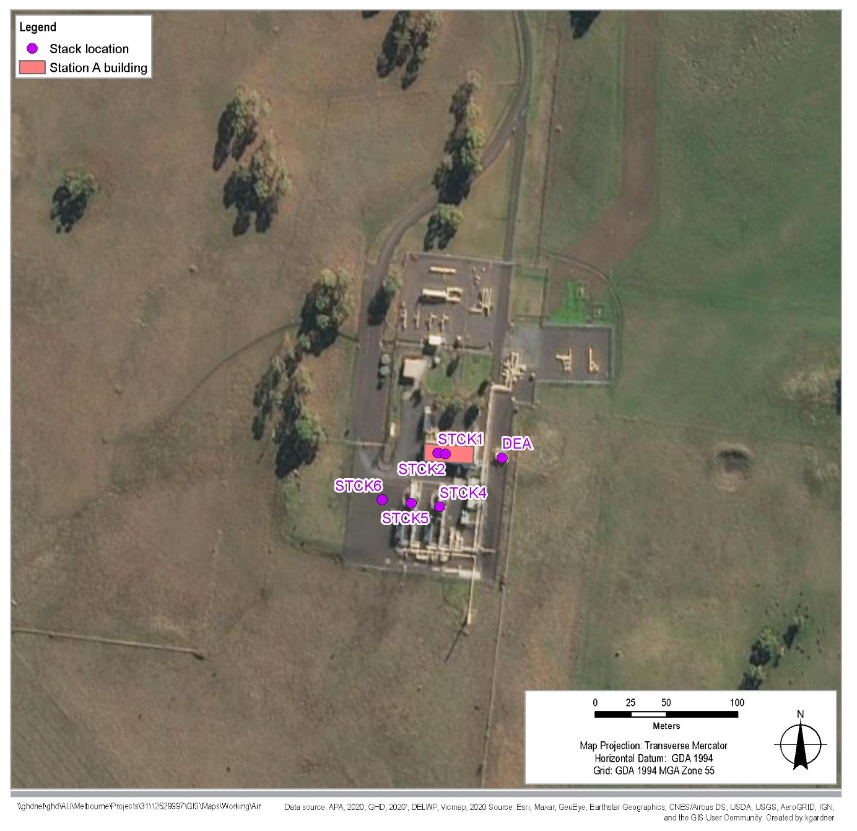

Based on the modelling, all emitted pollutants (with the exception of NO2 and PM2.5 in the scenario that includes the DEA) comply with the relevant SEPP AQM design criteria (refer Table 11‑5).

Table ‑ Wollert Compressor Station results

|  |  |  |  |  |  |  |  |  |
| --- | --- | --- | --- | --- | --- | --- | --- | --- |
| Pollutant | Criteria (µg/m3) | Averaging period | Percentile | Background (µg/m3) | Results including the DEA1 | | Results excluding the DEA | |
| Maximum predicted ground level concentration (GLC)% of SEPP AQM criterion | Comply with SEPP AQM? | Maximum predicted GLC % of SEPP AQM criterion | Comply with SEPP AQM? |
| 1. NO2 | 1. 190 | 1. 1 hour | 1. 99.9% | 1. 15.1 | 1. 106% | 1. **X** | 1. 74% | 1. **✓** |
| 1. CO | 1. 29,000 | 1. 1 hour | 1. 99.9% | 1. 380 | 1. 1% | 1. **✓** | 1. 1.5% | 1. **✓** |
| 1. SO2 | 1. 450 | 1. 1 hour | 1. 99.9% | 1. 0 | 1. 0.03% | 1. **✓** | 1. 0% | 1. **✓** |
| 1. PM10 | 1. 80 | 1. 1 hour | 1. 99.9% | 1. 21 | 1. 92% | 1. **✓** | 1. 27% | 1. **✓** |
| 1. PM2.5 | 1. 50 | 1. 1 hour | 1. 99.9% | 1. 8.8 | 1. 121% | 1. **X** | 1. 18% | 1. **✓** |
| 1. Benzene | 1. 53 | 1. 3 minute | 1. 99.9% | 1. 0 | 1. 0.5% | 1. **✓** | 1. 0.01% | 1. **✓** |
| 1. Formaldehyde | 1. 40 | 1. 3 minute | 1. 99.9% | 1. 0 | 1. 0.8% | 1. **✓** | 1. 0.4% | 1. **✓** |
| 1. PAH (as BaP) | 1. 0.73 | 1. 3 minute | 1. 99.9% | 1. 0 | 1. 0% | 1. **✓** | 1. 0% | 1. **✓** |
| 1. Toluene (odour) | 1. 650 | 1. 3 minute | 1. 99.9% | 1. 0 | 1. 0.02% | 1. **✓** | 1. 0.01% | 1. **✓** |
| 1. Xylenes (odour) | 1. 350 | 1. 3 minute | 1. 99.9% | 1. 0 | 1. 0.03% | 1. **✓** | 1. 0.01% | 1. **✓** |

Note 1: The maintenance firing of the emergency generator is short-lived and not considered a routine ‘worst-case’ emission for the purposes of modelling in SEPP AQM – “ ‘worst case’ emissions must be assumed to be continuous”.

The predicted area of non-compliance for NO2 and PM2.5 when the DEA is operating is small and when assessed in more detail using dispersion modelling, does not impact sensitive receptor locations, as the area lies over the APA-owned property which includes the Wollert Compressor Station (refer Figure 11‑5 and Figure 11‑6). The SEPP AQM ground level concentrations that are modelled are for human health impacts on the most sensitive population (for example, the elderly, children and people with respiratory illnesses) and are much more stringent than OH&S limits that apply on site for workers and visitors.

Operation of the Wollert Compressor Station is therefore expected to result in a low impact on air quality, through implementation of the proposed compressor design and standard monitoring measures that achieve relevant SEPP AQM requirements (EMM AQ2). These measures include installation of proposed compressor discharge point to SEPP AQM requirements and annual stack test monitoring and servicing of compressors.

Figure ‑ Scenario including the DEA, 1 hour NO2 concentration results 99.9th percentile

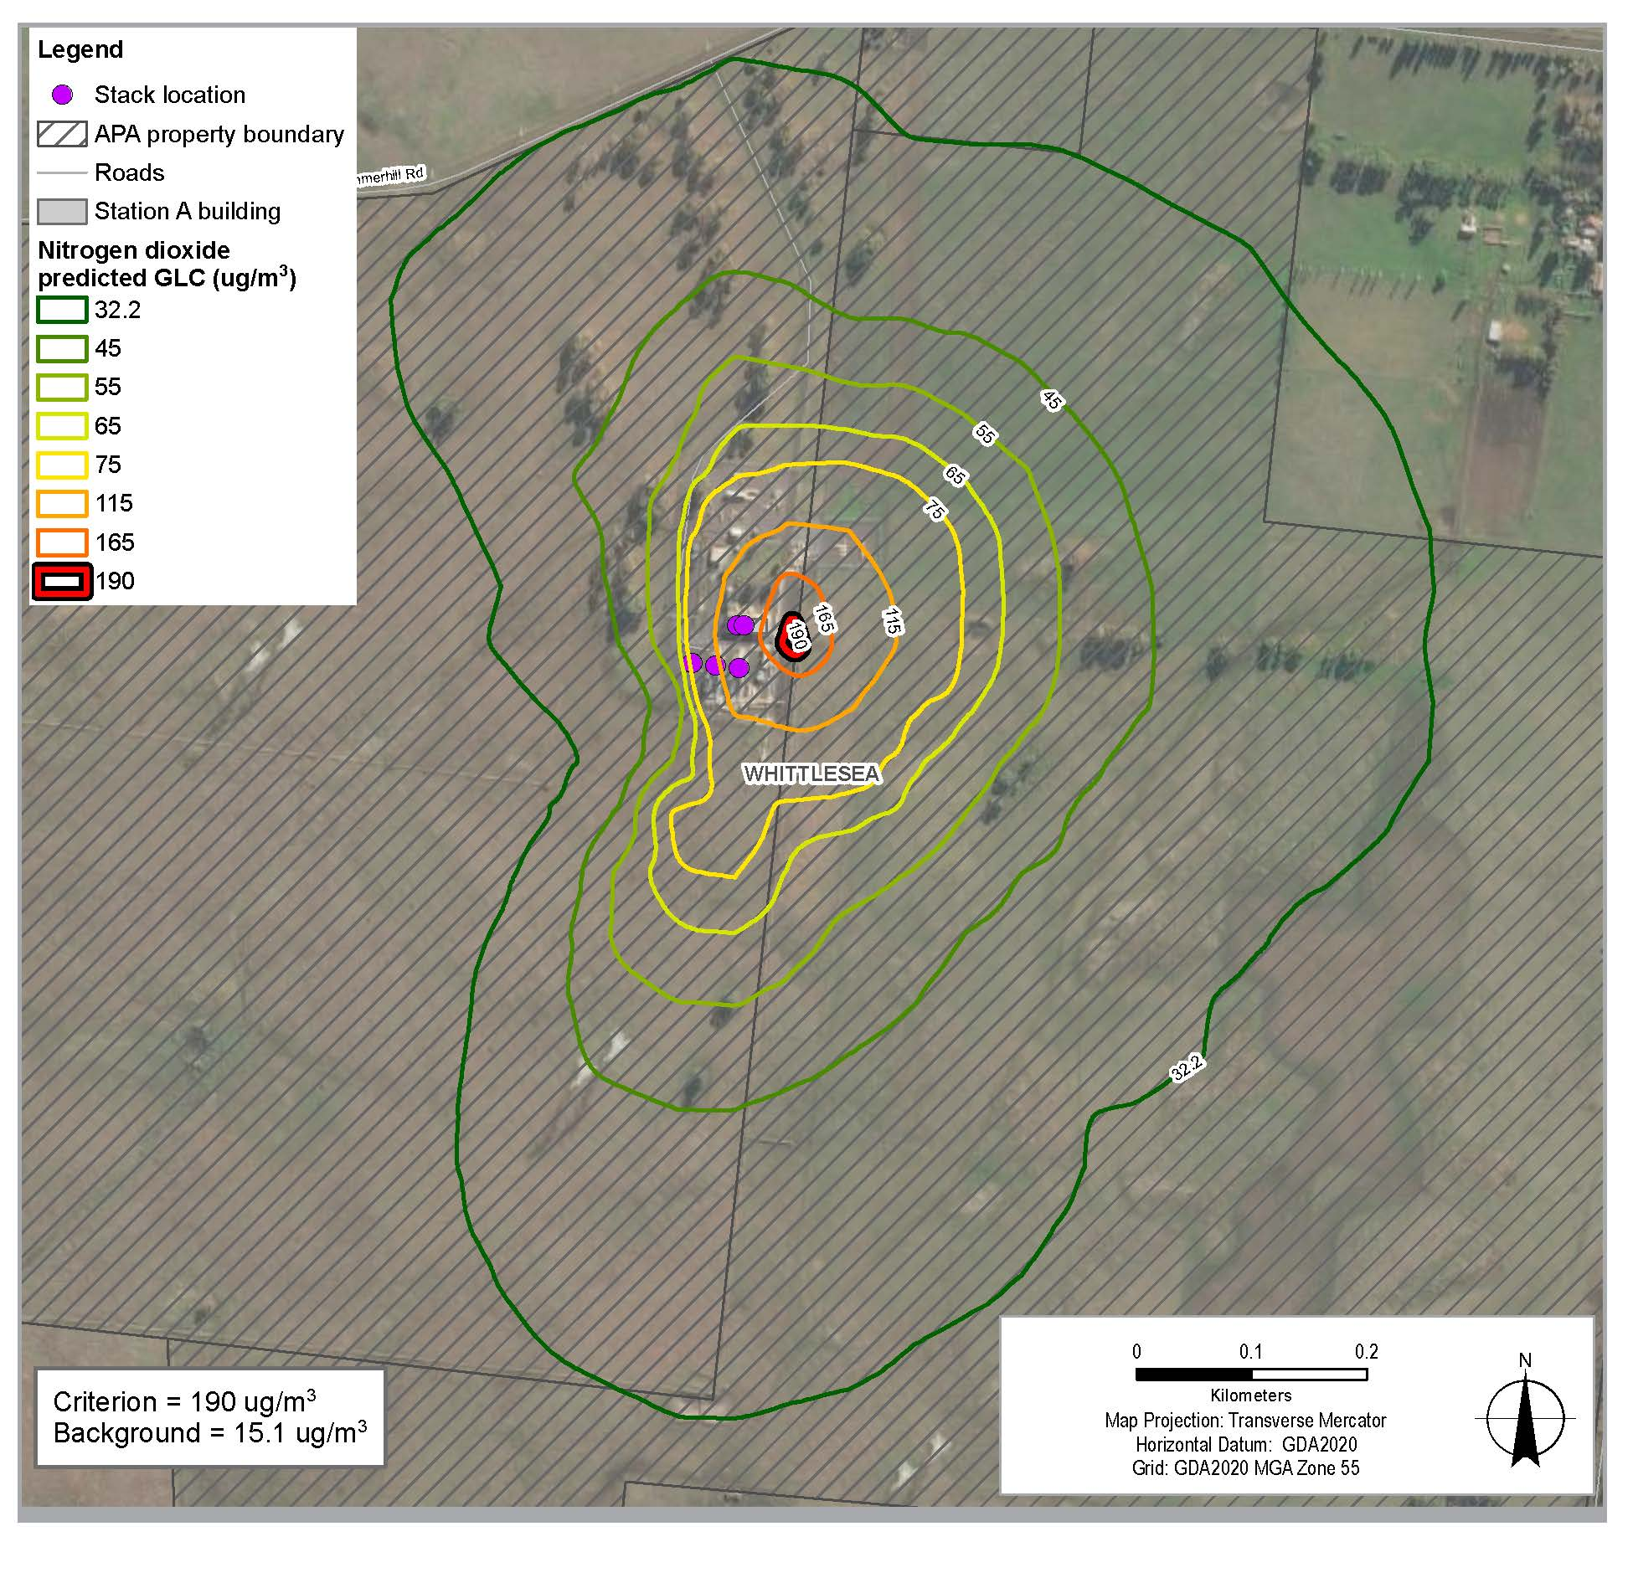

Figure ‑ Scenario including the DEA, 1 hour PM2.5 concentration results 99.9th percentile

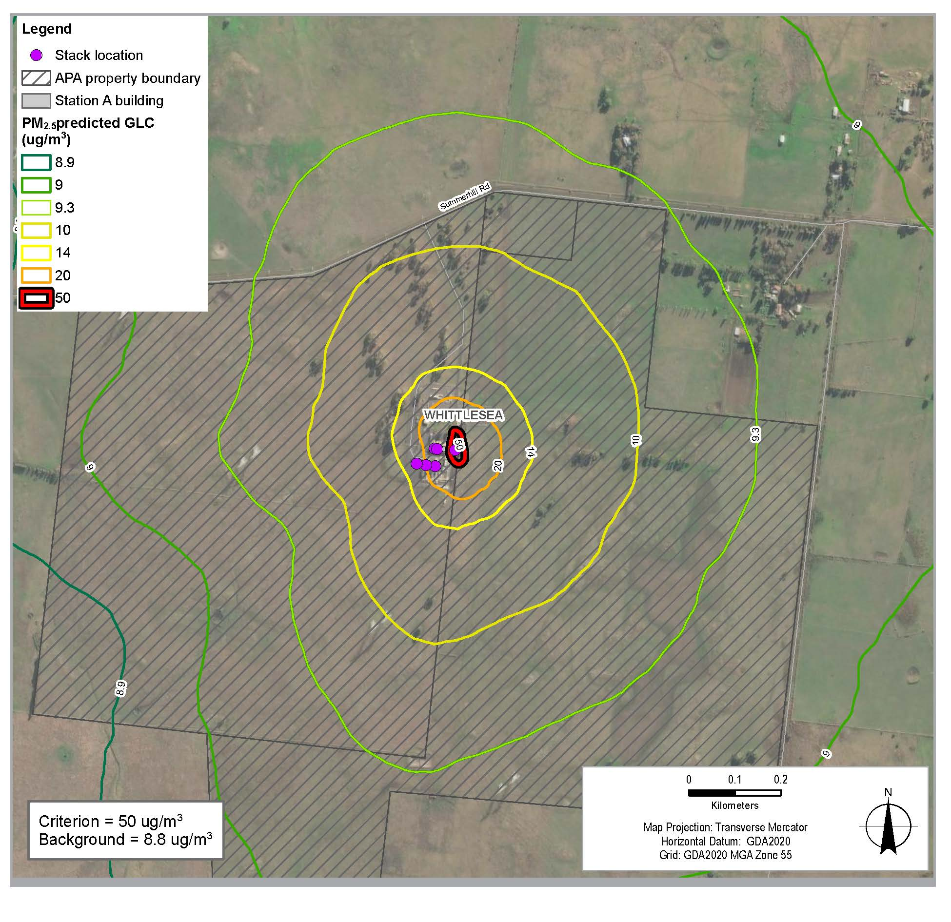

### Odour emissions

Operation of the compressor station has the potential to release odorous air emissions as a result of fugitive emissions of natural gas, in turn potentially impacting amenity for the closest sensitive receptors, located approximately 700 metres north east of the compressor station (Risk ID AQ6).

Units within both Station A and Station B have separate stacks where fugitive emissions are vented (which is separate to the stacks associated with engine exhausts described above)[8].

These fugitive vent stacks are typically used for emergency venting and maintenance to reduce pressure in the system. Fugitive emissions consist mostly of methane (natural gas) and can carry an odour (mercaptan odorant). Design of these stacks allow the venting emergency or routine maintenance gas (unburnt natural gas) higher into the atmosphere than simply allowing fugitive emissions at ground level. TheVTS Pipeline Integrity Management Plan details the activities that will be taken to ensure the integrity of the VTS pipelines, including avoiding leaks of odours during operation (EMM AQ4). These operational odour management measures minimise fugitive gas emissions.

Odorous air emissions as a result of operation of the Wollert Compressor Station are likely to result in a negligible impact on air quality, given operational odour management (as outlined for EMM AQ4). The occurrence of odorous fugitive emissions are expected to be rare and only to occur in exceptional circumstances, corresponding with minor amenity consequences for nearby residents. Odorous air emissions during operation have therefore not been considered further as part of the air quality assessment.

### Operation residual impacts summary

With the implementation of mitigation measures, residual impacts on air quality during operation are summarised as follows:

* When the DEA is included in the proposed design, residual impacts after utilising low NOx and CO technology and modelled stack heights are minor, given the area of exceedance is relatively small and not impacting sensitive receptor locations.

## Cumulative impact assessment

This section presents the findings of the cumulative air quality impact assessment for the Project.

For the purposes of this air quality impact assessment, cumulative impacts refer to the combined effect on background concentrations that take into account potential future background concentrations (such as the effect of potential future projects in the region) and predicted air quality impacts during construction and operation of the Project.

Potential future projects in the same region may include road, rail and major water supply infrastructure, such as the Outer Metropolitan Ring (OMR/E6) transport corridor, Sunbury Road upgrade and Melbourne Water’s Bald Hill to Yan Yean pipeline. Of these known nearby construction projects, only the Melbourne Water project may have a concurrent construction period and sensitive receptors are not highly concentrated in the area of that project.

Other large scale projects likely to generate construction dust include development of potential and planned Precinct Structure Plans (PSPs). Timing of PSP construction activities is unknown and the presence and location of new sensitive receptors would be unknown, given PSP construction is likely to occur in stages.

Construction activity from two or more separate projects is unlikely to occur at the same time and same location. However, there is a low probability that construction corridors may be adjacent to each other for short periods (noting that the pipeline construction activity can move rapidly over many hundreds of metres on any given day). Regardless of specific projects, where another project is generating dust near the Project construction activity, any dust being added to the Project’s construction dust can be considered as elevated background levels.

The trigger levels being monitored as part of the Project environmental management measures will detect if cumulative dust levels are becoming excessive so additional mitigation measures can be activated.

## Environmental management

### Environmental management measures

Table 11‑6 lists the recommended environmental management measures (EMMs) relevant to air quality. In general, these environmental management measures have been developed in accordance with industry best practice guidance including the SEPP AQM, SEPP AAQ, Mining PEM and EPA guidance including EPA Publication 1834.

In addition to the air quality environmental management measures, there are other relevant environmental management measures which will also contribute to mitigation of air quality impacts including EMM S6 (Consultation Plan) which has been included below. While cumulative impacts are not anticipated as set out in Section 11.7, EMM NV9 would provide for liaison with proponents on other major projects where combined construction impacts can be further managed.

In developing the environmental management measures, the air quality assessment adhered to the mitigation hierarchy, that is, an obligation to first avoid, minimise, and then restore the residual impacts that remain.

According to the Waste Hierarchy of SEPP AQM (Clause 8), avoidance is the first choice. This is possible for operation where technology choice (best practice) can be applied. The Project’s compressor has been designed and will operate to prevent and minimise air pollutant emissions with the new compressor being an efficient low emission compressor, with minimum ventilation stack height to ensure adequate dispersion. These design features will avoid significant impact.

Alignment selection has increased the distance to sensitive receptors in some locations, avoiding potential construction dust impacts. In instances where construction dust impacts on sensitive receptors cannot be avoided, the minimisation strategy is then linked to treatment and containment of the waste hierarchy by mitigation measures to minimise dust generation. Application of the mitigation hierarchy for each environmental management measure is identified in the mitigation hierarchy column in Table 11‑6.

Table ‑ Air quality environmental management measures

|  |  |  |
| --- | --- | --- |
| 1. EMM # | 1. Environmental Management Measure | 1. Mitigation hierarchy |
| 1. AQ1 | 1. Construction dust management 2. Implement management and control measures during construction activities to minimise dust including:  * Water carts to be used on unsealed work areas as required * Crushed rock to be placed on existing permanent unsealed access tracks where agreed with relevant stakeholders, especially in areas where housing abuts, or may abut by the time construction occurs, the construction corridor * Water spray units to be used, where required, on soil stockpiles and during the loading and unloading of dust generating materials, ie soil/sand/fill and aggregates * Vehicle loads to be covered when carrying dust (or litter) generating material * Vehicle speed within the construction area must be restricted to 30 km/hr * Dust suppression activities must consider weather patterns, ground cover, ground conditions eg type and moisture content of soil present, and type of activities being conducted as well as proximity to sensitive receptor locations * Undertake a sufficient level of compaction on stockpile surfaces to minimise dust.  1. If all available methods of dust stabilisation fail to suppress dust and dust emissions are evident beyond the site boundary at identified sensitive receptor locations (as identified by real-time reactive monitoring, as required), the contractor must temporarily modify or suspend dust-generating activities until conditions subside. 2. Additional controls must be implemented if dust is observed to be causing a hazard (such as a wind barrier where directly impacted residences are located immediately adjacent to the construction corridor). If dust levels cannot be contained, works must be modified or stopped until the dust hazard is reduced to a manageable level such that it can be controlled using standard measures. 3. Construction dust monitoring 4. Reactive dust monitoring instruments must be used during construction where isolated rural residences or rows of housing that abut the construction corridor are within the impact ‘footprint’ distances identified in Table 23 of Technical Report G Air Quality. 5. Instruments must be consistent with those detailed in the Protocol for Environmental Management: Mining and Extractive Industries and be capable of sending a text message to the contractor. 6. These instruments must be deployed for each work day subject to where the daily workfront is in relation to the specific areas where sensitive receptors are located. | 1. Minimisation |
| 1. AQ2 | 1. Air quality associated with operation of compressor station 2. Emissions of products of combustion (engines burning natural gas) during operation of the compressor station from the stacks must be in compliance with SEPP (Air Quality Management). Key design and operation measures must include:  * Compressor on a concrete area and surrounded by crushed rock hardstand * Above ground oily water separator with triple interceptor and underground overflow pit with level sensors, serviced annually * Residents notified prior to weed spraying (annual) * Annual stack test monitoring and servicing of compressors * Proposed compressor discharge point to be installed to achieve the SEPP AQM requirements. | 1. Avoidance 2. Minimisation |
| 1. AQ3 | 1. Odorous soils management 2. In the event that odorous soils (as a result of contamination or acid sulfate soils) are uncovered during construction, standard soil management measures must be undertaken, as outlined in EMM C1 (Implement spoil management measures). | 1. Minimisation |
| 1. AQ4 | 1. Operational odour management 2. Implement the VTS Pipeline Integrity Management Plan during operation. The VTS Pipeline Integrity Management Plan details the activities that will be taken to ensure the integrity of the VTS pipelines, including avoiding leaks of odours during operation. These are considered measures to minimise fugitive gas emissions. Measures that must be implemented include:  * Regular pipeline inspections and patrols * Pipelines to be constructed as per AS2885 or standards at time of construction * The pipeline to be identified in the ground via danger marker tape and above ground via pipeline marker sign on the easement * Cathodic protection system to be installed for corrosion resistance, with 24/7 monitoring and 12 month detail survey * Insulation of a series of sacrificial anodes along the pipe for corrosion resistance * Remote SCADA monitoring * Third party engagement ie when working around pipeline, emergency services, government, civil contractors * In line integrity pigging as determined by Pipeline Risk Assessments.  1. Design and construction of the Wollert Compressor Station to include a stack that is capable of venting emergency or routine maintenance gas (unburnt natural gas) higher into the atmosphere than simply allowing fugitive emissions at ground level. The existing emergency flaring stack must be used for this purpose. | 1. Avoidance 2. Minimisation |
| 1. S6 | 1. Develop and implement a Project Consultation Plan to facilitate ongoing consultation with relevant stakeholders throughout the Project’s planning and construction. The Plan must include:  * The approach to communicating and engaging with the community and potentially affected stakeholders in relation to:   + The likely timing and nature of the Project’s construction activities and potential impacts   + Changes to transport conditions. * The mechanisms and timing for communicating Project updates for all stakeholders through multiple channels (website, newsletters, local media) * The approach for communicating and engaging with vulnerable groups, including community groups and residents who do not speak English. Translation services will be promoted as and where appropriate for specific Project communications * Measures to evaluate the effectiveness of communication and engagement under the Plan * Arrangements for receipt and management of feedback and complaints, including timeframes for responding to complaints. | 1. Minimisation |

### Monitoring

To manage and monitor performance in accordance with the environmental management measures described above, the following performance criteria and monitoring would be applied.

* Construction: The dust management mitigation measures include a two-step process (that is, the type of construction activity and separation distance), which is a function of number and proximity of sensitive receptors to the dust generating activities.

EMM AQ1 requires dust observation and identifying when dust causes a hazard. This on-site observation is best practice. Controls can then be implemented suited to the activities and conditions on that day. EMM AQ1 also provides for reactive dust monitoring instruments to be used where isolated rural residences are within the separation distance set out in Section 11.5.1 or rows of housing abut the construction corridor (should this occur in the future). Performance criteria and monitoring instruments would be established through the contractor’s CEMP. These instruments would be deployed dependant on the location of sensitive receptors. Such instruments are capable of sending a text message to the contractor.

* Operation: As outlined in EMM AQ2, testing and monitoring will be undertaken as part of meeting SEPP AQM performance criteria as follows:
  + Annual stack testing of the discharge points and servicing of compressors, as is currently done for the existing facility

Implementing the VTS Pipeline Integrity Management Plan, including pipeline inspections and remote SCADA monitoring, will assist with operational odour management as a key element of EMM AQ4.

## Conclusion

This chapter has identified and assessed existing conditions, risks and impacts on air quality predicted for the Project. The key findings of the assessment relating to construction impacts are:

* During construction of the Project, the key air quality impacts would result from the creation of dust (PM10). Certain construction phases are likely to generate slightly more dust than others. Open trench construction activities have the higher potential for dust, requiring mitigation measures where sensitive receptors are within 75 metres of the corridor to achieve SEPP AAQ criteria trigger levels.
* Sensitive receptors near the construction corridor may be subject to dust emissions with a medium air quality impact rating without additional mitigation measures. Additional mitigation measures would vary depending on the sensitive receptor context (for example, isolated rural residence or future urbanised area) and proximity to the construction corridor. There are no residential properties currently directly abutting the construction corridor.
* Mitigation measures would include installing real time reactive monitors at isolated residences or a series of instruments for multiple residences leading to reducing or suspending work activities in the immediate area for a period when real-time monitors ‘alarm’ and when adverse conditions are likely (for example, dry gusty winds with sensitive receptors nearby and downwind).
* With the implementation of the environmental management measures, residual impacts to sensitive receptors within 75 m of the construction corridor are considered to be of minor significance, as dust would be managed to levels below the relevant criteria under AAQ. With achievement of AAQ, no health impacts are predicted, however, there may be minor nuisance to residents within 75 metres if background levels are elevated, such as more dust on windows or outdoor furniture. With construction progressing at 700 metres per day for open trenching, the impact on an individual rural residence will be for a short duration. The duration of other construction activities (such as boring and horizontal direct drilling (HDD)) can be longer; however, it is expected that the dust emissions associated with horizontal boring and HDD, and associated minor civil works, will be less than those associated with open trench construction as dust emissions will be localised to the entry and exit pits. Overall, residual impacts (including as a result of minor nuisance dust) are considered to be of minor significance, with the implementation of environmental management measures and given the duration and extent of the construction activities.
* The residual air quality impacts associated with construction vehicle combustion emissions is expected to be of minimal significance due to the scale of vehicles involved and low background concentrations of key combustion emissions.
* The potential residual air quality impacts associated with encountering odorous soils is of minimal significance, with implementation of soil management measures detailed in the CEMP.

In all cases, the implementation of additional mitigation measures would reduce the likelihood, intensity or extent of dust effects, resulting in residual impacts of low significance on air quality for sensitive receptors.

During operation, air quality impacts are likely to be limited to operation of the Wollert Compressor Station. Key findings from the assessment are as follows:

* Air dispersion modelling was conducted for CO, NO2, PM10, PM2.5, PAHs, SO2, benzene, formaldehyde, toluene and xylene which may be emitted by the Wollert Compressor Station under routine operations. Modelling assessed scenarios that took into account operation of the Compressor Station with and without the DEA emergency generator.
* When the impact was assessed for emissions from the site plus background concentrations, all pollutants with the exception of NO2 and PM2.5 (including the DEA) comply with the relevant criteria as outlined in the SEPP AQM. It is noted that the predicted area of non-compliance for NO2 and PM2.5, when the standby engine is operating, is small in area and largely over the Wollert Compressor Station and well within the boundaries of the APA site (that is, not impacting sensitive receptor locations).
* When the DEA was not modelled – an exclusion allowed for in the Environment Protection (Scheduled Premises) Regulations 2017 – all pollutants complied with the relevant criteria for worst-case normal operations.
* Overall, when the DEA is included in the proposed design, residual impacts after using low NOx and CO technology and modelled stack heights are expected to be of minor significance, given the area of exceedance is relatively small and not impacting sensitive receptor locations.

The Project’s compressor is best practice technology with low emissions and stack height design to ensure adequate dispersion. The significance of operation residual impacts is considered to be minimal and no additional mitigation is required.

Where potential impacts have been identified, application of the Project environmental management measures would minimise impacts associated with dust and the potential for odorous soils at construction, in addition to combustion and odour-related emissions of the Wollert Compressor Station at operation.

Following implementation of the Project EMMs, the potential residual impacts associated with air quality are not considered to be significant. In response to the relevant EES evaluation objective, the Project has been designed to prevent and minimise air pollutant emissions during construction and operation, incorporating best practice control measures. Effects of the Project on air quality have been assessed and environmental management measures have been identified which would minimise or avoid residual impacts on air quality and associated amenity values at a local scale.

1. EPA Victoria 2020, Civil Construction, Building and Demolition Guide, Publication 1834, November 2020.
2. State Environment Protection Policy (Air Quality Management) (SEPP AQM), State Government of Victoria, December 2001.
3. EPA Victoria 2013, Recommended Separation Distances for Industrial Residual Air Emissions – Guideline, Publication 1518.
4. EPA Victoria 2007, Protocol for Environmental Management: Mining and extractive industries. Publication 1191, December 2007.
5. National Pollutant Inventory (NPI) emission estimation technique (EET) manual for combustion engines (Version 3, June 2008).
6. EPA Victoria 2013, Guidance notes for using the regulatory air model AERMOD in Victoria. Publication 1551, October 2013.
7. State environment protection policy (Ambient Air Quality) 1999 (SEPP AAQ), as updated: State Environment Protection Policy (Ambient Air Quality) 2016, State Government of Victoria.
8. Refer Chapter 4 Project Description for information on stations and layout at the Wollert Compressor Station.