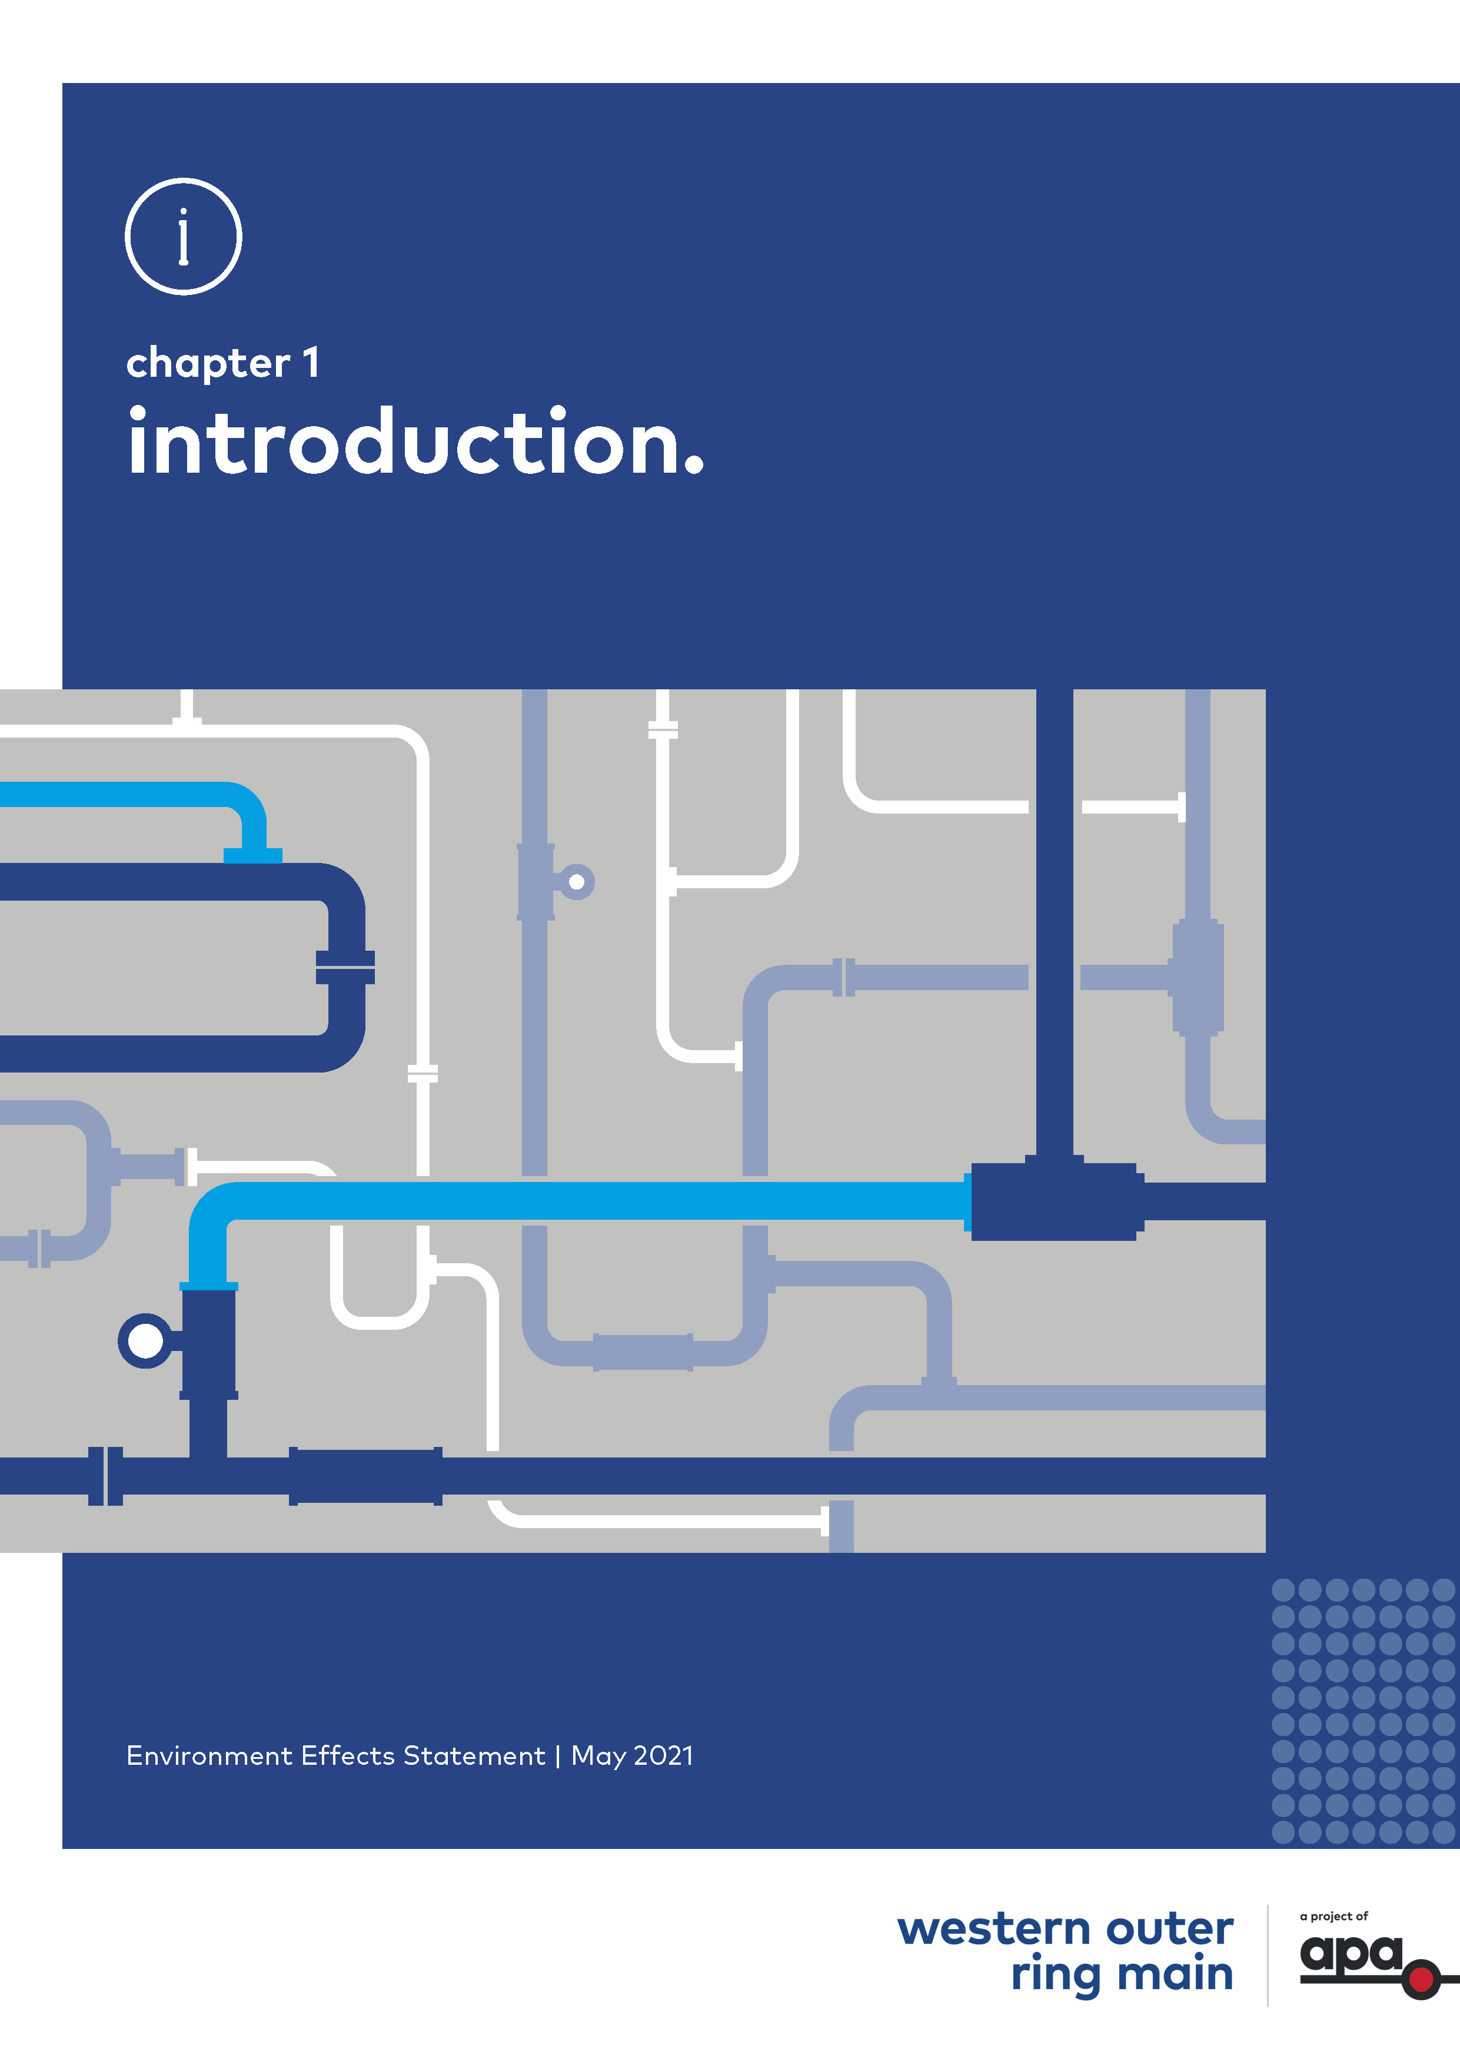
Chapter 1

Introduction

Contents
Chapter 1
1.1 Introduction 1-1
1.2 The Project proponent 1-1
1.2.1 Proponent profile 1-1
1.2.2 Health, Safety and Environment Policy 1-2
1.2.3 Health and safety national record 1-2
1.2.4 Environmental performance 1-3
1.3 Project objectives and benefits 1-3
1.4 Background to the Project 1-4
1.5 Project overview 1-6
1.6 Project Location 1-6
1.7 Project assessment and approvals 1-8
1.7.1 Environment Effects Statement 1-8
1.7.2 Commonwealth approvals 1-8
1.7.3 Victorian approvals 1-10
1.7.4 Relevant policies, strategies, guidelines and standards 1-10
1.8 Purpose of this EES 1-11
1.9 Approach to the EES 1-11
1.9.1 Scoping requirements and evaluation objectives 1-12
1.9.2 Environmental impact assessment 1-12
1.9.3 Environmental Management Framework and management measures 1-13
1.9.4 Consultation 1-13
1.10 EES Structure 1-14

Introduction
This chapter provides an overview of the proposed Western Outer Ring Main (WORM) gas pipeline project (the Project) and sets out the purpose and structure of the Environment Effects Statement (EES) for the Project.
APA VTS (Operations) Pty Ltd (the proponent) is proposing to construct a high pressure gas transmission pipeline between Plumpton and Wollert, in Victoria. The Project comprises 51 km of buried pipeline, and three mainline valve stations along the pipeline, a new gas compressor and associated process control equipment and pipework within APA’s existing gas compressor station site at Wollert. The pipeline would address a key capacity constraint in the VTS by providing a new high pressure connection between existing sources of natural gas supply in the north and east with those in the west of the state.
The Project would provide for efficient distribution of natural gas between supply sources and consumers, helping to deliver sufficient natural gas to Victorian homes for heating and cooking, as well as supplying natural gas for power generation during times of peak electricity demand. The Project also provides the opportunity for new growth suburbs on Melbourne’s urban fringe to be supplied with natural gas as those areas are developed.
The Project would provide for an increase in the amount of gas able to be stored at the Iona Underground Storage Facility (UGS) to meet peak winter demand, addressing forecast gas shortages through supply-demand imbalance, and therefore help ensure that all Victorians can continue to benefit from a reliable gas transmission system that meets the needs of the community both now and into the future.

The Project proponent

Proponent profile
APA VTS (Operations) Pty Ltd is a wholly-owned subsidiary of the APA Group (together referred to as APA). APA is a public company listed on the Australian Stock Exchange (ASX: APA).
APA is Australia’s leading energy infrastructure business with more than 15,000 km of gas pipelines that connect sources of supply and markets across mainland Australia. APA owns and/or operates around $22 billion of energy assets and delivers half the nation’s natural gas usage. APA operate and maintain gas distribution networks that connect 1.4 million Australian homes and businesses.
The 7,500 kilometre East Coast Grid of interconnected gas transmission pipelines provides the flexibility to move gas around eastern Australia, anywhere from Otway and Longford in the south, to Moomba in the west (South Australia) and Mount Isa and Gladstone in the north (Queensland). In the south, APA owns and operates the VTS, which transports gas from key supply sources such as the Bass Strait gas fields to customers across Victoria and eastern Australia. Almost all of the natural gas consumed in Victoria is transported through the VTS. | Victorian Transmission System (VTS)  The VTS is an existing gas pipeline network of approximately 2,267 km of pipelines transporting gas from various inlet points to load centres throughout Victoria. Almost all of Victoria’s natural gas is transported through the VTS.
APA is also helping to connect Australia to a clean energy future through investing in and operating assets including gas-fired power stations, electricity transmission interconnectors, wind farms and solar farms.

Health, Safety and Environment Policy
The APA Health, Safety and Environment Policy sets out APA’s commitment to achieving zero harm to its employees, contractors and third-party stakeholders that operate APA assets or work near them as well as zero harm to community members who live near APA assets. APA is also committed to avoiding and minimising environmental harm where APA assets are located.
Each APA employee, contractor and sub-contractor has an obligation to prevent or minimise any environmental harm arising from APA operations and activities. APA seeks to deliver an environmentally responsible, safe and essential service by:
- Taking a systematic and risk-based approach to environmental risk management
- Maintaining compliance with environmental laws in all jurisdictions including emissions reporting obligations
- Including environmental risk management in all investment and procurement decision-making
- Meeting or exceeding the Australian Pipelines and Gas Association (APGA) Code of Environmental Practice
- Contributing to policy and responding to climate change initiatives to promote the use of gas as essential to a cleaner energy mix
- Evaluating further renewable energy and low emission gas generation opportunities.
APA takes the approach of supporting reducing carbon emissions as a responsible risk mitigation response to climate change, including evaluating complementary clean energy projects.

Health and safety national record
APA aspires to a zero harm workplace for its employees and contractors. Overall, the Total Reportable Injury Frequency Rate (TRIFR) for APA in FY2020 was 7.73 against a target of 6.5 and the Lost Time Injury Frequency Rate (LTIFR) was 1.93 against a target of 1.0. These metrics include both employees and contractors. Contractor Management remains a key focus of APA. A number of initiatives have commenced including targeted contractor forums, senior management engagement sessions with contractors, and reviewing APA's active monitoring and assurance programs. These initiatives will continue as part of APA's FY20-22 HSE Strategic Plan.
Between FY2017 and FY2020 there were 16 Work health and Safety notices received by APA, of which one of these was a penalty notice. APA has worked proactively with contractors to ensure they continue to be equipped to conduct their work safely. APA would engage contractors for the construction of the Project. APA management systems for health, safety and the environment, and key roles and responsibilities for APA and contractors under the Environmental Management Framework are outlined in Chapter 19 Environmental Management Framework.

Environmental performance
Pursuing a high standard of environmental stewardship forms part of the APA Way, and APA is committed to minimising environmental harm across all areas of the business.
APA operates its assets under a number of approved environmental regulatory instruments within relevant federal, state and territory jurisdictions. Collaboration between APA’s Technical & Regulatory and Environment & Heritage Team functions ensures that environmental obligations are planned for concurrently with other regulatory requirements so that pipeline, distribution, power and gas processing assets owned and/or operated by APA are designed, constructed, tested, operated and maintained in accordance with requirements of the relevant regulatory departments.
Between FY2017 and FY2020, APA received six environmental warnings/notifications and four environmental penalty notices. The penalty notices were issued by the NSW Department of Planning and Environment to the Victorian–Northern Interconnect Expansion project in FY2017 in relation to erosion and sediment controls. The project was impacted by unprecedented rainfall in the region during the period of looping construction. APA remediated the impacted area and importantly completed an investigation resulting in amending our procedures in relation to soil management to prevent this type of event in the future.
During the most recent reporting period (FY2020), there were no significant environmental incidents and APA recorded zero penalty notices. APA investigated four instances in which warnings/notifications were received. In each case, the issues were rectified and responses were provided to the regulator(s) outlining internal action taken.
All of these instances have been thoroughly investigated and corrective actions are either underway or completed, including rectification of environmental issues and responses to the regulator(s) outlining internal action taken.
Further information on APA Group’s Health, Safety and Environmental performance is available in the annual sustainability reports: https://www.apa.com.au/about-apa/sustainability/sustainability-reports/.

Project objectives and benefits
The Project has been designed to provide critical infrastructure for Victoria’s gas supply, distribution, and consequent security, efficiency and affordability.
The Project would have a number of benefits. Critically, the Project would improve Victoria’s gas network capacity and performance allowing for greater volumes of gas to be efficiently transferred across the state and stored for when it is needed most.  It would increase energy security and resilience and address anticipated gas supply shortages in Victoria during times of peak demand, as forecast by the Australian Energy Market Operator (AEMO) in the March 2021 Victorian Gas Planning Report, by providing for increased gas to be stored at the Iona UGS. | The Project objectives are:  - Improved system resilience and security of gas supply  - Increasing the amount of natural gas that can be stored for times of peak demand  - Improved network performance and reliability  - Addressing potential gas shortages as forecast by AEMO in the March 2021 Victorian Gas Planning Report
The Project would make the overall VTS more resilient to Longford outages by allowing higher pressure gas to be moved efficiently across the VTS.
The Project is expected to involve a capital investment estimated at $167.3 million (excluding GST), with an annual operating cost of the WORM and additional Wollert compressor estimated at $600,000 per annum. Approximately 500 jobs would be generated during the planning, design and construction phase for the Project lifecycle. A minimal incremental increase in APA’s existing operational workforce would be required for the operation phase.
All Victorians would continue to benefit from a reliable gas transmission system that meets the needs of the community both now and into the future.

Background to the Project
Natural gas is an essential source of energy for Victoria with the VTS serving approximately two million customers using gas every day for domestic applications including cooking, heating and hot water. Natural gas is also used by approximately 60,000 industrial and commercial users throughout Victoria including manufacturers, and gas fired power generation plays a key role in ensuring a reliable electricity network.
The VTS has three main branches:
- The Longford Dandenong Pipeline (LDP) between Dandenong and South Eastern Victoria.
- The Victorian Northern Interconnect (VNI) between Wollert and the NSW border
- The South West Pipeline (SWP) between Brooklyn and South Western Victoria.
The LDP and the VNI are linked by the high pressure Outer Ring Main (Pakenham to Wollert Gas Pipeline). This provides the ability to send gas under high pressure between these pipelines.
There is no equivalent link between either the VNI and the SWP or the LDP and the SWP. Sending gas between these pipelines involves using the lower pressure Melbourne network, and this limits the amount of gas that can be moved across Victoria in these directions.
The VTS transmits gas to Victoria’s two major natural gas storage facilities, Iona UGS and Dandenong LNG Storage. Iona UGS is more significant with a total storage capacity of 26 Petajoules (PJ) (compared to 0.7PJ for Dandenong LNG). The Iona UGS is located near the town of Port Campbell and uses a depleted gas field to store natural gas. The storage facility is connected to the SWP with the ability to be refilled from the SWP as well as being able to inject into the SWP to flow gas from the UGS to Melbourne.
Figure 1-1 represents the VTS and the current constraint to gas flow between the SWP and Iona UGS, with the other components of the VTS.
The need for a high-pressure pipeline loop between the west and the north/east was first identified by APA and discussed with the Australian Energy Regulator (AER) over ten years ago.

Figure 1-1 Victorian Transmission System schematic including the WORM
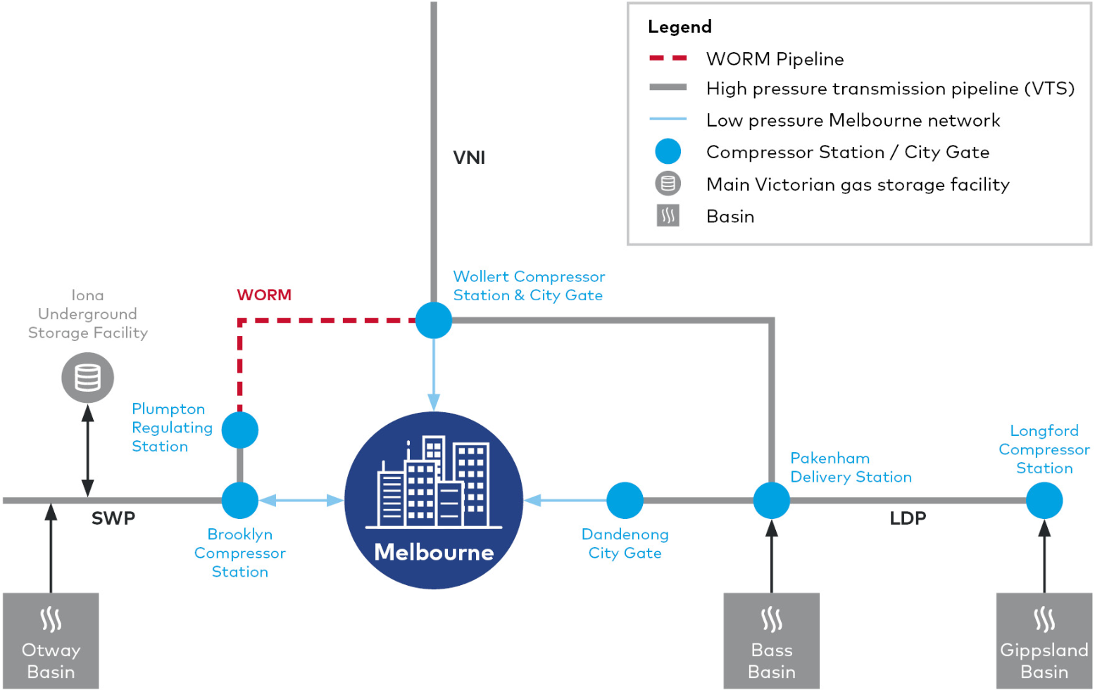

AEMO released its Gas Statement of Opportunity (GSOO) document in March 2017 and the Victorian Gas Planning Report 2017 (VGPR) which confirmed an urgency to progress the WORM project to completion to help address anticipated gas supply shortfalls. In April 2017 APA submitted an updated business case to the AER for the full WORM project. Project planning and development has proceeded since that time. In November 2017, the AER published its final decision on the APA VTS Access Arrangement that applies from 1 January 2018 to 31 December 2022. The AER approved the construction of the Project to increase SWP transportation capacity and improve security of supply across the Victorian Declared Transmission System (DTS).
AEMO's Victorian Gas Planning Report Update 2020 states that if the WORM is not available by mid-2022 as expected, there will be increased risk of depleting Iona storage levels and reduction in the available peak day supply capacity, further tightening the gas supply-demand balance in 2023 and 2024. The gas supply-demand balance remains tight in forecasts in AEMO's recently released Victorian Gas Planning Report 2021, even with the assumption that WORM will be constructed.
Further information on the Project rationale and development is contained in Chapter 2 Project rationale and Chapter 3 Project development.

Project overview
The Project includes the following key components:
- New pipeline
- Mainline valves
- Additional compressor unit and regulating station.
The pipeline would be approximately 51 kilometres in length. The pipeline would occupy a typical 15 metre wide permanent easement (or licence for Crown land) and be buried for its entire length to a minimum depth of cover of 750 millimetres (with the final depth determined as an outcome of the Safety Management Study in accordance with AS/NZS 2885.6). The pipeline would be a high pressure gas transmission pipeline of up to 600-millimetre nominal diameter. The pipeline would be constructed from high-strength steel line pipe with an external epoxy coating and internal epoxy lining.
A 30-metre corridor is required to construct the pipeline. Temporary access is required to additional construction workspace so that the pipeline can be constructed safely and efficiently.
Three mainline valves would be located along the pipeline alignment within the proposed easement.
The additional compressor unit and a regulating station would be at APA’s existing gas compressor station located at 365 Summerhill Road, Wollert.
The Project components are described in greater detail in Chapter 4 Project description.

Project Location
APA has identified an alignment for the pipeline based on assessment of key constraints such as environmental values, cultural heritage, terrain, existing and proposed infrastructure corridors, watercourses, and land use. It has also been informed by constructability constraints, landowner consultation and key stakeholder consultation.
The region that would be traversed by the Project is located north of Melbourne and lies between Somerton in the south and Kalkallo in the north and between Sunbury to the east and Wollert to the west.
The Project would be located within the local government areas of Melton City, Hume City, Mitchell Shire and Whittlesea City.
The key sections of the route are:
- From the Plumpton pressure reduction station, just north of Taylors Road, the pipeline would follow APA's existing Sunbury Pipeline easement north for approximately seven kilometres to the Calder Freeway
- The pipeline route then crosses the Bendigo rail line and the Calder Freeway and generally traverses the proposed Outer Metropolitan Ring (OMR) corridor through Diggers Rest, before deviating to the north and crossing Jacksons Creek, Sunbury Road and Deep Creek
- The pipeline then re-joins the OMR in Oaklands Junction before following it north east through Mickleham, Merrifield and Kalkallo
- The pipeline alignment would cross the Hume Highway at the existing intersection with Gunns Gully Road before again following the OMR east, across the North Eastern rail line, to the Victorian Northern Interconnect (VNI)
- The pipeline route then follows the existing VNI easement south for approximately eight kilometres to the Wollert compressor station.
A map of the pipeline route and surrounding areas is shown in Figure 1-2.
Figure 1-2 Project context
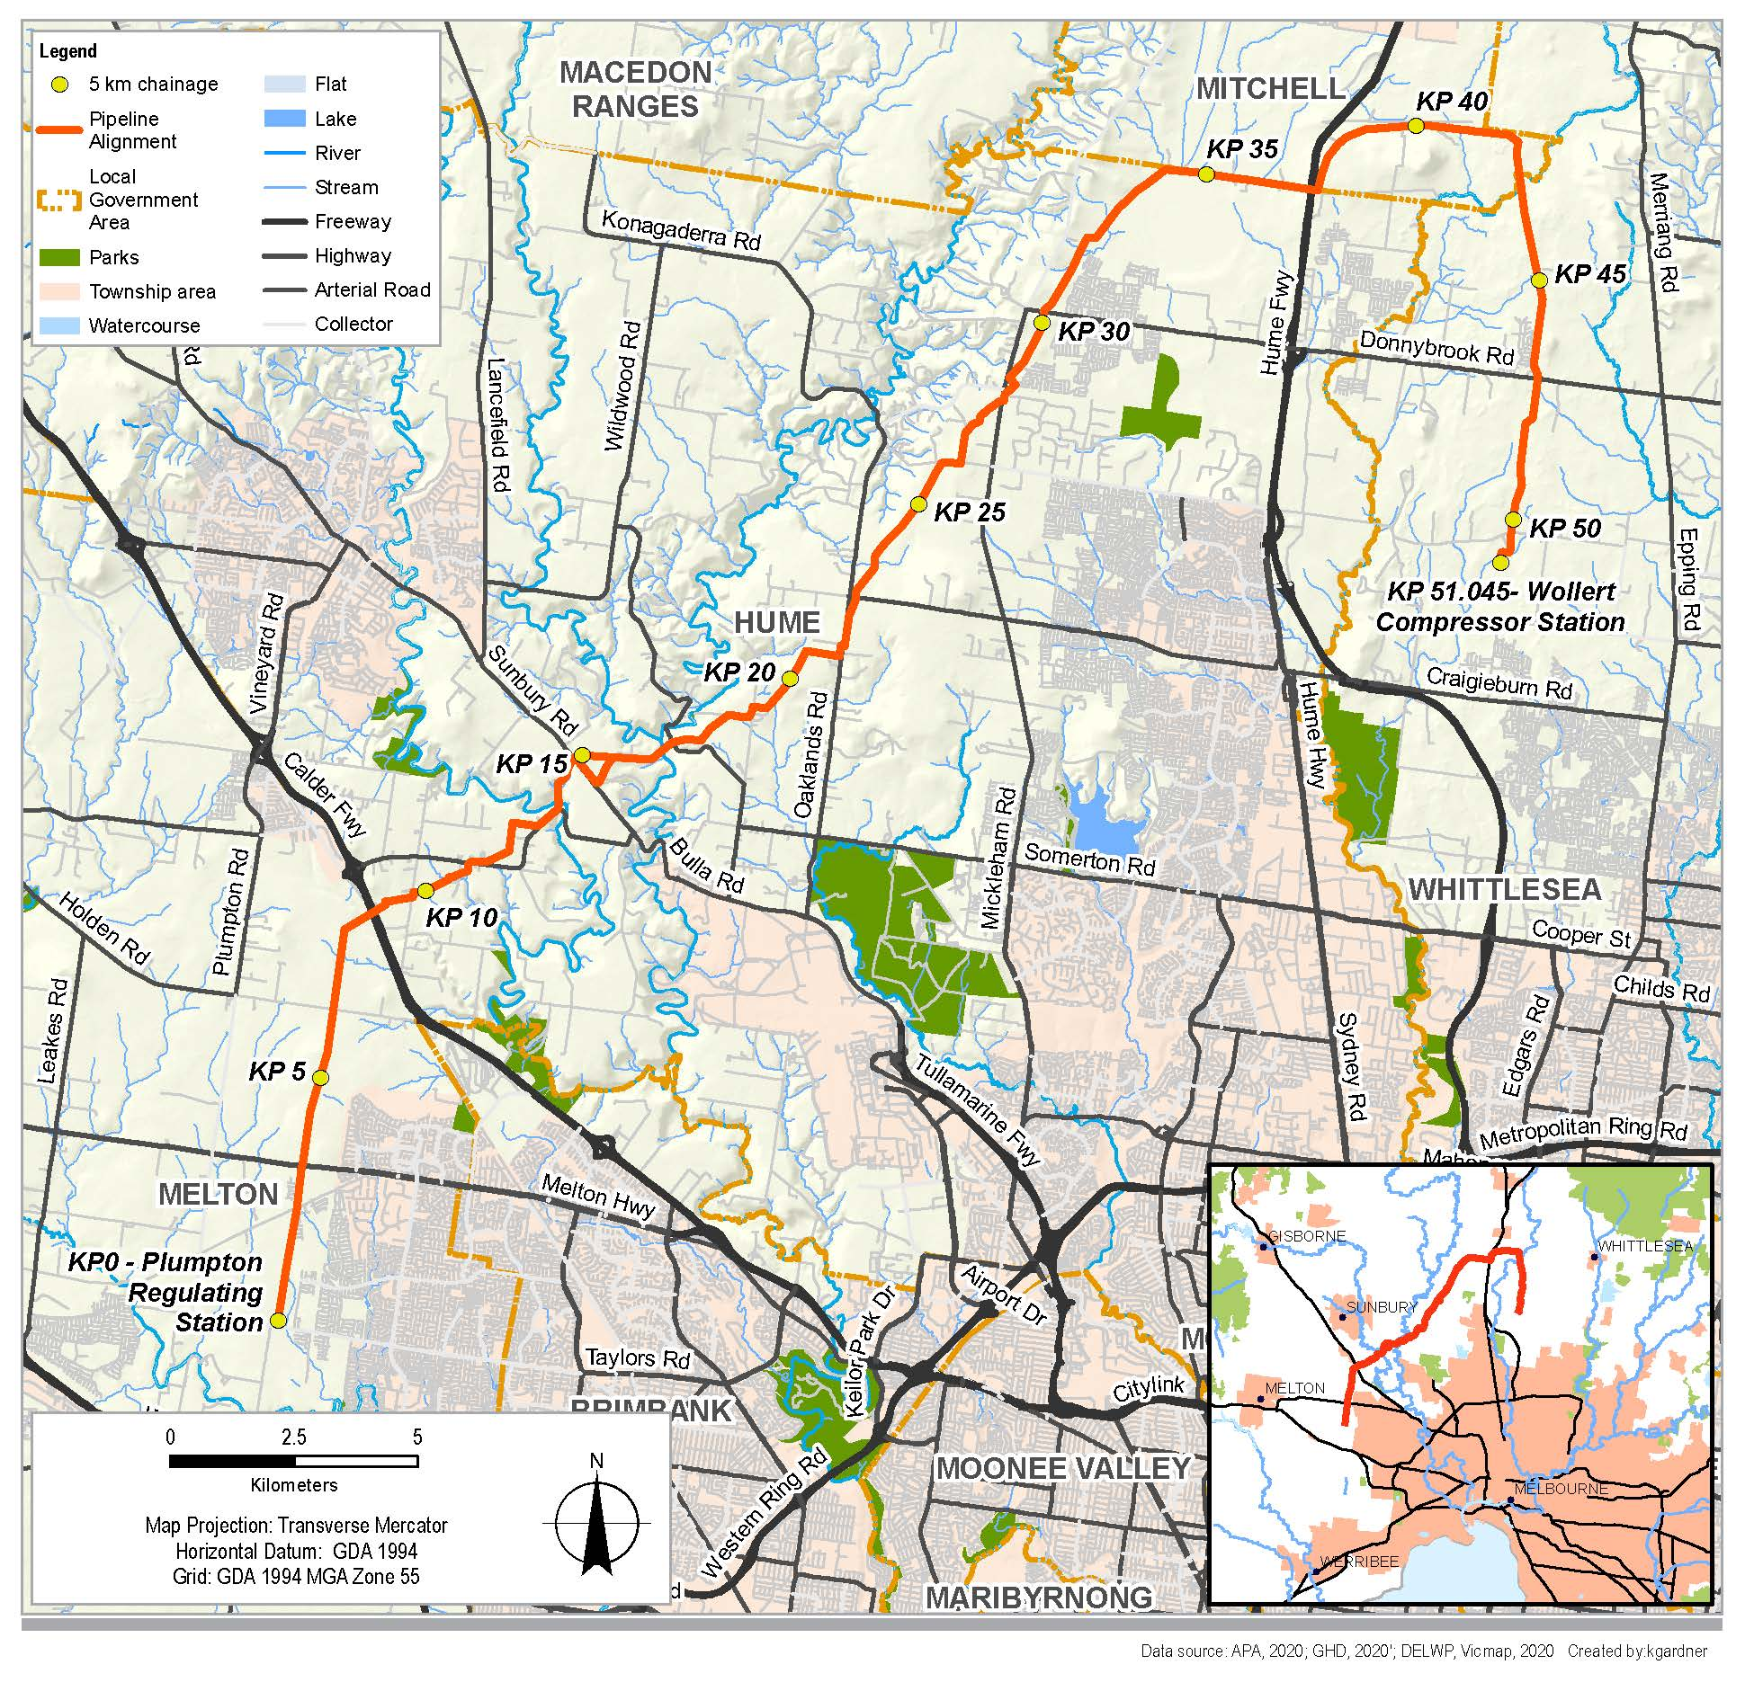

Project assessment and approvals
An overview of the steps and linkages between the EES and the statutory approvals is shown in Figure 1-3.
Further details are provided in Chapter 5 Evaluation and assessment framework.

Environment Effects Statement
Victoria’s Environment Effects Act 1978 (EE Act) and associated Guidelines set out the process under which the Victorian Minister for Planning may require the proponent of a project to prepare an EES.
An EES is the proponent’s statement about a proposed project and its environmental effects. The EES process provides for a comprehensive and integrated assessment of the environmental effects of a project. It enables an assessment to be made about whether the potential adverse effects are capable of being managed to achieve acceptable outcomes in accordance with project objectives.
The EES does not provide an approval, but an assessment of the environmental effects of the Project. The Minister’s assessment of the EES is provided to statutory decision makers to assist them to make informed decisions about the approvals required for the project to proceed.
The Project was referred to the Victorian Government under the EE Act on 28 October 2019 by APA.
On 22 December 2019, the Victorian Minister for Planning determined that an EES was required for the Project. The Minister’s reasons for making this decision were:
- The Project has potential for significant environmental effects, in particular on native vegetation, habitat of terrestrial and aquatic species listed under the Flora and Fauna Guarantee Act 1988 (FFG Act), ecologically sensitive waterways and wetlands, and on Aboriginal cultural heritage
- An Environment Effects Statement is warranted to provide an integrated, robust and transparent process to assess the proposal’s effects and associated uncertainties, and to evaluate effectiveness of the proposed avoidance, mitigation, management and offsetting measures, prior to any statutory approval decisions.

Commonwealth approvals
The Commonwealth Environment Protection and Biodiversity Conservation Act 1999 (EPBC Act) provides the legal framework to protect and manage designated Matters of National Environmental Significance (MNES). Under the EPBC Act, if the Commonwealth Minister for the Environment decides that a project has, will have, or could have a significant impact on a MNES, the project becomes a ‘controlled action’ that must be assessed and approved by the Minister before it can proceed.
The Project was referred to the Commonwealth Government under the EPBC Act on 21 October 2019. On 21 February 2020, the delegate for the Commonwealth Minister for the Environment and Energy determined that the Project was a ‘controlled action’ and that further assessment and approval was required under the EPBC Act before the Project could proceed.
The decision was made due to the potential for significant impacts on listed threatened species and communities.
The Victorian EES will serve as the accredited assessment process for the purpose of the EPBC Act under a Bilateral Assessment Agreement between the Commonwealth and Victorian governments.
After considering the Victorian Minister for Planning’s assessment under the EE Act, the Commonwealth Minister for the Environment or their delegate will decide whether the Project is approved, approved with conditions or refused under the EPBC Act.
Figure 1-3 EES process and statutory approvals for the Project
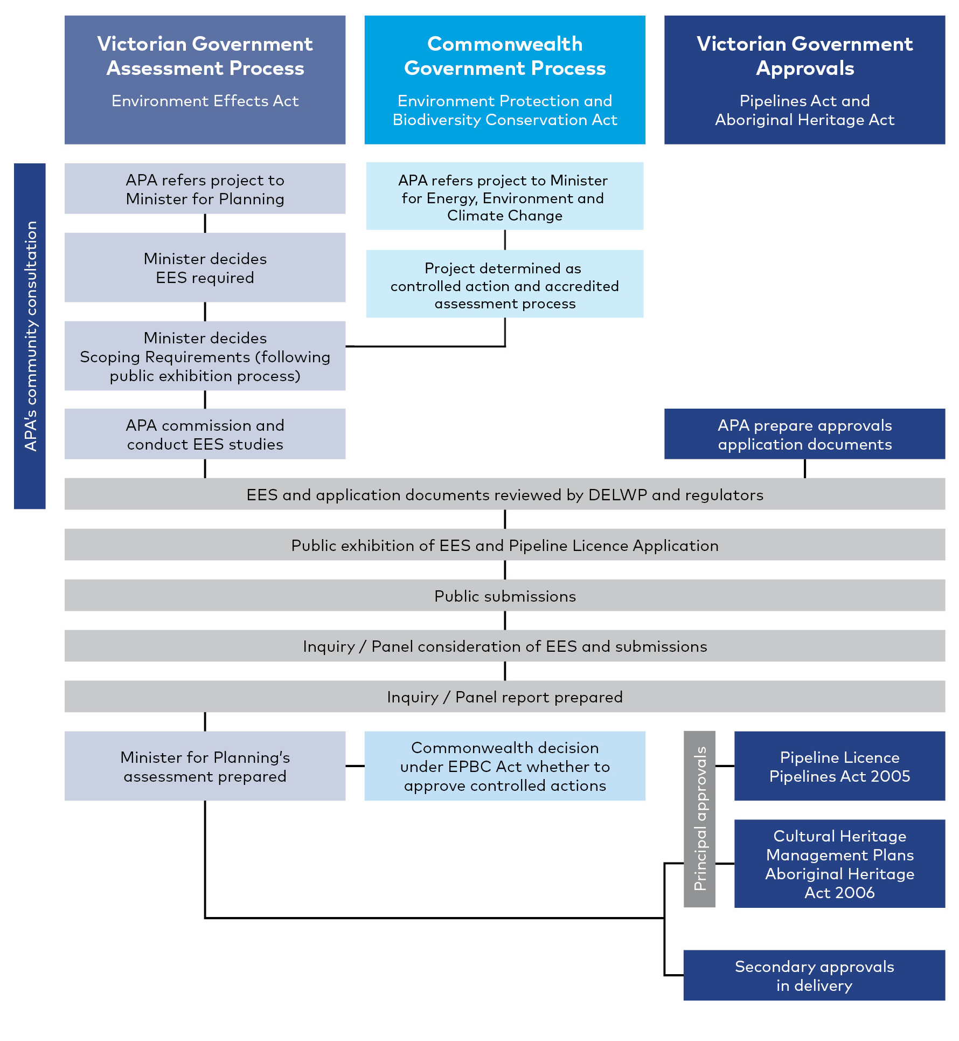

Victorian approvals
The Project requires the following principal approvals under Victorian legislation:
- Pipeline Licence under the Pipelines Act 2005 (Pipelines Act) for construction and operation of the pipeline. The Pipeline Licence application is exhibited with the EES
- Cultural Heritage Management Plan (CHMP) under the Aboriginal Heritage Act 2006 (AH Act). Two CHMPs are in preparation – CHMP 16594 covers the area from KP 0 to KP 8, and CHMP 16593 covers the area from KP 8 to KP 51.
The requirements under the Pipelines Act include additional aspects such as the acceptance of an Environment Management Plan, Safety Management Plan (SMP), and consent from Energy Safe Victoria (ESV) to Construct and to Operate the Project, pursuant to Section 128 (3) and 107 (1) of the Pipelines Act.
Section 49 of the Pipelines Act provides that, in granting a pipeline licence the Minister must consider among other matters:
              - the assessment of the Environment Effects Minister in relation to the proposed pipeline, if an assessment has been made;
              - any written comments received from the Planning Minister or the relevant responsible authority on the effect of the proposed pipeline on the planning of the area through which it is to pass.
Other approvals are likely to be required for the Project under Victorian legislation including:
- Permits to take native flora and fauna species listed under the FFG Act
- Approval of a Safety Case under the Gas Safety Act 1997 (Vic)
- Permits for works on waterways under the Water Act 1989 (Water Act).
Further detail on the legislative framework and approvals are provided in Chapter 5 Evaluation and assessment framework.

Relevant policies, strategies, guidelines and standards
The Project must consider relevant environmental policies, strategies, guidelines and standards.
The relevant policies, strategies, guidelines and standards have relevant requirements for the impact assessment and environmental management measures or contingency measures.
Relevant policies, strategies, guidelines and standards related to the principal approvals, and their implications for the Project are summarised in Chapter 5 Evaluation and assessment framework. Each technical report of the EES summarises the policies, strategies, guidelines and standards relevant to that specific impact assessment.

Purpose of this EES
The EES describes the Project and its potential environmental effects. It enables stakeholders and decision-makers to understand how the Project works are to be designed, constructed and operated and the likely environmental effects of doing so. The EES provides sufficient detail for the Minister for Planning to make a final assessment as to the Project’s acceptability.
The EES is required to apply a risk-based approach to identification of issues for assessment and provide an analysis of the significance of potential effects considering:
- The potential effects of the Project on individual environmental assets
- The likelihood of adverse effects
- Proposed avoidance or mitigation measures to reduce predicted impacts
- The residual effects and their significance
- The proposed approach to managing and monitoring environmental performance.
This EES was prepared in accordance with the Victorian Minister for Planning’s decision on the EES referral, the scoping requirements for this EES approved by the Victorian Minister for Planning on 23 August 2020 and the Ministerial guidelines for assessment of environmental effects under the EE Act.
The EES addresses the potential impacts on the environment and outlines an Environmental Management Framework (EMF) for the Project. Thirteen specialist technical studies were undertaken, and the findings of these studies are presented in the technical reports attached to this EES and summarised in Chapters 7 to 18.
The EES seeks to inform the public and stakeholders about the Project, its potential impacts and how these impacts can be avoided, minimised or managed. Community members and stakeholders can provide feedback on the EES and associated approvals applications during the public exhibition period. The EES process also provides for community and stakeholder input during the development of the EES so their knowledge can be considered in the project development.
The EES and any submissions will be considered by an inquiry/panel appointed by the Victorian Minister for Planning under the EE Act. A report will be prepared and provided to the Minister.
The EES, submissions and the inquiry report will enable the Minister to issue an assessment of the environmental effects of the Project under the EE Act. The Minister’s assessment will inform statutory decision makers.

Approach to the EES
This EES presents a holistic assessment of the Project. It considers the construction methodology, operation and specific potential environmental impacts of the works as well as the cumulative impacts of the Project combined with other major projects in the location.

Scoping requirements and evaluation objectives
The matters to be investigated and documented in the EES are set out in the scoping requirements issued by the Victorian Minister for Planning.
The scoping requirements set the framework for the EES including an outline of the key issues, potential effects and other content to be addressed in the EES.
As the Minister will be assessing the EES, the scoping requirements provide the guidance on information required in the EES to allow the Minister to undertake that assessment of the Project under the EE Act.
Draft scoping requirements were exhibited by the Department of Environment, Land, Water and Planning (DELWP) for public comment on 14 July 2020. After considering public submissions, the Minister approved the final scoping requirements on 23 August 2020. This EES was prepared in accordance with the final scoping requirements.
The scoping requirements established evaluation objectives for the EES which are listed in Table 1-1. The EES may further investigate significant issues not identified in the scoping requirements that emerged during the EES technical studies and consultation.
Table 1-1 Evaluation objectives
Evaluation objective
Energy efficiency, security, affordability and safety | To provide for safe and cost-effective pipeline connection between the eastern and western sections of the Victorian Transmission System.
Biodiversity and habitats | To avoid and minimise potential adverse effects on native vegetation, listed threatened and migratory species and ecological communities, and habitat for these species, as well as restore and offset residual environmental effects consistent with state and Commonwealth policies.
Water and catchment values | To maintain the functions and values of groundwater, surface water and floodplain environments and minimise effects on water quality and beneficial uses.
Cultural heritage | To avoid, or minimise where avoidance is not possible, adverse effects on Aboriginal and historic cultural heritage values.
Social, economic, amenity and land use | To minimise potential adverse social, economic, amenity and land use effects at local and regional scales.
Waste management | To minimise generation of wastes from the project during construction and operation, and to prevent adverse environmental or health effects from storing, handling, transporting and disposing of waste products.

Environmental impact assessment
To ensure all key issues identified in the EES scoping requirements are addressed, 13 specialist technical assessments evaluated the potential environmental effects of the Project design, construction methodologies and operational requirements.
The technical studies assessed how potential adverse environmental effects could be avoided, managed and mitigated. The findings of the studies are provided in the technical reports attached to this EES and summarised in Chapters 7–18.
A risk-based approach was applied to identifying and assessing potential environmental effects of the Project. The assessment approach is described in Chapter 5 Evaluation and assessment framework.

Environmental Management Framework and management measures
The EMF provides a framework for managing the environmental effects identified in the EES. The EMF describes the overall governance framework for the delivery of the Project through construction and operation. The EMF includes the management measures that APA would implement to mitigate potential adverse effects.
Environmental management measures are the approaches, requirements or actions that would avoid, mitigate, minimise or manage environmental impacts. The 13 specialist technical assessments considered an initial set of management measures based on compliance with legislation and standard requirements as part of their impact assessments.
Through the risk assessment process, the initial set of management measures were refined to a set of recommended management measures that address the findings of the impact assessment, and community and stakeholder inputs.
Additional management measures were developed where initial risk ratings were categorised as medium or higher, and incorporated into the Project design or description and/or included in the EMF.
The management measures would inform the conditions administered by relevant statutory authorities, and subject to those conditions would become part of the environmental management plans implemented during construction and operation.
The proponent and their contractors would be responsible for their implementation. Contractual arrangements with contractors responsible for construction, operation and decommissioning of the Project would include requirements for contractors to adhere to specified management measures and approval conditions.
The management measures for the Project are outlined in Chapter 19 Environmental Management Framework.
The approach adopted to develop and refine the management measures is described in Chapter 5 Evaluation and assessment framework. The EMF and management measures are presented in Chapter 19 Environmental Management Framework.

Consultation
In January 2019, the Minister responsible for the Pipelines Act approved a consultation plan developed by APA as required by the Pipelines Act which sets out the information that APA would provide owners and occupiers of land that would be potentially impacted about the pipeline’s construction or operation. The consultation plan outlines the opportunity for landowners, occupiers and managers and other stakeholders to be informed of and raise issues relating to the construction and operation of the pipeline.
In May 2020, a separate consultation plan was developed to guide consultation with the community and other stakeholders for the EES phase of the Project. The consultation process included opportunities for community and other stakeholders to raise issues of concern and inform the EES technical studies and the design and mitigation measures for the Project.
Community consultation and stakeholder engagement would continue to be undertaken during construction of the Project. This consultation program is described in Chapter 6 Community and stakeholder consultation.

EES Structure
The structure of this EES is shown in Figure 1-4.
Figure 1-4 EES Structure
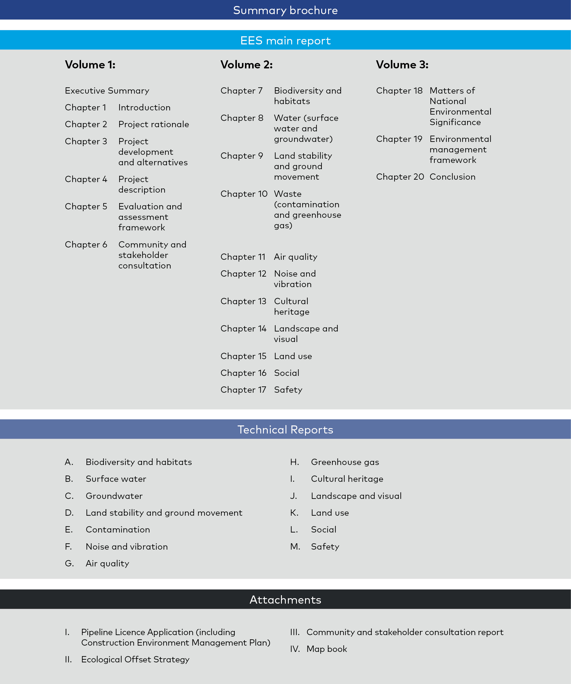

APA WORM business case submission, page 12.
AEMO (2020), Victoria Gas Planning Report Update, page 30.
AEMO (2021), Victoria Gas Planning Report, page 53.

