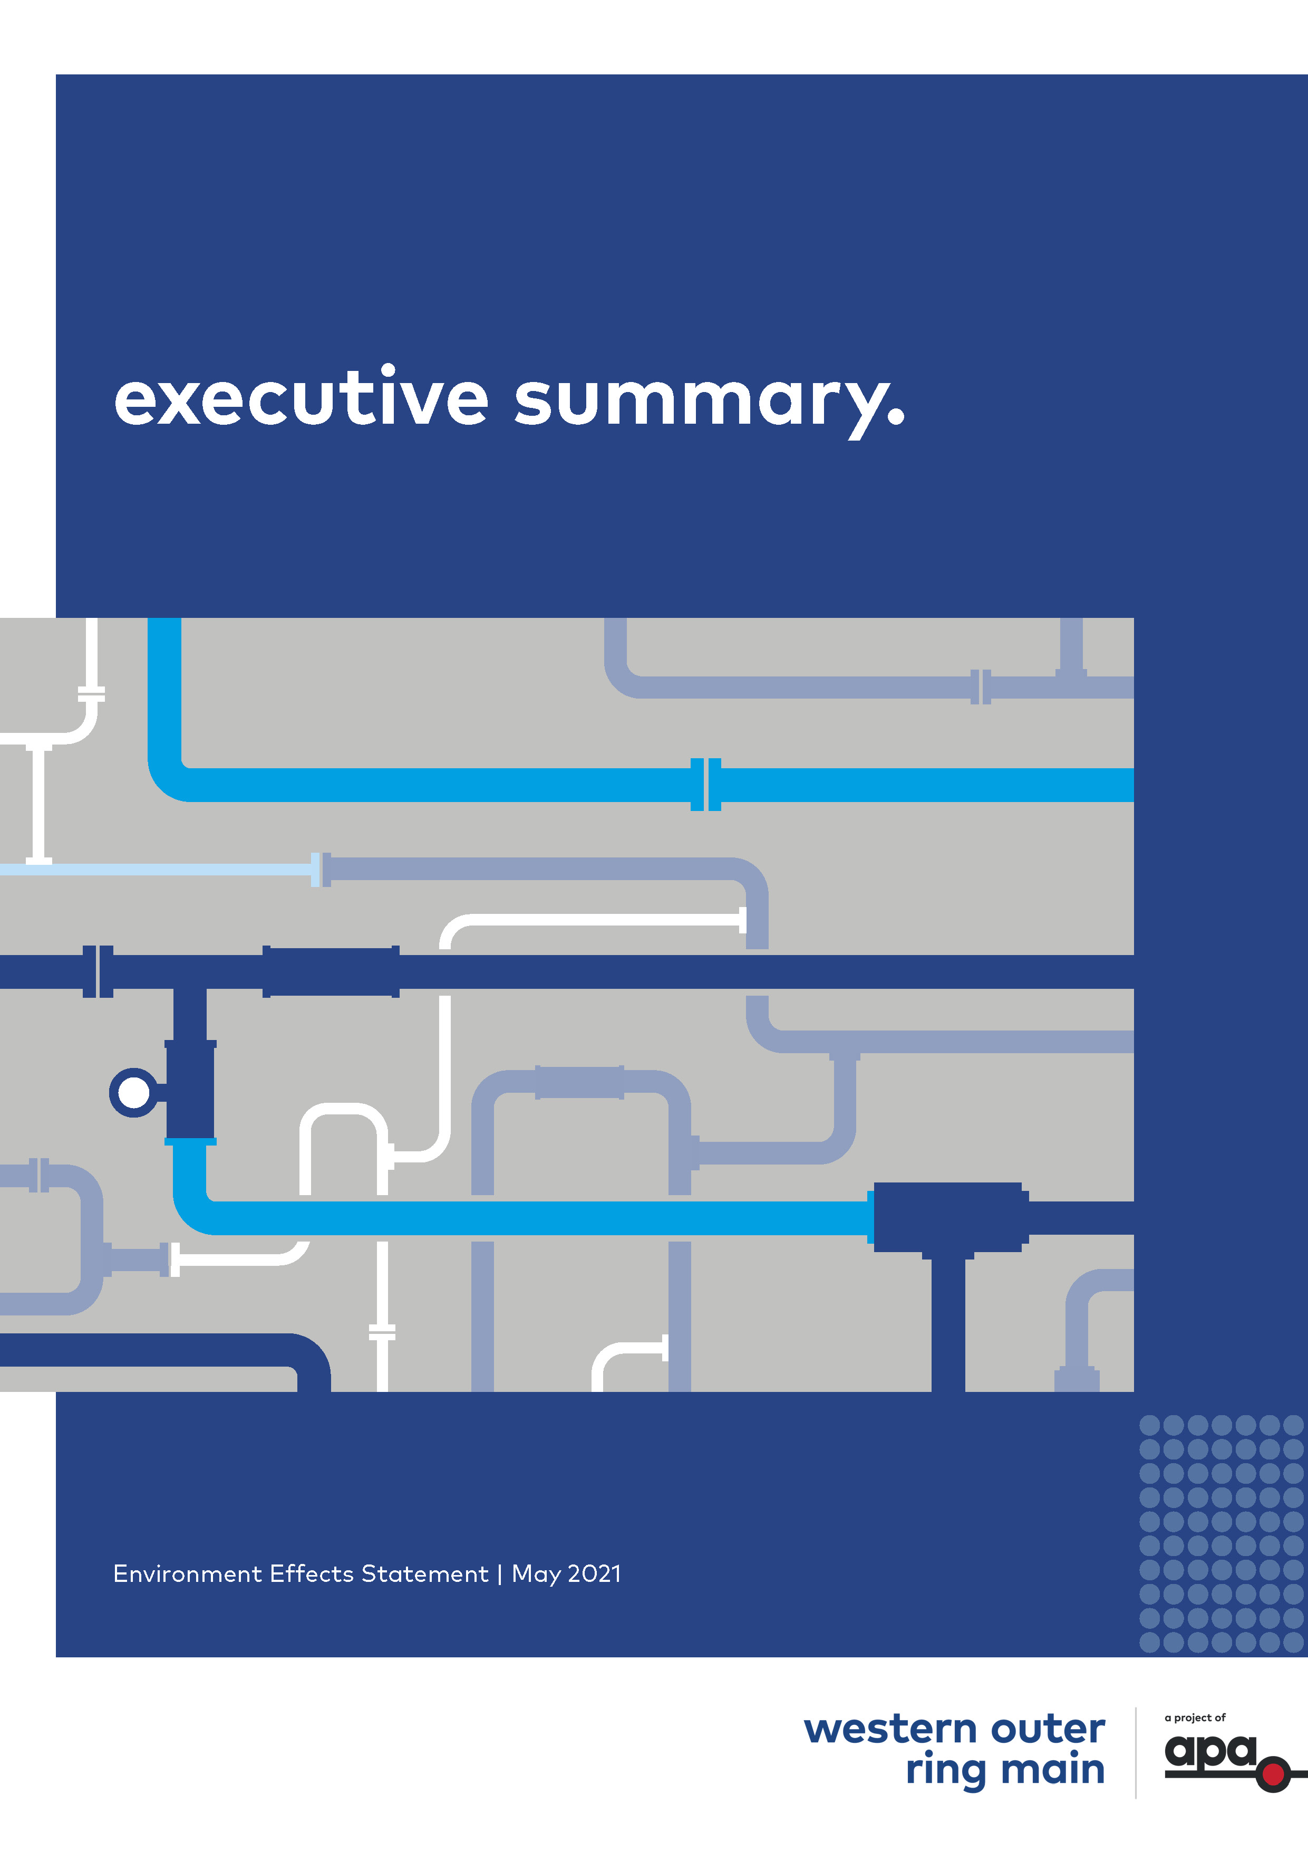
Executive summary

Contents
Executive summary
ES.1 Introduction ES-1
ES.1.1 Project background and rationale ES-1
ES.1.2 Project objectives and benefits ES-2
ES.2 The Project ES-3
ES.2.1 Project development and alternatives ES-3
ES.2.2 Construction ES-6
ES.2.3 Rehabilitation and pipeline commissioning ES-7
ES.2.4 Operation and maintenance ES-8
ES.3 Planning ES-8
ES.3.1 The EES process ES-8
ES.3.2 Project approvals ES-8
ES.4 Assessing the Project's impacts ES-10
ES.4.1 Assessment approach ES-10
ES.4.2 Cumulative impacts ES-10
ES.4.3 Technical studies ES-10
ES.5 Assessment of potential impacts ES-11
ES.5.1 Energy efficiency, security, affordability and safety ES-11
ES.5.2 Biodiversity and habitats ES-13
ES.5.3 Water and catchment values ES-17
ES.5.4 Cultural heritage ES-20
ES.5.5 Social, economic, amenity and land use ES-22
ES.5.6 Waste management ES-37
ES.6 Managing the Project's impacts ES-40
ES.7 Consulting with the community ES-40
ES.8 Concluding the EES process ES-43
ES.8.1 Exhibition and submissions ES-43
ES.8.2 Next steps ES-44

Introduction
This executive summary provides a summary of the content and key findings of the Environment Effects Statement (EES) for the Western Outer Ring Main Project (the Project). The executive summary highlights the Project background, description and approach to the EES which is detailed in Volume 1 of the EES Main Report. It provides the key findings of the assessment of potential impacts which are detailed in Volume 2 and Volume 3 of the EES Main Report. It also explains the next steps in the EES process.
APA VTS (Operations) Pty Ltd (APA) is proposing to construct a high pressure gas transmission pipeline between Plumpton Regulating Station (approximately 38 kilometres north west of Melbourne’s CBD) and Wollert Compressor Station (approximately 26 kilometres north east of Melbourne’s CBD). This would provide an additional connection between the eastern and western pipeline networks of the Victorian Transmission System (VTS). Figure 1 represents the VTS and the current constraint to gas flow to the Iona underground storage (UGS) facility, with other components of the VTS.
Figure 1 Victorian Transmission System Schematic including the WORM
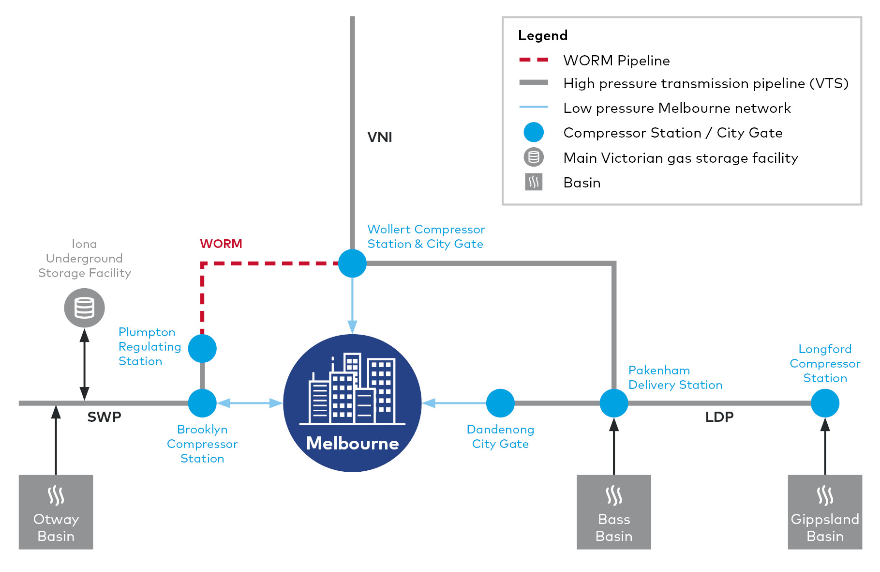

Project background and rationale
The Victorian economy is highly dependent on gas, with gas demand in Victoria primarily driven by the residential and small commercial sectors. During winter, Victoria experiences a peak demand in gas as consumption of hot water and heating increases, and broader demand pressure is placed on energy generators. This seasonal change in consumption causes a tightening of the gas supply-demand balance for Victoria from June to September. To combat this, Victoria’s gas network allows for the transfer and storage of excess gas that is generated during summer months, when gas demand is lower, to support demand requirements for the coming winter.
The Iona UGS basin is Victoria’s largest natural gas storage facility and stores the majority of Victoria’s gas supplies. Gas stored at the Iona UGS is crucial for meeting peak gas demand, ensuring access to natural gas throughout the year. However, sufficient storage volumes must be achieved at the facility over summer in order to cover this winter peak.
The Project responds to the forecast changes in supply locations and would directly support the timely transfer of higher volumes of gas from the east to the west of the state. This will increase the efficiency in which gas supply can be transported to end-destinations including the Iona UGS basin, Victorian customers and export facilities.
The Project would make the overall VTS more resilient by allowing gas to be moved at a higher pressure and more efficiently across the VTS, ensuring all Victorians continue to benefit from a reliable gas transmission system.
More efficient gas transmission would also facilitate the development of the renewable energy sector. The Victorian Renewable Energy Target (VRET) has set a policy goal of achieving 50 per cent renewable energy generation in Victoria by 2030. Energy generation investment in Victoria (January 2018 to March 2020) has largely comprised wind and solar. As wind and solar generation continues to grow, the intermittent nature of these renewables will require what the Australian Energy Regulator describes as firming capacity, via gas powered plants or storage to support energy reliability and security for consumers.
Beyond 2024, the role of gas will increase in proportion to the decline in coal generation, with gas playing a particularly important role between 2030 and 2050 as the renewable energy sector expands in line with VRET and broader climate change policy. As an Australian natural gas infrastructure owner and operator, APA is committed to being part of the successful transition to a lower carbon future.

Project objectives and benefits
Natural gas is an essential source of energy for Victoria with approximately two million customers a day relying on gas for cooking, heating and hot water. Natural gas is also used by approximately 60,000 Victorian industrial and commercial users. Gas fired power generation plays a key role in ensuring a reliable electricity network. The Project has been designed to provide critical infrastructure for Victoria’s gas supply, distribution, and consequent security, efficiency and affordability. Project objectives are:
- Improved system resilience and security of gas supply
- Increasing the amount of natural gas that can be stored for times of peak demand
- Improved network performance and reliability
- Addressing potential gas shortages as forecast by AEMO in the March 2021 Victorian Gas Planning Report.
The Project would have a number of benefits. Critically, the Project would improve Victoria’s gas network capacity and performance allowing for greater volumes of gas to be efficiently transferred across the state and stored for when it is needed most.
It would increase energy security and resilience and address anticipated gas supply shortages in Victoria during times of peak demand and make the overall VTS more resilient to Longford outages. All Victorians would continue to benefit from a reliable gas transmission system that meets the needs of the community both now and into the future.

The Project
The Project comprises three key components:
- A new fully buried pipeline 51 kilometres in length. Key pipeline data is provided in Table 1
- Three mainline valves located along the pipeline alignment near kilometre points (KP) 6, KP22 and near KP 35
- An upgrade of the Wollert Compressor Station (including construction of new Solar Centaur 50 compressor, an end of line scraper station and a regulating station) within the existing APA facility at Wollert.
Table 1 Key pipeline data
Underground pipeline key data
Length | 51.045 km.
Material | American Petroleum Institute (API) Specification 5L X52 high strength steel pipe. Internally lined with epoxy and externally coated with dual layer fusion bonded epoxy with field applied joint coating.
Nominal diameter | 600 mm.
Nominal capacity | Approximately 750 TJ/day.
Pipe wall thickness | 10.31 mm standard wall thickness.  12.7 mm heavy wall thickness.
Pipe segment length | 18 m.
Depth of cover (depth below ground surface) | Minimum of 750 mm to the top of the pipeline (deeper at crossing of third-party infrastructure and waterways). The final depth would be determined as an outcome of the Safety Management Study.
Easement | Nominally 15 m wide.
Design principles | Strictly in accordance with the latest version of AS2885 Pipelines – Gas and liquid petroleum.
Design life | 60 years.

Project development and alternatives
Route options for the Project, have been considered since at least 2007 and discussed with energy regulators since 2012. From early 2018, APA has undertaken a comprehensive investigation process to identify and consider five key pipeline alignment options. The Route Options Report – Western Outer Ring Main Project (APA, March 2019) is available on the APA Project website.
Despite being the longest route alignment identified (almost 12 kilometres longer than then shortest route proposed) and the second costliest option, the preferred route outlined in the Environment Effects Statement (EES) was assessed as being the optimum alignment for satisfying the environment and heritage, community and land criteria, which were weighted with the greatest importance. This route also scored well in terms of constructability and operability.
Figure 2 presents a map of the pipeline route and surrounding areas.
Figure 2 Pipeline route
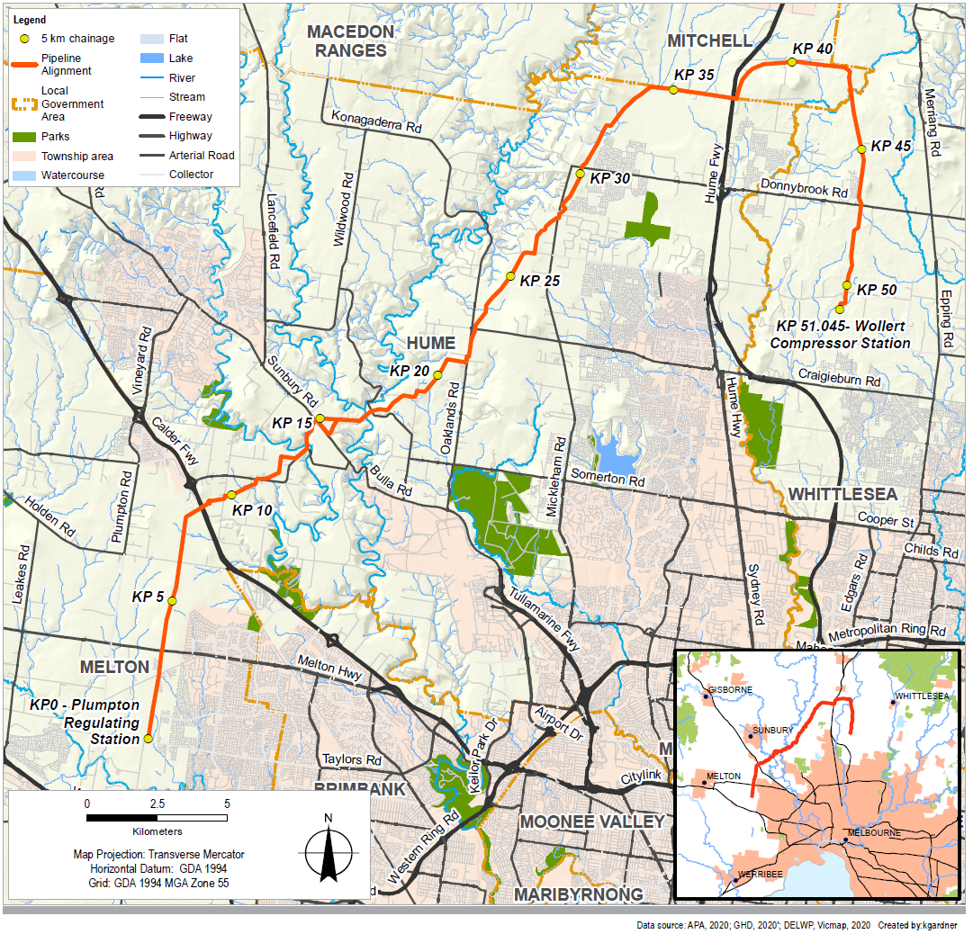
Through stakeholder consultation and engagement with landowners and VicRoads (now the Department of Transport (DoT)) from early 2019 and through the EES preparation to early 2021, further route refinement was undertaken with a number of changes being incorporated as a result including:
- Minor alignment changes at the crossings of Jacksons Creek, Sunbury Road and Deep Creek
- Refinements to the alignment’s position relative to the Outer Metropolitan Ring (OMR) corridor at various locations
- Amendment of the crossing location at Hume Freeway.
The route has also been further refined in response to additional field surveys (including biodiversity and cultural heritage) and design/constructability assessments undertaken between mid-2019 and early 2021 including through the EES technical studies with adjustments in pipeline alignment for example to:
- Avoid established tree-lines along some property boundaries
- Reduce the construction footprint in identified locations including creek crossings
- Avoid wetlands
- Avoid or minimise impact on vegetation or habitat of value including at KP 11, KP 23, KP 43, and KP 51.
The consideration of options for aspects of construction methodology has progressed as design has developed and through the EES studies. A key consideration in construction methodology is the trenched and trenchless construction technique alternatives at watercourses, roads and other crossings. Particular consideration was given to trenchless construction options at the crossings for the three main waterways, Deep Creek, Jacksons Creek and Merri Creek. Key factors are:
- Geology – the type of geology at a crossing location determines the risk of pipeline construction methodologies, for example layers of gravel present a risk for boring whereas siltstone is a good medium for boring
- Length of pipeline crossing, pipe stringing and exit angle – the horizontal directional drilling (HDD) length is influenced by the depth for the pipe to go under a creek. This depth/length then influences the entry and exit angles which is important to reduce pipe bend and avoid pipe damage
- Hydrofracture risk – fluid used for drilling may escape where the rock is at risk of fracturing. Borehole stability is also influenced if there is a risk of fracture
- Construction arrangement and access – as the pipe is stringed together before installing, a longer pipe requires larger construction area. HDD requires a larger construction area at the pit locations for rig set up, pipe laydown and access. To avoid access across a creek, appropriate access from the pit locations to a road is preferred
- Environmental conditions – terrestrial and aquatic habitat, flow conditions, slope and geomorphology of the riverbed and riverbanks, can influence the ability to minimise impacts with different types of construction technique.
A summary of the crossing considerations at Jacksons, Deep and Merri Creeks is outlined in Table 2.
Table 2 Summary of crossing considerations
Location | HDD | Open trench | Selected methodology
Jacksons Creek | Potential for high risk of hydrofracture due to the geology not being conducive to maintaining borehole stability.  Overbend of pipe at exit.  Requires additional construction footprint for pipe stringing in private property currently used as a wheat cultivation paddock. | Relatively high potential for stream bed and bank erosion based on modelled flows of greater than 1.5 m/s.  Some riparian woodland and large trees present in the area that could provide fauna habitat, however the crossing falls in the most degraded part of the creek and the quality of habitat in the waterway is poor. | Open trench – has been selected due to major risks associated with HDD. Specific environmental mitigation measures and rehabilitation proposed for the Project will manage risks associated with erosion for works in waterways.
Deep Creek | Low risk of hydrofracture due to the geology providing a good medium for drilling, with some potential stability issues.  No overbend required.  No additional construction footprint required for stringing of the pipeline. | Relatively high potential for stream bed and bank erosion due to modelled flows of greater than 1.5 m/s.  Some riparian woodland and large trees present that could provide fauna habitat. Growling Grass Frogs have been recorded within Deep Creek. | HDD – geology at this location would enable drilling to avoid the relatively fast-flowing waterway and minimise environmental impacts directly in watercourse.
Merri Creek | Moderate hydrofracture risk due to geology.  Overbend not expected.  Requires a new temporary access track (3.4 km x 5–10 m wide) from Beveridge Road to facilitate construction of HDD works and pipeline construction between the railway line and Merri Creek (KP 41–43) or as an alternative a temporary access track would need to be constructed across Merri Creek for the duration of construction works. | Low potential for erosion due to presence of basalt at relatively shallow depths and modelled flows of less than 1.5 m/s.  Some riparian woodland and trees present in the vicinity that could provide fauna habitat, however the habitat in the immediate vicinity is of poor quality.  Works within the watercourse will be undertaken within the existing APA easement for the VNIE pipeline. The VNIE pipeline has been previously open cut in this area and reinstated. | Open trench – has been selected to minimise impacts associated with additional access requirements. Temporary access across Merri Creek is required to facilitate construction works between the rail crossing and Merri Creek (KP 41–43). Works will be contained within an existing APA easement directly in Merri Creek to minimise additional impacts. Specific mitigation measures and rehabilitation will manage risks associated with erosion.

Construction
Subject to obtaining all required regulatory approvals for the Project in 2021, the Project is expected to be constructed over a period of six to nine months and be operational by late 2022. General timeframes to complete works in any one area from site establishment to rehabilitation are four to six months. It is likely that there would be multiple work fronts for open cut excavations.
Construction work would generally be undertaken between 6 am and 6 pm, seven days per week, with 24 hour operation potentially required for short periods for the type of construction under road or rail.
The construction area would typically comprise a 30 metre wide corridor along the pipeline alignment. The activities and facilities within the construction corridor include:
- Access tracks (upgrade of existing and construction of new), which would be less than 10 metres wide and usually constructed out of gravel
- Additional work areas to accommodate vehicle turn-around points, additional work spaces for crossings, set up areas to accommodate HDD, laying out of pipe for HDD, and stockpiling and storage areas. Temporary construction gateways would be installed at fence lines intersected by the construction area to provide security for farm stock during construction
- Water supply tanks and temporary dams for storing water required for dust suppression and hydrostatic testing (pressure testing) of the pipeline.
Two temporary laydown/compound areas would be established, an offsite compound for pipeline works at a suitable site near the pipeline route, and a laydown for compressor station works within the existing Wollert facility.
Pipeline construction is expected to progress at a rate of approximately 700 metres per day for open trenching, however, HDD and bored crossings are likely to have lower daily progress rates and could take between two to three weeks at a particular location. Trenches would generally remain open for no longer than three months after excavation. The use of rock saws, hammers, or blasting is expected to be required to excavate the trench in some areas of rock. When trenching through waterways (including Jacksons Creek and Merri Creek), diversion dams and trench breakers would be constructed of appropriate materials to minimise watercourse sedimentation. | Figure 3 Trench excavation works  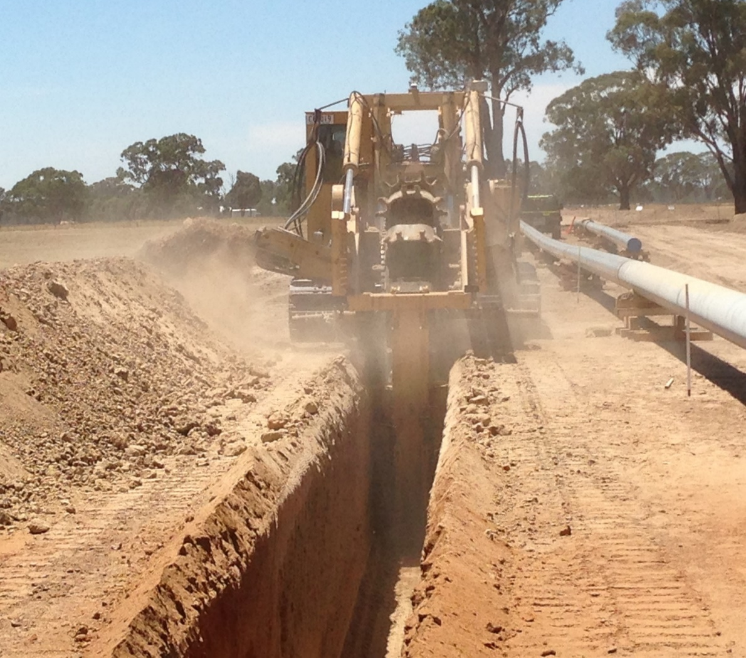
In some cases, due to the presence of areas of high ecological significance, existing assets or other constraints, the pipeline would be constructed using trenchless construction techniques such as HDD or shallow horizontal boring.
Excavated soil will be stockpiled to be re-used in backfilling. The volume of material reused would vary location to location based on soil profile and quality. Spoil would be stockpiled separate from vegetation and topsoil to provide for appropriate reinstatement of material excavated.

Rehabilitation and pipeline commissioning
Rehabilitation of the construction area and all temporary facilities, temporary access tracks and extra work areas would begin as soon as practicable after the completion of the construction activities, with the aim of restoration of ground cover within six months.
The pipeline would be pressure tested prior to commissioning. Hydrostatic testing involves sections of the pipeline being filled with water and then pressurised. Following testing, commissioning and the issue of a Consent to Operate from Energy Safe Victoria, gas flow would commence in the pipeline.

Operation and maintenance
The land within the pipeline construction corridor would be generally returned to its previous use following rehabilitation. The pipeline would be owned and maintained by APA. The operational footprint will be delineated by an easement, with a standard width of nominally 15 metres. Routine corridor inspections would be undertaken to monitor the pipeline easement for any operational or maintenance issues.

Planning

The EES process
On 22 December 2019, the Minister for Planning determined that the Project would require an EES under the Environment Effects Act 1978 (Vic) (EE Act). The EE Act sets out the process for the Minister to require the proponent of a project to prepare an EES where a project is considered to have a significant environmental or social effect pursuant to the EES Guidelines.
Following this decision, the Minister issued the draft EES scoping requirements for public comment, which the Minister then finalised and approved on 23 August 2020. This EES has been prepared in accordance with scoping requirements issued by the Minister.
An EES provides sufficient detail for the Minister for Planning to make a final assessment as to the Project’s acceptability. An EES assessment demonstrates the ability of the Project to meet statutory requirements. The EES Inquiry Report and Minister's Assessment of Environmental Effects will provide decision-makers (including Ministers and other statutory authorities) with the information they need to make decisions about whether statutory approvals for the Project should be granted and, if so, what conditions should apply.
The EES describes the Project and its potential environmental effects. It enables the public, stakeholders and decision-makers to understand how the Project works are to be designed, constructed and operated and the likely environmental effects. An EES process provides fair opportunities for public participation in assessment processes. APA is committed to responding to and implementing a high standard of consultation and engagement principles in communications and engagement for the Project.

Project approvals
The principal environmental approval for the Project under Commonwealth legislation is assessment and approval under the Environment Protection and Biodiversity Conservation Act 1999 (EPBC Act), under the assessment bilateral agreement with Victoria made under section 45 of the EPBC Act.
This is in accordance with the Minister for the Environment's determination in February 2020 that the proposed Project is a controlled action due to significant impact on listed threatened species and communities, which are designated Matters of Environmental Significance (MNES). Part of the Project is located within an approved Melbourne Strategic Assessment (MSA) area approved under Part 10 of the EPBC Act. For all projects within the approved MSA areas, no further approvals are required under the EPBC Act for the Project provided certain conditions are adhered to.
The Project requires the following principal approvals under Victorian legislation:
- Pipeline Licence under the Pipelines Act 2005 (Pipelines Act) for construction and operation of the pipeline
- Cultural Heritage Management Plans (CHMP) under the Aboriginal Heritage Act 2006 (AH Act).
Other approvals for the Project under Victorian legislation would be sought as a secondary process after the above principal approvals are obtained.
The approvals process is outlined in Figure 4.
Figure 4 Approvals process
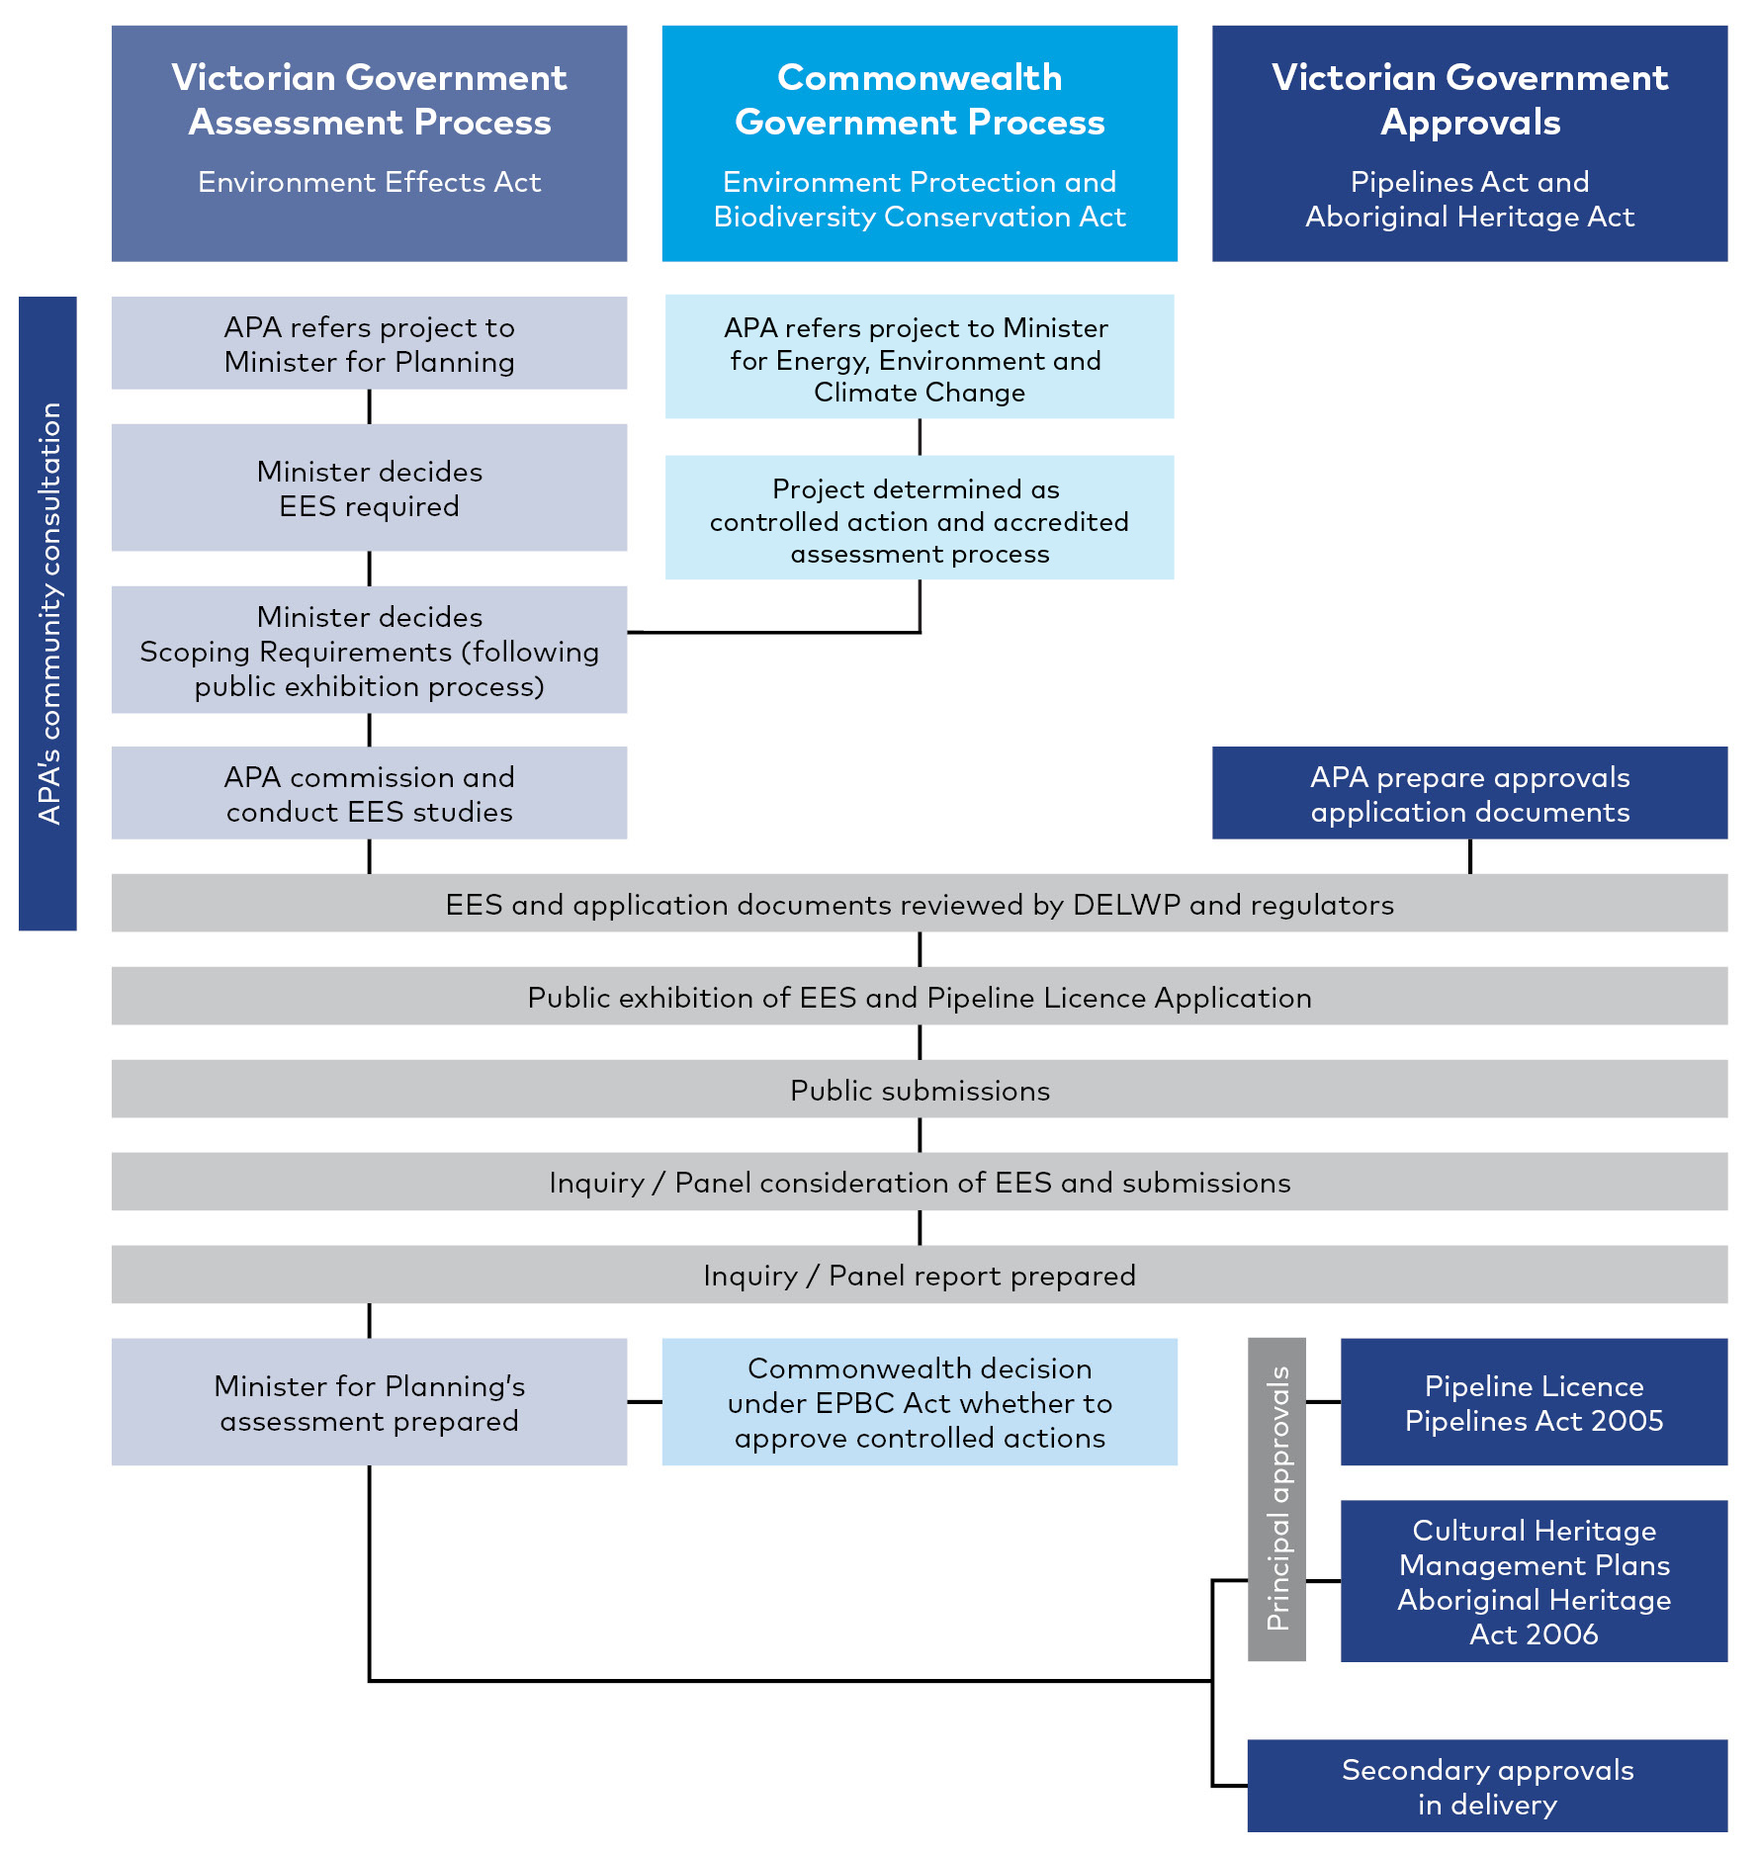

Assessing the Project's impacts

Assessment approach
To ensure a consistent and transparent approach to the evaluation of potential impacts on the environment, an assessment framework was developed for the Project EES.
The key components of the assessment framework are:  - Evaluation framework – the EES scoping requirements including the evaluation objectives identify desired environmental outcomes for the Project as established by the Minister for Planning. Relevant policy and legislation also establish the framework for assessment | What is the difference between a risk and an impact?  A risk is the function of the likelihood of an adverse event occurring and the potential consequences of the event.  An impact relates to the outcome of an event in relation to an asset, value or use.
- Assessment approach – the process for undertaking the technical reports including an assessment of existing conditions, risk assessment to screen for key aspects of assessment, impact assessment, development of environmental management measures, and identification of residual impact with the application of management and mitigation measures. The approach evaluates whether the Project’s effects are maintained within permissible levels and proposes contingency approaches if they are not
- Project development – the progression of the Project design. Ongoing refinement of the Project (including from the above assessment) is a key input to the EES as modifications to the design can lead to mitigation of environmental impacts.

Cumulative impacts
Cumulative impacts could arise where other major projects are constructed within the same geographic area in a similar period. These potential impacts have been addressed through the environmental impact assessment process undertaken for each technical study, as relevant. Key impacts identified within the cumulative impact assessments include those arising during construction in relation to air quality (dust), noise, ground movement and impacts to assets, access, and amenity values, as well as permanent cumulative impacts of removal of native vegetation or cultural heritage values. Other projects assessed for cumulative impacts are the Outer Metropolitan Ring (OMR)/E6 transport corridors project, the Sunbury Road Upgrade, the Bald-Hill–Yan Yean Pipeline and the Western Victoria Transmission Network project.

Technical studies
Thirteen specialist technical assessments evaluated the potential environmental effects of the Project. An overview of the findings of each of these technical studies follows. The studies are:
- Biodiversity  - Land stability and ground movement  - Greenhouse gas  - Landscape and visual  - Safety | - Surface water  - Air quality  - Cultural heritage  - Land use | - Groundwater  - Contamination  - Noise and vibration  - Social

Assessment of potential impacts

Energy efficiency, security, affordability and safety
The evaluation objective outlined in the Minister’s scoping requirements for this EES in relation to energy efficiency, security, affordability and safety is ‘to provide for safe and cost-effective pipeline connection between the eastern and western sections of the Victorian Transmission System’. This objective was considered by the following technical reports:
- Technical report M Safety. This report identified and assessed existing conditions, risks to safety and appropriate mitigation measures for the Project
- Technical report H Greenhouse gas. This report identified and assessed energy use and greenhouse gas emissions for the Project.

Energy efficiency, security and affordability
Chapter 2 Project Rationale outlines the energy efficiency, security and affordability benefits of this connection between the eastern and western sections of the VTS. The Project responds to the forecast changes in supply source locations and would directly support the timely transfer of higher volumes of gas from the east to the west of the state. To support the operational efficiency of the new high pressure pipeline once it is connected to the VTS, upgrades to the Wollert Compressor Station are also proposed as part of the Project.
The additional compressor and a regulating station proposed at Wollert would allow for increased volumes of gas (approximately an additional 100 Tj per day) to be compressed and transferred to the Iona Underground Storage basin. This upgrade would require significantly less compression to achieve gas transfer, compared with the current network arrangement, which depends on two or more compressor stations at Brooklyn. This efficiency significantly reduces power consumption, as well as compressor maintenance costs.
Operation of the Project is predicted by AEMO to lead to efficiency gains in the overall Victorian gas supply network, leading to a net reduction in total greenhouse gas emissions across the VTS. The net reduction in state and national emissions would equate to 10,110 t CO2-e per annum, which the greenhouse gas assessment found to equate to a reduction of 0.010% and 0.002% of state and national totals respectively.

Safety
A pipeline licence is required for the pipeline works under the Pipelines Act. Licensed pipelines are to be constructed and operated safely in accordance with the Pipelines Act and the requirements in AS/NZS 2885. This standard requires that the integrity of the pipeline is maintained throughout the operation phase of the Project. Under the Pipelines Act, the pipeline licensee has a general duty to implement a range of safety measures to reduce foreseeable risks associated with operating a pipeline and to minimise, so far as is reasonably practicable (SFAIRP), hazards and risks to public safety.
As part of a Safety Management Study (SMS), potential threats to safety were assessed taking into account a location analysis. The location analysis classified land use based on population density and existing and reasonably foreseeable land uses within the pipeline Measurement Length (being 659 metres from the centreline of the pipeline alignment). This informed the risk assessment and proposed engineering and procedure control measures. Approximately 40 percent of the Project is inside the Urban Growth Boundary, with the primary location classification being Residential. The remaining 60 percent of the Project is located outside of the Urban Growth Boundary on land primarily used for grazing and cropping, which has a location classification of Rural, with some Rural-residential or Residential.
All safety hazards were assessed as having a residual risk rating of low or below. The mitigation controls planned to be implemented by APA were identified and additional mitigation recommendations have been introduced to further reduce risks so far as is reasonably practicable. Additional risk mitigation measures would continue to be identified by APA and implemented to continue reducing risks to so far as is reasonably practicable.
The key safety risk identified in the construction phase is from fire, starting either within or outside the construction corridor. Other risks include human factor errors taking place in the management of blasting activities (if required for the removal of very hard rock) resulting in impacts on workers or the general public; the likelihood of this is rare and therefore the residual risk is low.
The residual risks during construction would be controlled using emergency response plans that are developed by the construction contractor with specific controls for risks such as bushfires, and other low likelihood construction related risks associated with the management of hazardous materials, blasting and vehicle movement. A blast management plan would be developed and provide a detailed approach to blasting including impact and exclusion zones based on the contractor's methodology.
The key credible threats in the operation phase relate to external impact, natural events and geohazards, intentional damage and external impact from operation of machinery. Bushfire is also a risk in the operation phase.
As a result of design requirements in AS/NZS 2885.1 (for example, wall thickness and depth of cover) and engineering controls such as the layout and design of the infrastructure in compliance with the relevant codes, technical standards, and industry best practice, the risks of gas release and/or ignition through rupture is not considered a credible failure. The Area of Consequence is therefore reduced from the full Measurement Length to 65 metres each side of the pipeline. APA would continue to monitor any proposals for sensitive uses proposed within this area during the operational life of the pipeline.
Residual bushfire risks would be managed by APA’s emergency response procedures and Bushfire Management Action Plan.
Mitigation measures would be applied through design and Project management measures, to reduce potential safety hazards during Project construction and operation to people, property and the environment so far as is reasonably practicable. The Project would be compliant with the energy release rate limits within AS/NZS 2885.1.

Biodiversity and habitats
The evaluation objective outlined in the Minister’s scoping requirements for this EES in relation to biodiversity and Matters of National Environmental Significance (MNES) is ‘to avoid and minimise potential adverse effects on native vegetation, listed threatened and migratory species and ecological communities, and habitat for these species, as well as restore and offset residual environmental effects consistent with state and Commonwealth policies’. This objective was considered and assessed by:
- Technical report A Biodiversity and habitats. This report includes an assessment of Matters of National Environmental Significance (MNES) under Commonwealth policies which is summarised in Chapter 18 MNES
- Technical report G Air quality. This report considers potential impacts of dust on biodiversity and habitats
- Technical report F Noise and vibration. This report provides inputs for consideration of noise or vibration impacts on biodiversity and habitats.

Biodiversity existing conditions
Native vegetation within the construction corridor is generally degraded and fragmented, reflecting the area’s long history of agricultural land use, and more recently urban development. Vegetation is dominated by pasture grasses and in some areas extensive tracts of noxious weeds. Shelterbelts and windbreaks are common and mostly consist of species that are not indigenous to Victoria.  15.32 hectares of native vegetation was mapped within the construction corridor with 141 flora (86 native, 55 introduced) species. Of these, the extent of native vegetation patches surveyed outside the Melbourne Strategic Assessment (MSA) was 13.39 hectares and ranged in condition from low to moderate. | Figure 5 Patches of grassland  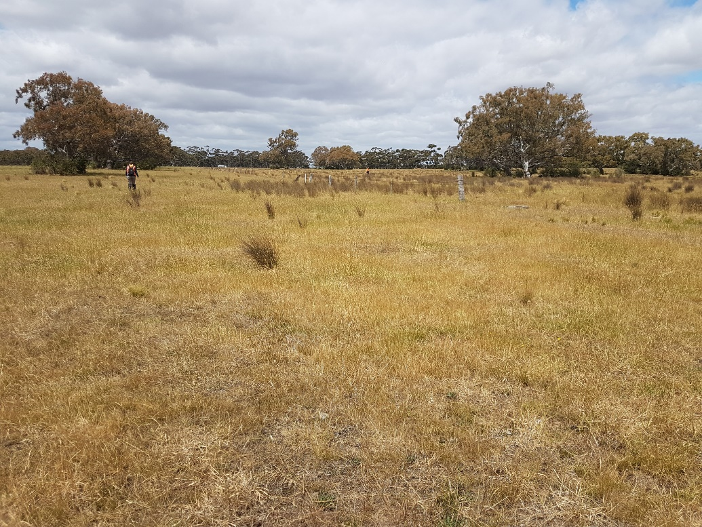
Some patches of Plains Grassland or Plains Grassy Woodland were recorded, which meet condition thresholds for MNES under the EPBC Act-listed communities Natural Temperate Grassland of the Victorian Volcanic Plain and Grassy Eucalypt Woodland of the Victorian Volcanic Plain.
Desktop assessments indicated that suitable habitat for 19 flora species listed under the EPBC Act, as well as 30 species listed under the FFG Act, may occur within the study area. Targeted field surveys for predicted species determined that an extremely low number of threatened flora were present.
Targeted surveys were conducted for Striped Legless Lizard, Golden Sun Moth and Growling Grass Frog. The Striped Legless Lizard population found is considered important. Golden Sun Moth habitat within the construction corridor outside the MSA area is estimated as approximately 19.93 ha. Four mapped wetlands consisting of Plains Grassy Wetland and Plains Grassland Ecological Vegetation Classes (EVCs) were identified within the construction corridor. Eight waterbodies contained water and at least some habitat attributes known to be associated with Growling Grass Frog. This species was recorded within Deep Creek and within an offline waterbody within the MSA area.
The alignment crosses 23 waterways. Seven nationally or state-listed threatened aquatic species or potential habitats have the potential to occur in the construction corridor. These include potential habitat for Platypus, the threatened Eastern Snake-necked Turtle, the Murray River Turtle and the Australian Grayling. Most of the threatened species or habitats are considered to have a low likelihood of occurrence, with Australian Grayling the only species with a medium likelihood.
MNES within the construction corridor are illustrated in Figure 6 and Figure 7.
Figure 6 MNES within the construction corridor (KP 0–KP 20)
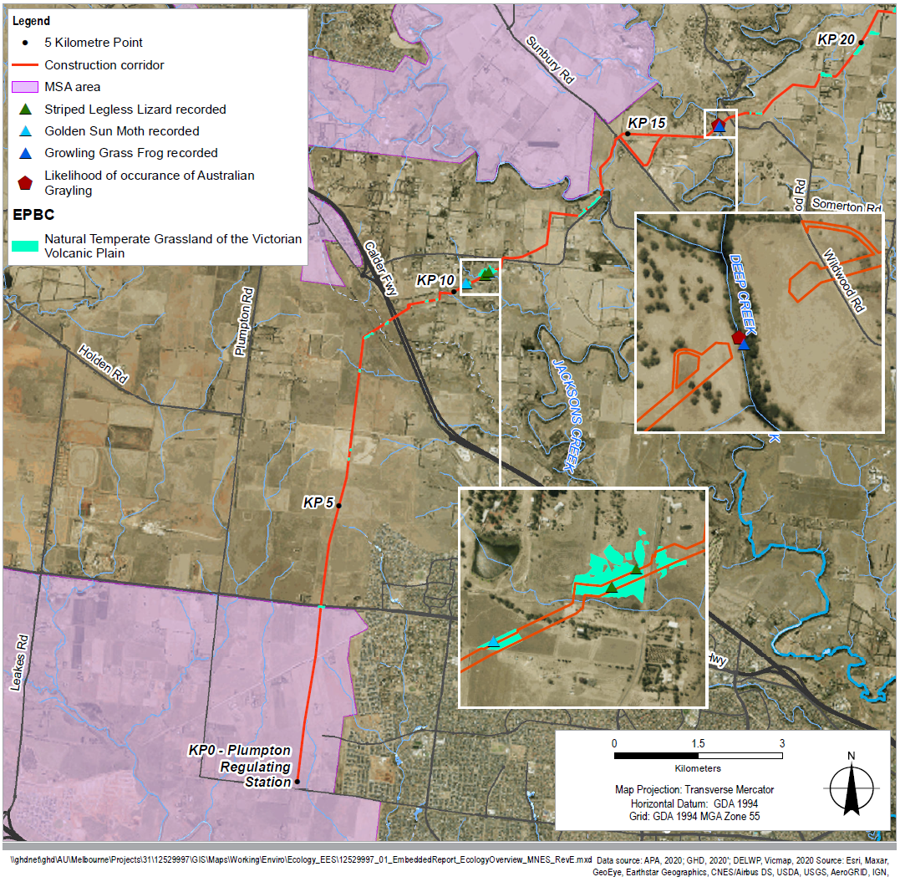

Figure 7 MNES within the construction corridor (KP 20–KP 51)
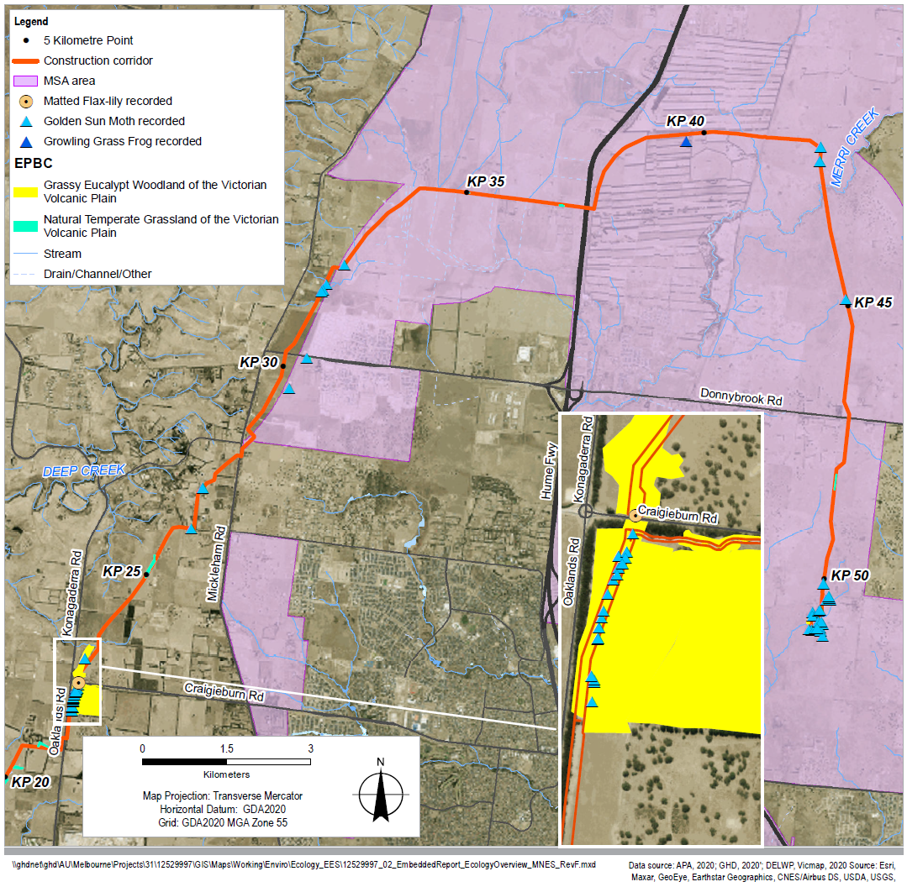

Biodiversity impact assessment
A number of biodiversity values identified will be avoided through pipeline re-alignment and use of HDD. These include:
- Two species of threatened flora (one Matted Flax-lily Dianella amoena and 48 Tough Scurf-pea Cullen tenax)
- Ten large River Red Gum trees within a threatened community
- 2.7 hectares of grassy woodland (EPBC/EVC/FFG) and 1.26 hectares of grassland (EPBC/EVC/FFG)
- 1.24 hectares of known and assumed Striped Legless Lizard habitat (outside of the MSA) and 4.08 hectares of known or assumed Golden Sun Moth habitat (outside of the MSA).
Direct vegetation loss is expected of:
- 15.32 hectares of native vegetation in patches from six EVCs; 12 large trees within patches; 16 large scattered trees, and 16 small scattered trees
- 4.16 hectares of EPBC Act-listed threatened community Natural Temperate Grassland of the Victorian Volcanic Plain (3.43 hectares outside the MSA area)
- 2.26 hectares of EPBC Act-listed threatened community Grassy Eucalypt Woodland of the Victorian Volcanic Plain (2.20 hectares outside the MSA area)
- 10.36 hectares of FFG Act-listed threatened community Western (Basalt) Plains Grasslands Community (8.98 hectares outside the MSA area)
- 4.62 hectares of FFG Act-listed threatened community Western Basalt Plains (River Red Gum) Grassy Woodland (4.30 hectares outside the MSA area).
The Project is likely to have a significant impact on Grassy Eucalypt Woodland of the Victorian Volcanic Plain based on five EPBC Act significance criteria, and is also likely to have a significant impact on Natural Temperate Grassland of the Victorian Volcanic Plain based on two criteria.
Impacts on native vegetation have been minimised as far as practicable. However, since vegetation removal would occur, any further reduction of the residual impacts has not been achievable. Areas that are disturbed during construction would be reinstated in accordance with the reinstatement requirements recommended for the Project.  Impacts on threatened fauna are expected to be limited to four species: Golden Sun Moth, Striped Legless Lizard, Growling Grass Frog and Tussock Skink. Golden Sun Moth and Striped Legless Lizard are expected to experience the greatest impacts of land clearance, with respective totals of 19.93 hectares and 39.34 hectares of known or potential habitat expected to be impacted. | Figure 8 Growling Grass Frog
Removal of endangered EVCs and large trees would be managed through an offsetting arrangement in accordance with the Guidelines for the removal, destruction or lopping of native vegetation (DELWP, 2017a). Offsets for the loss of FFG Act-listed communities would be addressed through offsets for endangered EVCs Plains Grassland and Plains Grassy Woodland. An Ecological Offset Strategy has been prepared and identified offsets are currently readily available for purchase. This would also address offsets for the impacted EPBC Act species.
The Project traverses two conservation areas within the MSA, as approved under Part 10 of the EPBC Act. The extent of the construction corridor within Conservation Area 34a – Northern Growth Corridor is 0.59 hectares excluding the existing easement between KP 42.6 and KP 43.3. The extent of the construction corridor within Conservation Area 28b - Summerhill Road (East) is 0.53 hectares excluding the existing easement between KP 48.6 and KP 49.1. Native vegetation is present at the Merri Creek crossing of Conservation Area 34a but is not present at Conservation Area 28b. Project realignment has resulted in a minor reduction in the extent of the construction corridor within Conservation Area 34a. A Works in Conservation Area (WICA) approval is required from DELWP prior to works commencing, and will detail the extent of native vegetation and habitat considerations.
Indirect impacts (from erosion/sedimentation, dust, litter, release of contaminants or soil compaction) on botanical values are expected to be minor and temporary during construction and operation of the Project.
The risk of habitat fragmentation is low. The loss of habitat connectivity associated with the Project is expected to be temporary, localised, and minimal for most species. Habitat fragmentation would be minimised through measures to avoid accidental loss of habitat, and contractor awareness. Reinstatement of vegetation and topsoil management would help reduce the long-term effect of additional habitat fragmentation.
Dewatering drawdown is likely to be temporary, minor and localised, and impacts on Groundwater Dependent Ecosystems (GDEs) are predicted to be insignificant. Refuge pools in creeks, riparian margins considered to be GDEs and those providing important habitat during low flow or drought conditions, are typically outside the expected area where groundwater drawdown would occur.
Indirect impacts on aquatic ecology values are expected to be minor and temporary during the Project’s construction and operation. The majority of aquatic habitats intersected by the pipeline were deemed highly unlikely to support EPBC Act or FFG Act-listed species. The recently FFG Act-listed Platypus is known to exist in Jacksons Creek and have been observed in close proximity to the construction corridor. Although there is a direct risk of injury or death of Platypus due to open cut construction, the risk would be minimised or avoided through the implementation of a Platypus-specific management measure in accordance with management guidelines from the Australian Platypus Conservancy.

Biodiversity management measures
Application of Project environmental management measures will avoid or minimise impacts on biodiversity and habitats during construction and operation, and include requirements for monitoring against baseline data. Environmental management measures include measures to manage vegetation and fauna during construction, control of pest organisms, manage runoff and erosion, enhance contractor awareness, mitigate GDE impacts, manage reinstatement and rehabilitation and threatened species impact mitigation. In addition, the offset strategy will also be implemented to offset the impacts that are unavoidable.
Effects of the Project on biodiversity have been assessed and environmental management measures have been identified to minimise or avoid impacts on flora, fauna and aquatic values, and manage any residual impacts to biodiversity values.

Water and catchment values
The evaluation objective outlined in the Minister’s scoping requirements for this EES in relation to water is ‘to maintain the functions and values of groundwater, surface water and floodplain environments and minimise effects on water quality and beneficial uses’. This objective was considered and assessed by:
- Technical report B Surface water
- Technical report C Groundwater
- Technical report D Land stability and ground movement.
The proposed Project alignment would interface with existing waterways and floodplains, which could lead to impacts on flow characteristics and water quality. To facilitate construction of the pipeline, there is likely to be some excavations that are deeper than the groundwater table.

Existing conditions
The Project alignment crosses 23 waterways located within the Werribee River, Maribyrnong River and Yarra River catchments. The most significant waterways include Jacksons, Deep and Merri Creeks. The existing condition of Jacksons, Deep and Merri creeks is:
- Jacksons Creek upstream and downstream (including Maribyrnong River) exceeds the State Environment Protection Policy (SEPP) guideline values for the majority of water quality parameters. The riparian woodland vegetation on the west bank is intact, dense and has a healthy mix of deep-rooted trees and ground cover vegetation. The east bank is more open and exposed with limited ground storey vegetation. Within the upstream reach there is a sharp meander bend in the creek and some minor erosion of the stream banks evident. A grade rock structure providing protection to the stream bed is located immediately upstream of the Project. The Project location is within a relative straightened reach of stream. Two sections of riffles are characterised by shallow depths with fast, turbulent water agitated by rocks and vegetation.
- Deep Creek upstream and downstream (including Maribyrnong River) exceeds the SEPP guideline values for the majority of water quality parameters. The riparian woodland vegetation of both banks is intact, dense and has a healthy mix of deep-rooted trees and ground cover vegetation. On the west side the riparian zone is protected, and the east bank is more exposed. The Project crossing location is within a relatively straightened section of the stream which extends from the Emu Creek confluence upstream and continues downstream. There is a section of riffles characterised by shallow depths with fast, turbulent water agitated by rocks and vegetation.
- Merri Creek downstream exceeds the SEPP guideline values for the majority of water quality parameters. The riparian woodland vegetation of the banks and channel is dense with a healthy mix of deep-rooted trees and ground cover vegetation along the waterway, which provides protection of both sides of the waterway. Within both the upstream and downstream reaches there are sharp meander bends. The Project crossing location is on a meandering section of Merri Creek which continues downstream, with relatively quiet water flowing through a thickly vegetated stream bed. There is a section of riffles characterised by shallow depths with fast, turbulent water agitated by rocks and vegetation. At the location of the construction corridor, the creek is ephemeral.
A desktop assessment identified that the majority of the alignment travels through areas where depth to groundwater has been interpreted to be greater than 5 metres.

Groundwater impact assessment
The areas of potential groundwater interaction along the alignment represent approximately five per cent of the entire pipeline length. Considering the limited extent of the pipeline below the water table, and the relatively small pipe diameter and trench depth below the water table compared to the aquifer thickness, it is expected that groundwater local flow paths will not be significantly altered or blocked.
Given the anticipated short duration (less than four weeks) of dewatering activities at each location, the consequence of impact on any surrounding bores is considered moderate, and the risk of groundwater dewatering impacting neighbouring bores is low. During construction dewatering, additional drawdown or lowering of the groundwater level near a GDE such as Jacksons Creek and Merri Creek may cause a loss in groundwater availability that may impact the GDE health and function. However, the risk is minor.
In areas where HDD will occur below the water table aquifer (such as Deep Creek), there is potential for the drilling fluids to interact with the aquifer system. This would be addressed through specific management measures. Any residual impact would be low.

Surface water impact assessment
Twenty-three waterways are intersected by the Project alignment. Six of these were assessed as higher risk waterways and assessed in more detail. Of these, three main 'complex waterways' were identified and formed the focus of the surface water impact assessment: Jacksons, Deep and Merri creeks.
Potential impacts on surface water values were assessed, including erosion and changes to waterways. The crossing method at Jacksons, Deep and Merri creeks was a key factor in assessing potential impacts. Open trench construction is proposed at Jacksons and Merri creeks, and HDD is proposed at Deep Creek. HDD construction methodology was considered at Jacksons Creek but this option has been eliminated due to geological, accessibility, topographic and bore length constraints. For Merri Creek, geotechnical investigations indicated underlying presence of bedrock, which means that the risk of erosion is lower and open trenching can be readily managed with standard controls. The crossing location is also within an existing APA pipeline easement that was previously trenched. The residual construction impacts on surface water and waterways are generally considered to be low following the application of both standard control measures and additional site-specific controls.
Potential impacts of erosion during open trench construction are identified as potentially more significant for Jacksons Creek than the other waterways. This is due to complexities of the geomorphological processes and the exposure to more highly erodible materials below the surface. Additional controls relating to surface water and biodiversity monitoring, site-specific construction management and rehabilitation measures are essential to monitor and reduce the likelihood of unexpected erosion occurring at this waterway crossing.
Figure 9 Jacksons Creek
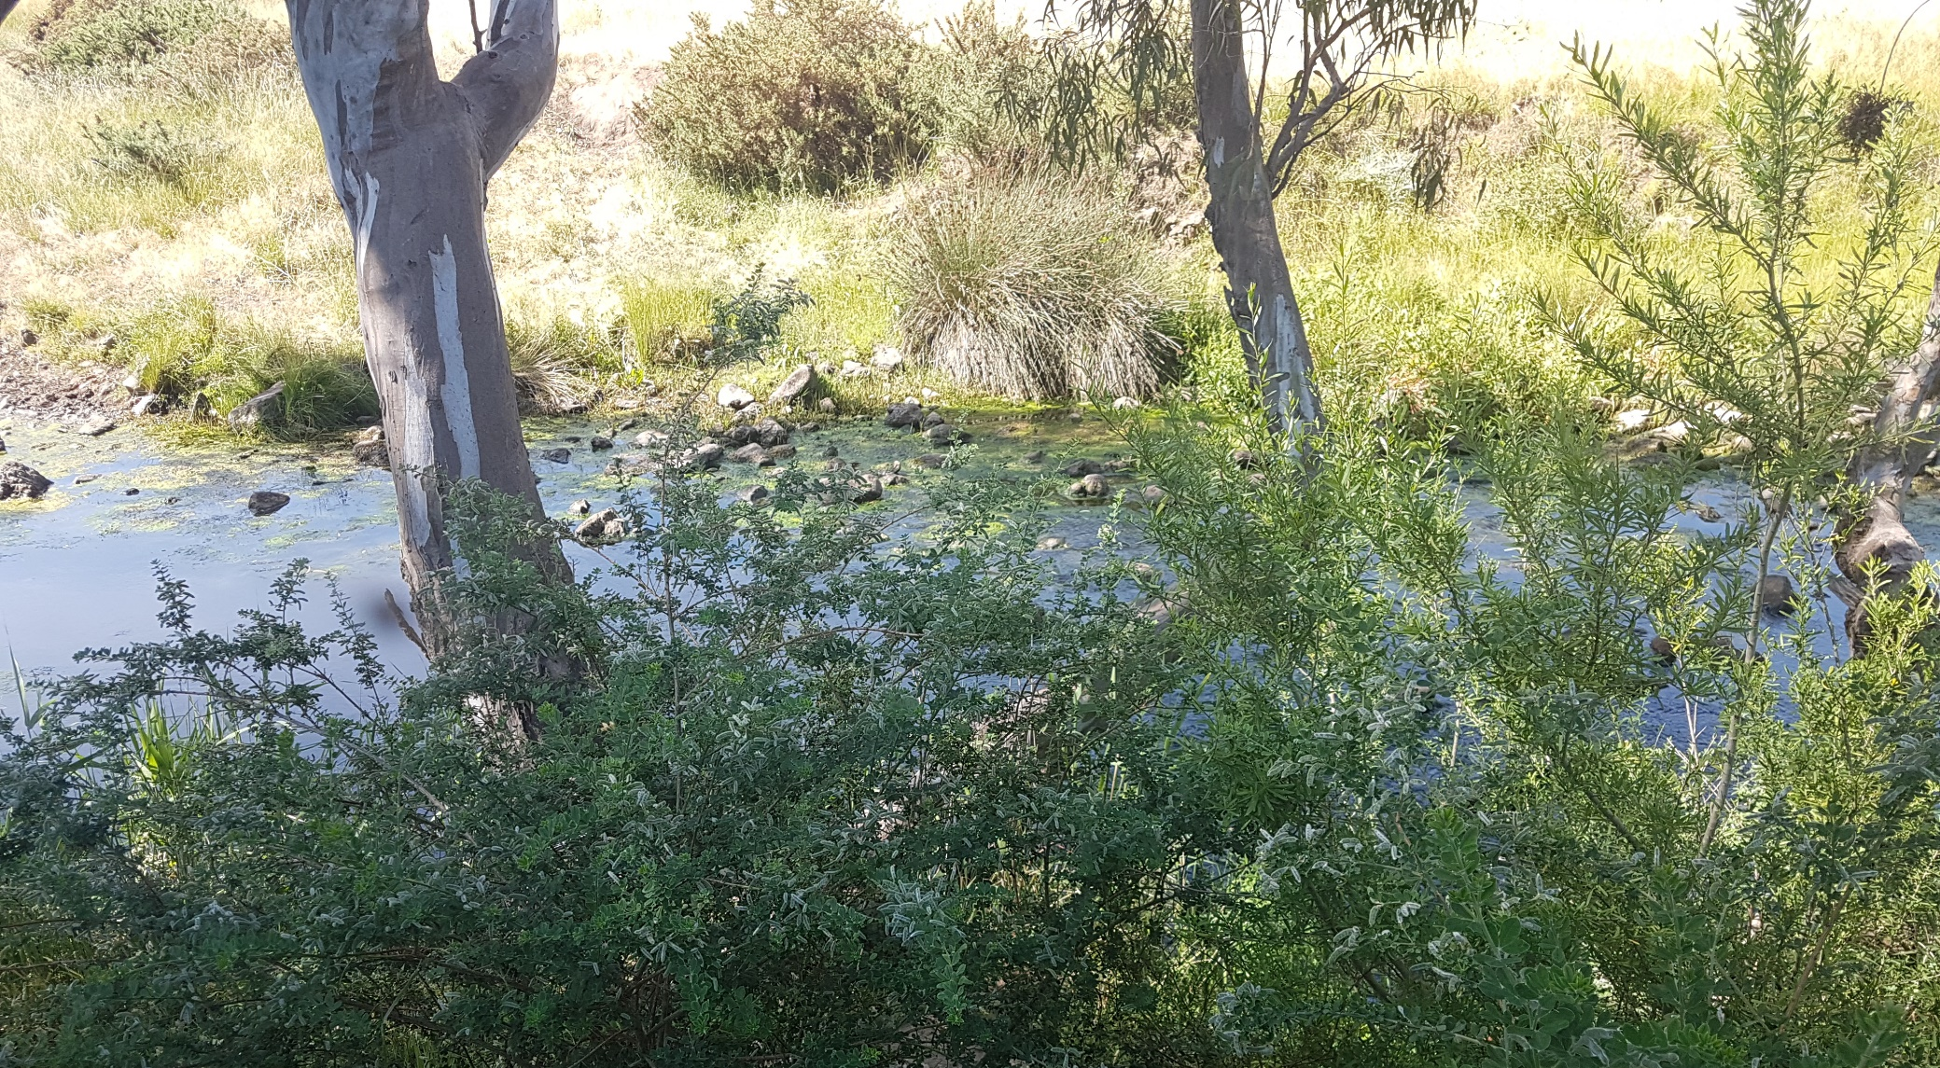
Potential impacts of erosion during open trench construction for Merri Creek are associated with identified sensitive downstream receptors. Given the ephemeral nature of the waterway in this reach and the presence of basalt at shallow depths at Merri Creek to limit the depth and extent of future bed erosion, the impacts can be more readily managed than compared to Jacksons Creek. Whilst there remains low residual impact to unexpected erosion associated with the works, any potential impact to water quality would be expected to be short term and localised and promptly remediated to reduce the downstream extent and magnitude of the impact.
Potential impacts due to permanent changes to the waterways are also identified as potentially more significant for bed and bank erosion at Jacksons Creek, than the other waterways. This can be reduced by additional design, construction and rehabilitation management measures implemented for Jacksons Creek to mitigate future erosion and prevent permanent changes.

Management measures
Project environmental management measures would be implemented to minimise impacts that could lead to changes to surface water quality, flows and flooding, and erosion and damage to property and infrastructure. These include requirements for managing runoff from adjacent construction areas, managing discharge from dewatering activities or spills, waterway and floodplain function management during construction, site rehabilitation measures for disturbance caused by open cut trench construction, implementing a monitoring program in Jacksons Creek and Merri Creek, site-specific design and construction management measures at Jacksons Creek, and a Flood Management and Response Plan for Jacksons Creek, Deep Creek, Kalkallo Creek and Merri Creek.

Cultural heritage
The evaluation objective outlined in the Minister’s scoping requirements for this EES in relation to cultural heritage is ‘to avoid, or minimise where avoidance is not possible, adverse effects on Aboriginal and historic cultural heritage values’. This objective was considered by Technical report I Cultural heritage. In addition, two Cultural Heritage Management Plans (CHMPs 16593 and 16594) are being developed for the Project.

Existing conditions
The Project transects multiple creeks and tributaries that have the potential to contain Aboriginal cultural heritage material and places such as stone artefact scatters and scarred trees.
Aboriginal stakeholders for the Project include the Registered Aboriginal Party (RAP) Wurundjeri Woi Wurrung Cultural Heritage Aboriginal Corporation (WWCHAC) and the Traditional Owners located on or near the Project Area. Aboriginal stakeholders have been involved in investigations and management planning as the Project has progressed, including during APA's preparation of two CHMPs for the Project, which have informed the Aboriginal cultural heritage assessment for the EES.
CHMP 16593 is being prepared in consultation with the WWCHAC as RAP for the area between KP 9 and KP 51. CHMP 16594 is being prepared in consultation with Aboriginal Victoria and the Traditional Owners for the area between KP 0 and KP 9 where there is no RAP.
Thirty-seven previously registered Aboriginal places are identified within or near the construction corridor, based on progress to date. Of the 37 registered Aboriginal places identified, 13 are located within the construction corridor and 24 are located within 50 metres of the construction corridor. Any impacts to registered Aboriginal cultural heritage must be undertaken in accordance with the management conditions of CHMPs 16593 and 16594.
Two historic sites are located within 100 metres of the construction corridor and two sites are located within 100 metres of the possible access tracks to the north of the Project. One site on the Victorian Heritage Inventory is within the construction corridor, Holden Cobbled Stone Road, shown in Figure 10. Sections of dry-stone wall in poor condition were found inside the construction corridor but are not within heritage overlays.
Figure 10 View of section of Holden Cobbled Stone Road
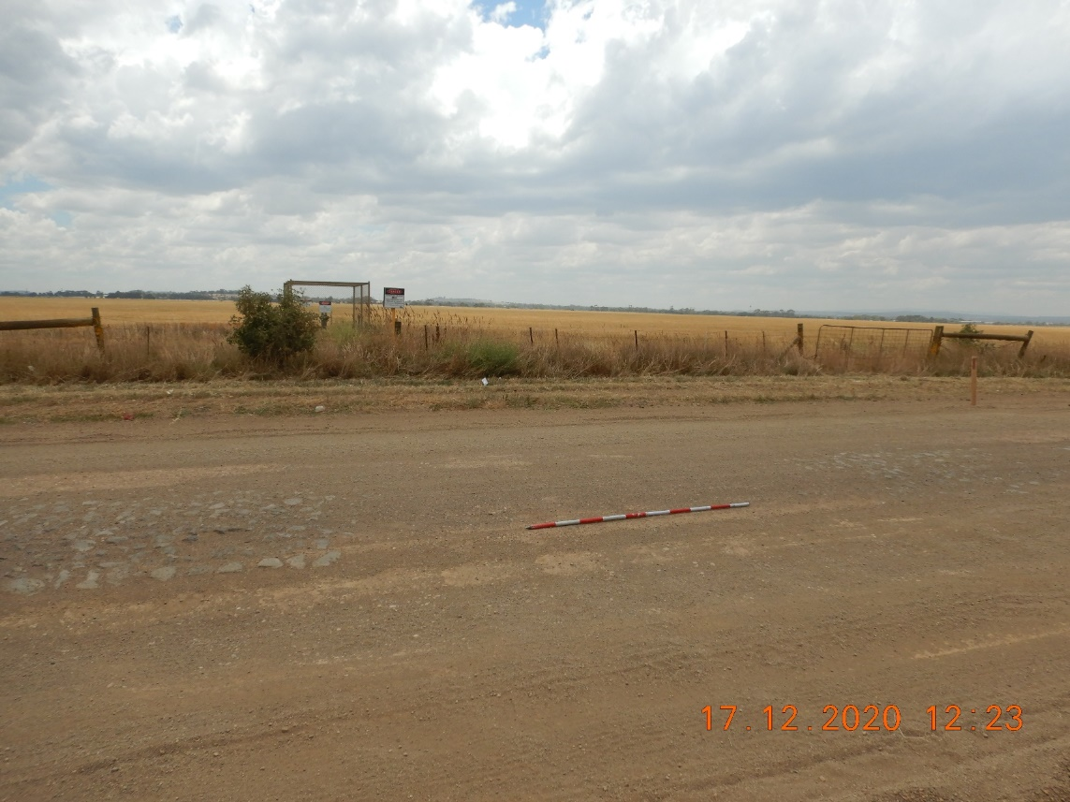

Impact assessment
The impact of clearing the construction corridor and trenching would involve potential disturbance of Aboriginal cultural heritage deposits within the construction corridor. The impact on historical and research significance of Aboriginal places was assessed based on the nature of the known places and the potential impact of Project activities on those places. The extent of impact is determined by the number and location of registered places in the construction corridor, with some of the 13 places fully destroyed, some partially destroyed, and some previously salvaged or removed. No indirect effects on Aboriginal cultural heritage have been identified.
Mitigation measures would be confirmed through the final CHMP and through consultation with the RAP, Aboriginal Victoria and Traditional Owners respectively, and are likely to include surface collection of artefacts, subsurface salvage, inductions for construction staff and compliance checks. Contingency measures would also provide measures to protect unidentified Aboriginal cultural heritage found during construction. Residual impacts remain as there would be a loss of Aboriginal cultural heritage values as a result of the Project.
No impacts to Holden Cobbled Stone Road are predicted due to the construction technique to bore under the road in this location.

Management measures
Mitigation measures and management conditions associated with Aboriginal cultural heritage are specified within CHMPs 16593 and 16594 currently being prepared for the Project. These are agreed during consultation with the RAP WWCHAC (CHMP 16593) and AV with Traditional Owner groups Bunurong Land Council Aboriginal Corporation, Boon Wurrung Land and Sea Aboriginal Corporation BLaSC and WWCHAC (CHMP 16594).
Based on the Project's construction methodology, there are no anticipated residual construction impacts to Holden Cobbled Stone Road. However, as the Project works are being undertaken within the curtilage of a listed historic site, a Consent application is required and any conditions on the Consent would be implemented through the Project CEMP. An unexpected finds procedure within the CEMP would provide the contingency measures to be followed if any unknown historic heritage site, value or object is identified during construction.

Social, economic, amenity and land use
The evaluation objective outlined in the Minister’s scoping requirements for this EES in relation to social, economic, amenity and land use is ‘to minimise potential adverse social, economic, amenity and land use effects at local and regional scales'. This objective was considered and assessed by:
- Technical report D Land stability and ground movement
- Technical report F Noise and vibration
- Technical report G Air quality
- Technical report J Landscape and visual
- Technical report K Land use
- Technical report L Social.

Land stability and ground movement

Existing conditions
The construction corridor is characterised by multiple Quaternary basalt volcanic eruption points that protrude above extensive lava plains produced by repeated volcanic episodes over long time periods. Within this predominantly volcanic setting, ranges of low hills protrude above the basalt plains, composed of pre-volcanic basement rocks and Neogene cover units. Approximately 90 percent of the soil samples tested comprise fine grained (cohesive) soil. The remaining 10 percent comprise granular material (ie sand or gravel) as the primary component.
The topography of the study area is generally flat to gently undulating, with the exception of significant low elevations at Jacksons Creek and Deep Creek where the valley sides are steep compared to the surrounding plains.

Impact assessment
Key land stability and ground movement impacts include trench wall instability, ground movement (or volume loss) and impacts on slope stability. Following mitigation these potential residual impacts are considered to be low.
Excavation of deep trenches during construction can result in wall instability. Without any mitigation measures, wall collapse could result in a large amount of land disturbance to a localised area near the trench. Trench excavations required for the Project are slightly deeper (approximately 2 metres) than usual shallow trenches (less than 1.2 metres). If the trench is not supported through trench shields, struts or anchors, trench stability will depend on the strength of the material through which the trench is excavated.
Although the majority of trench excavation through fine grained clays or silts are expected to be stable, the potential for unfavourable conditions, such as encountering granular soils, requires management to reduce potential impacts on nearby land. There is insufficient geotechnical information to determine specific locations where granular soils may be encountered along the alignment. It is considered that there is potential for granular soils to be encountered at any location along the alignment. Encountering cohesionless granular material in trench construction could result in trench wall collapse and result in localised impact on nearby land.
Ground conditions are expected to vary between three main ground condition types, which have different implications on ground movement (or volume loss). Trenchless crossings may result in a minor (only aesthetic) level of asset damage as a result of ground strains. The potential residual impact associated with volume loss at trenchless crossings is considered to be minor and is unlikely to affect the serviceability of the utilities assessed.

Management measures
Application of the Project environmental management measures would minimise impacts associated with land stability and ground movement. These include requirements for HDD trenchless bore management, adherence to third party asset clearances, development and implementation of a sodic soils management plan, and provision of trench support or battering to reduce the potential for slope or trench wall failure and associated impacts. Following implementation of the Project environmental management measures the potential residual impacts associated with land stability and ground movement are not considered to have a significant impact.

Noise and vibration

Existing conditions
Within the study area defined as a corridor of approximately one kilometre from the centre of the Project construction corridor, 525 sensitive receptors were identified as potentially impacted by construction noise. 521 are rural-residential or residential activities. Background noise levels during the daytime are expected to be between 40 – 45 dB(A) and during the night-time between 30–35 dB(A). In locations surrounding the Calder Freeway and the Hume Freeway background noise levels are expected to be around 50 dB(A) during daytime and 40 dB(A) during night-time. The sensitive receptors related to construction impacts are shown in Figure 12.
The main sources of operation noise emissions would be the Wollert Compressor Station and the MLV sites. There are 31 sensitive receptors within the vicinity of the Wollert Compressor Station, with the closest being around 700 metres away from the existing facility (refer Figure 11). The mainline valve (MLV) sites are separated by substantial buffers from the nearest noise sensitive receptors with the closest sensitive receptor being approximately 300 metres away from a MLV site. Results of previous noise monitoring programs have found that background noise levels in the area surrounding the Wollert Compressor Station are low (with and without the compressor station operating), typical for rural areas.
Figure 11 Wollert Compressor Station sensitive receptors
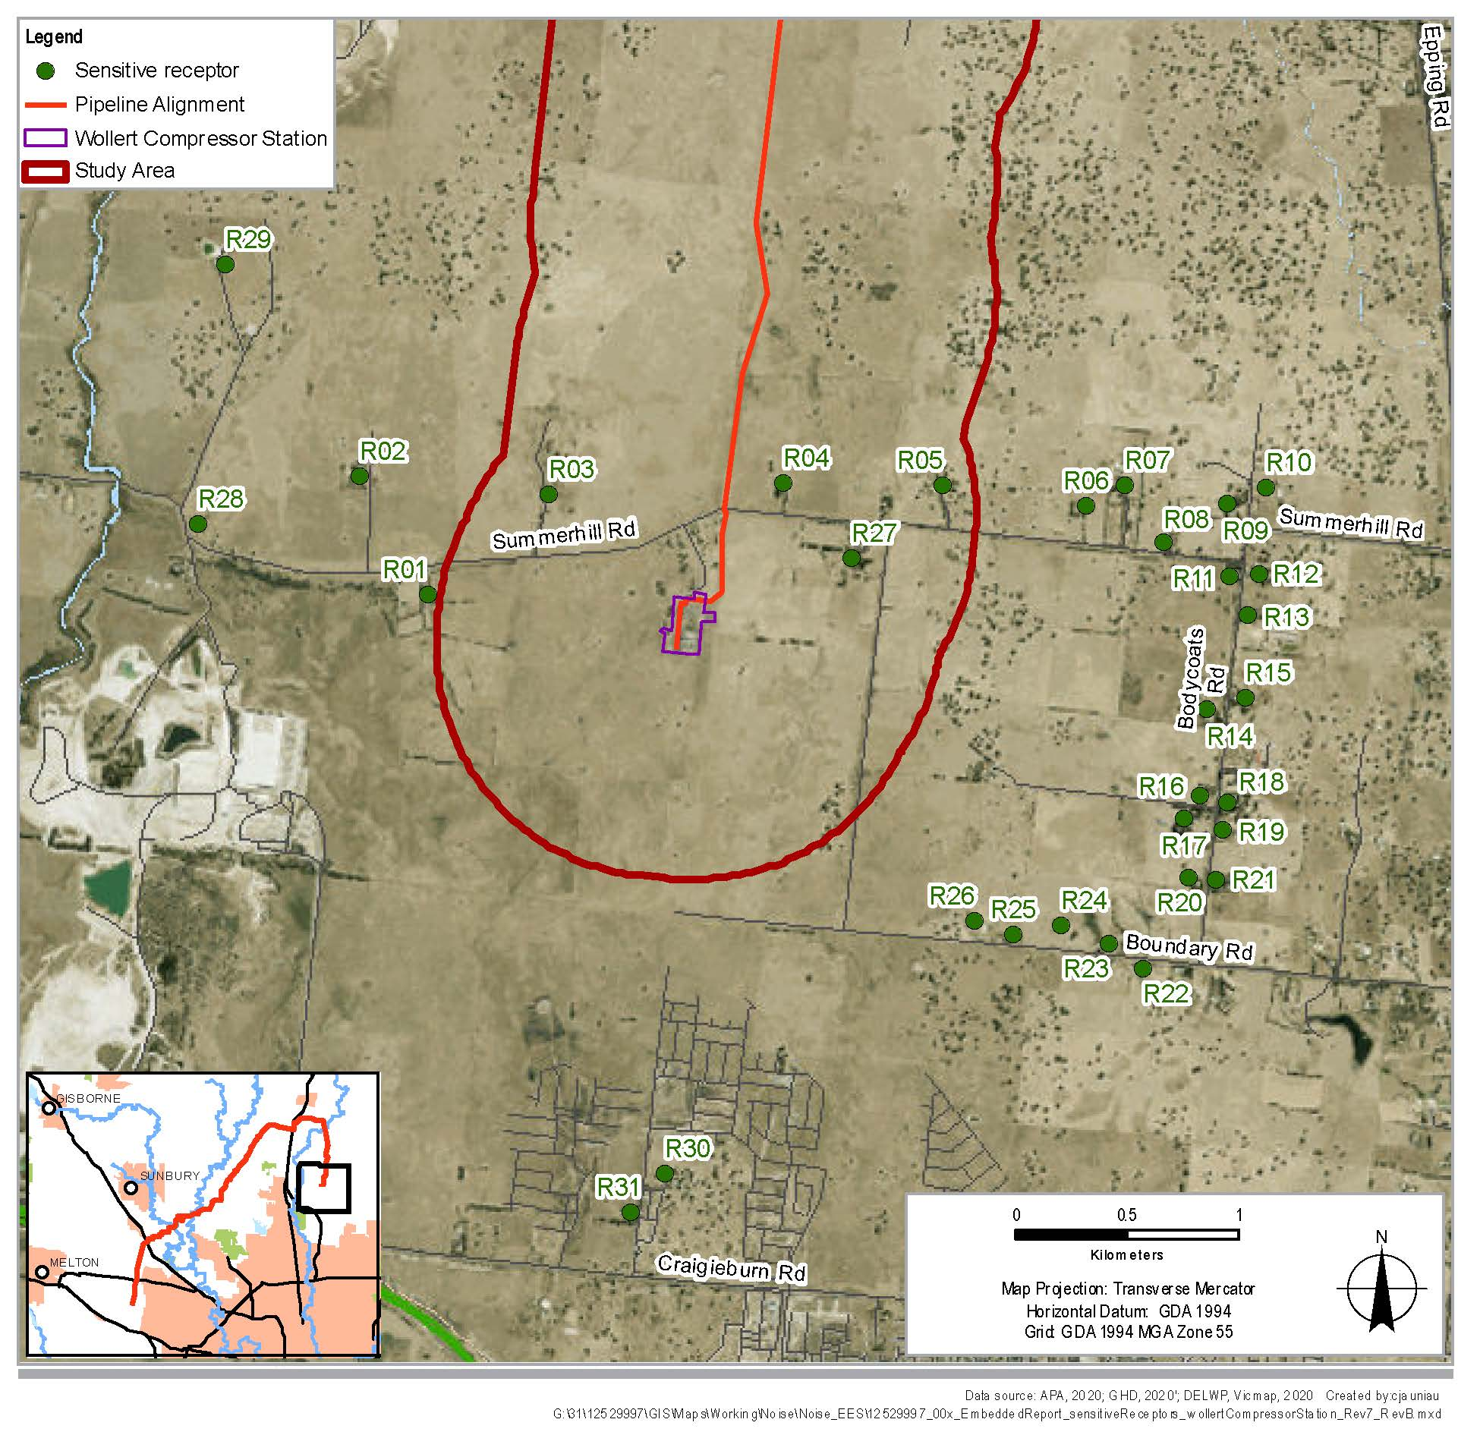

Impact assessment
The adopted daytime noise criteria at residential receptors is 75 dB(A). For evening and weekend work, the noise criteria is 10 dB(A) above that of the existing background noise levels. Noise is required to be 'inaudible' within a habitable room for night-time work.
Where works would occur near a noise sensitive receptor, construction activities may result in short-term noise impacts. Modelling indicated a number of receptors where construction noise criteria would be exceeded without mitigation, with the noisiest activity expected to be associated with non-destructive testing which would involve grit blasting for open trench construction.
Generally, along the construction corridor there are less than five sensitive receptors in any particular location where construction is expected to exceed the daytime criteria, without any mitigation in place. The exception to this is around Morefield Court in Diggers Rest where there are approximately eight sensitive receptors where construction is expected to exceed the daytime criteria. While boundary fences at some properties in this location would provide noise attenuation, even with the fencing, the daytime noise criterion is expected to be exceeded for open trench construction.
Figure 12 Noise level exceedances at sensitive receptors for daytime, open trench construction – without mitigation
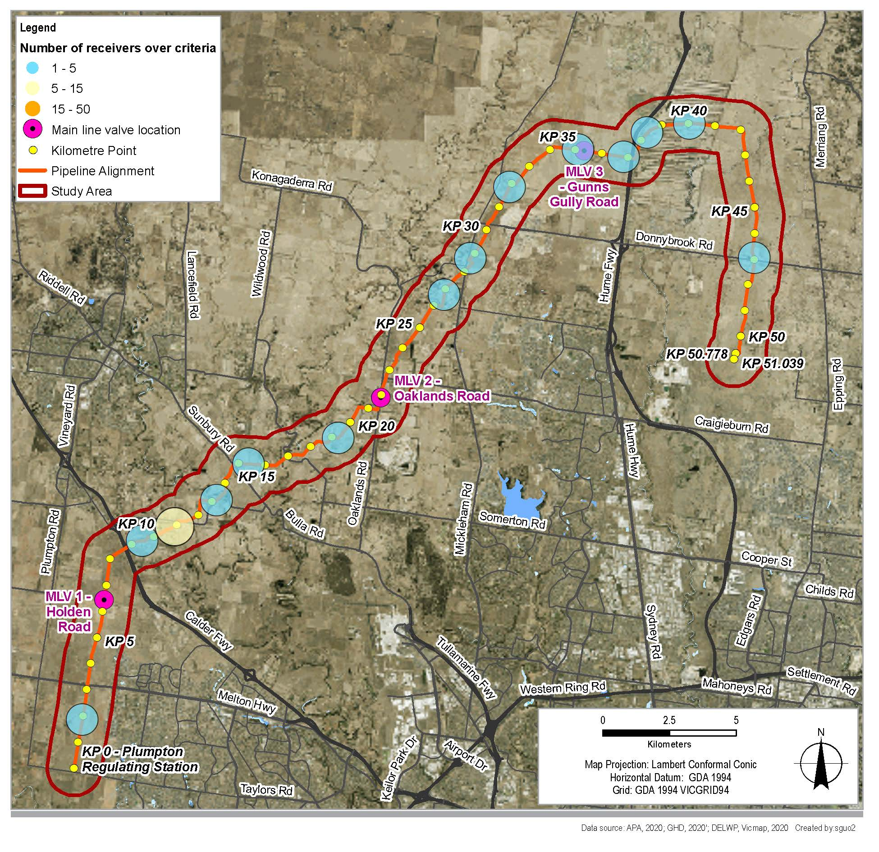
Noise levels from crossings with HDD and bore operations are predicted to meet the daytime criterion, however, as HDD and boring would sometimes be required during the evening and night-time, without mitigation, these activities have the potential to exceed the evening noise and night-time criteria. During the evening, exceedances of the recommended noise criteria are predicted at 12 locations. It is estimated that less than 15 individual sensitive receptors are likely to be affected at each location where exceedances occur. Night-time exceedances are predicted at 14 locations along the construction corridor and there could be as many as 100 sensitive receptors in some locations, with more at Mickleham, Hillside and Fraser Rise.
HDD and bored crossings could take between two to three weeks at a particular location and mitigation measures would be required to avoid and minimise impacts during this time.
Noise levels have been modelled for the maximum operating capacity of the current and upgraded Wollert Compression Station. Noise levels at the facility are predicted to comply with the applicable noise limits at all of the sensitive receptors during the day and the night during neutral and adverse metrological conditions, as illustrated in Figure 13.
There are no statutory limits for vibration within Victoria, however international guidelines are usually referred to. Typically at a distance of 50 metres from the vibration generating activity, vibration is expected to meet the 0.3 mm/s human perception guidance value in international guidelines. However, it is expected that vibration may be perceivable at distances of up to 100 metres during dozer or other intensive operations (without mitigation).
Potential blasting locations would be located at least 100 metres or more from residential buildings. At this distance, blasting with the use of charges of less than one kilogram would not exceed the human comfort criteria of 5 mm/s or the structural damage criterion. Use of an eight kilogram charge may be required at one location in the northern end of the Project, and this charge may exceed the human comfort levels, but would be below the structural damage criterion.
Melbourne Water’s Yan Yean to Bald Hill pipeline project and Major Road Projects Victoria’s (MRPV) Sunbury Road upgrade project may be constructed at the same time. Details of sequencing of works and types of activities for these projects is not yet known, however should construction activities occur at the same time as this Project, there is potential for cumulative noise and vibration impacts at the sensitive receptors and possible exceedances of noise criteria. Liaison with MRPV and Melbourne Water would be undertaken prior to and during construction to avoid, where practicable, works being undertaken at the same time and in the same location.

Management measures
Noise and vibration management measures have been identified to avoid and minimise impacts associated with noise and vibration during the construction of the Project. These include preparation of a Construction Noise and Vibration Plan detailing measures to avoid and minimise noise and vibration, and condition/dilapidation surveys where required. Controls would be implemented suited to the individual locations and circumstances and could reduce the noise levels by around 5 dB(A) to as much as 50 dB(A) where enclosures are used around stationary equipment. Measures to avoid and minimise the impacts of construction vibration would be considered in locations where sensitive receptors are located within 100 metres from construction and subject to vibration-generating construction activities. This would include measures such as alternative work methods, restricted hours, and increasing distance between equipment and sensitive receptors.
In the event that the residual noise and vibration impacts (after management measures are implemented) exceed the recommended construction noise and vibration criteria or construction works are planned close to the sensitive receptors, information on the impact will be discussed with affected residents and individual mitigation would be implemented (EMM NV6).
Prior to blasting, a detailed blast study and impact management and would be developed to confirm potential blasting impacts and identify any further management measures required.
Figure 13 Noise contours from the Wollert Compressor Station during neutral and adverse meteorological conditions, source: Wood, 2020
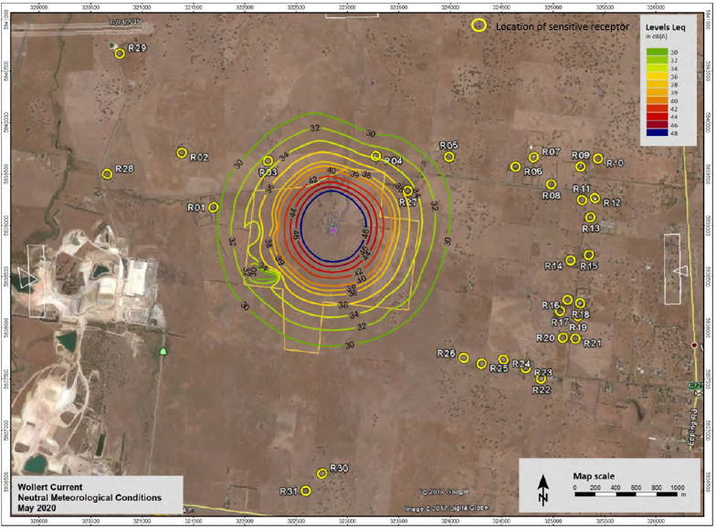
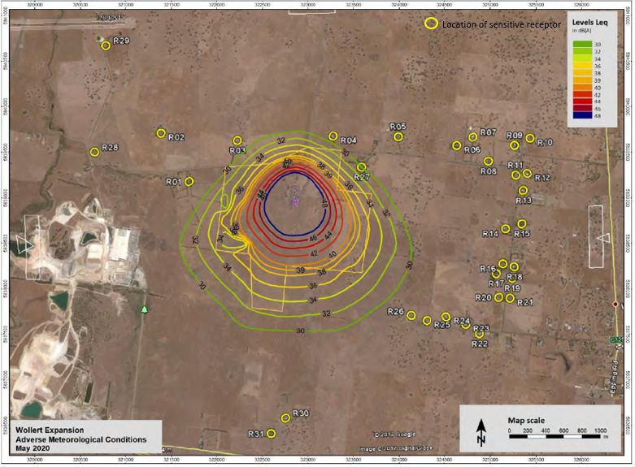

Air quality
The primary evaluation objective outlined in the Minister’s scoping requirements for this EES in relation to air quality is ‘to minimise potential adverse social, economic, amenity and land use effects at local and regional scales’.

Existing conditions
An air quality impact assessment considered sensitive receptors within 500 metres of the Project alignment for the construction and operational phases of the pipeline, and within 2.5 km (for the purposes of dispersion modelling) of the Wollert Compressor Station. A total of 484 sensitive receptors were identified. The closest sensitive receptors to the Project are six individual rural residences located in the range of 35 metres to 50 metres from the construction corridor. Most of the identified receptors are considered residential or rural-residential activities for the purposes of the air quality assessment. The air quality study area and sensitive receptors are illustrated in Figure 14.

Impact assessment
During construction, the key air quality impacts would result from the creation of dust (PM₁₀). Trenching activities have the higher potential for dust, requiring mitigation measures where sensitive receptors are within 75 metres of the corridor to achieve State Environment Protection Policy (SEPP) Ambient Air Quality criteria trigger levels. As part of standard construction and environmental risk management, dust mitigation measures and dust monitoring would be implemented to reduce the likelihood, intensity or extent of dust effects. Additional mitigation measures, where required, would include reducing or suspending works when real-time particulate monitors ‘alarm’ and when adverse conditions are likely (for example, dry gusty winds with sensitive receptors nearby and downwind). In all cases, the implementation of additional mitigation measures would reduce the likelihood, intensity or extent of dust effects, resulting in low impact on air quality to sensitive receptors.
During operation, air quality impacts are limited to operation of the Wollert Compressor Station. Air dispersion modelling was conducted for CO, NO2, PM10, PM2.5, PAHs, SO2, benzene, formaldehyde, toluene and xylene. All pollutants complied with the relevant criteria in the EPA Victoria SEPP Air Quality Management for worst-case normal operations, when modelled in accordance with the Environment Protection (Scheduled Premises) Regulations 2017. Additional modelling was completed including the emergency generator which may operate on occasions and this showed a small area of exceedance for NOx and CO within the APA site boundaries (ie not impacting sensitive receptor locations).

Management measures
Application of the Project environmental management measures would minimise impacts associated with dust and the potential for odorous soils at construction, in addition to combustion and odour-related emissions of the Wollert Compressor Station at operation.
In developing the environmental management measures, the air quality assessment adhered to the mitigation hierarchy; that is, an obligation to first avoid, minimise, and then restore the residual impacts that remain. According to the Waste Hierarchy of SEPP AQM (Clause 8), avoidance is the first choice. This is possible for operation where technology choice (best practice) can be applied. The Project’s compressor utilises best practice technology with low emissions and stack height design to ensure adequate dispersion. The operation effects are considered minimal and no additional mitigation is required.
Figure 14 Air quality study area and sensitive receptors
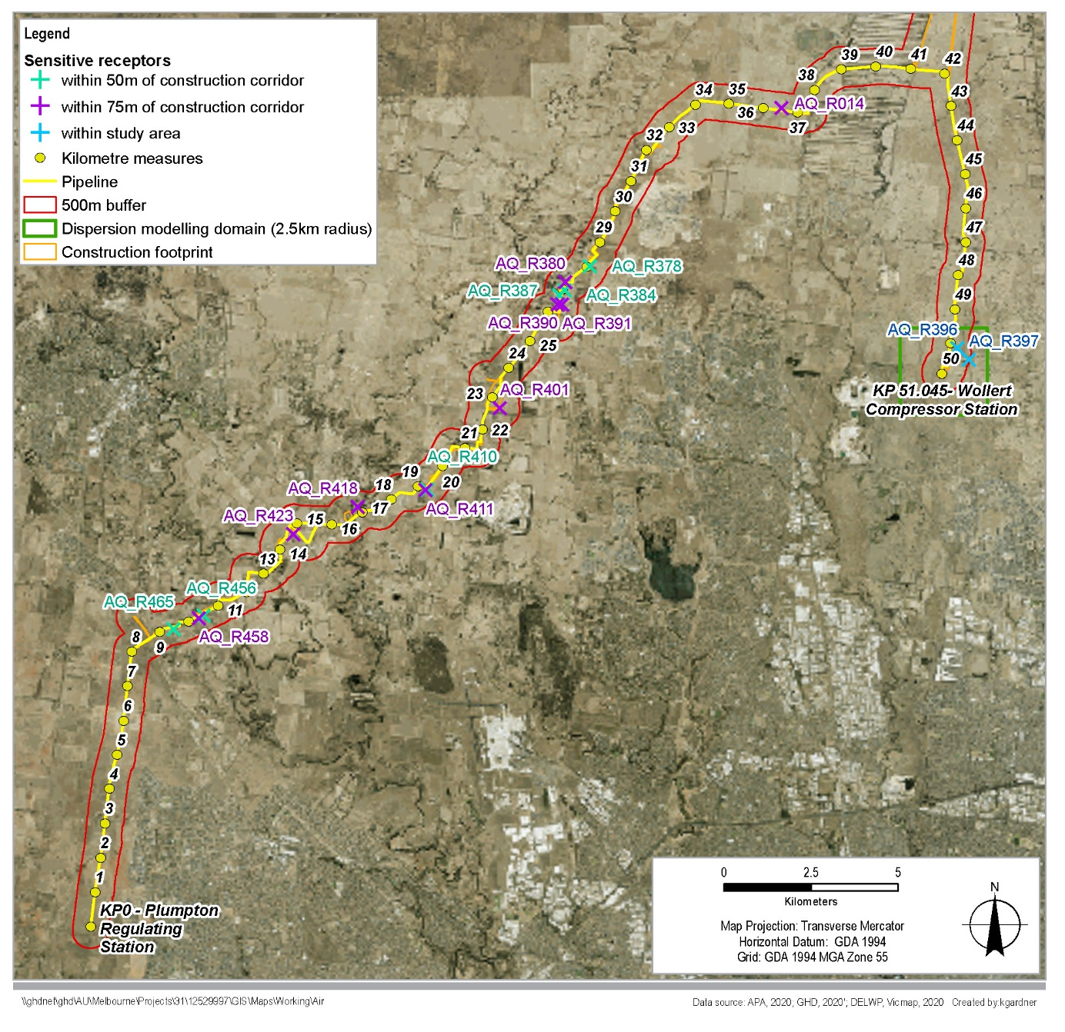

Landscape and visual
The evaluation objective outlined in the Minister’s scoping requirements for this EES in relation to landscape and visual is ‘to minimise potential adverse social, economic, amenity and land use effects at local and regional scales’.

Existing conditions
Landscape character areas (LCA) were identified to establish the existing landscape character and to provide a framework for assessing the impact of the Project on the landscape. The LCAs identify areas that share the same homogenous environmental or cultural qualities or pattern such as topography, vegetation, hydrology, land use and settlement, built form scale and character, cultural and recreational characteristics. The six LCAs are shown in Figure 15 and Figure 16.
The existing conditions assessment identified that a significant portion of land within the study area is experiencing rapid development of residential areas, where construction activity would already be common occurrence in these areas. Additionally, in rural areas as well as along major roads and highways, construction type activity would also be observed in relation to farming activity and as part of road upgrade and maintenance works.
Figure 15 Landscape and visual study area and landscape character areas (Part 1)
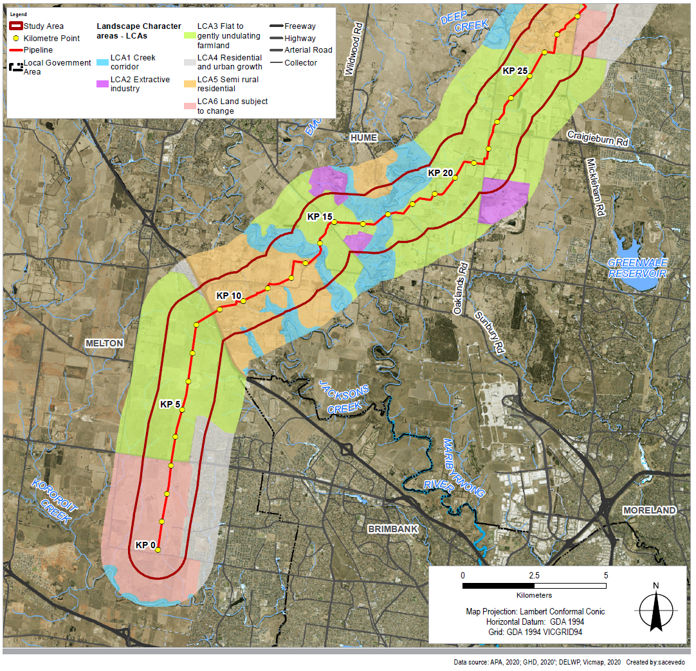
Figure 16 Landscape and visual study area and landscape character areas (Part 2)
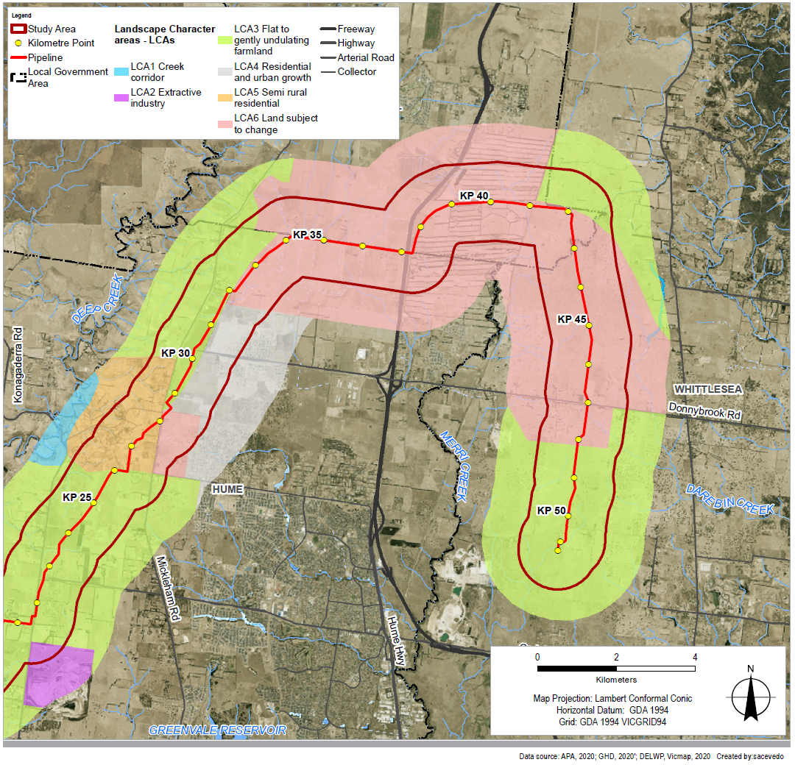

Impact assessment
The potential landscape and visual residual impacts as a result of the Project have been assessed as low given the short duration and temporary nature of the proposed construction activities, the pipeline being located underground, and the nature of the existing landscape.
Vegetation clearance required for the pipeline generally presented the most significant landscape and visual impacts, particularly within areas of close proximity to creek corridors and semi-rural residential areas along the pipeline alignment. Landscape character impacts were assigned a moderate overall significance pre-mitigation but with mitigation the residual impact is assessed as low to negligible across all LCAs. Rehabilitation of land and replacement of vegetation buffers where practicable would ensure that impacts on views from public places or private residences with existing screening from road reserves would be low.
MLV1 would be co-located with the existing Sunbury Pipeline facility and MLV 2 would be screened from view given the existing roadside vegetation at the site. MLV3 would represent a discernible change to the existing view, however it has the potential to be mitigated through applications such as planting to provide screening from roads or residences.
Lighting impacts as a result of the Project are expected to have negligible residual impact given their temporary nature and due to the nearest dwelling being located approximately 350 metres away from an HDD site (Deep Creek). There would be no night time lighting from construction of the Project which is directly adjacent to residential areas elsewhere along the Project alignment.
The application of the management measures would minimise the residual landscape and visual impacts to low or negligible across the alignment.

Management measures
Tree removal would be avoided as far as reasonably practicable through design and alignment considerations. Where trees and shrubs within the approved construction area are lost and affect public places or existing screening of private residences from road reserves, trees would be replaced where practicable, reasonably requested and in consultation with the affected landholder and/or responsible authority. A planting and remediation plan would guide planting of trees and shrubs, in consultation with any affected landowners and consistent with APA guidelines on uses within an easement.

Land use
The evaluation objective outlined in the Minister’s scoping requirements for this EES in relation to land use is ‘to minimise potential adverse social, economic, amenity and land use effects at local and regional scales’.

Existing conditions
The Project is located within peri-urban Melbourne, with approximately half of the Project being located within the Urban Growth Boundary (UGB) and the remaining area being within the green wedge. This area of Melbourne is undergoing significant change in land use structure which would continue for the foreseeable future, including causing pressure on peri-urban green wedge areas.
The Project is supported by policy within Plan Melbourne, the Planning Policy Framework (PPF) and Municipal Strategic Statement (MSS) of each municipality, in that it addresses a key gap in the VTS, while not prejudicing existing agricultural land uses within green wedges. The land use study area and approved Precinct Structure Plans (PSPs) is illustrated in Figure 17.

Impact Assessment
Prior to construction, APA would secure land access for the pipeline construction and easement, and acquire land for the three MLVs. Engagement with directly affected landholders commenced in 2018 and would continue with individual negotiations through to agreement. The construction of the Project may include temporary, minor impacts on the continuation of agricultural land uses. The continuation of agricultural land uses along the Project would be interrupted by occupation during construction, resulting in loss of access and inability to use the land. Additionally, the Project may cause temporary, minor impacts on the amenity of surrounding land uses, particularly to established residential areas, including noise, dust and vibration during construction.
Figure 17 Land use study area and surrounding PSPs
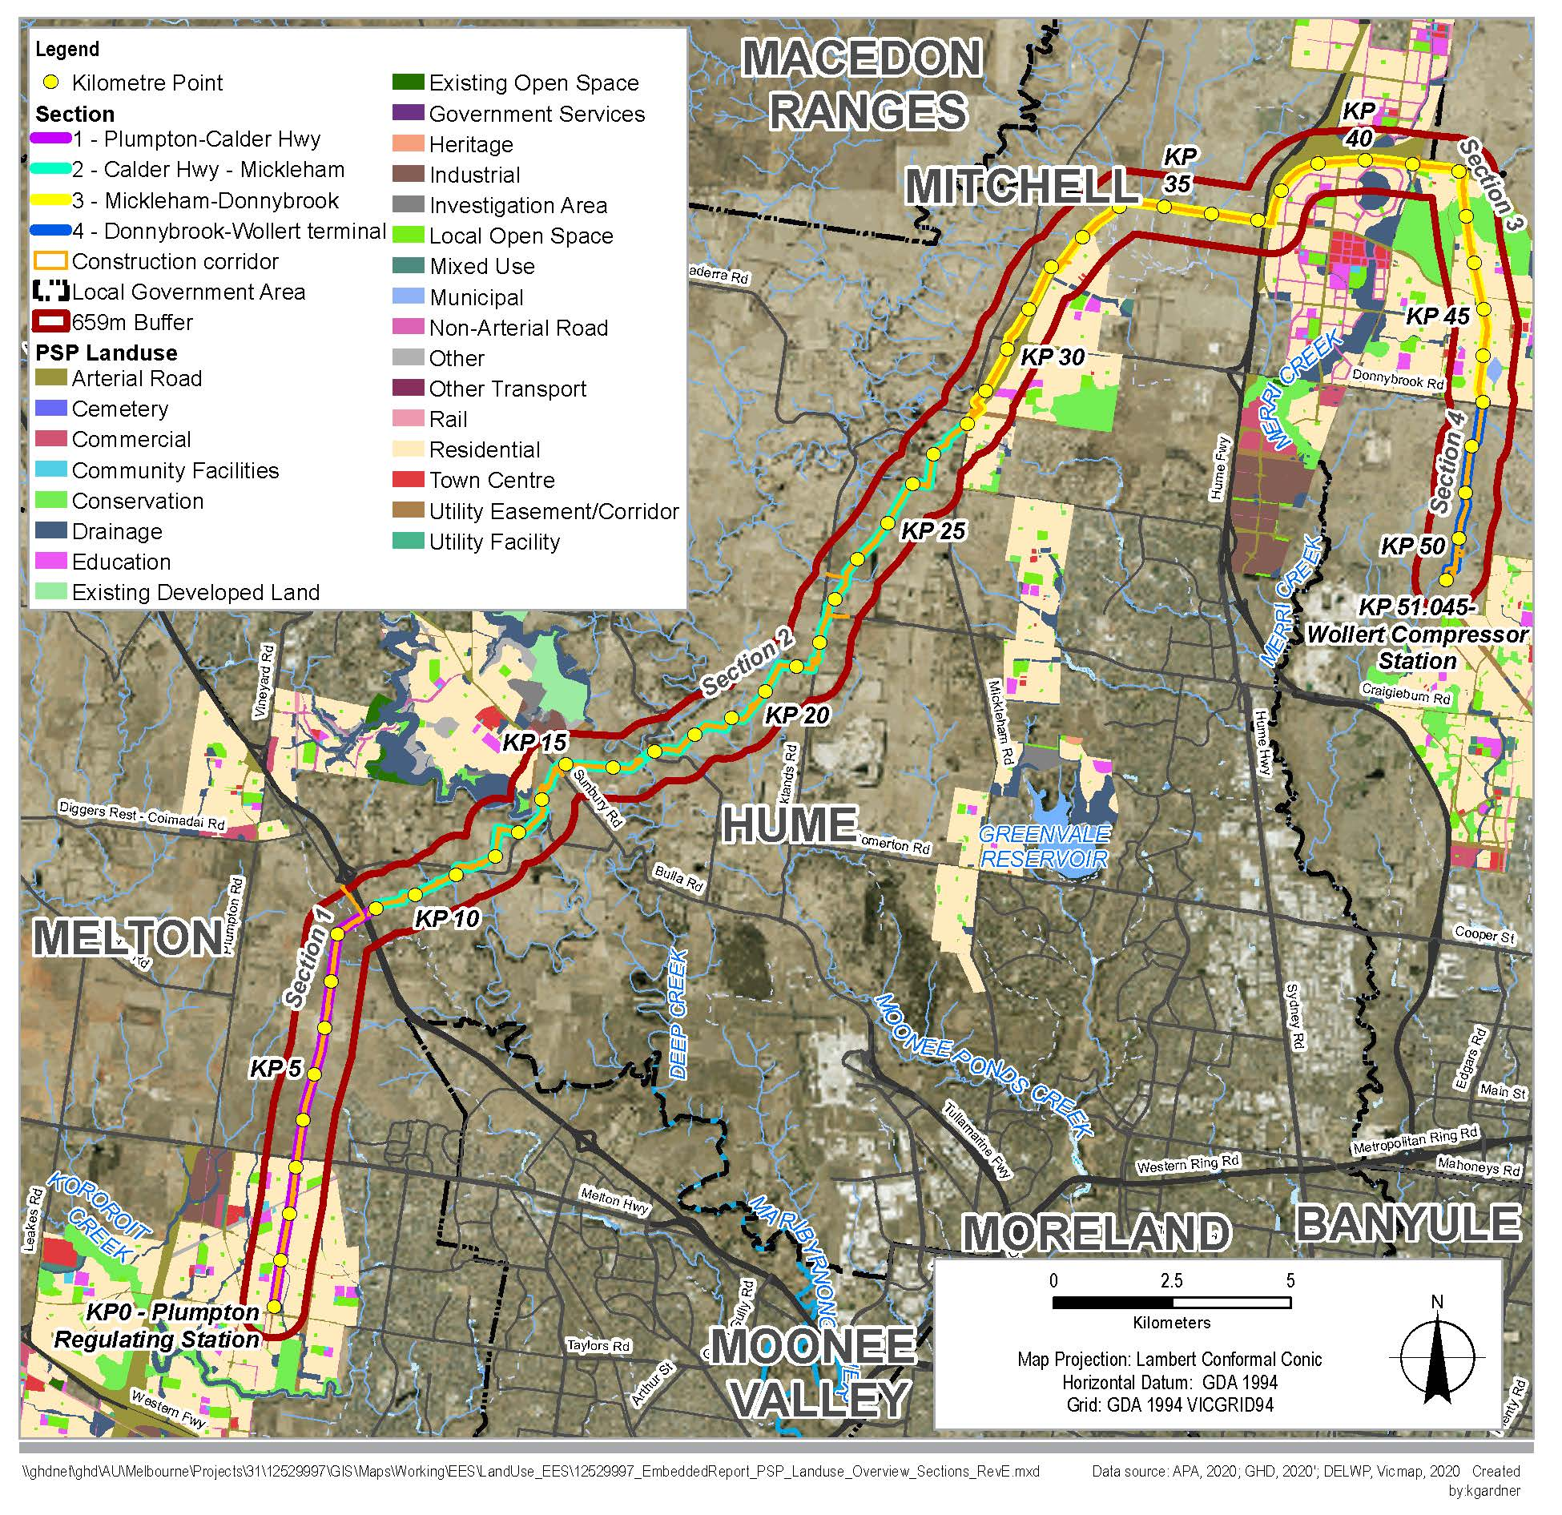
During operation, the Project is controlled through the provisions of the Pipelines Act. There would be restrictions on the use and development of land within the 15 metre easement corridor. Existing agricultural uses would be able to continue following rehabilitation of the construction corridor. In addition, in the Area of Consequence, APA would seek to monitor and potentially restrict the establishment of new sensitive uses as defined in AS2885.
The pipeline easement provides an opportunity to increase open space and amenity within new urban areas. While APA would encourage the establishment of active open space within its easements, it would ultimately be the decision of the landowner as to whether to landscape noting this would be in accordance with APA's Site Planning and Landscape National Guidelines.
The Project has been refined in negotiation with the Department of Transport so that the future use of land for the OMR/E6 Transport corridor is not prejudiced by the Project, subject to Department of Transport information.

Management measures
Minimisation of land use impacts has been achieved primarily by avoiding commercial, residential, industrial and community land uses. In addition, a Construction Environment Management Plan (CEMP), Project Consultation Plan, and Traffic Management Plan, amongst other measures will be utilised to further minimise impacts on individual land uses. Where construction impacts cannot be minimised or avoided through HDD or boring, land rehabilitation would be undertaken.

Social
The evaluation objective outlined in the Minister’s scoping requirements for this EES in relation to social impacts is ‘to minimise potential adverse social, economic, amenity and land use effects at local and regional scales’.

Existing conditions
Potential social changes brought about by the Project can include changes to visual amenity and character, changes to the social cohesion of communities, and changes to access and connectivity to an area.
The Project intersects 137 parcels of land through four local government areas (LGA) of Melton, Hume, Mitchell, and Whittlesea, with 85 unique landowners. Each LGA in the regional study area experienced population growth between 2009 and 2019 at a higher rate than those in Victoria overall. Considerable population growth is expected in the region between 2018 and 2036.
The majority of parcels (75 of the 137 parcels) that the Project intersects are rural residential or agricultural parcels. These parcels vary in intensity of use and type of agricultural activity, including established cropping and grazing businesses and equestrian training or breeding.
The alignment intersects 19 roads, along with Hume Freeway at the northern end of the alignment and Calder Highway at the southern section of the alignment.

Impact assessment
Temporary changes to amenity for residents and the community and community facilities and recreation areas as a result of the Project’s construction activities may result from dust or noise impacts. These changes in amenity have potential to result in changes to people’s day to day lives, such as the temporary reduction in use of backyards or temporary reduction in use of community facilities. The time required to engage with the Project, along with changes to amenity and privacy may result in stress, anxiety, and frustration for some landholders, which may be heightened for landholders that do not wish to host the Project.
There would be temporary reduction in the area of land available for grazing, cropping, or other productive activities and potential to increase or change agricultural property management requirements during construction. Without mitigation, the economic impact to agriculture at the construction stage is estimated at $0.2 million over 12 months which is equivalent to 0.13% of the annual value of agricultural production within the regional study area. Following rehabilitation of the construction corridor, normal agricultural activities and production would be able to resume. Compensation for any productivity loss would be paid to landowners of agricultural properties.
Potential changes to accessibility during the construction period could result in disruption to agricultural and rural residential land uses and businesses. To minimise property damage and disruption due to Project construction, the construction activities would be undertaken in accordance with agreements made with the landowners and occupiers regarding the use of existing roads or tracks, the selection of new access routes and any property-specific measures to implement during construction.
Landholders will be entitled to compensation for the establishment of the easement on their property and impacts associated with construction, including any damage that occurs. APA would seek voluntary compensation agreement based on a fair valuation of land and impacts, with external advice from valuation professionals obtained.

Management measures
A CEMP, Project Consultation Plan, and Traffic Management Plan, amongst other measures will be utilised to minimise social impacts. Measures will include:
- Third party infrastructure including farm infrastructure identified and marked on the ground. Reinstatement of all fences, gates and tracks
- Biosecurity management measures and avoiding impacts to landholder national vendor declarations
- Reinstatement of land as soon as possible to original contours including appropriate compaction and soil amelioration
- Actions to minimise noise, vibration, air quality, and landscape and visual amenity impacts to residents directly adjacent to the alignment, community facilities and recreation areas.
Community and residential access and connectivity impacts will be minimised by utilising construction methods such as HDD at road crossings. Further, access impacts will be managed via the implementation an approved TMP and undertaking stakeholder communications in accordance with the Project Consultation Plan.
Impacts to Precinct Structure Plans (PSPs) and growth areas would be mitigated by protecting the pipeline with an easement and identifying the easement in PSPs along the Project. In locations with existing PSPs, the pipeline is designed in accordance with AS/NZS 2885 with consideration to planned PSP land use. There would be an ongoing requirement that future sensitive land uses would be managed within proximity of the pipeline with the 'Area of Consequence' length (65 metres) identified in future PSPs, as the area where a risk assessment of sensitive uses would be undertaken. Notification provisions in planning schemes would enable APA to assess any potential implications for sensitive uses in the 'Area of Consequence' along the pipeline easement.
The operational easement would provide an opportunity to increase open space and amenity within new urban areas to benefit the local community in line with the PSPs.
The Project is consistent with relevant state and local land use planning policy, and impacts on land use during construction and operation are considered to be low with the application of the relevant environmental management measures which would minimise or avoid impacts on land use values.

Waste management
The evaluation objective outlined in the Minister’s scoping requirements for this EES in relation to waste is 'to minimise generation of wastes from the Project during construction and operation, and to prevent adverse environmental or health effects from storing, handling, transporting and disposing of waste products'.
This objective was considered and assessment by:
- Technical report E Contamination
- Technical report H Greenhouse gas.
In addition, the air quality assessment considered waste (air quality impacts) associated with the compressor station emissions.

Greenhouse gas

Existing conditions
Victoria’s total net greenhouse gas emissions in 2018 was 102.2 Mt CO2-e, which represents a reduction of 17.5% from 2005 levels. Total national emissions for 2018 was 537.4 Mt CO₂-e, which represents a reduction of 12.8% from 2005 levels.

Impact assessment
The Project’s estimated Scope 1 and Scope 2 construction emissions are estimated to contribute the equivalent of 0.019% of Victoria’s and 0.004% of Australia’s annual greenhouse gas emissions. This is largely attributed to land use changes due to removal of vegetation in the construction corridor and emissions associated with fuel use.
Operation emissions are estimated to contribute the equivalent of 0.014% of Victoria’s and 0.003% of Australia’s annual greenhouse gas emissions. This is largely attributed to fuel use at the compressor station. Operation of the Project is predicted by AEMO to lead to efficiency gains in the overall Victorian gas supply network, leading to a net reduction in total greenhouse gas emissions across the VTS. The net reduction in state and national emissions would be 10,110 t CO2-e per annum, which equates to a reduction of 0.010% and 0.002% of state and national totals respectively.

Management measures
Application of the Project environmental management measures, including consideration and use of low embodied energy materials, fuel efficient plant and equipment, locally sourced materials, and reduction of vegetation removal along the pipeline alignment, would reduce construction emissions. During operation, implementation of the Protocol for Environmental Management (PEM): Greenhouse Gas Emissions and Energy Efficiency in Industry 2001 would include consideration of energy efficiency best practice, to reduce operation emissions.

Contamination

Existing conditions
The construction corridor is dominated by the Newer Volcanics basaltic flows and stony rises. Alluvium is present around Jacksons Creek and Deep Creek with colluvium and alluvial terraces in Mickleham. Soil sampling has not identified acid sulphate soils and they are unlikely to be present within the construction corridor, however the presence of alluvium raises the possibility for acid sulphate soil to be present. With the exception of industrial land use, the existing land uses within the Project area are considered to have a relatively low potential for soil and groundwater contamination. There are several properties that have been identified as having industrial uses related to quarrying, landfilling and uncontrolled dumping or storage of wastes such as old car bodies.
The potential sources of contamination and their locations in relation to the Project is illustrated in Figure 18.

Impact Assessment
While there is generally low risk of contaminated soil, indicating that shallow soils are likely suitable for reuse at the site of origin in areas not identified as potential sources of contamination, material directly within and under the creek beds (below the water table) has not been directly assessed. Additional sampling by the Contractor at Jacksons Creek and Merri Creek before construction, would inform spoil management planning at these specific locations. It is not anticipated that an EPA approved acid sulfate soil management plan would be required.
The potential for contaminated groundwater to be intercepted across the construction corridor, is considered to be low. This is because the majority of identified potential sources of contaminated soil are located where groundwater is expected to be greater than 5 metres below ground level.
Waste streams considered for the Project construction include commercial and industrial waste (such as pipelining wastes, timber and steel), construction waste (such as spoil and rock), and domestic waste (such as putrescible and general waste, plastic, paper and cardboard packing).

Management measures
Construction wastes, including contaminated spoil, would be managed in accordance with the waste hierarchy and the EPA Industrial Waste Resource Guidelines. Designated facilities would be used to handle the identified waste streams including necessary segregation and storage requirements. Waste facilities would be located away from natural drainage systems and low-lying areas. Prescribed industrial waste (such as waste oils, oily water mixtures, oily rags and oil filters, etc) would be segregated, labelled and securely stored and transported to a facility licensed to accept these wastes.
During construction, environmental management measures include requirements for classifying spoil and managing existing contamination, HDD fluids, uncontaminated spoil, unknown contamination, chemicals, fuels and hazardous materials, waste streams and hydrostatic test water. Furthermore, the Project includes requirements for minimising potential impacts and risks from disturbance of acid sulfate soil, contaminated groundwater, and vapour and ground gas intrusion.
During operation and maintenance activities, waste and contamination impacts associated with leaks and spills would be managed in accordance with the existing VTS OEMP. With management measures, residual waste impacts would be low.
Figure 18 Potential sources of contamination
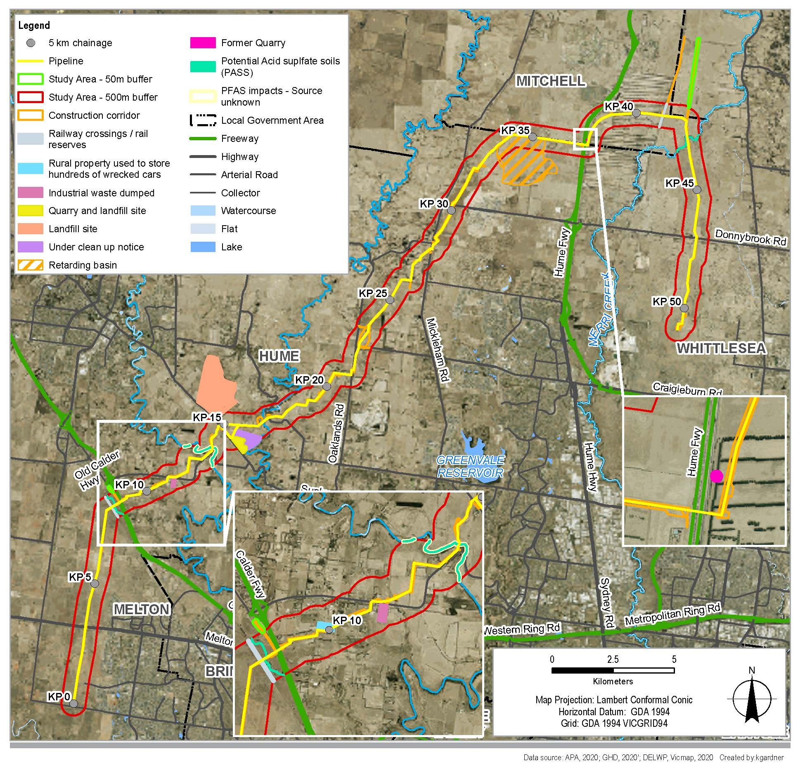

Managing the Project's impacts
Chapter 19 Environmental Management Framework presents the proposed environmental management arrangements for Project delivery. It sets out the statutory approvals and agreements that underpin the environmental management plans and measures required to manage the environmental effects identified in the EES. It also sets out the Environmental Management System to be adopted, environmental monitoring requirements, an overview of environmental management plans and environmental management measures (EMMs), and the proposed approach to evaluating and reporting environmental outcomes and performance.
The environmental management arrangements, including the EMMs have been informed by relevant legislation, policy, guidelines, specialist technical reports completed as part of the EES as well as APA systems and processes. In particular, under Section 133(1) of the Pipelines Act, APA is required to develop an environmental management plan for the Project for approval by the Minister for Energy, Environment and Climate Change.
APA would develop, implement and maintain environmental management plans for both the construction and operation of the Project. These would address the requirements of the statutory approvals and consents and contain processes, procedures and requirements to protect environmental and social values potentially impacted by the Project.
A draft Construction Environmental Management Plan (CEMP) has been prepared and is included with the Pipeline Licence Application documents exhibited with the EES. This draft CEMP would be updated following the EES process and submitted to the Minister for Energy, Environment and Climate Change for approval. The existing VTS Operation Environmental Management Plan would apply to the operational phase of the Project.

Consulting with the community
The EES process requires consultation and a publicly available consultation plan has been prepared to guide APA’s consultation specific to the EES. A range of approaches have been adopted for engagement, many of which were held virtually or remotely due to COVID restrictions. Consultation underpins the Pipelines Act. A separate Pipelines Act Consultation Plan was prepared which covers all phases of the Project. This consultation plan is provided to owners and occupiers of land and outlines information about the Project, how potential impacts are to be managed and legislative approvals required to facilitate construction and operation of the Project.
APA is committed to effective consultation and engagement and will continue to engage through construction and operation, should the Project be approved. APA has maintained a list of Project landholders and other stakeholders since investigations began for the Project in 2018.
Project stages 1–7, along with a description of the key activities informing consultation for each stage are illustrated in Figure 19.
The Project is currently at Stage 5 and consultation for the EES is taking place during Stage 5.
Figure 19 Summary of Project stages and consultation

During the EES preparation consultation activities included:
- Consultation on draft EES Scoping Requirements
- APA meetings with stakeholders
- Emailed communications providing regular community updates and news
- Physical mail out of newsletters
- The Technical Reference Group (TRG) was convened with government and approval agencies to review the EES draft documentation and specialist technical studies
- Virtual community information sessions in late 2020, with face to face information sessions in early 2021
- Digital public engagement platform (Social Pinpoint) available for community feedback, survey, updates, discussion forum and links to relevant documents
- Dedicated 1800 number and email address available
- Factsheets, newsletters, flyers and community resource guide produced during this stage.
Key issues raised during consultation include:
- Pipeline alignment and impacts on existing and future land use, including farming and future residential
- Pipeline construction impacts on waterways and habitat disruptions in areas of biodiversity value, including Platypus and Growling Grass Frog, particularly at Merri Creek and Jacksons Creek
- Pipeline construction impacts on trees (landscape and biodiversity values) and adjusting alignment to minimise impact
- Avoiding spread of weeds during construction
- Access disruption at local roads and properties
- Potential for foot and bike paths on the easement
- Notifications of work to local residents during construction and schedule of construction, particularly in reference to potential noise impacts
- Options for dust control
- Minimising impacts on infrastructure such as roads or underground pipes
- Rehabilitation timing and process.

Concluding the EES process

Exhibition and submissions
The EES and Pipeline Licence Application will be on public exhibition for 30 business days from 7 July 2021 to 17 August 2021. During this time, members of the public can view the EES and make written submissions. Copies of the EES, Pipeline Licence Application and supporting material can be downloaded from the Project website: www.apa.com.au/worm/ees.
Free copies of the EES Summary brochure and USBs containing all the EES documentation are available at the public exhibition locations or directly from APA. Subject to COVID-19 restrictions, during the public exhibition period, hard copies of the EES are available for inspection during office hours at:
- State Library of Victoria, 328 Swanston Street, Melbourne VIC 3000
- Caroline Springs Library & Learning Hub, 193-201 Caroline Springs Boulevard, Caroline Springs VIC 3023
- Craigieburn Library, 75-95 Central Park Avenue, Craigieburn VIC 3064
- Greater Beveridge Community Centre, Corner Lithgow Street and Mandalay Circuit, Beveridge VIC 3753
- City of Whittlesea Civic Centre Office – South Morang, 25 Ferres Boulevard, South Morang VIC 3752.
Subject to COVID-19 restrictions on Community Facilities. Please check the COVIDSafe Settings for metropolitan Melbourne for updates.
Submissions on the EES and Pipeline Licence Application must be made in writing and received by 11.59 pm on Tuesday 17 August 2021. Each submission is a public document and will be treated as a submission on the EES and the Pipeline Licence Application.
Online submissions are preferred and can be lodged via the Victorian Government's engagement website: www.engage.vic.gov.au/worm-inquiry.
Where a submitter is unable to lodge a submission online, they must contact Planning Panels Victoria through the DELWP Customer Call Centre on 136 186 (select option 6) and request a hard copy submission coversheet issued by Planning Panels Victoria.
All submissions must state the name and address of the person making the submission. Petitions will be treated as a single submission and only the first names from a petition submission will be registered and contacted.
All submissions will be treated as public documents in accordance with the Planning Panels Victoria Privacy Collection Notice and will be published on the Victorian Government’s engagement website. Do not include personal information in the body of your submission (such as your email address or phone number). Your submission and name will be made public.
Members of the Public and any other parties seeking to be heard at a public hearing are required to submit a written submission and indicate on the submission form that they would like to be heard at the hearing.
The submissions process is independently managed by Planning Panels Victoria and any inquiries regarding the management of submissions and the Hearing process should be directed to them.
For more information about the submission process, contact Planning Panels Victoria on 136 186 (select option 6) or email planning.panels@delwp.vic.gov.au.

Next steps
Following public exhibition of the EES and Pipeline Licence, an Inquiry appointed by the Minister for Planning will consider the EES and public submissions. A Panel may also be appointed by the Minister for Energy to consider the submissions received in relation to the Pipeline Licence. It is likely that the same members would be appointed as the Panel for the Pipeline Licence. The inquiry will make recommendations to assist the Minister’s assessment of the environmental effects under the Environment Effects Act. The Inquiry may conduct formal public hearings at which APA and people who have made submissions can make presentations.
Following receipt of the Inquiry's report, an assessment of the Project will be made by the Minister for Planning. The Minister’s assessment makes recommendations about whether the environmental effects of the Project are acceptable, along with any modifications or further management measures the Minister considers appropriate. In preparing this assessment, the Minister considers all relevant information, including the EES documents, public submissions and the report from the Inquiry.
After considering the Victorian Minister for Planning’s assessment under the EE Act, the Commonwealth Minister for the Environment or their delegate will decide whether the Project is approved, approved with conditions or refused under the EPBC Act.
The relevant decision-makers for the approvals required by the Project would then consider the Minister’s assessment.

Victorian Renewable Energy Target – 2018-19 Progress Report, Table 1, page 7.
https://www.apa.com.au/globalassets/about-apa/our-projects/western-outer-ring-main-project/western-outer-ring-main-project-route-options-report.pdf.
Code of practice for noise and vibration control on construction and open sites, British Standard BS 5228-2:2009.

