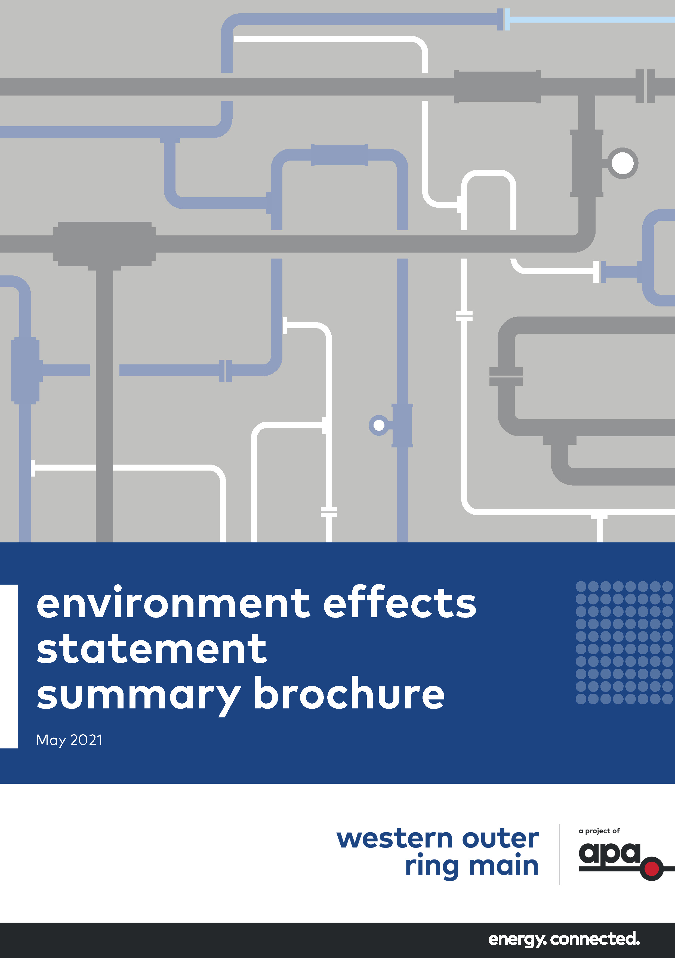
Environment effects statement

Summary brochure
May 2021

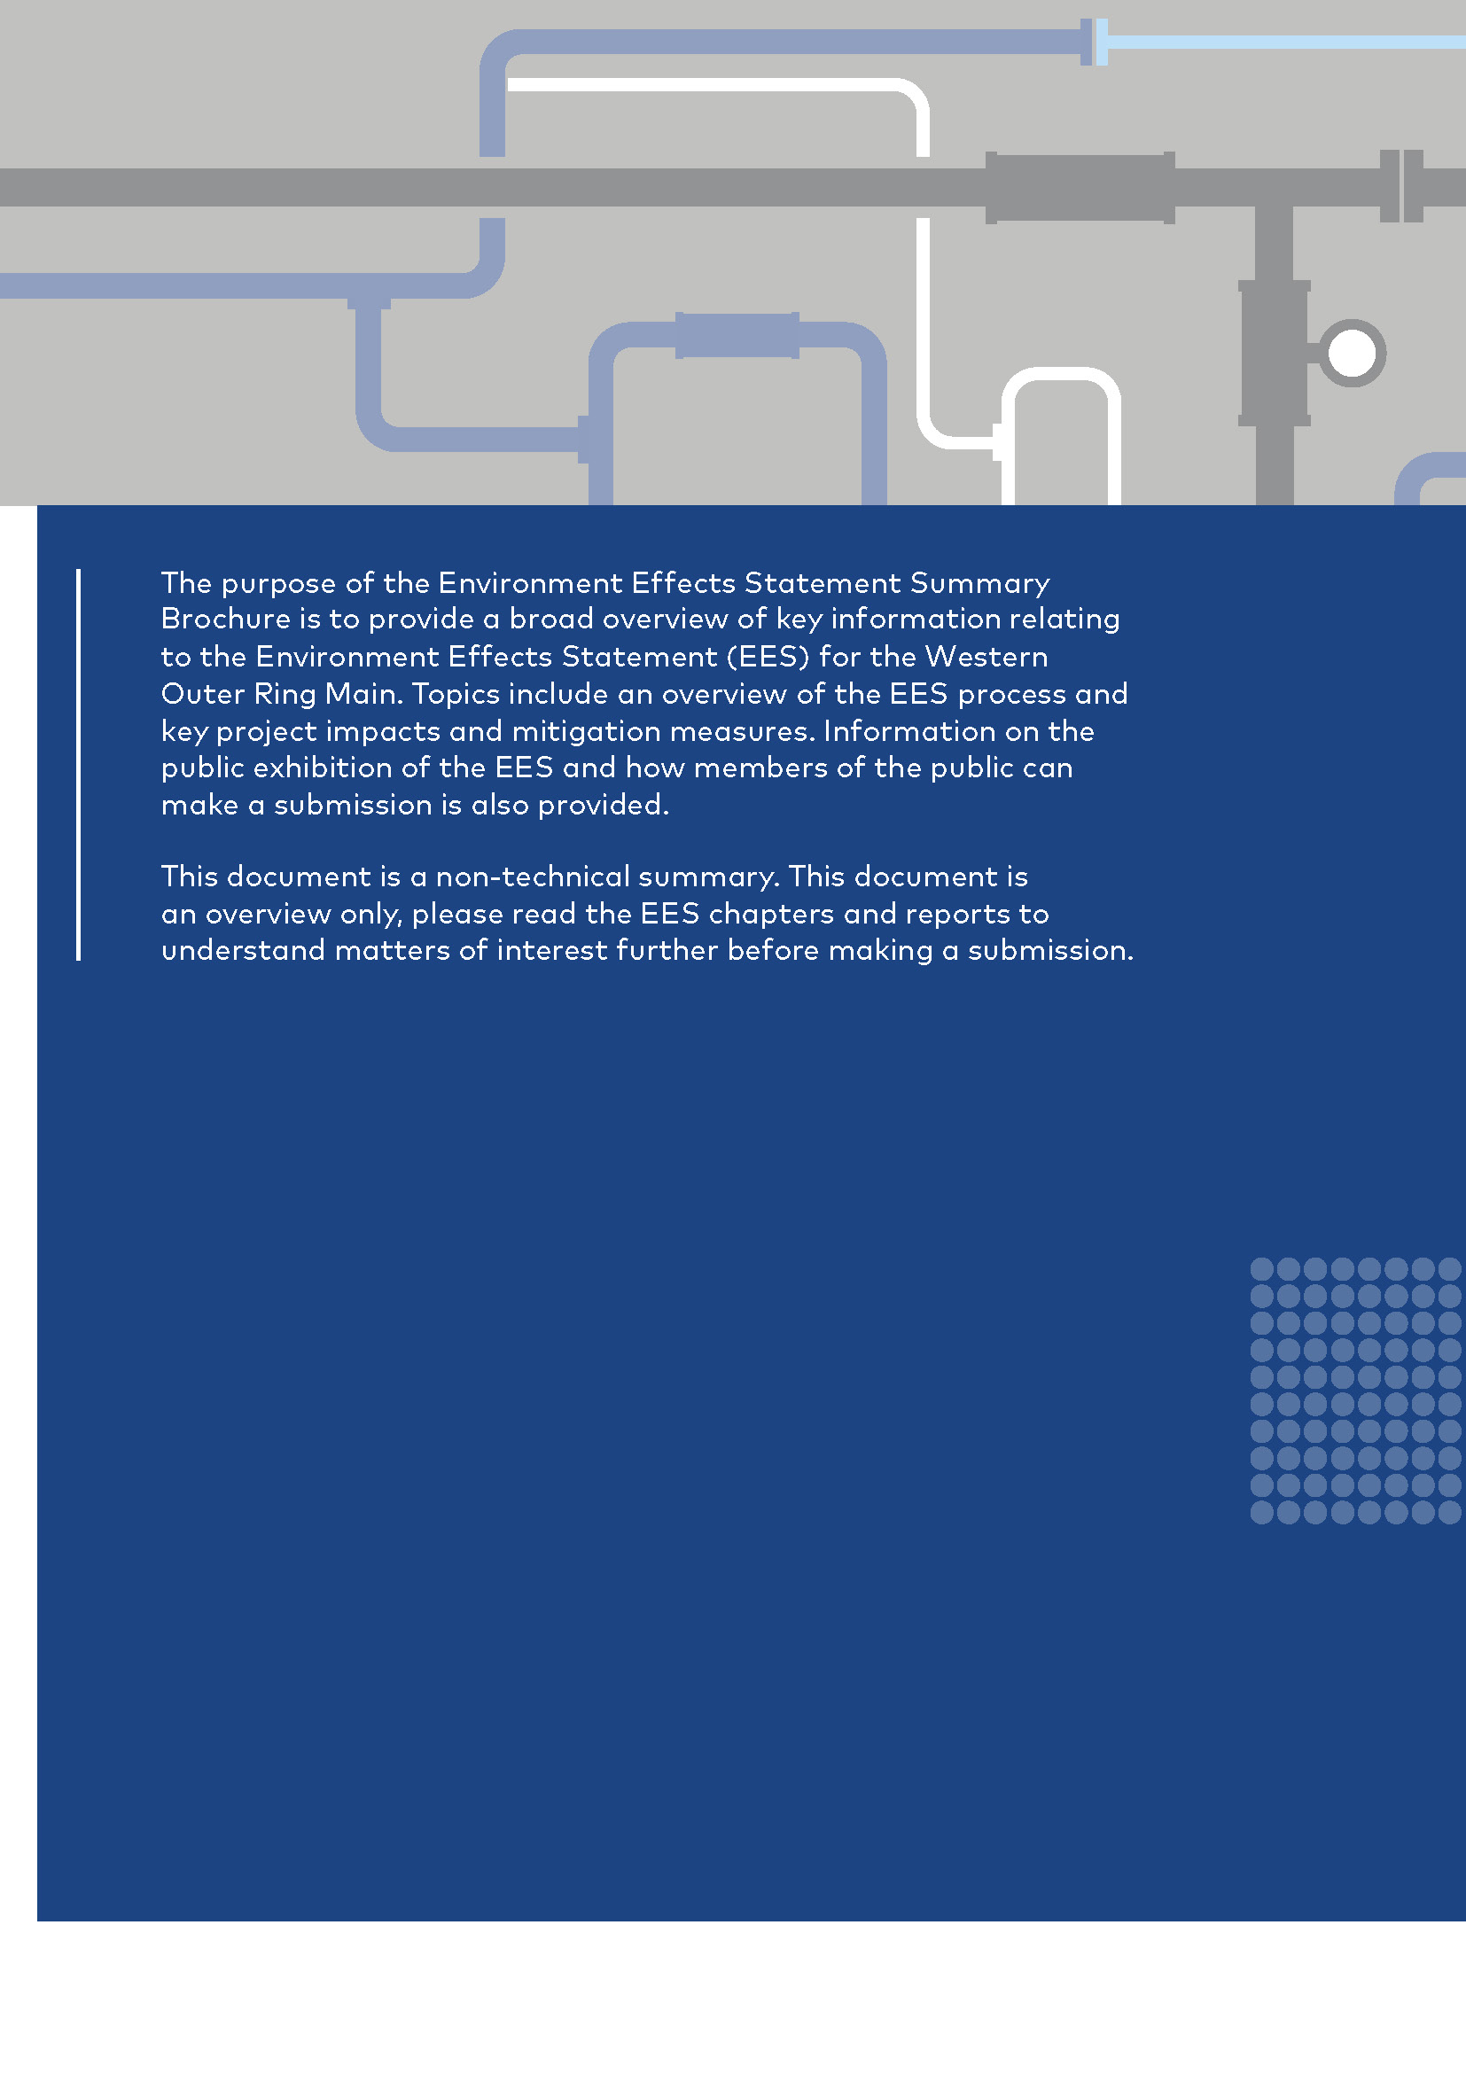

Contents
Summary brochure
1 The Project 2
2 Why an EES is required 7
3 Project approvals 7
4 Assessing and managing the Project’s risks and impacts 9
5 Assessment of potential impacts 10
6 Approach to manage effects 17
7 EES exhibition and submissions 18
8 Next steps and concluding the EES process 20

The Project

Natural gas is an essential source of energy for Victoria with approximately two million customers a day relying on gas for cooking, heating and hot water. Natural gas is also used by approximately 60,000 Victorian industrial and commercial users. Gas fired power generation plays a key role in ensuring a reliable electricity network.
APA VTS (Operations) Pty Ltd (APA) is proposing to construct a high pressure gas transmission pipeline between Plumpton Regulating Station (approximately 38 kilometres north west of Melbourne’s CBD) and Wollert Compressor Station (approximately 26 kilometres north east of Melbourne’s CBD) providing an additional connection between the eastern and western networks of the Victorian Transmission System (VTS) as shown in Figure 1.
The Western Outer Ring Main (WORM) Project comprises three key components:
- A new fully buried pipeline 51 km in length
- Three mainline valves located near kilometre point (KP) 6, KP 22 and KP 35
- An upgrade to the existing Wollert Compressor Station (including a new compressor, an end of line scraper station and a regulating station).
Table 1 summarises key data for the underground pipeline. Figure 1 presents a map of the pipeline route and surrounding area.

Project rationale
The Victorian economy is highly dependent on gas. During winter, Victoria experiences a peak demand as consumption of hot water and heating increases. There is a seasonal tightening of the gas supply-demand balance for Victoria from June to September. To combat this, Victoria’s gas network transfers and stores excess gas generated during summer, when gas demand is lower, to support demand for the coming winter.
The Project would improve the transfer of gas volumes circulated around the state, increasing the efficiency in which gas supply can be transported to the Iona Underground storage (UGS) basin, Victorian customers and export facilities.
Figure 1 represents the VTS and the current constraint to gas flow. The Iona UGS stores the majority of Victoria’s gas supplies and is crucial for ensuring access to natural gas throughout the year. Sufficient storage volumes must be achieved over summer in order to cover this winter peak.

Table 1 Key pipeline data
Underground pipeline key data
Length | 51.045 km
Material | American Petroleum Institute (API) Specification 5L X52 high strength steel pipe. Internally lined with epoxy and externally coated with dual layer fusion bonded epoxy with field applied joint coating
Nominal diameter | 600 mm
Nominal capacity | Approximately 750 TJ/day
Pipe wall thickness | 10.31 mm standard wall thickness  12.7 mm heavy wall thickness
Pipe segment length | 18 m
Depth below ground surface | Minimum of 750 mm to the top of the pipeline (deeper at crossing of third-party infrastructure and waterways). The final depth would be determined as an outcome of the Safety Management Study
Easement | Nominally 15 m wide
Design principles | Strictly in accordance with the latest version of AS2885 Pipelines – Gas and liquid petroleum
Design life | 60 years

The Project would make the overall VTS more resilient by allowing gas to be moved at a higher pressure and more efficiently across the VTS, ensuring all Victorians continue to benefit from a reliable gas transmission system. WORM would directly support the timely transfer of higher volumes of gas from the east to the west of the state.
More efficient gas transmission would also facilitate the development of the renewable energy sector. The Victorian Renewable Energy Target (VRET) has set a goal of achieving 50 per cent renewable energy generation in Victoria by 2030¹.
Energy generation investment in Victoria (January 2018 to March 2021) has largely comprised wind and solar. The intermittent nature of these renewables will require what the Australian Energy Regulator calls firming capacity, via gas powered plants or storage to support energy reliability and security.
Gas will play an important role between 2030 and 2050 as the renewable energy sector expands in line with VRET and broader climate change policy. As an Australian natural gas infrastructure owner and operator, APA is committed to being part of the successful transition to a lower carbon future.
If the Project is not built, the impacts predicted through the EES process would not occur. However, if the Project is not built, the opportunity would be missed for the Project to assist in reducing potential interruptions to gas supplies.
Detailed information on the Project rationale is available in EES Chapter 2. Please read this section to understand your interests before making a submission.

Figure 1 Victorian Transmission System Schematic including the WORM
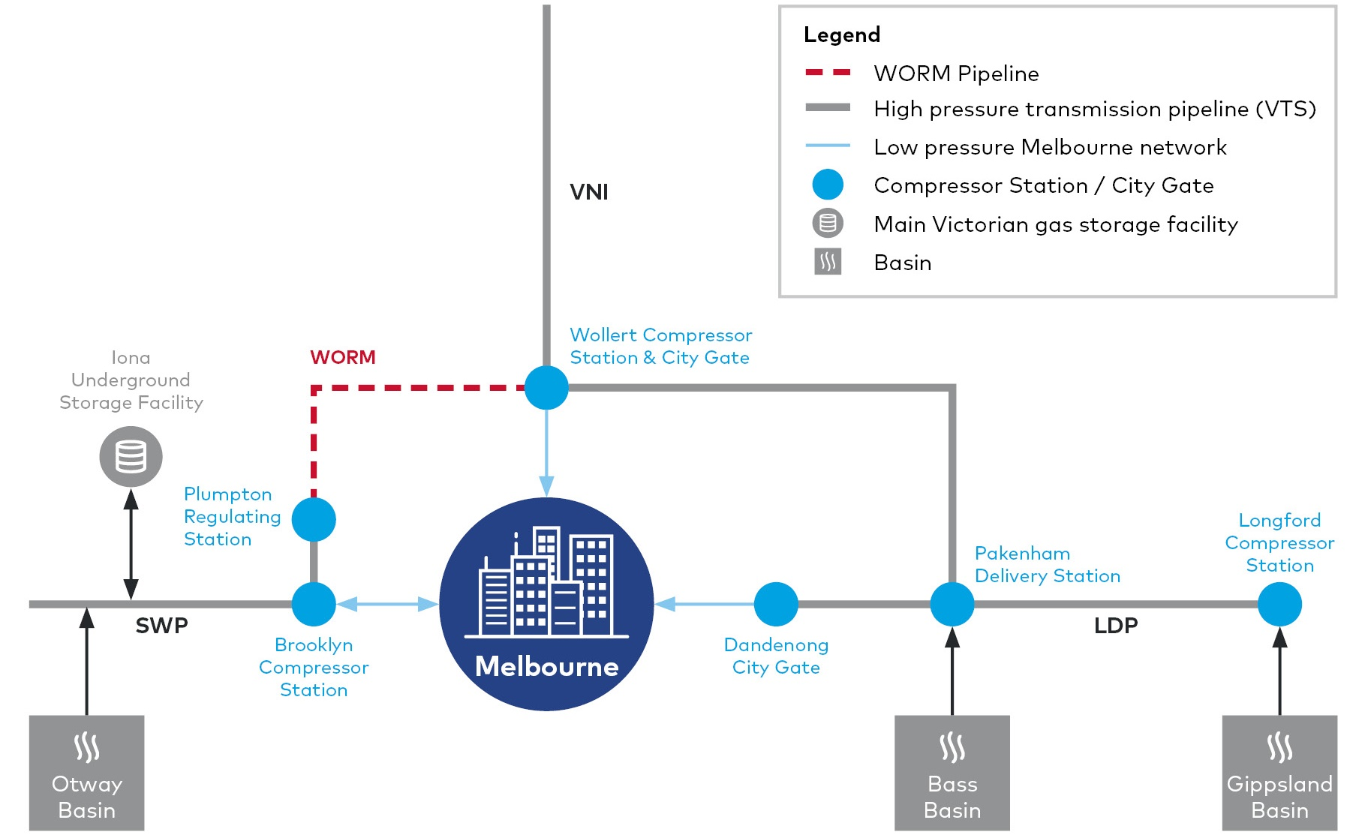

Pipeline route options
Route options for the Project have been considered since 2007 and discussed with energy regulators since 2012. From early 2018, APA has undertaken comprehensive investigation of five key pipeline alignment options. APA's Route Options report is available on the Project website².
Despite being the longest route identified (almost 12 kilometres longer than the shortest route) and the second costliest, the route outlined in the EES was assessed as the optimum for satisfying the environment and heritage, community and land criteria, which were weighted with the greatest importance. This route also scored well in terms of constructability and operability.

Detailed information on the Project development/ options is available in EES Chapter 3.
Please read these sections to understand your interests before making a submission.
Figure 2 Pipeline route
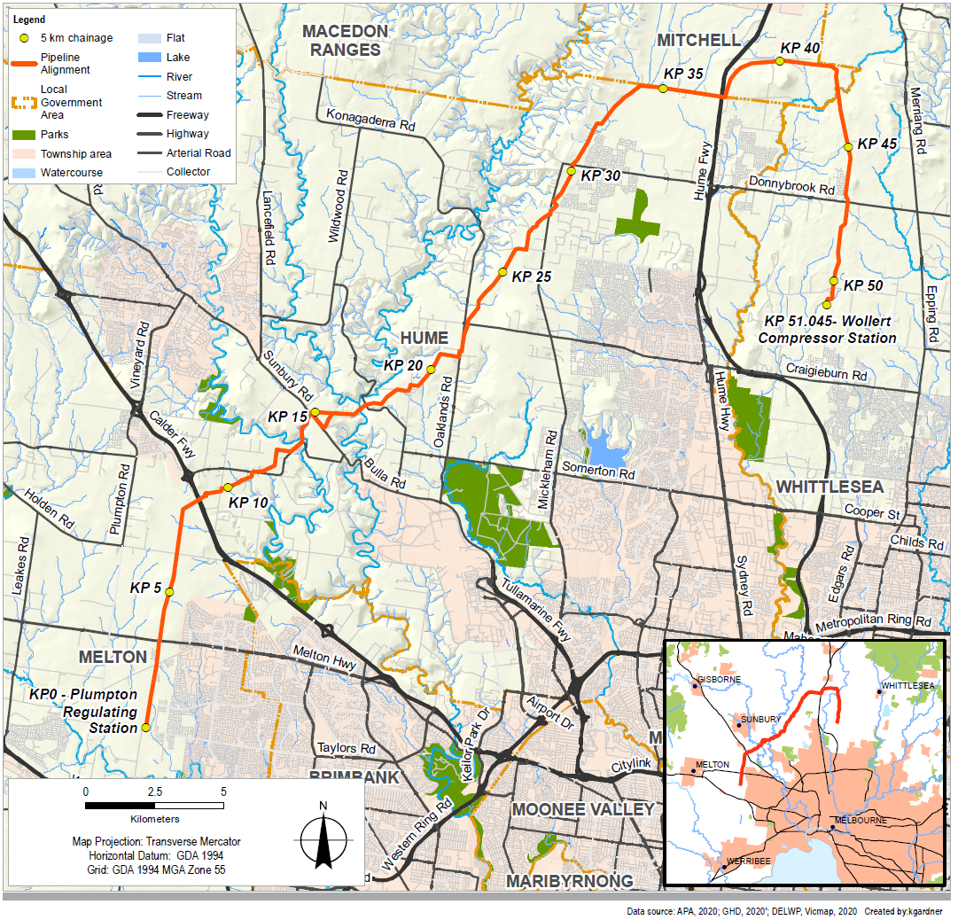

Construction

Subject to obtaining all required regulatory approvals, the Project is expected to be constructed over a period of six to nine months and be operational by late 2022. General timeframes to complete works in any one area from site establishment to rehabilitation are four to six months. It is likely that there would be multiple work fronts for open cut excavations.
Construction work would generally be undertaken between 6 am and 6 pm, seven days per week, with 24 hour operation potentially required for short periods for construction under road or rail.
The construction area would typically comprise a 30 metre wide corridor along the pipeline alignment with activities within the corridor including:
- Access tracks (upgrade of existing and construction of new), less than 10 metres wide and usually constructed of gravel
- Water supply tanks and temporary dams for storing water required for dust suppression and hydrostatic testing of the pipeline
- Additional work areas to accommodate vehicle turn-around points, additional work spaces for crossings, set up areas to accommodate horizontal directional drilling (HDD), laying out of pipe for HDD, and stockpiling and storage areas. Temporary construction gateways would be installed at fence lines intersected by the construction area to provide security for farm stock during construction.
Two temporary laydown/compound areas would be established, an offsite compound for pipeline works at a suitable site near the pipeline route, and a laydown for compressor station works within the existing Wollert facility.
Pipeline construction is expected to progress at a rate of approximately 700 metres per day for open trenching, however, HDD and bored crossings are likely to have lower daily progress rates and could take between two to three weeks at a particular location.
Trenches would generally remain open for no longer than three months after excavation. The use of rock saws, hammers, or blasting is expected to be required to excavate the trench in some areas of rock.
When trenching through waterways (including Jacksons Creek and Merri Creek), diversion dams and trench breakers would be constructed of appropriate materials to minimise watercourse sedimentation.
In some cases, due to the presence of areas of high ecological significance, existing assets or other constraints, the pipeline would be constructed using trenchless construction techniques where the pipe is installed by drilling under the ground without disturbance at ground level such as HDD or shallow horizontal boring.
Excavated soil will be stockpiled to be re-used in backfilling. The volume of material reused would vary location to location based on soil profile and quality. Spoil would be stockpiled separate from vegetation and topsoil to provide for appropriate reinstatement of material excavated.

Rehabilitation and commissioning the pipeline
Rehabilitation of the construction area and all temporary facilities, temporary access tracks and extra work areas would begin as soon as practicable after the completion of the construction activities, with the aim of restoration of ground cover within six months.
The pipeline would be pressure tested prior to commissioning. Hydrostatic testing involves sections of the pipeline being filled with water and then pressurised. Following testing and the issue of a Consent to Operate from Energy Safe Victoria, gas flow would commence in the pipeline.

Operation and maintenance
The construction corridor would be generally returned to its previous use. The pipeline would be owned and maintained by APA. The operational footprint will be delineated by an easement, with a standard width of 15 metres. Routine corridor inspections would be undertaken to monitor the pipeline easement for any operational or maintenance issues.
A detailed Project description is in EES Chapter 4. Please read these sections to understand your interests before making a submission.

Figure 3 Pipeline construction sequence
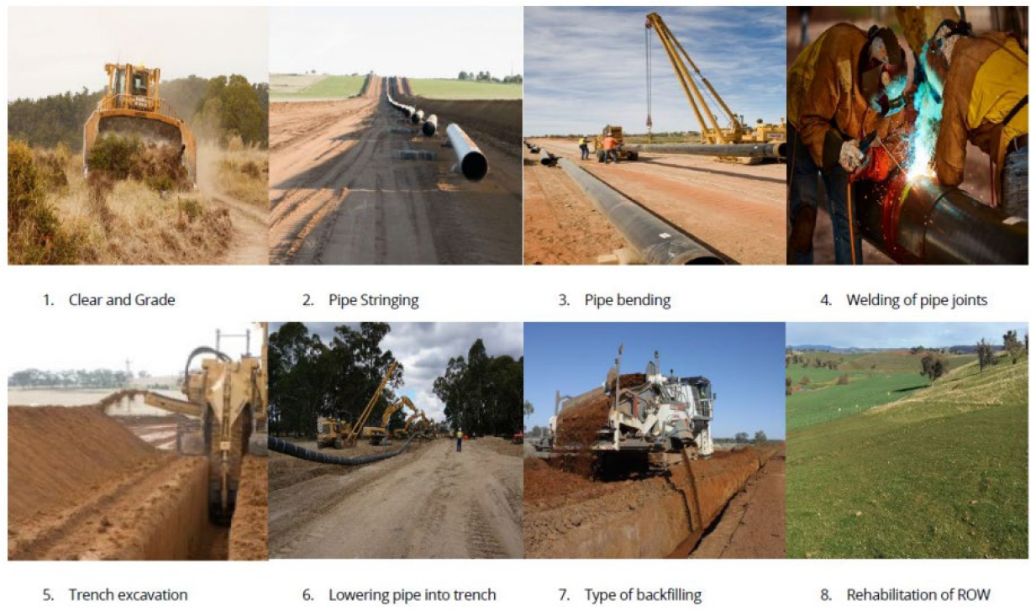

Why an EES is required

On 22 December 2019, the Minister for Planning determined that the Project would require an EES under the Environment Effects Act 1978 (Vic) (EE Act). There were two reasons why the Minister decided an EES was required:
- The project has the potential for significant environmental effects, in particular on native vegetation, habitat of terrestrial and aquatic species listed under the Flora and Fauna Guarantee Act 1988, ecologically sensitive waterways and wetlands, and on Aboriginal cultural heritage
- An EES is warranted to provide an integrated, robust and transparent process to assess the proposal’s effects and associated uncertainties, and to evaluate effectiveness of the proposed avoidance, mitigation, management and offsetting measures prior to any statutory approval decisions.
Following this decision, the Minister issued the draft EES scoping requirements for public comment, which the Minister then finalised and approved on 23 August 2020.
An EES should provide sufficient detail for the Minister for Planning to make a final assessment as to the Project’s acceptability.
An EES assessment demonstrates the ability of the Project to meet statutory requirements. The EES and Minister’s assessment provide decision-makers (including Ministers and other statutory authorities) with information to make decisions about whether statutory approvals for a project should be granted and, if so, what conditions should apply.
The EES describes the Project and its potential environmental effects. It enables the public, stakeholders and decision-makers to understand how the Project works are to be designed, constructed and operated and the likely environmental effects. An EES process provides fair opportunities for public participation in assessment processes.

Project approvals

The principal environmental approval required under Commonwealth legislation is assessment and approval under the Environment Protection and Biodiversity Conservation Act 1999 (EPBC Act).
The Minister for the Environment determined in February 2020 that the proposed Project is a controlled action due to significant impact on listed threatened species and communities, which are designated Matters of National Environmental Significance (MNES).
Part of the Project is located within an approved Melbourne Strategic Assessment (MSA) and no further approvals are required under the EPBC Act for the Project in that area provided certain conditions are adhered to.
The Project requires the following principal approvals under Victorian legislation:
- Pipeline Licence under the Pipelines Act 2005 (Pipelines Act) for construction and operation of the pipeline
- Cultural Heritage Management Plans (CHMP) under the Aboriginal Heritage Act 2006.
Other approvals for the Project under Victorian legislation would be sought as a secondary process after the above principal approvals are obtained.
The approvals process is outlined in Figure 4.
Information on Project approvals is in EES Chapter 5. Please read this chapter to understand your interests before making a submission.

Figure 4 Overview of assessment and approvals process
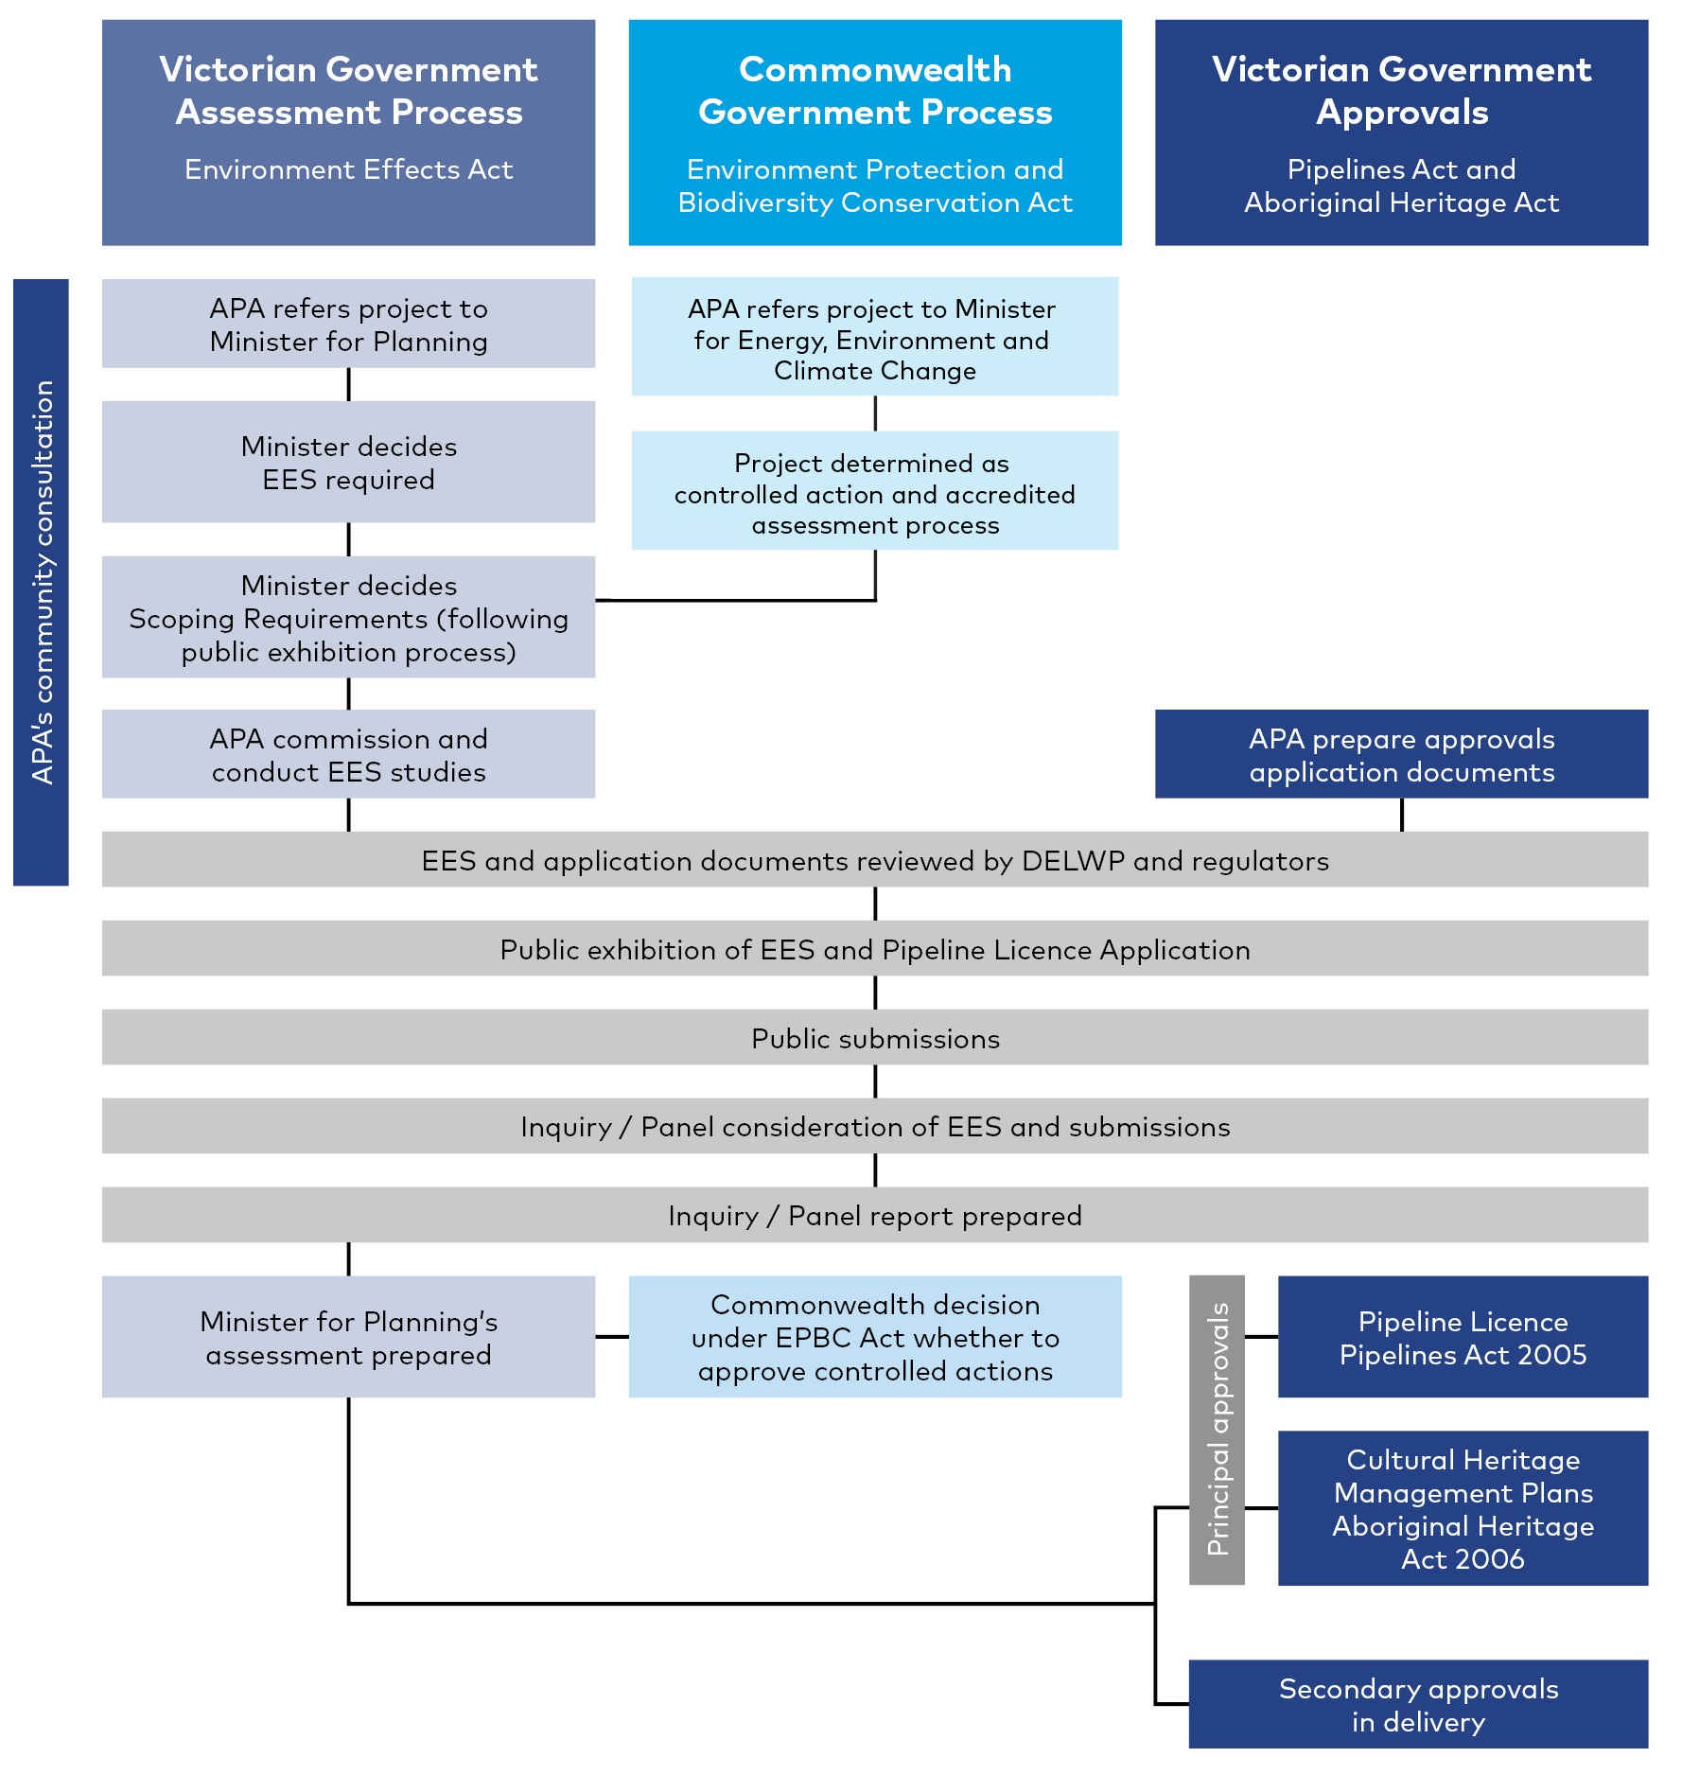

Assessing and managing the Project’s risks and impacts

Assessment approach
To ensure a consistent and transparent approach to the evaluation of potential impacts on the environment, an assessment framework was developed for the Project EES.
The key components of the assessment framework are:
- Evaluation framework – the EES scoping requirements including the evaluation objectives identify desired environmental outcomes and relevant policy and legislation also establishes the framework for assessment
- Assessment approach – the process for undertaking the technical reports including an assessment of existing conditions, risk assessment to screen for key aspects of assessment, impact assessment and development of mitigation measures
- Project development – the progression of the Project design (including from the above assessment) is relevant to the EES as modifications to design can lead to mitigation of environmental impacts.
The assessment approach included consideration of cumulative impacts which could arise where other major projects are constructed within the same geographic area in a similar period. Potential construction impacts include dust, noise and impacts to assets and access. Permanent cumulative impacts include removal of native vegetation or cultural heritage values.
Information on assessing and managing the Project’s impacts is in EES Chapter 5 and 19. Please read these sections to understand your interests before making a submission.

Consultation
The EES process requires consultation and a publicly available consultation plan has been prepared specific to the EES. A range of approaches have been adopted, many of which were held virtually or remotely due to COVID restrictions.
Consultation underpins the Pipelines Act. A separate Pipelines Act Consultation Plan was prepared which covers all phases of the Project. This consultation plan is provided to owners and occupiers of land and outlines information about the Project, how potential impacts are to be managed and legislative approvals required to facilitate construction and operation of the Project.
APA is committed to effective consultation and engagement and will continue to engage through construction and operation, should the Project be approved. APA has maintained a list of Project landholders and other stakeholders since investigations began for the Project in 2018.
Information on Project consultation is in EES Chapter 6. Please read this section before making a submission.

Technical studies
An overview of the thirteen specialist technical studies which evaluated the potential environmental effects of the Project is in Section 5:
- Biodiversity  - Groundwater  - Air quality  - Noise and vibration  - Heritage (Aboriginal cultural and historic)  - Landscape and visual  - Land use | - Surface water  - Land stability and ground movement  - Contamination  - Greenhouse gas  - Social  - Safety
All technical reports are available with the EES. Please read these reports to understand your interests before making a submission.

Assessment of potential impacts

Biodiversity and Matters of National Environmental Significance (MNES)

Native vegetation within the construction corridor is generally degraded with pasture grasses and extensive tracts of noxious weeds dominant. Shelterbelts and windbreaks are common and mostly species that are not indigenous to Victoria.
15.32 hectares of native vegetation was mapped within the construction corridor. Targeted field surveys found an extremely low number of threatened flora, and found habitat for listed species Striped Legless Lizard, Golden Sun Moth, and Growling Grass Frog (recorded within Deep Creek).
A number of biodiversity values will be avoided by pipeline re-alignment and use of HDD (pipeline installed by drilling underground) which reduces ground level disturbance. Avoidance includes two species of threatened flora (one Matted Flax-lily and 48 Tough Scurf-pea), ten large River Red Gum trees, 2.7 hectares of grassy woodland, 1.26 hectares of grassland, 1.24 hectares of known or assumed Striped Legless Lizard habitat and 4.08 hectares of known or assumed Golden Sun Moth habitat.
The Project is expected to clear:
- 10.36 hectares of Western (Basalt) Plains Grasslands Community
- 4.62 hectares of Western Basalt Plains (River Red Gum) Grassy Woodland
- 15.32 hectares of native vegetation in patches; 12 large trees within patches; 16 large scattered trees, and 16 small scattered trees
- 4.16 hectares of Natural Temperate Grassland of the Victorian Volcanic Plain and 2.26 hectares of Grassy Eucalypt Woodland of the Victorian Volcanic Plain.
Impacts on threatened fauna habitat are expected for Golden Sun Moth (19.93 ha), Striped Legless Lizard (39.34 ha), Growling Grass Frog and Tussock Skink.
Indirect impacts (for example from dust or soil compaction or erosion) on botanical values and aquatic ecology values are expected to be minor and temporary.
The majority of aquatic habitats in the construction corridor are highly unlikely to support listed species. Australian Grayling was not found in surveys. Platypus is known to be in Jacksons Creek and risk of injury or death would be minimised or avoided in accordance with Australian Platypus Conservancy guidelines.
Figure 5 Patches of grassland
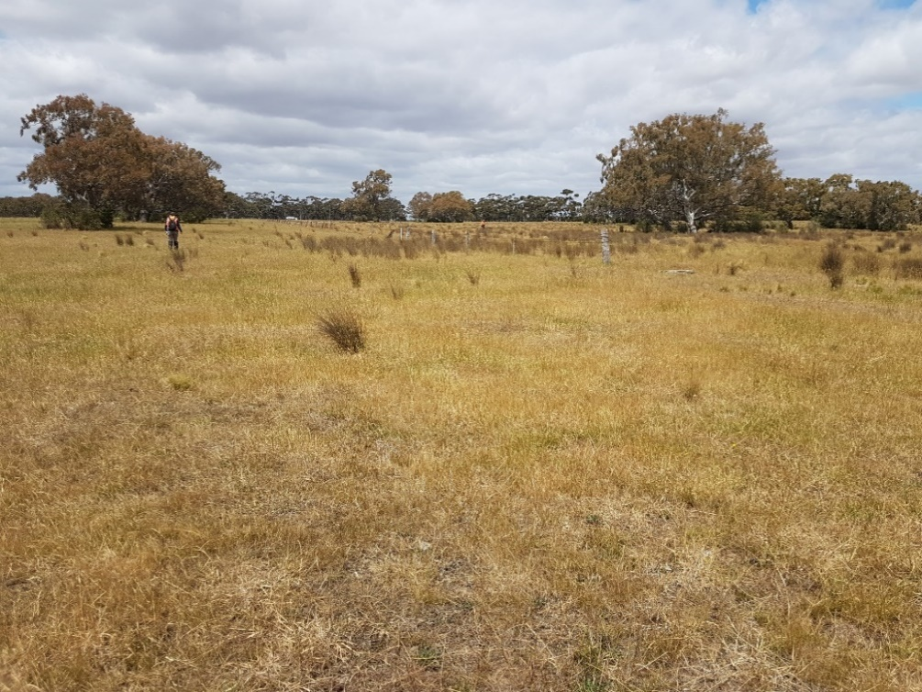
Impacts would be avoided or minimised through measures including control of pests, managing erosion, good contractor awareness, measures specific to threatened species including Platypus and Growling Grass Frog, reinstatement and rehabilitation following construction. Monitoring against baseline conditions would be undertaken.
Residual impacts would be offset in accordance with the Guidelines for the removal, destruction or lopping of native vegetation (DELWP, 2017a) and Department of Environment policy. An Ecological Offset Strategy has been prepared.
Detailed information on existing biodiversity and habitats values, predicted impacts, avoidance, minimisation and mitigation is available in EES Chapter 7 and Technical report A. Information on MNES and predicted impacts on MNES is available in EES Chapter 10 and Technical report A. Information on offsets is available in Technical Report A and Attachment II. Please read these to understand your interests before making a submission.

Water

The alignment crosses a number of waterways with the most significant being Jacksons, Deep and Merri Creeks. Potential impacts on surface water values include erosion and changes to waterways. The crossing method was a key factor in assessing potential impacts. Open trench construction is proposed at Jacksons and Merri creeks, and HDD (installation by drilling underground) is proposed at Deep Creek.
The construction impacts on surface water and waterways are generally considered to be low following standard control measures and additional site-specific controls at Jacksons Creek. Impacts of erosion are potentially more significant for Jacksons Creek due to complexities of the materials below the surface.
Project environmental management measures to minimise impacts to waterways include managing runoff from adjacent construction areas, managing discharge from dewatering, measures to prevent flood risk, site rehabilitation following open cut trench construction.
At Jacksons Creek and Merri Creek, site-specific design, monitoring and construction management measures would be implemented.
Groundwater has been generally found greater than 5 metres deep, however in approximately five per cent of the pipeline length, excavations may be deeper than the groundwater.
Given the anticipated short construction (less than four weeks) of dewatering activities at each location, the risk of groundwater dewatering impacting neighbouring bores is low. During construction dewatering, additional drawdown or lowering of the groundwater level near a Groundwater Dependent Ecosystem (GDE) has only a minor risk.
Specific measures would manage dewatering and manage the potential for drilling fluids to interact with groundwater.
Detailed information on existing conditions, predicted impacts and mitigation is available in EES Chapter 8 and Technical reports B (Surface water) and C (Groundwater). Please read these to understand your interests before making a submission.

Figure 6 Jacksons Creek
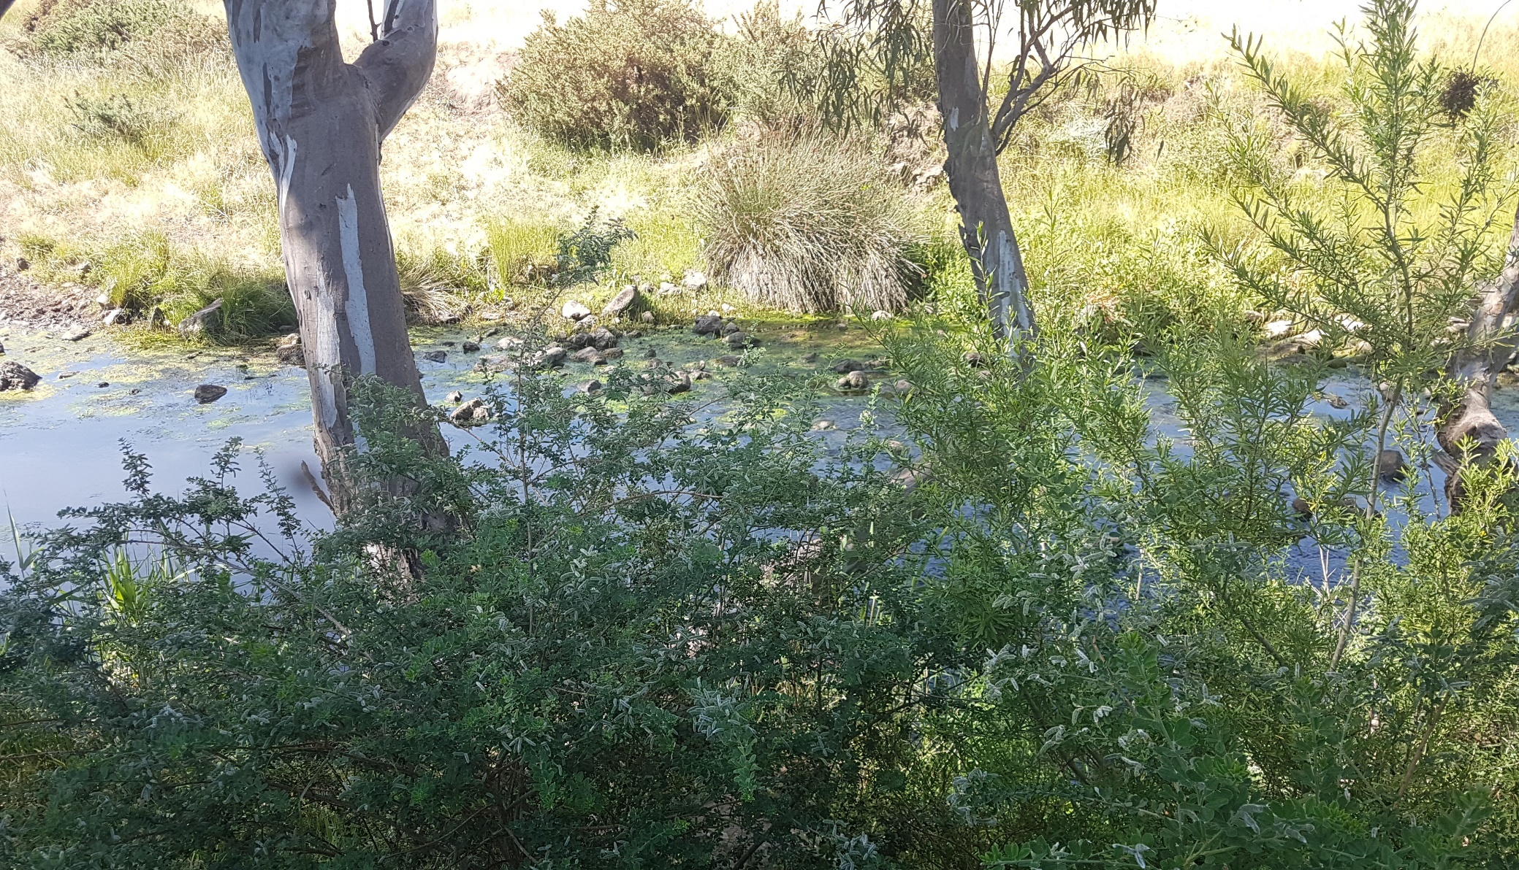

Land stability and ground movement
The vicinity of the construction corridor is generally flat to gently undulating, with low elevations at Jacksons Creek and Deep Creek. Approximately 90 percent of the soils tested are fine grained (cohesive) soil. The remaining 10 percent comprise granular material (ie sand or gravel) as the primary component.
Clays or silts may remain stable during trenching whereas vertical cuts cannot be sustained in granular soils and there could be localised impact. There is potential for impact on slope stability in the valley north of the Jacksons Creek crossing.
Trenchless crossings may result in a minor (only aesthetic) level of asset damage. The potential impact is unlikely to affect the serviceability of the utilities assessed.
Application of the Project environmental management measures would minimise impacts including requirements for bore support during trenchless crossings, third party asset clearances, sodic soils management, and trench support.
Detailed information on existing conditions, predicted impacts, and mitigation is available in EES Chapter 9 and Technical report D. Please read these to understand your interests before making a submission.

Air quality
A total of 484 residential or community activities (sensitive receptors) were identified within 500 metres of the alignment, and within 2.5 km of the Wollert Compressor Station. The closest are six individual residences located between 35 metres and 50 metres from the construction corridor.
During construction, the key air quality impacts would result from dust. Trenching activities have the higher potential for dust, requiring mitigation where sensitive receptors are within 75 metres of the corridor to achieve State Environment Protection Policy (SEPP) Ambient Air Quality criteria trigger levels.
Dust mitigation measures and dust monitoring would be implemented to reduce the likelihood, intensity or extent of dust effects.
Figure 7 Trench excavation works
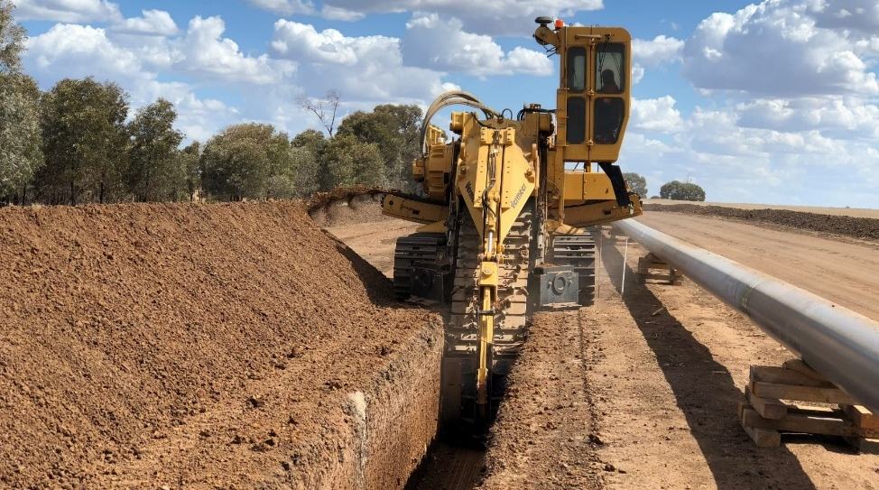
Additional mitigation measures, where required, would include reducing or suspending works when adverse conditions are likely (for example, dry gusty winds with sensitive receptors nearby and downwind).
The mitigation measures would reduce the likelihood, intensity or extent of dust effects, resulting in a low impact to sensitive receptors.
During operation, air quality impacts are limited to operation of the Wollert Compressor Station. Modelling found that all pollutants complied with the relevant criteria in the SEPP Air Quality Management, when modelled in accordance with the Environment Protection (Scheduled Premises) Regulations 2017.
Detailed information on existing conditions, predicted impacts and mitigation is available in EES Chapter 11 and Technical report G. Please read these to understand your interests before making a submission.

Waste (contamination and greenhouse gas)
Land uses in the construction corridor have a low potential for soil and groundwater contamination. There are uses near the construction corridor related to quarrying, landfilling or similar activities. Acid sulfate soils are unlikely to be present. Shallow soils are likely suitable for reuse in areas not identified as potential sources of contamination.
The potential for contaminated groundwater to be intercepted is low because the potential sources of contaminated soil are located where groundwater is greater than 5 metres below ground level.
Construction wastes, including contaminated spoil, would be managed in accordance with the waste hierarchy and EPA guidelines. Designated facilities would be used for identified waste streams.
The Project’s construction is estimated to contribute the equivalent of 0.019% of Victoria’s annual greenhouse gas emissions due to removal of vegetation and fuel use. The Project would result in efficiency gains in the overall Victorian gas supply network, leading to a net reduction in total greenhouse gas emissions of 10,110 t CO₂-e per annum, equating to a reduction of 0.010% and 0.002% of state and national totals respectively.
The Project environmental management measures would reduce construction emissions, including lower embodied energy materials, and fuel efficient plant and equipment. Energy efficiency best practice would reduce operation emissions.
Detailed information on existing conditions, predicted impacts, and mitigation is available in EES Chapter 10 and Technical reports E (Contamination) and H (Greenhouse gas). Please read these to understand your interests before making a submission.

Cultural heritage
The Registered Aboriginal Party Wurundjeri Woi Wurrung Cultural Heritage Aboriginal Corporation and Traditional Owners located near the Project have been involved in investigations and management planning during APA's preparation of two Cultural Heritage Management Plans (CHMP) 16593 and 16594.
Thirty-seven previously registered Aboriginal places are identified within or near the construction corridor, with 13 within the construction corridor.
Clearing the construction corridor and trenching would involve removal of Aboriginal cultural heritage deposits, with some of the 13 places fully destroyed, some partially destroyed, and some previously removed.
No indirect effects on Aboriginal cultural heritage have been identified.
Figure 8 Archaeological investigations
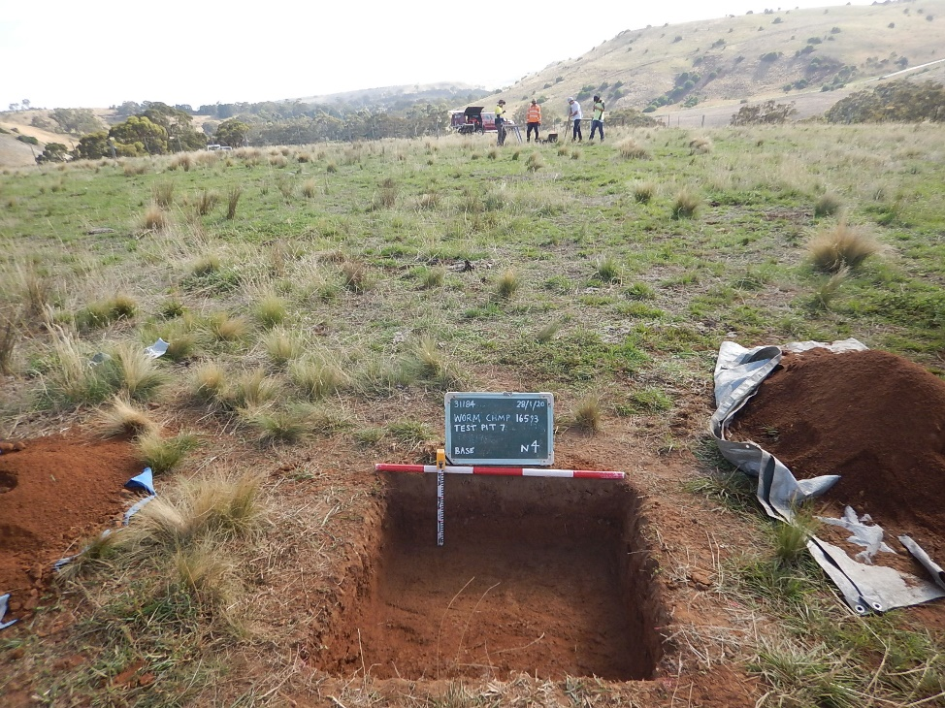
Mitigation and contingency measures would be confirmed through the final CHMPs and are likely to include surface collection of artefacts, subsurface salvage, inductions for staff, and compliance checks.
Two historic sites are located within 100 metres of the construction corridor. One site on the Victorian Heritage Inventory is within the construction corridor, Holden Cobbled Stone Road. No impacts are predicted due to the construction technique to bore under the road in this location.
An unexpected finds procedure would provide the measures to be followed if any unknown historic heritage value is identified during construction.
Detailed information on existing values, predicted impacts, and mitigation is available in EES Chapter 13 and Technical report I. Please read these to understand your interests before making a submission.

Noise and vibration
Within the study area, 525 residential or community activities (sensitive receptors) were identified, almost all being residential activities. There are generally less than five sensitive receptors in any location where construction is expected to exceed daytime criteria.
Works would sometimes be required during the evening and night-time for crossings where the pipeline will be installed by drilling underground (HDD and boring).
Without mitigation, these activities have the potential to exceed the evening (12 locations) and night-time (14 locations) noise criteria. HDD and bored crossings could take between two to three weeks and mitigation measures would be required to avoid and minimise impacts. Mitigation measures are predicted to reduce the noise levels by around 5 dB(A) to as much as 50 dB(A) where barriers or enclosures are used.
Where noise is still predicted to exceed the adopted criteria, information on the impact will be discussed with affected residents. Depending on the circumstances, individual measures to minimise noise impacts will be considered including alternative temporary accommodation.
Measures to avoid and minimise the impacts of construction vibration for sensitive receptors within 100 metres could include restricted hours, and increasing distance between equipment and sensitive receptors.
Blasting locations would be located at least 100 metres or more from residential buildings. At this distance, blasting would generally not exceed the human comfort criteria or the structural damage criterion. A detailed blast study would be developed to confirm potential blasting impacts and management measures required.
Melbourne Water’s Yan Yean to Bald Hill pipeline project and Major Road Projects Victoria’s (MRPV) Sunbury Road upgrade project may be constructed at the same time.
Liaison with MRPV and Melbourne Water would be undertaken to avoid, where practicable, works being undertaken at the same time and in the same location.
The source of operation noise emissions would be the Wollert Compressor Station. The closest sensitive receptor is around 700 metres away. Noise levels modelled show the facility would comply with the applicable noise limits at all sensitive receptors during the day and the night.
Detailed information on existing conditions, predicted impacts and mitigation is available in EES Chapter 12 and Technical report F. Please read these to understand your interests before making a submission.

Landscape and visual
Landscape character areas (LCA) were identified to establish the existing landscape character and assess impact on the landscape.
The potential landscape and visual impacts as a result of the Project have been assessed as low given the short duration and temporary nature of the proposed construction activities, the pipeline being located underground, and the nature of the existing landscape.
Vegetation clearance for construction generally presented the most impacts, particularly close to creeks and semi-rural residential areas.

Figure 9 Landscape character area – gently undulating farmland
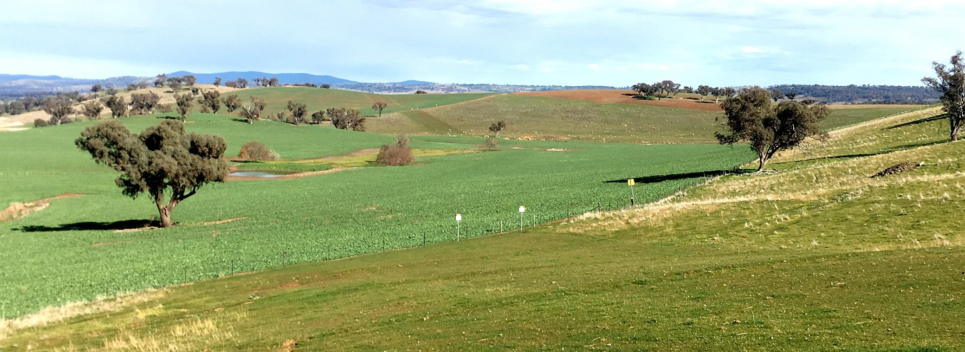

Rehabilitation of land and replacement of vegetation buffers where practicable would ensure that impacts on views from public places or private residences with existing screening from road reserves would be low.
The Mainline valve station at Gunns Gully Road would bring a change to the existing view, however, has the potential to be screened.
Lighting impacts are expected to have negligible impact given their temporary nature and due to the nearest dwelling being located approximately 350 metres from an area of night works (Deep Creek).
The application of the management measures would minimise landscape and visual impacts to low or negligible across the alignment.
Detailed information on existing values, predicted impacts and mitigation measures is available in EES Chapter 14 and Technical report J. Please read these to understand your interests before making a submission.

Land use
The Project is located within peri-urban Melbourne, with approximately half of the Project located within the Urban Growth Boundary. This area of Melbourne is undergoing significant change.
Prior to construction, APA would secure land access for the pipeline construction and easement and acquire land for the three mainline valves. Engagement with directly affected landholders commenced in 2018 and would continue with individual negotiations through to agreement.
The construction of the Project may include temporary, minor impacts on the continuation of agricultural land uses and on the amenity of surrounding land uses. Existing agricultural uses would be able to continue following rehabilitation of the construction corridor.
Minimisation of land use impacts has been achieved primarily by avoiding commercial, residential, industrial and community land uses.
A Construction Environmental Management Plan, Project Consultation Plan, and Traffic Management Plans, amongst other measures will minimise construction impacts on individual land uses.
The Project has been refined in negotiation with the Department of Transport to manage potential risks to the future use of land for the OMR/E6 Transport corridor.
During operation, there would be restrictions on use and development of land within the 15 metre easement. The easement provides an opportunity for linear open space in new urban areas, subject to landowner agreement and location.
Detailed information on existing conditions, planning framework, predicted impacts and mitigation is available in EES Chapter 15 and Technical report K. Please read these to understand your interests before making a submission.

Social
The Project intersects 137 parcels of land through four local government areas (LGA) of Melton, Hume, Mitchell, and Whittlesea, with 85 unique landowners. The majority of parcels are rural residential or agricultural parcels.
Changes to amenity from dust or noise during construction have potential for temporary reduction in use of backyards or use of community facilities.
The temporary reduction in the area of land available for productive agriculture activities has potential, without mitigation, for economic impact of $0.2 million over 12 months. This is equivalent to 0.13% of the annual value of agricultural production across the LGAs.
Construction activities would be undertaken in accordance with agreements made with the landowners and occupiers. Following rehabilitation, normal agricultural activities and production would be able to resume. Landholders will be entitled to compensation for productivity loss during construction and the establishment of the easement.
Impacts to community and residential access will be minimised by utilising construction methods such as boring under the road at road crossings.
A Construction Environmental Management Plan, Project Consultation Plan, and Traffic Management Plans, will be utilised to minimise social impacts.
Other measures will include reinstatement of all fences and tracks, biosecurity management measures and actions to minimise amenity impacts to adjacent residents and community facilities.
Detailed information on social conditions, predicted social impact and mitigation measures is available in EES Chapter 16 and Technical report L. The technical report incorporates an agricultural impact assessment. Please read these to understand your interests before making a submission.

Safety
A pipeline licence is required for the pipeline works under the Pipelines Act. Licensed pipelines are to be constructed and operated safely in accordance with the Pipelines Act and the requirements in AS/NZS 2885.
Under the Pipelines Act, the licensee has a general duty to implement a range of safety measures to minimise foreseeable risks and hazards to public safety associated with operating a pipeline ‘so far as is reasonably practicable’ (SFAIRP).
To minimise the risk of a gas release, a number of mitigation measures are incorporated into the design and ongoing management.
Minimum mitigation controls include:
- Separation – through appropriate setbacks and physical controls such as pipeline thickness, concrete protection slabs
- Awareness – liaison with landholders along the pipeline route, and controls such as Dial Before You Dig and pipeline marker signs.
The assessment looked at the risk of a bushfire, including fires igniting from a Project activity or fires igniting outside the Project and impacting the Project. The APA Bushfire Management Action Plan includes measures for bushfire suppression, early-warning and evacuation measures.
APA would implement their Health, Safety and Environment Management System in construction and operation. This includes aspects such as routine inspections, training, APA permit for higher risk activities, a Project Construction Safety Management Plan, emergency response.
Detailed information on the Safety Management Study, safety risks bushfire assessment, and management measures is available in EES Chapter 17 and Technical report M. Please read these to understand your interests before making a submission.

Figure 10 Landowners and occupiers
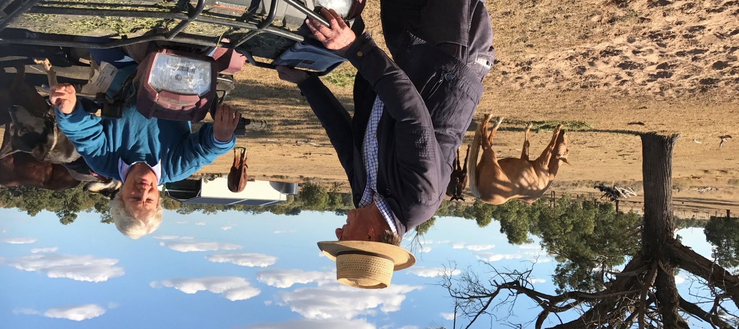

Approach to manage effects

The Project would be delivered in accordance with APA's environmental management measures to avoid, minimise or offset potential environmental, social and safety impacts. These measures together with other Project requirements would be implemented through a series of environmental documents. The key environmental management documents are shown in Figure 11.
APA is required to develop an environmental management plan for construction (CEMP), to accompany the Pipeline Licence Application for approval by the Minister for Energy, Environment and Climate Change. Operation of the Project would be managed in accordance with the Operation Environmental Management Plan for the Victorian Transmission System (VTS OEMP).
A range of monitoring programs would be implemented informed by regulatory requirements and scale of environmental risk.
Contractors will be required to comply with relevant legislation, approval conditions, the CEMP and VTS OEMP.
A Safety Management Plan prepared with the Pipeline Licence Application for the Project must be approved by Energy Safe Victoria prior to operations.
In the event of a complaint from the community regarding noise, waste, or other aspect of construction or operation issues, further investigation will be undertaken in line with APA's complaint management process.
Further information on the Environmental Management Framework is available in EES Chapter 19. The draft CEMP is part of the Pipeline Licence Application in Attachment I. Please read these to understand your interests before making a submission.

Figure 11 Key environmental management documentation
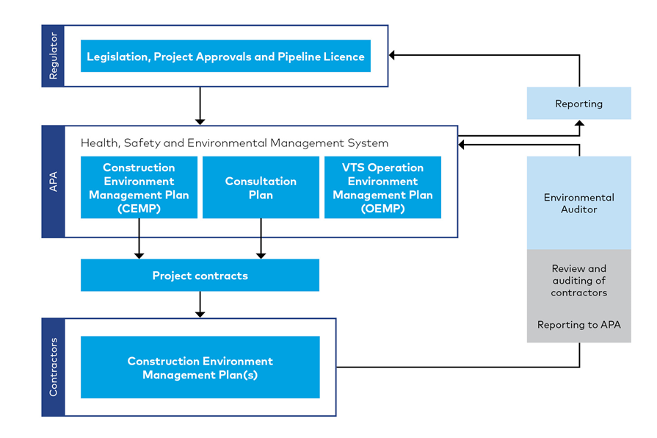

EES exhibition and submissions

Viewing the EES
The APA WORM Project EES and Pipeline Licence Application will be on public exhibition for 30 business days from 7 July 2021 to 17 August 2021. During this time, members of the public can inspect the EES and make written submissions about any matters described in the EES and Pipeline Licence Application.
Copies of the EES, Pipeline Licence Application and supporting material can be downloaded from the Project website: www.apa.com.au/worm/ees
Free copies of the EES Summary brochure and USBs containing all the EES documentation are available at the public exhibition locations or directly from APA. Subject to COVID-19 restrictions, during the public exhibition period, hard copies of the EES are available for inspection during office hours at:
- State Library of Victoria, 328 Swanston St, Melbourne VIC 3000
- Caroline Springs Library & Learning Hub, 193–201 Caroline Springs Blvd, Caroline Springs VIC 3023
- Craigieburn Library, 75–95 Central Park Ave, Craigieburn VIC 3064
- Greater Beveridge Community Centre, Cnr Lithgow St and, Mandalay Cct, Beveridge VIC 3753
- City of Whittlesea Civic Centre Office – South Morang, 25 Ferres Blvd, South Morang VIC 3752
Subject to COVID-19 restrictions on Community Facilities. Please check the COVIDSafe Settings for metropolitan Melbourne for updates.

Making a submission
Submissions on the EES and Pipeline Licence Application must be made in writing and received by 11.59 pm on Tuesday 17 August 2021.
Each submission is a public document and will be treated as a submission on the EES and the Pipeline Licence Application.
Online submissions are preferred and can be lodged via the Victorian Government’s engagement website: www.engage.vic.gov.au/worm-inquiry.
Where a submitter is unable to lodge a submission online, they must contact Planning Panels Victoria (PPV) through the DELWP Customer Call Centre on 136 186 (select option 6) and request a hard copy submission coversheet issued by PPV. Each hard copy written submission must have a coversheet issued by PPV.
All submissions must state the name and address of the person making the submission. Petitions will be treated as a single submission and only the first names from a petition submission will be registered and contacted.
All submissions will be treated as public documents in accordance with the PPV Privacy Collection Notice and will be published on the Victorian Government’s engagement website. Do not include personal information in the body of your submission (such as your email address or phone number). Your name will be made public.
Anyone seeking to be heard at a public hearing is required to submit a written submission and indicate on the submission form that they would like to be heard at the hearing.
The submissions process is independently managed by PPV and any inquiries regarding the management of submissions and the hearing process should be directed to them.
For more information about the submission process, contact PPV on 136 186 (select option 6) or email planning.panels@delwp.vic.gov.au.

Navigating the EES
The structure of the EES and where to find topics of interest is shown in Figure 12.
Figure 12 EES Structure
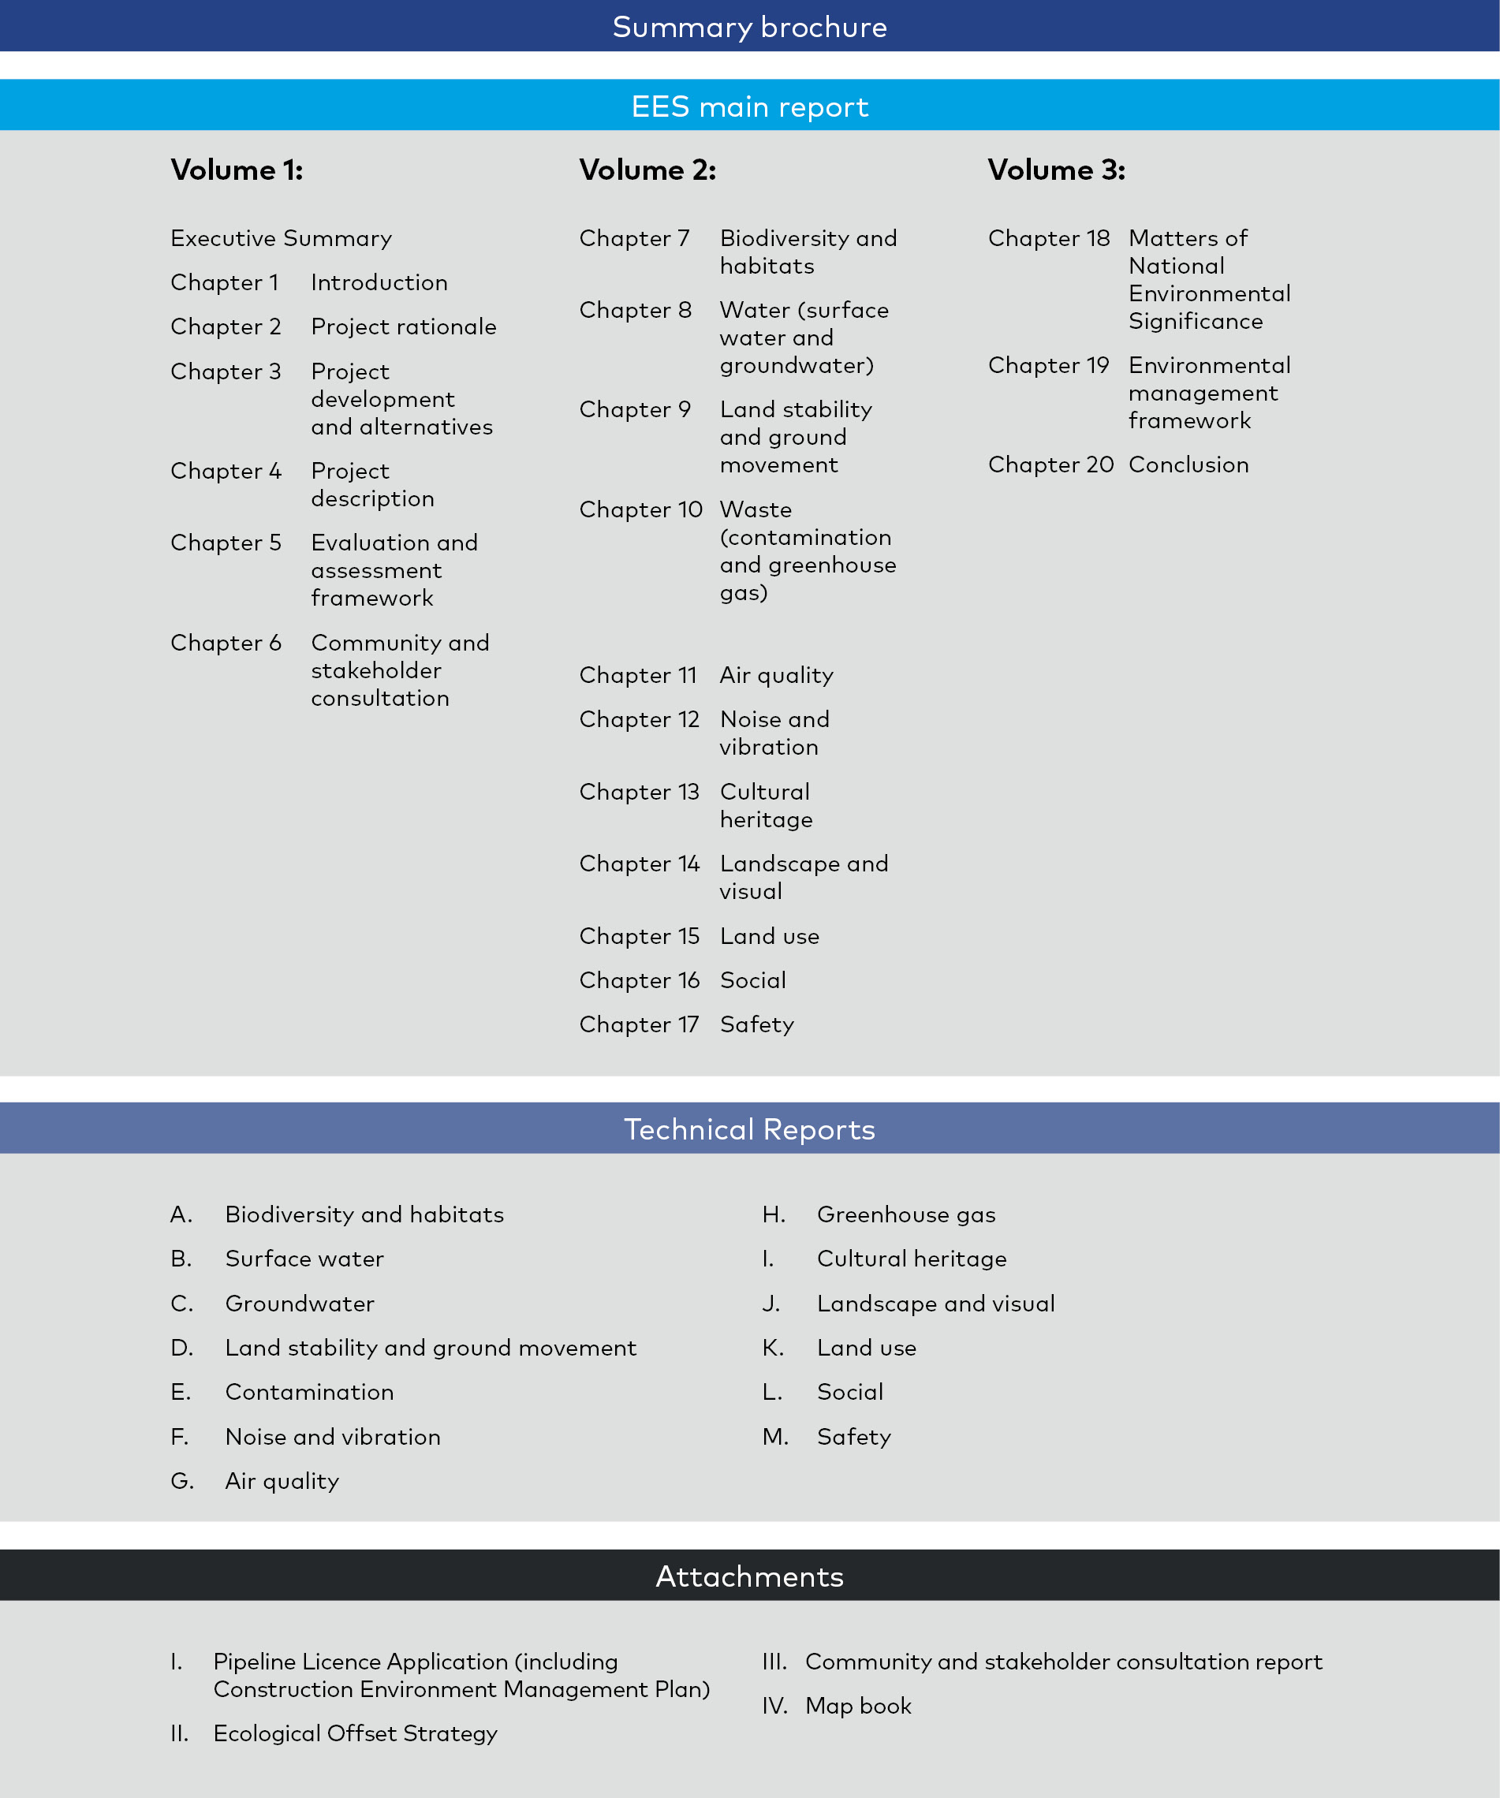

Next steps and concluding the EES process

Following public exhibition of the EES, the Inquiry appointed by the Minister for Planning will review public submissions, the EES and consider the environmental effects of the project in accordance with terms of reference issued by the Minister for Planning.
The Inquiry may also be appointed by the Minister for Energy, Environment and Climate Change as a panel under the Pipelines Act to consider the Pipeline Licence Application. If appointed as a panel, it must act in accordance with the requirements of the Pipelines Act and any specifications in its instrument of appointment.
After the exhibition period, the Inquiry will hold a Directions Hearing where the necessary arrangements and timetable for the public hearing will be established. Further information about the Directions Hearing arrangements (including whether it will be held in person or conducted online by video conference), will be published on the Engage Victoria website: www.engage.vic.gov.au.
The Inquiry will follow the health advice from the Victoria Government and the Chief Health Officer in making this decision.
A public hearing will be held to give people an opportunity to speak in support of their written submission. The Public Hearing is open for anyone to watch.
Following receipt of the Inquiry’s report, an assessment of the Project will be made by the Minister for Planning.
The Minister’s written assessment makes recommendations about whether the environmental effects of the Project are acceptable, along with any modifications or further management measures the Minister considers appropriate.
In preparing this assessment, the Minister considers all relevant information, including the EES documents, public submissions and the report from the Inquiry.
The relevant decision-makers for the approvals required by the Project would consider the Minister’s assessment in deciding whether to approve and set conditions of approval on the Project.

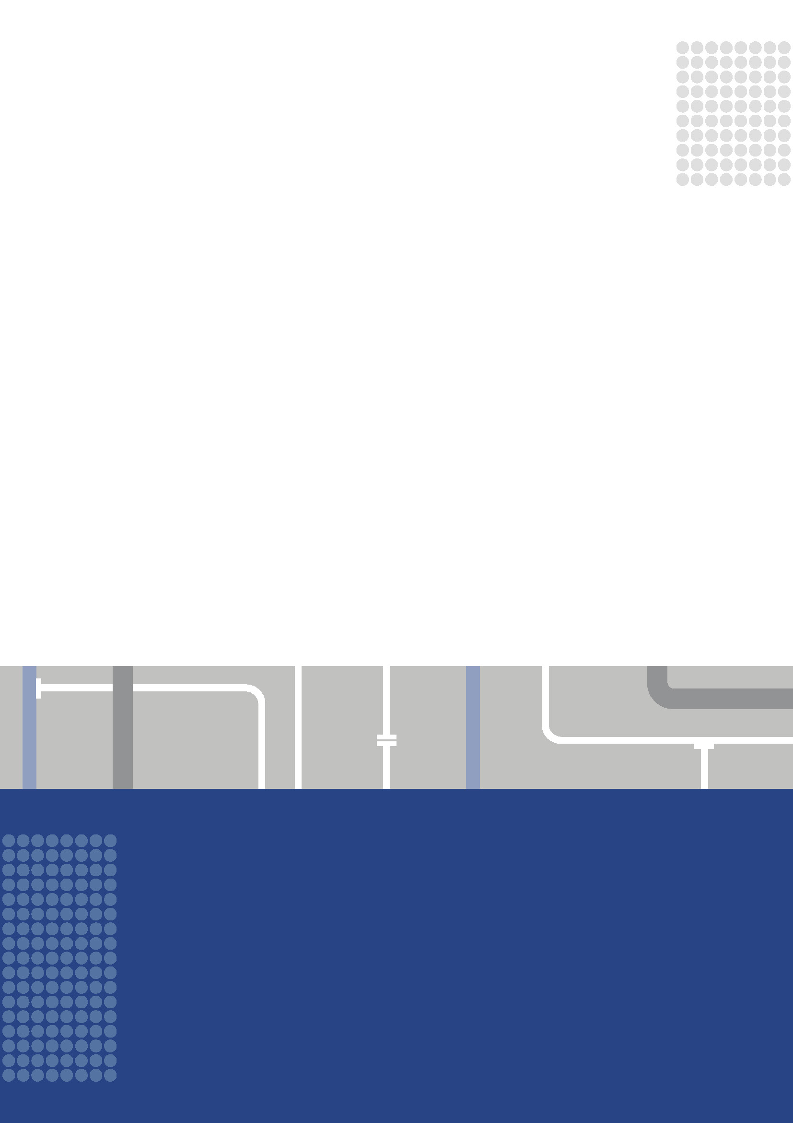
Questions?
More detail about the Western Outer Ring Main Project is available at www.apa.com.au/worm
The full Environment Effects Statement and Technical reports can be downloaded at www.apa.com.au/worm/ees
Contact us
APA
Level 14, IBM Building, 60 City Road, Melbourne, VIC 3006 Phone: 1800 951 444
Email: worm@apa.com.au
EES process
Impact Assessment Unit, Department of Environment, Land, Water and Planning
Phone: (03) 8392 5503
Email: environment.assessment@delwp.vic.gov.au
Pipeline licence application
Pipelines Regulation, Department of Environment, Land, Water and Planning
Phone: 136 186
Email: pipeline.regulation@delwp.vic.gov.au
Inquiry process and making a submission
Planning Panels Victoria
Phone: 136 186 (select option 6)
Email: planning.panels@delwp.vic.gov.au
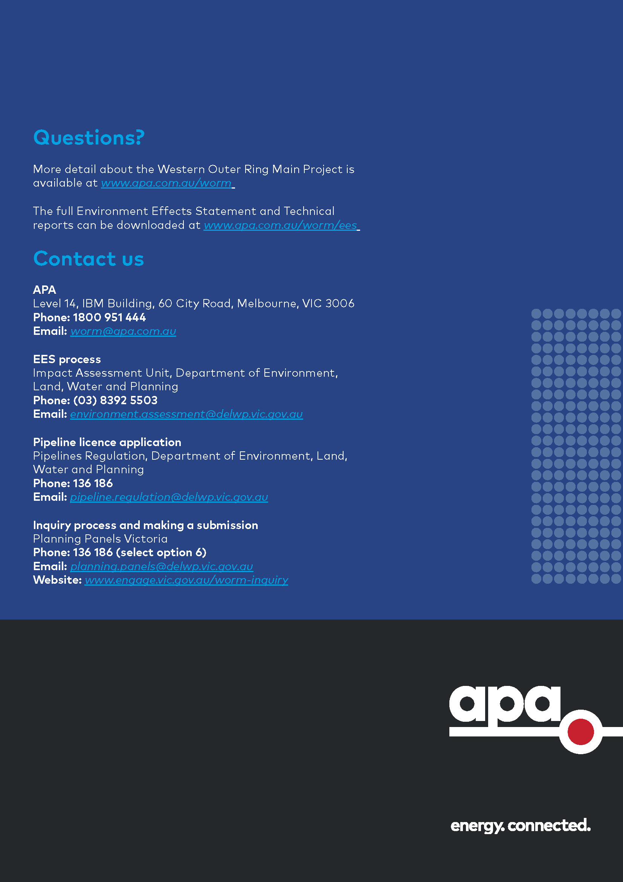
Website: www.engage.vic.gov.au/worm-inquiry

Victorian Renewable Energy Target – 2018–19 Progress Report, Table 1, page 7.
Route Options Report - Western Outer Ring Main Project (APA, March 2019) https://www.apa.com.au/globalassets/about-apa/our-projects/western-outer-ring-main-project/western-outer-ring-main-project-route-options-report.pdf.

